Ex. No.4 STUDENT INFORMATION SYSTEM
Date:

AIM
To develop a project Student Information System using Rational Rose Software and to implement the software in Java.

PROBLEM ANALYSIS AND PROJECT PLANNING
A Student information system (SIS) is a software application for educational establishments to manage student data. Student information systems provide capabilities for entering student test and other assessment scores, building student schedules, tracking student attendance, and managing many other student-related data needs in a school, college or university.

PROBLEM STATEMENT
- Effective for Administration Purpose
b. Cheap
c. Better Service

UML DIAGRAMS:
The following UML diagrams describe the process involved in the online recruitment system
a. Use case diagram
b. Class diagram
c. Sequence diagram
d. Collaboration diagram
e. Activity diagram
f. Component diagram

USE CASE DIAGRAM:

A use case is a methodology used in system analysis to identify, clarify, and organize system requirements. The use case is made up of a set of possible sequences of interactions between systems and users in a particular environment and related to a particular goal. It is represented using ellipse. Actor is any external entity that makes use of the system being modelled. Its
represented using stick figure

For Administrator:

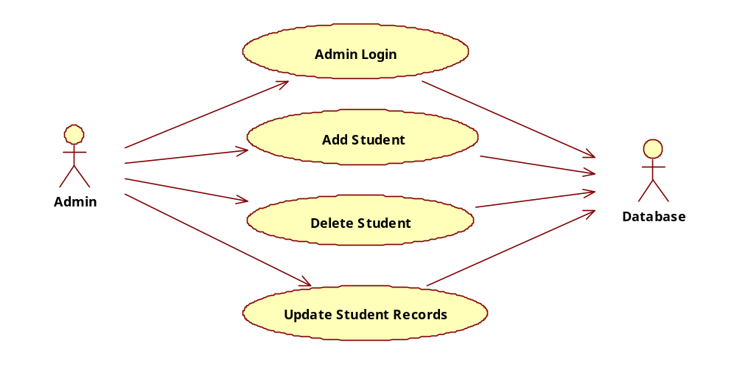

For Student:
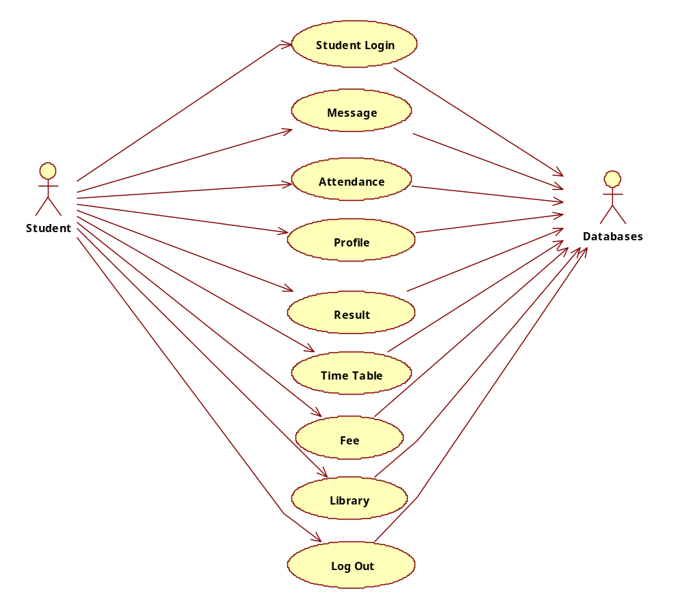

DOCUMENTATION OF USE CASE DIAGRAM

The actors in this use case diagram are Admin, Student, Database. The use cases are the activities performed by actors.

a. Admin register login, and store the student records details in database.

b. Student Register from the Student Login process.

c. Then the database is searched for details and verified.

d. Database stores the details and returns acknowledgement

CLASS DIAGRAM:

A class diagram in the unified modeling language (UML) is a type of static structure diagram that describes the structure of a system by showing the system's classes, their attributes, and the relationships between the classes. It s represented using a rectangle with three compartments. Top compartment have the class name, middle compartment the attributes and the bottom compartment with operations.

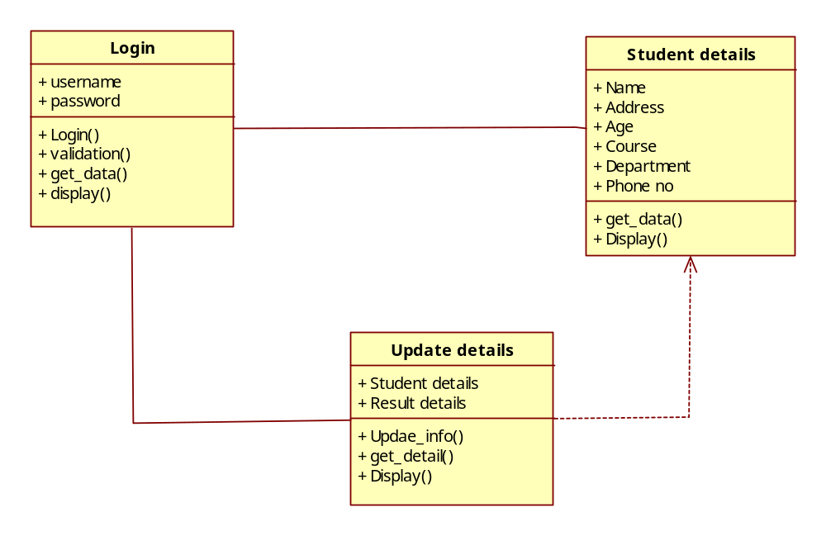
DOCUMENTATION OF CLASS DIAGRAM

This class diagram has three classes Login, Student details and Update details in database.

a. Students – is the class name. Its attributes are name, Address, DOB, Gender, College, Subjects, Semester, Year, Degree, Branch. The operations Performed in the students class, Store database and Update.
b. Administration– is the class name. Its attributes are Login, Password and database. The operations performed are Student Details store in database and send acknowledgement.
c. Database – is the class name. The operations performed are storing Search and storing the values.

SEQUENCE DIAGRAM:

A sequence diagram in Unified Modeling Language (UML) is a kind of interaction diagram that shows how processes operate with one another and in what order. It is a construct of a Message Sequence Chart. There are two dimensions.
1. Veritcal dimension-represent time.
2. Horizontal dimension-represent different objects.

For Validity:
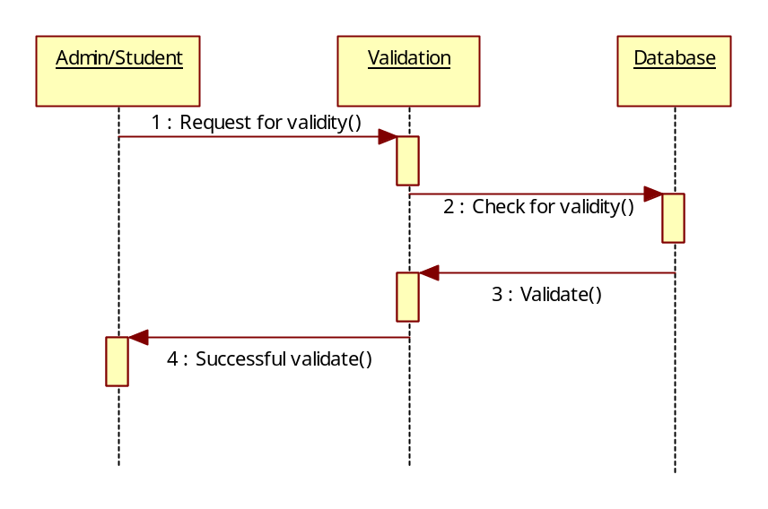

For Administrator:
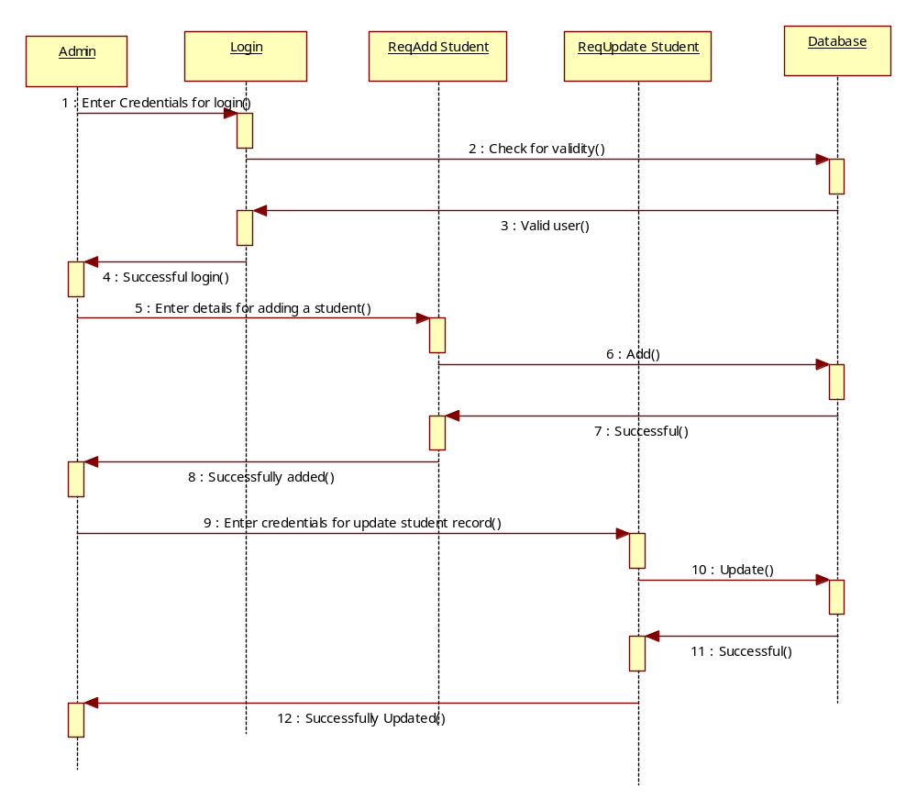

For Student:
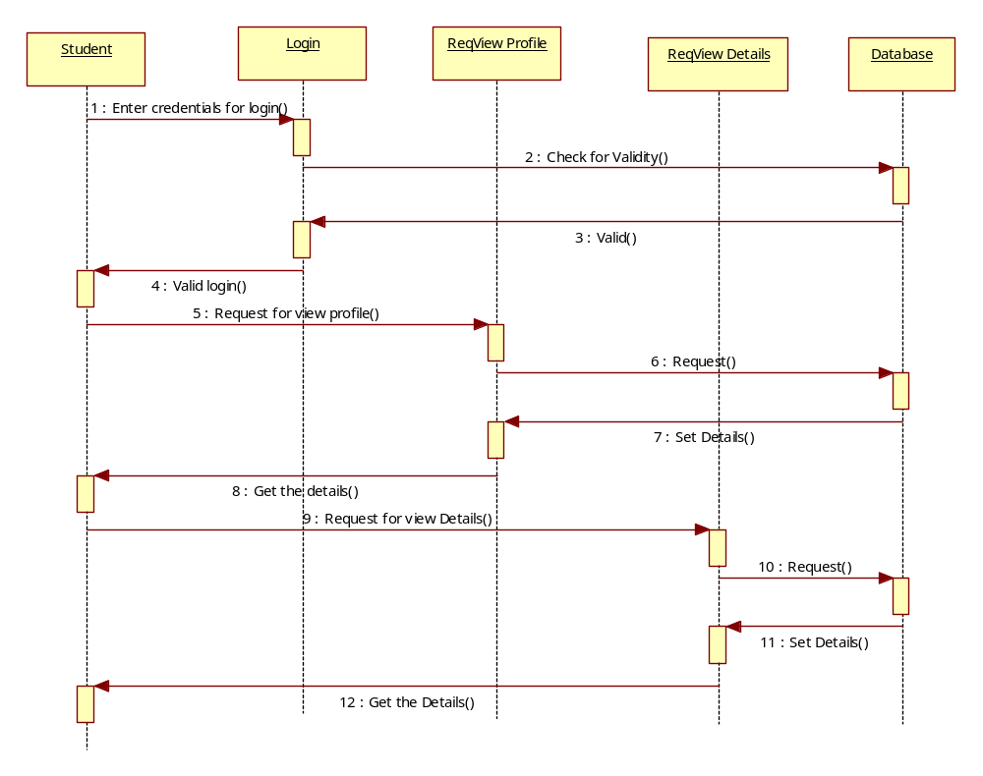

DOCUMENTATION OF SEQUENCE DIAGRAM

The sequence diagram describes the sequence of steps to show

- The Admin login and registering for Add Stduent Details.

b. The verification done by the interface and sending acknowledgement for registration.

c. Searching the database with login and displaying it for maintenance.

COLLABRATION DIAGRAM:

A collaboration diagram, also called a communication diagram or interaction diagram,. A sophisticated modeling tool can easily convert a collaboration diagram into a sequence diagram and the vice. A collaboration diagram resembles a flowchart that portrays the roles, functionality and behavior of individual objects as well as the overall operation of the system in real time

For Validity:
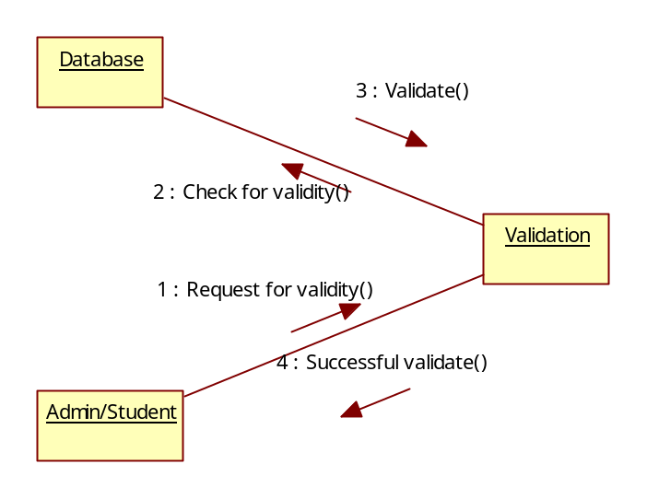

For Administrator:
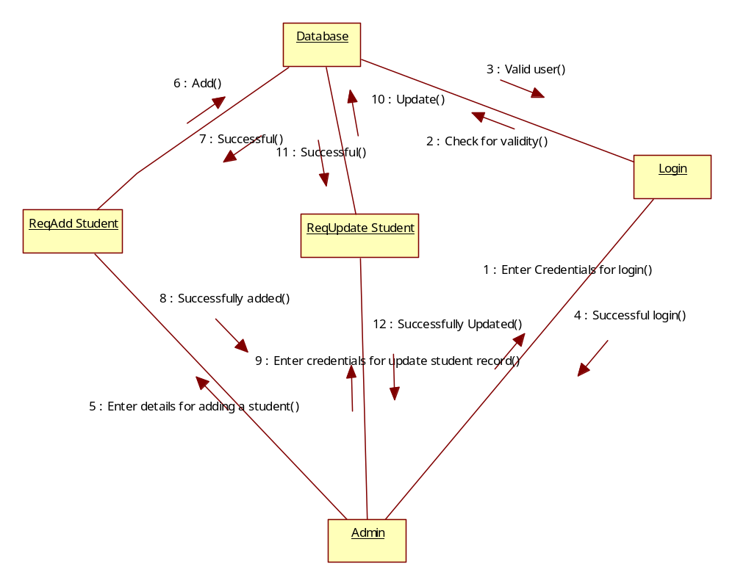

For Student:
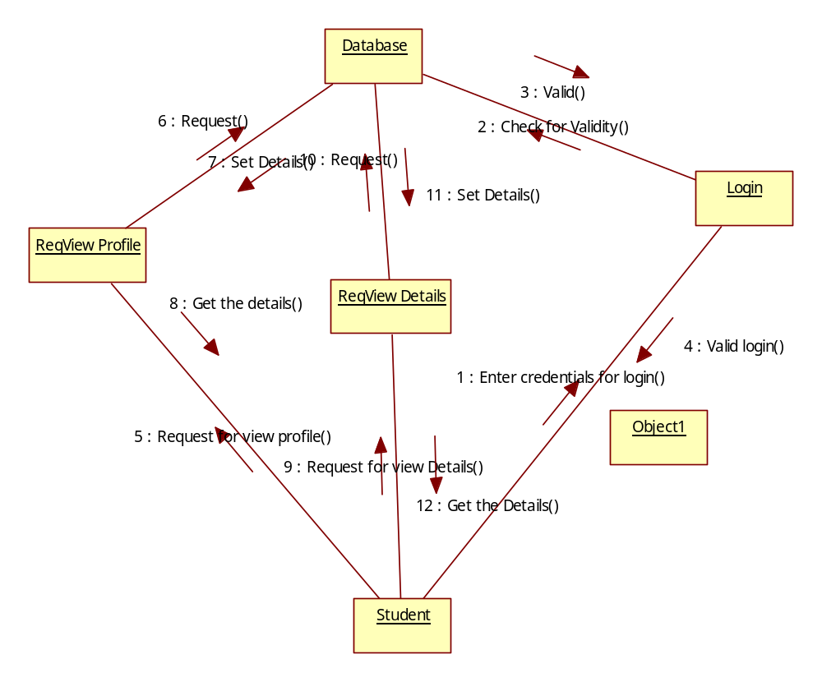

DOCUMENTATION OF COLLABRATION DIAGRAM

The collaboration diagram is to show how the Student registers and the authorities maintains the details of the registered students in the Information system. Here the sequence is numbered according to the flow of execution.

ACTIVITY DIAGRAM:

Activity diagrams are graphical representations of workflows of stepwise activities and actions with support for choice, iteration and concurrency. In the Unified Modeling Language, activity diagrams can be used to describe the business and operational step-by-step workflows of components in a system. An activity diagram shows the overall flow of control. An activity is shown as an rounded box containing the name of the operation.

DOCUMENTATION OF ACTIVITY DIAGRAM

This activity diagram flow of stepwise activities performed in recruitment system.

a. The student details are Add and stored in database.

b. Select the course from the given Course by student.

c. Search Profile and Result with login and if data present in the database.

d. The searched data is displayed if available and then Log Out.
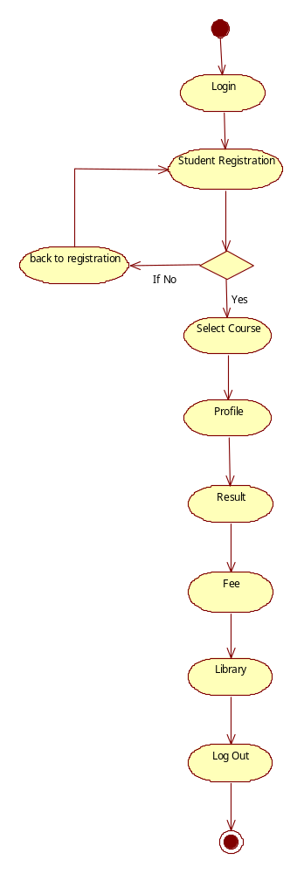
COMPONENT DIAGRAM:

The component diagram's main purpose is to show the structural relationships between the components of a system. It is represented by boxed figure. Dependencies are represented by communication association.

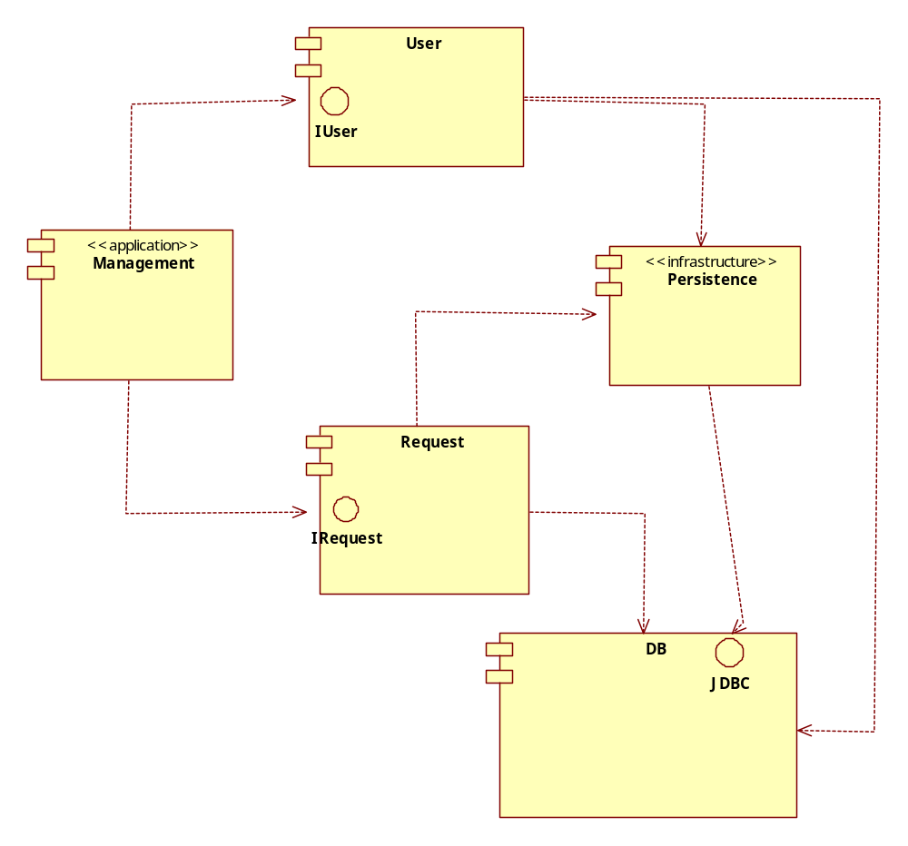

DOCUMENTATION OF COMPONENT DIAGRAM

The main component in this component diagram is Student Information system. And register, User and Manage, Request details are the components comes under the main component.

DEPLOYMENT DIAGRAM:
A deployment diagram in the unified modeling language serves to model the physical deployment of artifacts on deployment targets. Deployment Diagrams show "the allocation of artifacts to nodes according to the Deployments defined between them. It is represented by 3-dimentional box. Dependencies are represented by communication association.

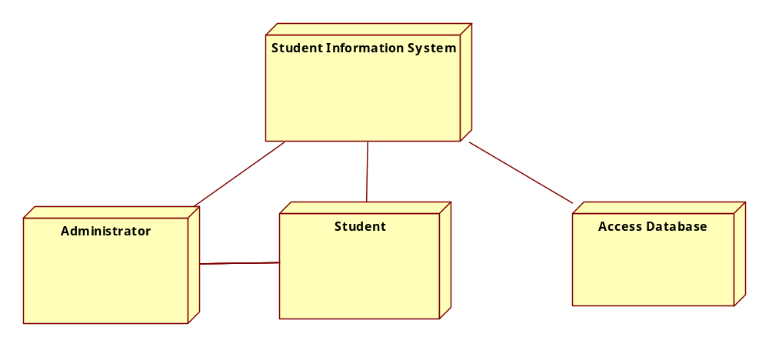

DOCUMENTATION OF DEPLOYMENT DIAGRAM

The processor in this deployment diagram is the Student Information System which is the main part and the Student are the Admin, verify and search which are the some of the main activities performed in the system.

Coding:
import java.awt.*;
import java.awt.event.*;
import javax.swing.*;
import java.sql.*;
public class jdbcframe1 extends JFrame implements ActionListener
{
public JLabel l1,l2,l3,l4,l5;
public JTextField t1,t2,t3,t4,t5;
public JButton b1;
Container c;
public jdbcframe1()
{
setSize(180,400);
setTitle("STUDENT DETAILS");
setVisible(true);
setDefaultCloseOperation(JFrame.EXIT_ON_CLOSE);
c=getContentPane();
c.setLayout(new FlowLayout());
l1=new JLabel("Regno");
c.add(l1);
t1=new JTextField(10);
c.add(t1);
l2=new JLabel("Name");
c.add(l2);
t2=new JTextField(10);
c.add(t2);
l3=new JLabel("Dept");
c.add(l3);
t3=new JTextField(10);
c.add(t3);
l4=new JLabel("Course");
c.add(l4);
t4=new JTextField(10);
c.add(t4);
l5=new JLabel("Contact");
c.add(l5);
t5=new JTextField(12);
c.add(t5);
b1=new JButton("SAVE");
c.add(b1);
b1.addActionListener(this);
}
public void actionPerformed(ActionEvent ae)
{
if(ae.getSource()==b1)
{
try
{
Class.forName("sun.jdbc.odbc.JdbcOdbcDriver");
Connection con=DriverManager.getConnection("jdbc:odbc:student");
Statement st=con.createStatement();
PreparedStatement ps,ps1;
ps1=con.prepaeStatement("select * from student where regno="+t1.getText());

ps=con.prepareStatement("insert into student(regno,name,dept,course,contact)values(?,?,?,?,?)");
ps.setString(1,t1.getText());
ps.setString(2,t2.getText());
ps.setString(3,t3.getText());
ps.setString(4,t4.getText());
ps.setString(5,t5.getText());
ps.executeUpdate();
JOptionPane.showMessageDialog(null,"RECORD SAVED");
}
catch(SQLException sq)
{
System.out.println(sq);
System.out.println("\nHai this place is error occur");
}
catch(Exception e)
{
System.out.println(e);
}
}
}
public static void main(String args[])
{
jdbcframe1 f=new jdbcframe1();
}
}

Output:

