# To support your MTC Zero experience, please complete this template by providing: Internal description, External description and timing by scenario.

# Internal descriptions of the experience(s) to be used by the MTC with sellers:

**Business Analytics & AI Demo for Azure 10 Solutions**

Intelligent Customer Care with Bot Framework, Cognitive Services, Big Data, Machine Learning, Dynamics

**Abstract:**

This demo walks through a customer experience who is looking for insurance for her new car. The intelligent customer care bot will engage in a conversation with the customer and recommend quotes based on the customer profile and other factors. At some point, the bot will involve a human agent when it senses churn risk. The human agent can access the customer profile information and determine the best promotions and offers. Finally, the entire process metrics can be viewed from the operational dashboard and provide leaders on insights of the business.

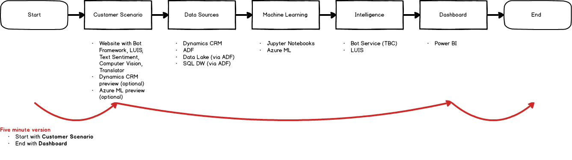

# External customer ready description of the experience(s) that can be added to a Strategy Briefing agenda:

**Business Analytics & AI Demo for Azure 10 Solutions**

Intelligent Customer Care with Bot Framework, Cognitive Services, Big Data, Machine Learning, Dynamics

**Abstract:**

This demo walks through a customer experience who is looking for insurance for her new car. The intelligent customer care bot will engage in a conversation with the customer and recommend quotes based on the customer profile and other factors. At some point, the bot will involve a human agent when it senses churn risk. The human agent can access the customer profile information and determine the best promotions and offers. Finally, the entire process metrics can be viewed from the operational dashboard and provide leaders on insights of the business.

# Timing approximations per scenario:

|  |  |
| --- | --- |
| 5 min | **Scenario walkthrough – Chat Bot**   1. The customer just purchased a new car and needs an insurance quote. 2. The customer goes to their insurance provider’s website for support via a “Get Started” link. 3. The customer service bot requests verification information. 4. After verification, the bot asks for information about the new car including a picture. 5. The bot also accesses customer’s profile in Dynamics CRM. 6. The bot recognizes that the customer’s dependent is going to turn 16 and up-sells to add the dependent to the policy. 7. Based on the CRM data + regional demographic data, the insurance provider uses machine learning to accurately assess the customer’s risk of churn and provides a quote. 8. The customer declines at which point the bot hands over to an agent. 9. Alternatively, if the customer accepts the quote, the bot can directly transact on behalf of the customer showing integration and automation into the insurance company’s business process. |
| 3 min | **Scenario walkthrough – CRM View for agent**   1. Agent reviews the customer profile and chat history from automated bot 2. Agent prepares the promotion to offer to the customer to prevent churn 3. Agent also has access to up-self opportunities for increased revenue |
| 3 min | **Scenario walkthrough – Power BI dashboard for VP of Operations**   1. Executive has insight into global customer support operations 2. Notices issue in the Australia region 3. Takes immediate action to reduce business impact |