**Semantic Segmentation**

**Introduction**

In this project, you'll label the pixels of a road in images using a Fully Convolutional Network (FCN).

**Setup**

**GPU**

main.py will check to make sure you are using GPU - if you don't have a GPU on your system, you can use AWS or another cloud computing platform.

**Fully Connected Neural Network Architecture**

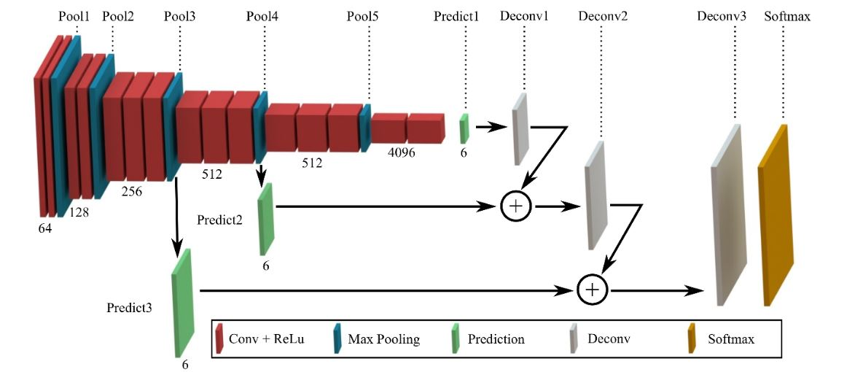

**Results at 50 epochs**

[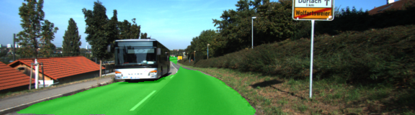](https://github.com/sachink20aug/CarND-Semantic-Segmentation/blob/master/images/um_000032.png)

[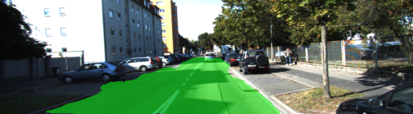](https://github.com/sachink20aug/CarND-Semantic-Segmentation/blob/master/images/um_000062.png)

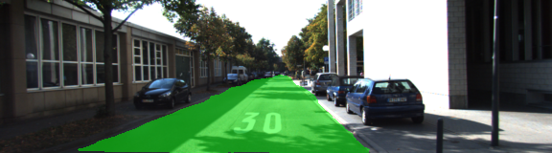

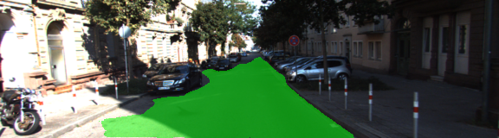

**Frameworks and Packages**

Make sure you have the following is installed:

* [Python 3](https://www.python.org/)
* [TensorFlow](https://www.tensorflow.org/)
* [NumPy](http://www.numpy.org/)
* [SciPy](https://www.scipy.org/)

**Dataset**

Download the [Kitti Road dataset](http://www.cvlibs.net/datasets/kitti/eval_road.php) from [here](http://www.cvlibs.net/download.php?file=data_road.zip). Extract the dataset in the data folder. This will create the folder data_road with all the training a test images.

**Start**

**Implement**

Implement the code in the main.py module indicated by the "TODO" comments. The comments indicated with "OPTIONAL" tag are not required to complete.

**Run**

Run the following command to run the project:

python main.py

**Note** If running this in Jupyter Notebook system messages, such as those regarding test status, may appear in the terminal rather than the notebook.

**Submission**

1. Ensure you've passed all the unit tests.
2. Ensure you pass all points on [the rubric](https://review.udacity.com/#!/rubrics/989/view).
3. Submit the following in a zip file.

* helper.py
* main.py
* project_tests.py
* Newest inference images from runs folder (**all images from the most recent run**)

**Tips**

* The link for the frozen VGG16 model is hardcoded into helper.py. The model can be found [here](https://s3-us-west-1.amazonaws.com/udacity-selfdrivingcar/vgg.zip).
* The model is not vanilla VGG16, but a fully convolutional version, which already contains the 1x1 convolutions to replace the fully connected layers. Please see this [post](https://s3-us-west-1.amazonaws.com/udacity-selfdrivingcar/forum_archive/Semantic_Segmentation_advice.pdf) for more information. A summary of additional points, follow.
* The original FCN-8s was trained in stages. The authors later uploaded a version that was trained all at once to their GitHub repo. The version in the GitHub repo has one important difference: The outputs of pooling layers 3 and 4 are scaled before they are fed into the 1x1 convolutions. As a result, some students have found that the model learns much better with the scaling layers included. The model may not converge substantially faster, but may reach a higher IoU and accuracy.
* When adding l2-regularization, setting a regularizer in the arguments of the tf.layers is not enough. Regularization loss terms must be manually added to your loss function. otherwise regularization is not implemented.

**Using GitHub and Creating Effective READMEs**

If you are unfamiliar with GitHub , Udacity has a brief [GitHub tutorial](http://blog.udacity.com/2015/06/a-beginners-git-github-tutorial.html) to get you started. Udacity also provides a more detailed free [course on git and GitHub](https://www.udacity.com/course/how-to-use-git-and-github--ud775).

To learn about REAMDE files and Markdown, Udacity provides a free [course on READMEs](https://www.udacity.com/courses/ud777), as well.

GitHub also provides a [tutorial](https://guides.github.com/features/mastering-markdown/) about creating Markdown files.