**JEWELLERY MANAGEMENT SYSTEM**

**SE CSE Mini project**

By:

**NAME ROLL NO.**

**Aditya Laddha 21**

**Sachin Khutan 17**

**Arjun Shinde 38**

**Ashwin Pijdurkar 30**

**Ashish Gawari 09**

Under the guidance of :

**Prof. Nilesh Patel**



Department of Computer Engineering

**BRaCT’S Vishwakarma Institute Technology**

**PUNE – 411 037**

|  |  |
| --- | --- |
|  | Bansilal Ramnath Agarwal Charitable Trust’s  **Vishwakarma Institute Technology**  **PUNE – 411 037** |

**CERTIFICATE**

Certified that this Project report titled “**Jewellery Management System**” by “Aditya (21), Sachin (17), Arjun (38), Ashwin (30), Ashish (09) ” is approved by me for submission. Certified further that, to the best of my knowledge, the report represents work carried out by the student as the Mini project as prescribed by the University of Pune in the academic year 2013-14

**Date: Guide Head of Department**

**ACKNOWLEDGEMENT**

It gives us great pleasure to express our gratitude towards our

Prof. Mr. Nilesh Patel for his guidance, support and encouragement throughout the duration of the project. He helped us understand the Computer Language **C#** and without his motivation and help the successful completion of this project would not have been possible.

Name of student: Aditya Sachin Arjun Ashwin Ashish

**CONTENTS**

1. **Introduction** 
   1. **C#**
   2. **Windows Form**
   3. **Jewellery Management System**
   4. **Existing System**
   5. **Functional Specifications**
   6. **Features & Benefits**
2. **Problem Definition**
3. **Pictorial View**
4. **Conclusion**
5. **References**
6. **Bibliography**

**Introduction**

**C#**

C# is a multi-paradigm programming language encompassing strong typing, imperative, declarative, functional, generic, object-oriented class-based and component-oriented programming disciplines.

**Windows Forms**

Windows Forms or WinForms is a graphical GUI (Graphical User Interface) class library included as a part of Microsoft.NET Framework, providing a platform to write rich client applications for desktop, laptop, and tablet PCs.

It is seen as replacement for the earlier and more complex C++ based Microsoft Foundation Class Library, it does not offer a comparable paradigm and only acts as a platform for the user interface tier in a multitier solution.

**Jewellery Management System**

Jewellery Management System is a user friendly application software which can be used by the Jewellery vendors to record the sales and stock of Jewellery purchased by the customer.

A Jewellery Shop faces a tremendous task of maintaining and accounting of thousands of Jewellery items in a single store. The high value of Jewellery items make the loss of even one item potentially very expensive. Since many Jewellery displays are set up daily and then stored in safes in the evenings, there is ample opportunity for loss of product.

**Existing System**

Currently, mostly jewelers track inventory on daily or weekly basis. This is often a completely manual process, which is very time consuming, requires handling of each Jewellery item, and is error prone. Some jewels are barcodes, which still requires line of sight for reading and still leads to additional, unnecessary handling of Jewellery items. A Jewellery store with thousands of high values ornaments find it difficult to know the exact stock of the Jewellery in their stores, since the process is manual and time consuming. The need of these stores is thus a system that can automate the inventory taking process thus reducing manual effort and saving time.

**Functional Specifications**

* **Admin can update the Jewellery price.**
* **Admin can add and view products.**
* **Admin can update design and icon of the Jewellery.**
* **Admin can generate the bill.**
* **Admin can generate a category wise report.**

**Features & Benefits**

* **The software is easy to learn and use. Screens are designed using a ‘point and click’ method. There is no need to memorize the keystroke commands.**
* **Pop-up boxes speed up the data entry and ensures data consistency.**
* **Sub database menu gives the operator the flexibility to define data in pop-up boxes**

**Pictorial View**

**The Start Up page of the Application**

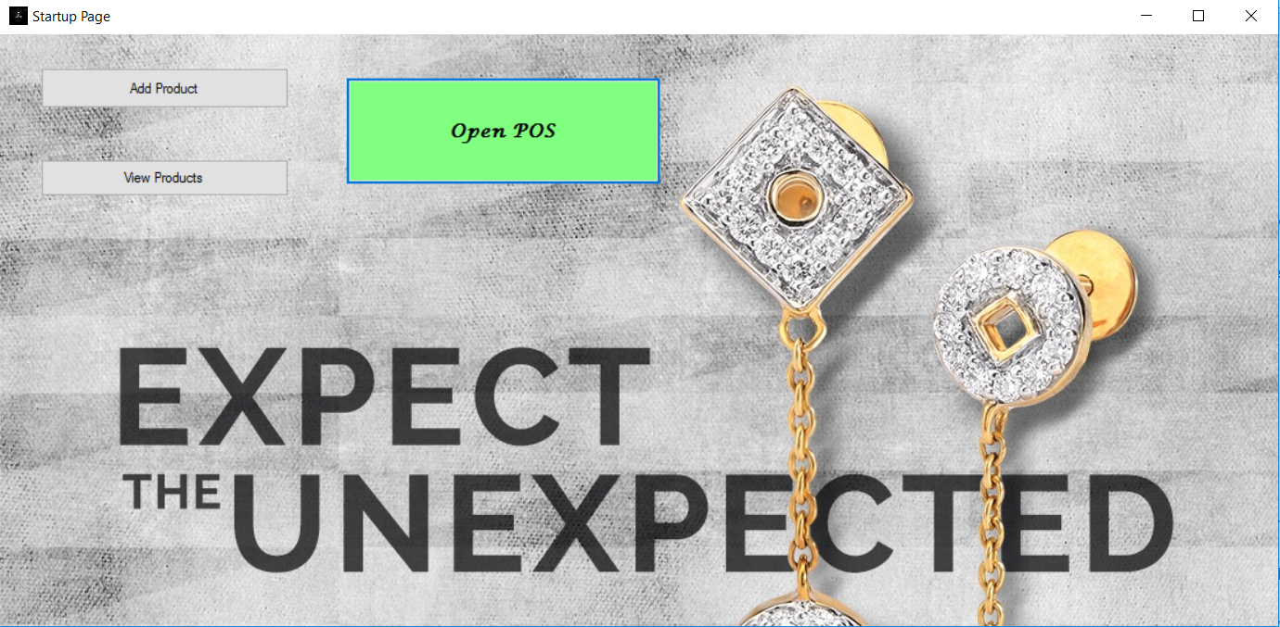

**View Product Page**

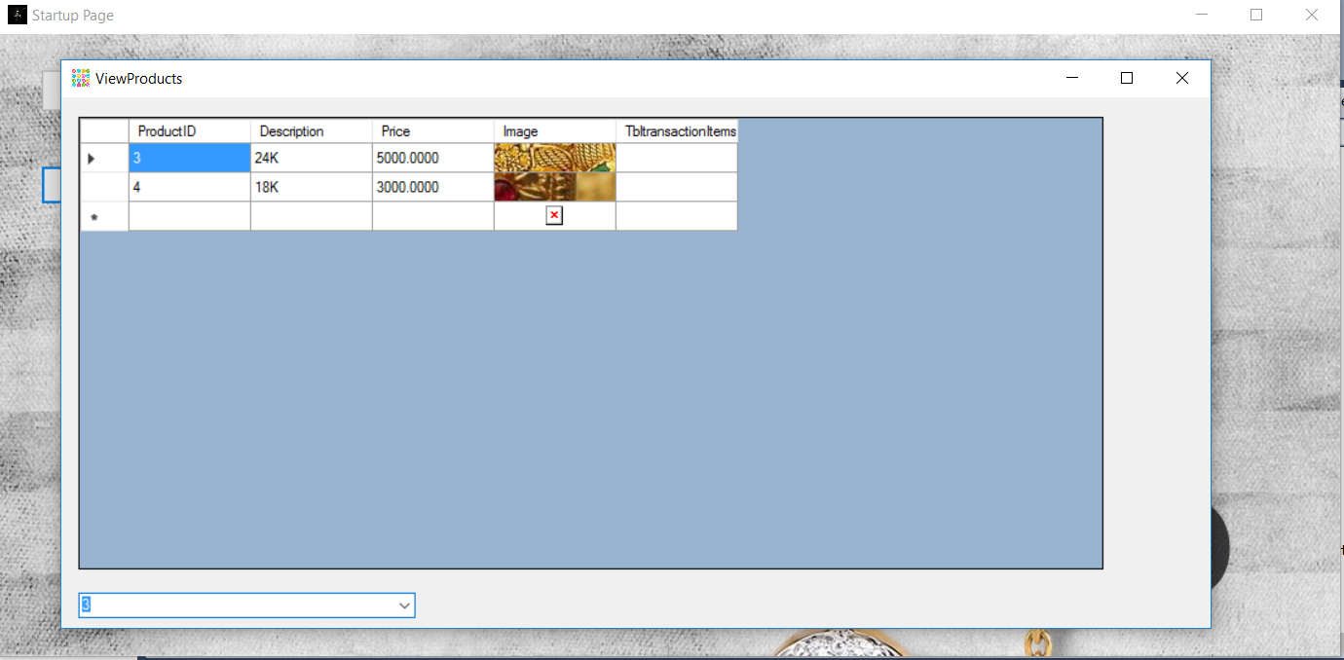

**Add Product Page**

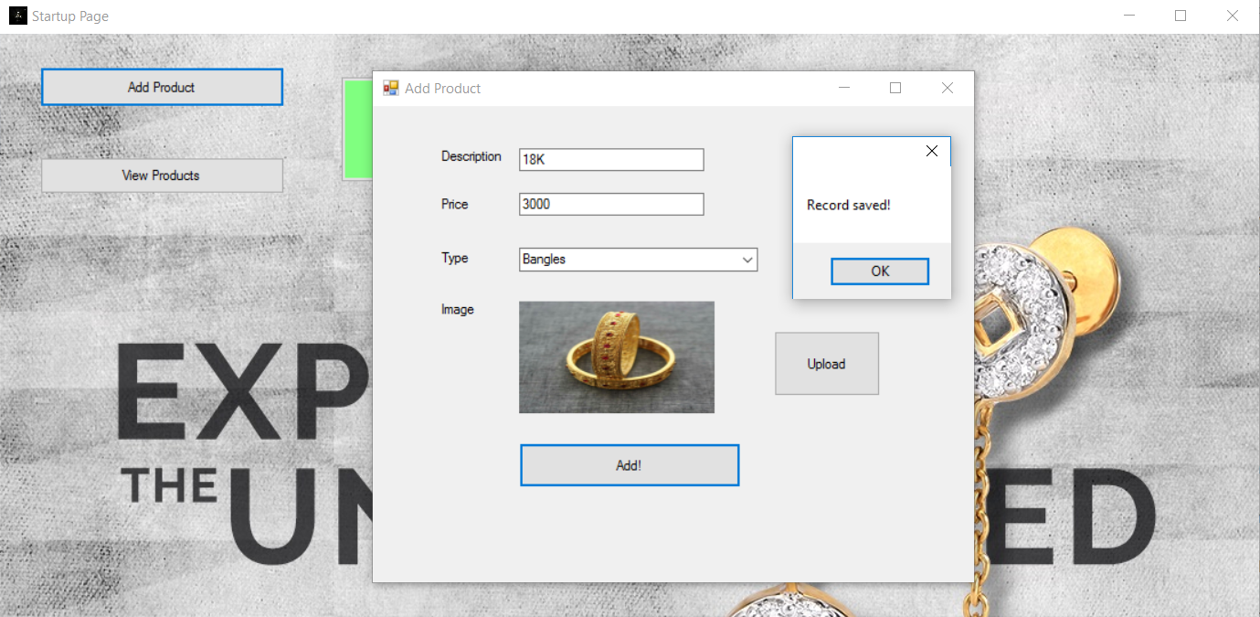

**Point of Sale**

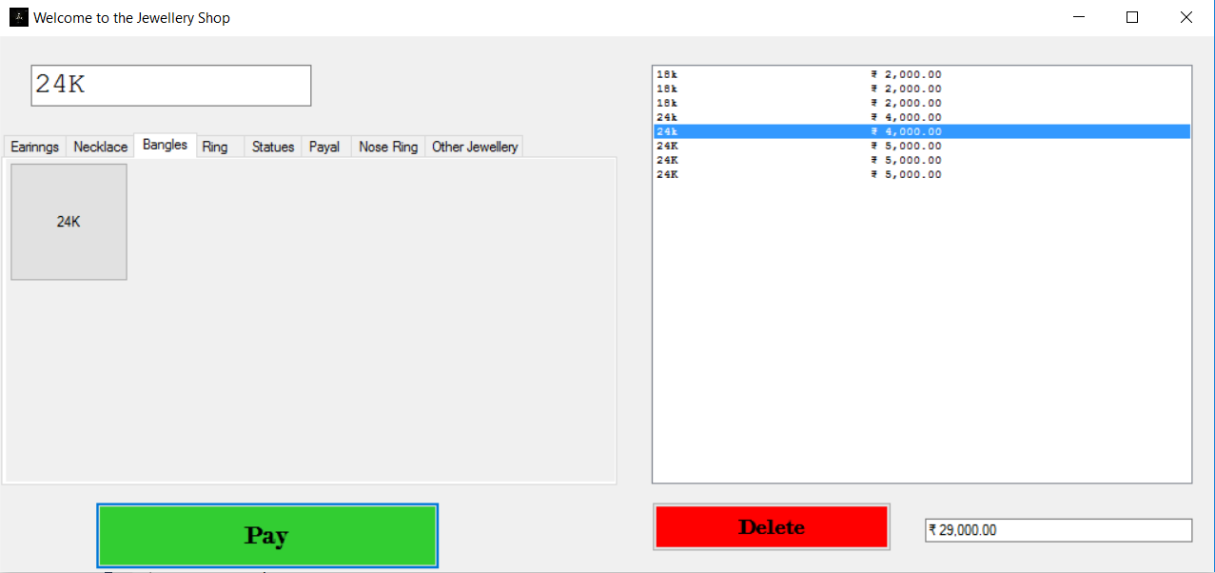

* **Can add product category wise.**
* **Select Quality of material.**
* **List of items to be Purchased.**
* **Items can be added or deleted.**

**Payment Page**

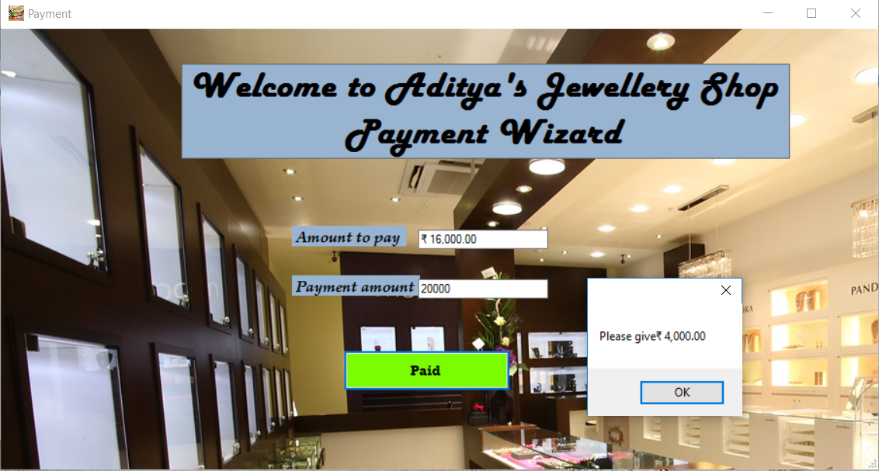

* **Billing Page is Displayed.**
* **Amount to be Paid is shown according to items Purchased.**
* **Amount Paid is to be entered.**
* **Return amount is Displayed.**

**Conclusion**

The Project Titled **“Jewellery Management System” developed under Microsoft Visual Studio 2010.**

**Tha main objective of the project is to computerize the existing system where all the process is carried out manually. We have put our sincere effort to implement this project.**

**Problem Definition**

**Jewellery Shops sell various types of Jewellery items and it is very difficult to categorize these items on the basis of their manufacturing dates, type of gold used to manufacture it such as either using 18K or 24K. It is also very difficult to analyze the overall transaction for a particular customer. To solve these problems this system has been developed.**

**References**

1. [**www.youtube.com**](http://www.youtube.com)
2. [**www.tutorialpoint.com**](http://www.tutorialpoint.com)

**Bibliography**

1. **ASP.NET With C# - Shyam.N.Chavda**
2. **The Complete Reference C# 3.0 -Herbert Schidt**

**THANK YOU**