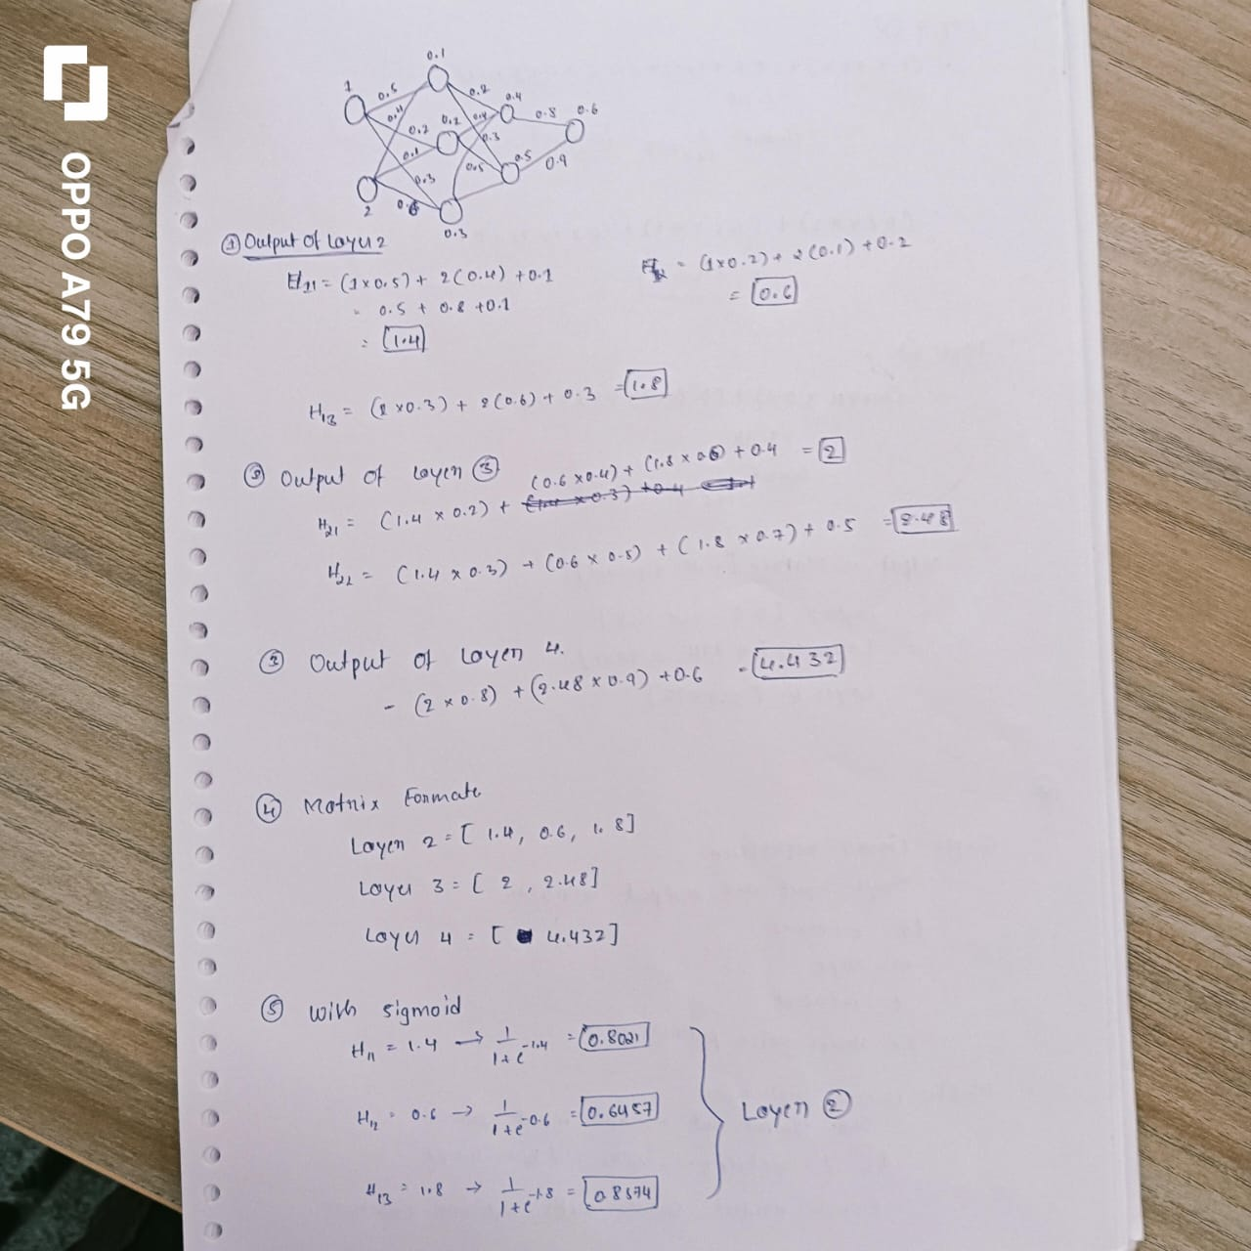

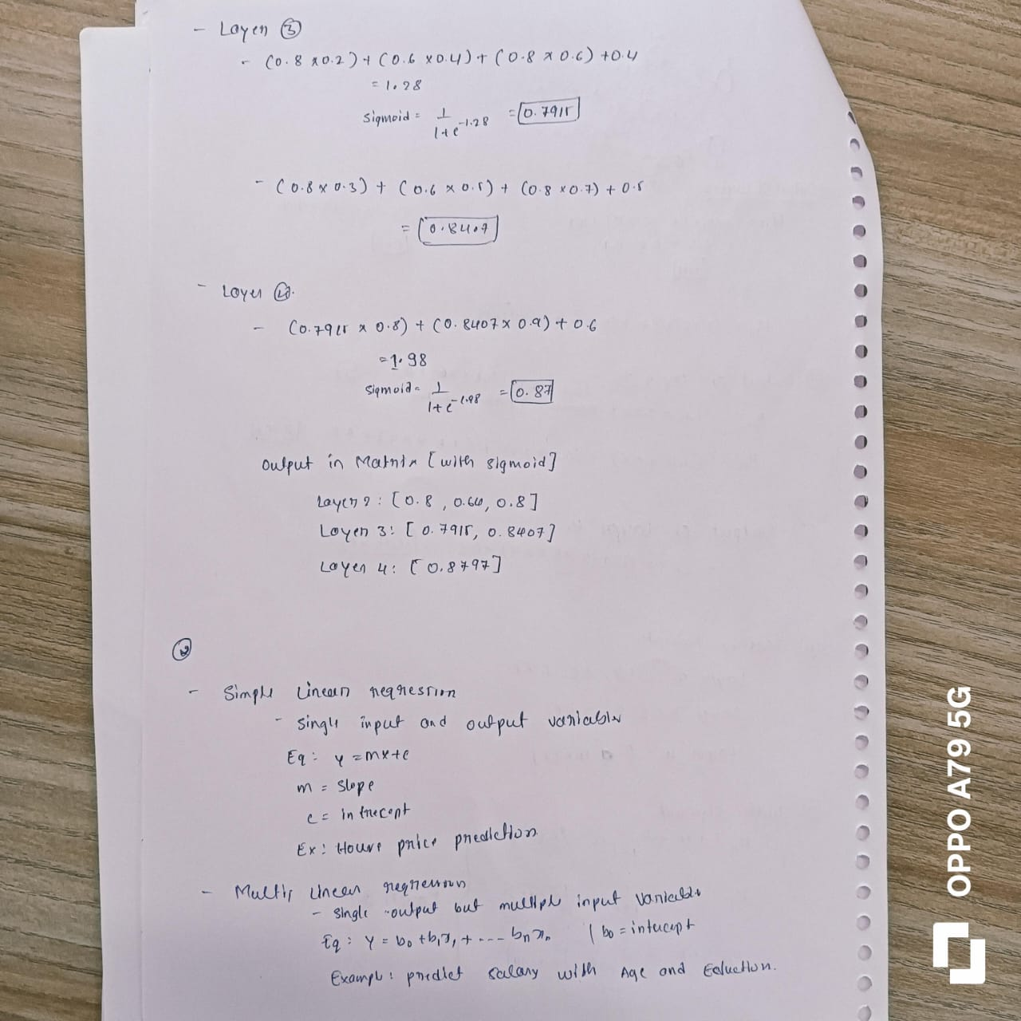

**4 Prompt Engineering**

**4.1 Task 1 – Prompt Quality Assessment**

1. "Explain something about computers."
   * Classification: Vague.
   * Reason: This prompt is extremely broad. It lacks any specific focus, making it difficult for a model to provide a targeted and useful response.
2. "Compare HTTP/1.1 vs HTTP/3 with latency benchmarks."
   * Classification: Good.
   * Reason: This prompt is specific and well-defined. It asks for a comparison of two protocols with a concrete metric (latency benchmarks), providing clear direction for the model.
3. "Describe a scientific principle."
   * Classification: Vague.
   * Reason: Similar to the first prompt, this lacks specificity. It doesn't indicate which scientific principle to describe, leading to ambiguity.
4. "List 3 IoT security risks for smart homes with mitigation strategies."
   * Classification: Good.
   * Reason: This prompt is clear and specific. It asks for a list of risks within a defined context (smart homes) and requires practical solutions (mitigation strategies).

**4.2 Task 2 – Prompt Crafting**

1. **Explaining transformer neural networks to high school students.**
   * Prompt: "Imagine you're teaching a high school computer science class. Explain how transformer neural networks work, focusing on the key concepts like attention mechanisms, in simple terms and using relatable examples. Avoid complex mathematical jargon."
2. **Generating a mystery plot involving AI ethics.**
   * Prompt: "Create a mystery plot where a detective investigates a series of strange events linked to a powerful AI system. The AI seems to be making decisions that benefit some individuals while harming others. The detective must uncover the AI's motives and the ethical dilemmas it poses. Develop the plot with twists, suspense, and a thought-provoking resolution."
3. **Summarizing a research paper on CRISPR gene editing.**
   * Prompt: "Summarize the key findings and contributions of the research paper titled '[Insert Paper Title Here]' on CRISPR gene editing. Focus on the methodology, results, and implications of the study. Explain the main points in a concise and accessible manner for someone with a background in biology."

**4.3 Task 3 – n-Shot Prompts**

**1. Zero-shot: Explain quantum entanglement without examples.**

* Prompt: "Explain quantum entanglement."
* Expected Response: "Quantum entanglement is a phenomenon where two or more particles become correlated in such a way that their quantum states are dependent on each other, even when separated by large distances. Measuring the state of one particle instantaneously influences the state of the other(s), regardless of the distance between them."

**2. Two-shot: Convert two imperial measurements to metric.**

* Prompt:
  + "Convert 5 feet to meters: 1.52 meters."
  + "Convert 10 inches to centimeters: 25.4 centimeters."
  + "Convert 3 yards to meters:"
* Expected Response: "2.74 meters."

**3. Chain-of-thought: Solve d/dx (3x² + ln x) step-by-step.**

* Prompt: "Solve d/dx (3x² + ln x) step-by-step."
* Expected Response:
  + "First, apply the sum rule of differentiation: d/dx (f(x) + g(x)) = d/dx f(x) + d/dx g(x)."
  + "So, d/dx (3x² + ln x) = d/dx (3x²) + d/dx (ln x)."
  + "Next, apply the power rule: d/dx (x^n) = nx^(n-1) and the constant multiple rule: d/dx (cf(x)) = c * d/dx f(x)."
  + "Therefore, d/dx (3x²) = 3 * d/dx (x²) = 3 * 2x^(2-1) = 6x."
  + "Then, apply the derivative of the natural logarithm: d/dx (ln x) = 1/x."
  + "Finally, combine the results: 6x + 1/x."
  + "The solution is 6x + 1/x."

**4.4 Bonus Task**

**Revision 1:**

Generative AI, with its ability to produce human-like text, images, and code, presents a range of ethical challenges. One major concern is the potential for **bias**. AI models are trained on massive datasets that often reflect existing societal biases, leading to discriminatory outputs. For example, language models may perpetuate harmful stereotypes about gender, race, or religion. Another critical issue is the spread of **misinformation and disinformation**. Generative AI can be used to create convincing but false content, such as deepfakes or misleading news articles, which can have serious social and political consequences.

**Revision 2:**

The rapid advancement of Generative AI raises significant ethical concerns. One key issue is the potential for **bias amplification**. These models learn from vast datasets, often reflecting existing societal biases. This can lead to discriminatory outputs, such as biased job applicant screenings or biased news reporting. Furthermore, the ease with which AI can generate realistic but false content poses a serious threat. Deepfakes, for example, can be used to spread misinformation and manipulate public opinion. This raises concerns about the erosion of trust in information and the potential for social unrest.

**Revision 3:**

Generative AI, with its ability to create novel content, presents a complex ethical landscape. **Bias amplification** remains a critical concern, as AI models trained on biased data perpetuate and even amplify existing societal prejudices. This can lead to discriminatory outcomes in various domains, from hiring processes to loan applications. Moreover, the potential for **misinformation and disinformation** is alarming. Deepfakes, AI-generated text, and manipulated media can be used to deceive, manipulate, and sow discord. This raises concerns about the erosion of trust in information sources and the potential for social and political instability. Furthermore, the rise of AI-generated content raises questions about **copyright and intellectual property**. When AI models are trained on vast amounts of copyrighted material, the lines between inspiration and plagiarism blur, creating legal and ethical dilemmas for creators and artists.

**Final Essay:**

Generative AI, with its capacity to create novel text, images, and code, presents a complex ethical landscape. One of the most pressing concerns is **bias amplification**. These models, trained on massive datasets that often reflect societal biases, can perpetuate and even exacerbate existing prejudices. This can lead to discriminatory outcomes in various domains, such as hiring, lending, and criminal justice. Furthermore, the ease with which AI can generate realistic but false content poses a significant threat. Deepfakes, AI-generated text, and manipulated media can be used to deceive, manipulate, and sow discord, undermining trust in information sources and potentially destabilizing social and political systems. Finally, the rise of AI-generated content raises questions about **copyright and intellectual property**. When AI models are trained on vast amounts of copyrighted material, the lines between inspiration and plagiarism blur, creating legal and ethical dilemmas for creators and artists. Addressing these ethical challenges requires a multi-faceted approach, including responsible data collection and model development, robust fact-checking mechanisms, and a broader societal conversation about the ethical implications of this powerful technology.

**Key Improvements:**

* **Specificity:** Moved beyond general statements to address specific concerns like bias amplification, misinformation, and copyright issues.
* **Clarity:** Refined language and sentence structure for better readability and flow.
* **Depth:** Added a brief discussion on copyright and intellectual property issues.
* **Conciseness:** Trimmed down the essay while maintaining key points.

This iterative refinement process demonstrates how to gradually improve the essay by focusing on clarity, depth, and addressing specific ethical concerns.