**Project Team5**

* **18K41A0599**
* **18K41A0596**
* **18K41A0536**
* **18K41A04C3**

Project Title 5: Blue-Green Deployment.

Project Statement: Deploy the application and route the traffic in blue-green deployment environment routing 50% traffic to prod stack and 50% traffic to pre-prod.

Task 1: Deploy an App service

Task 2: Load the code from the source control

Task 3: Deploy a pre-prod slot

Task 4: Distribute half of the traffic to each slot.

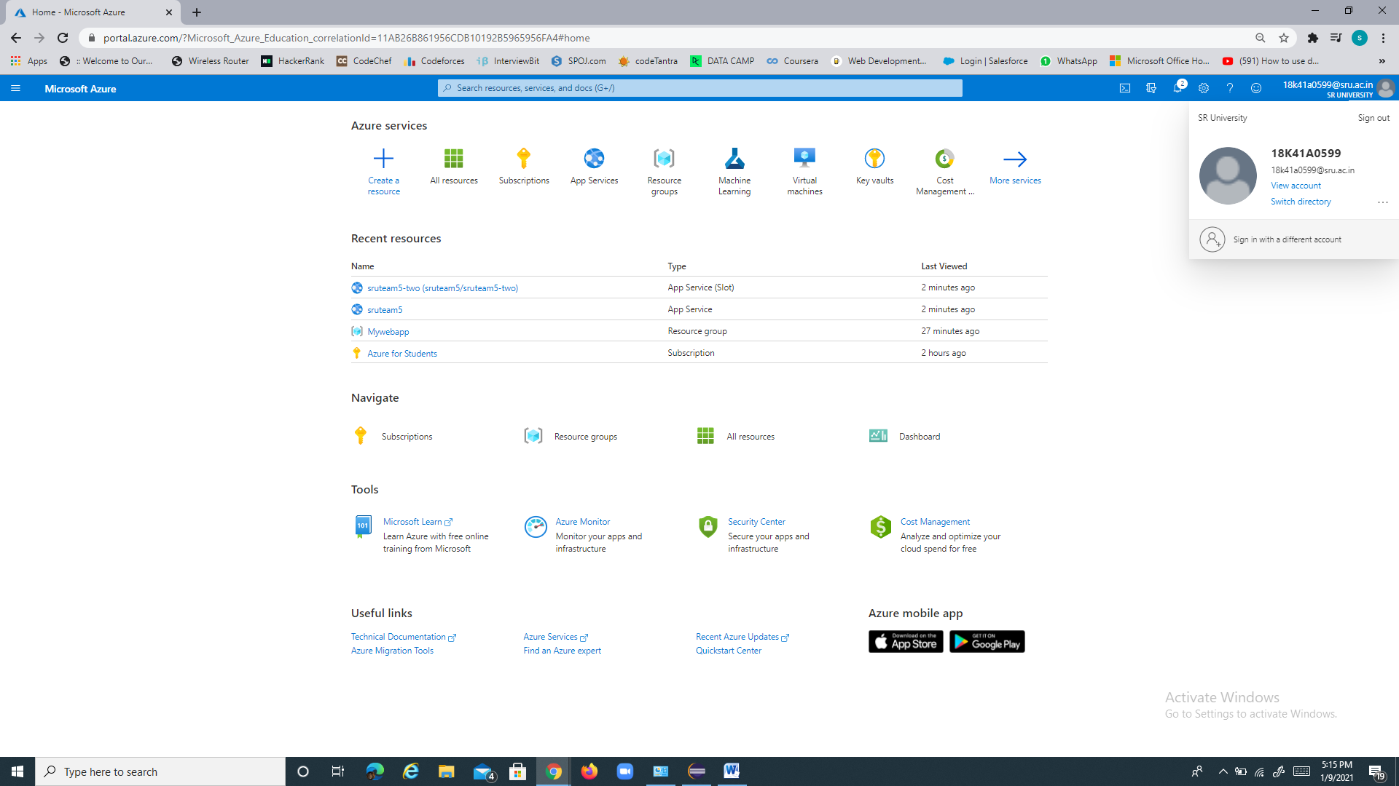

Task-1

We have deployed app service sruteam5

App service : sruteam5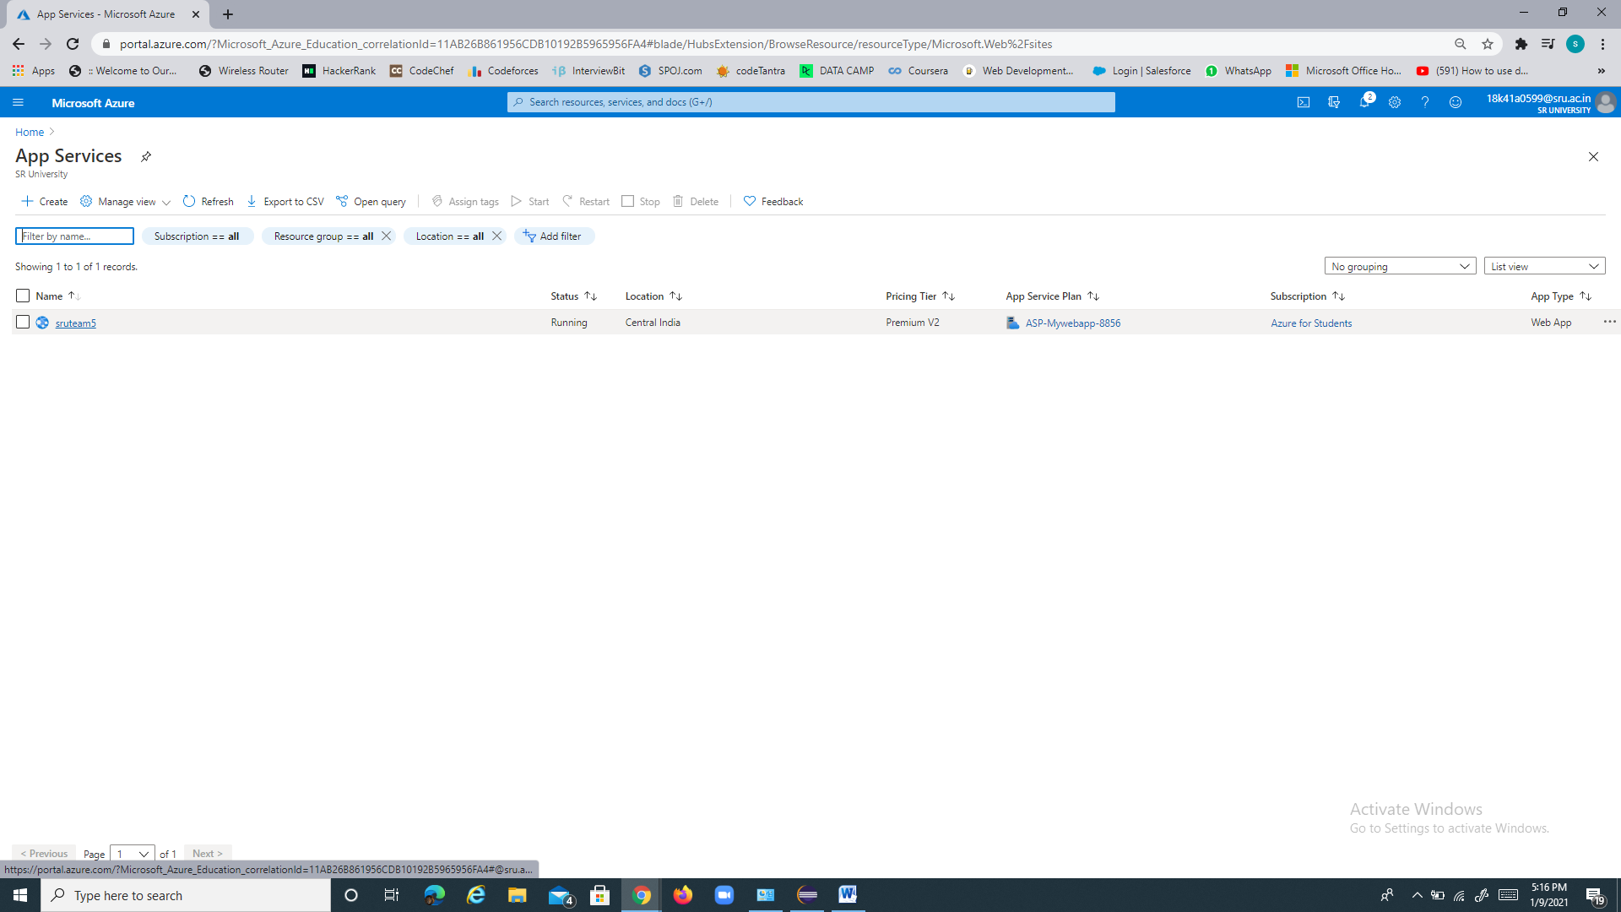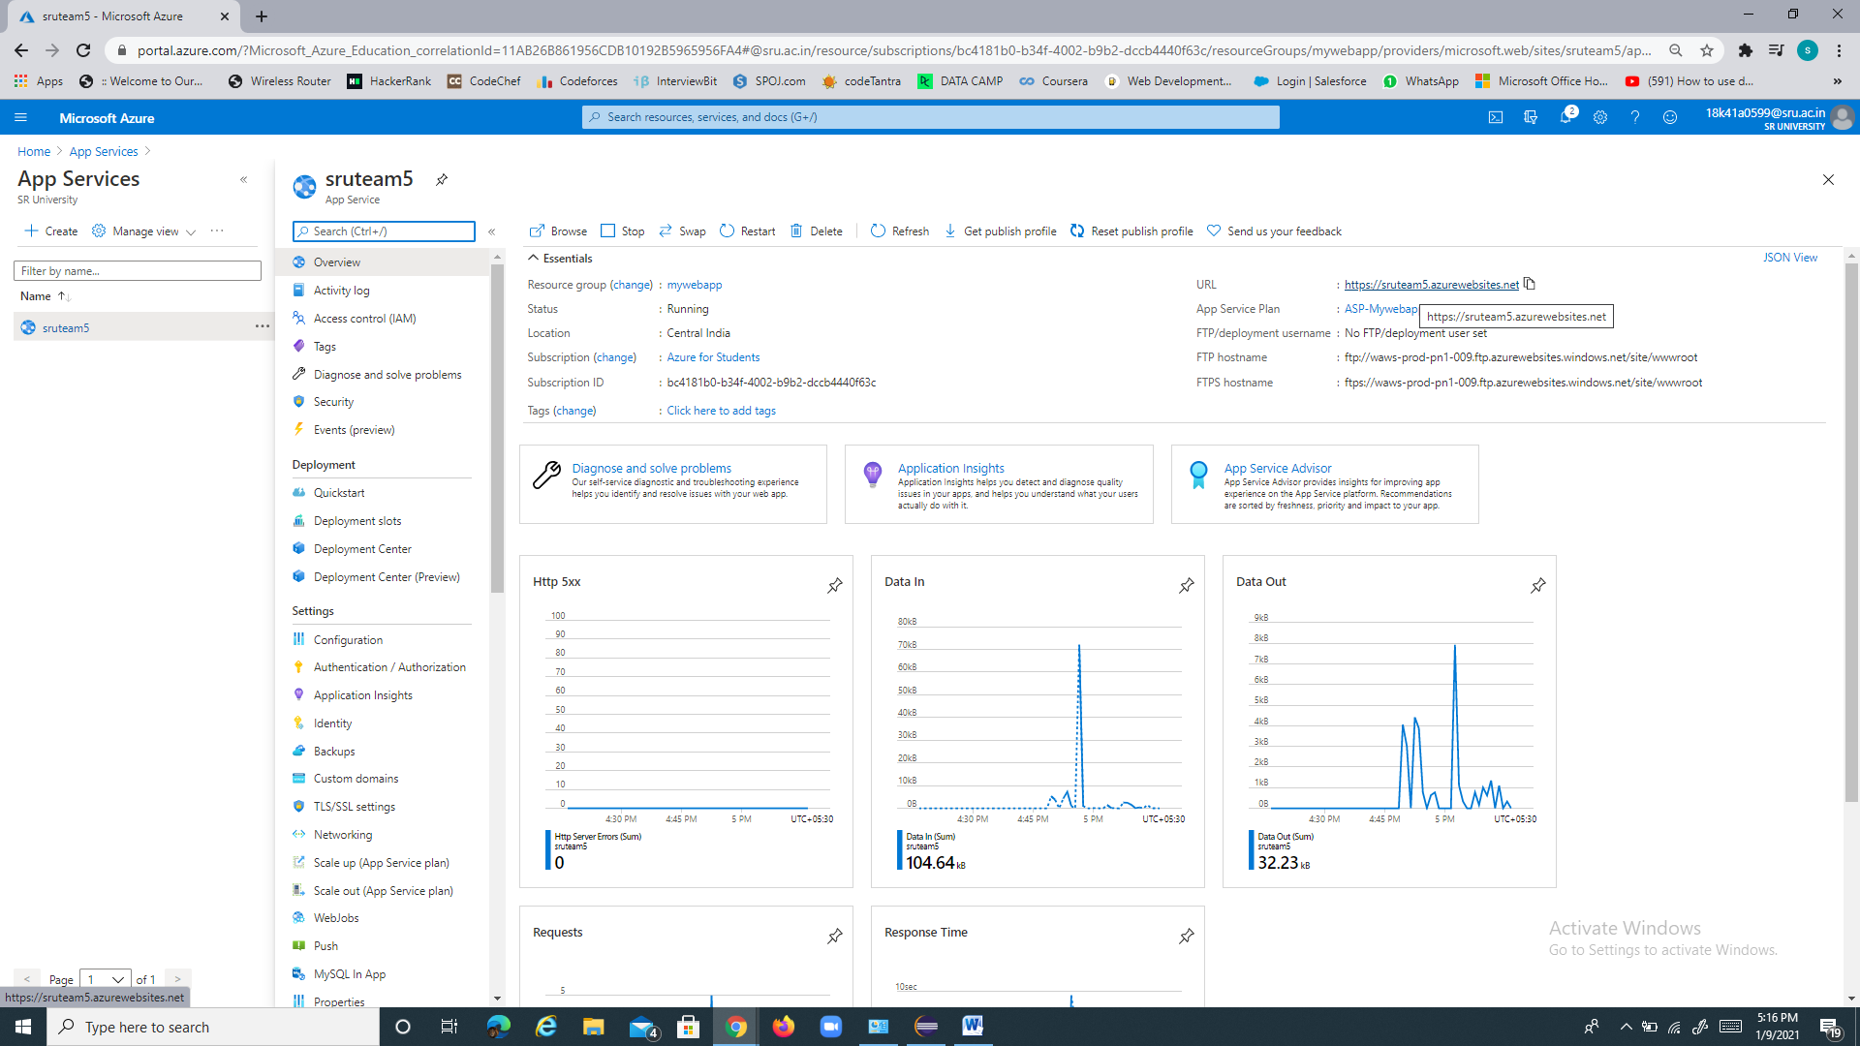

Task -2

Load code from source control

We have created a webapp in eclipse IDE and deployed it to sruteam5 webapp

Web app:

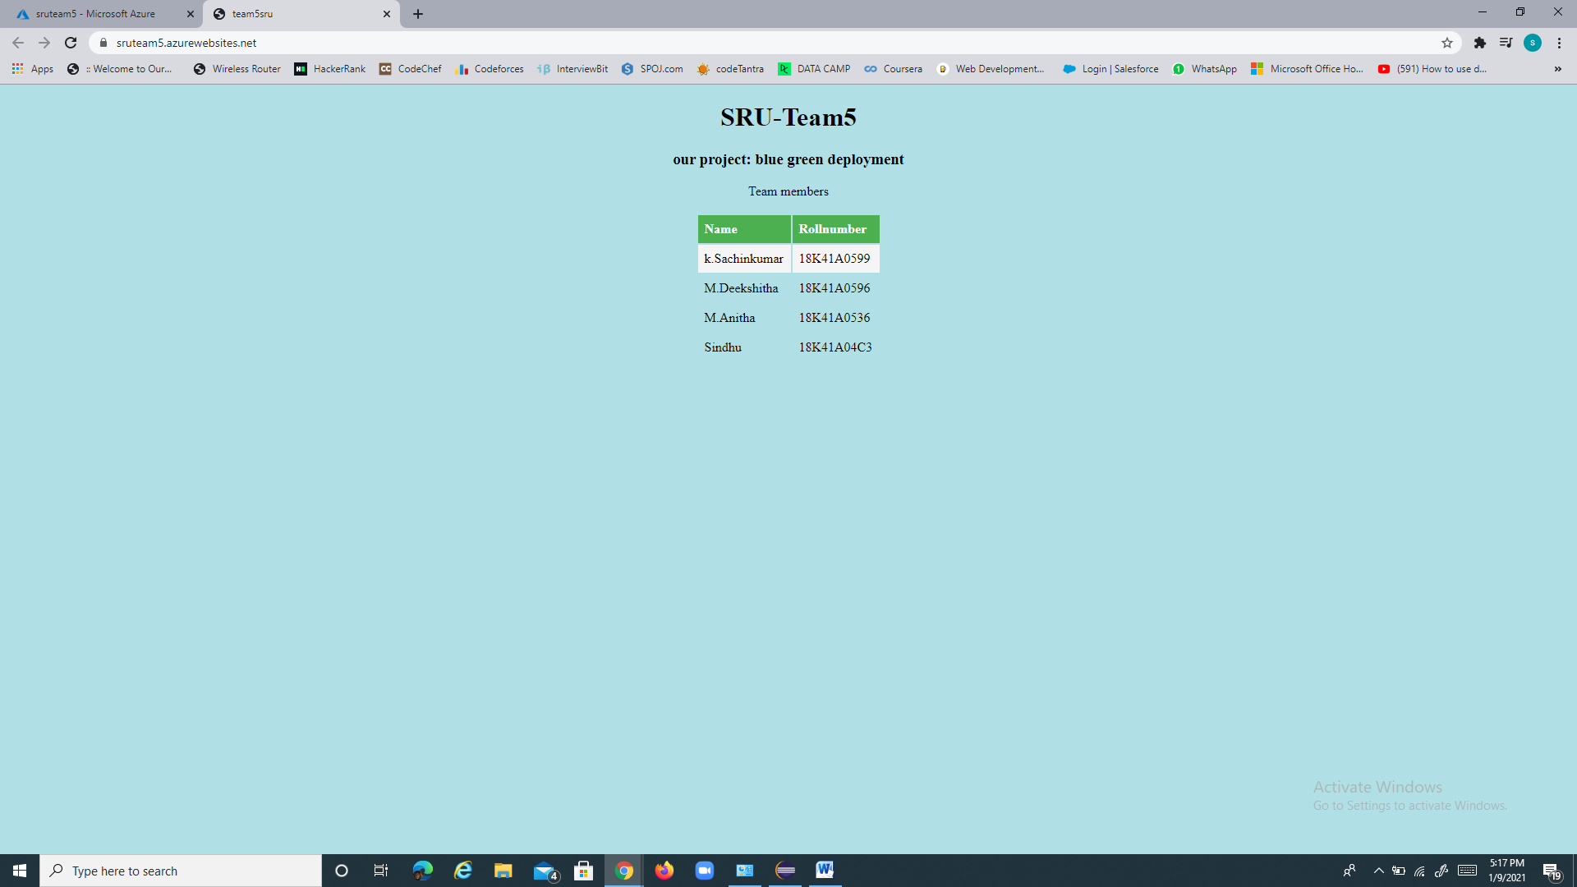

Click on text to view webapp : [sruteam5](https://sruteam5.azurewebsites.net/)

Task -3

Deploy a pre-prod slot

We have deployed a slot sruteam5-two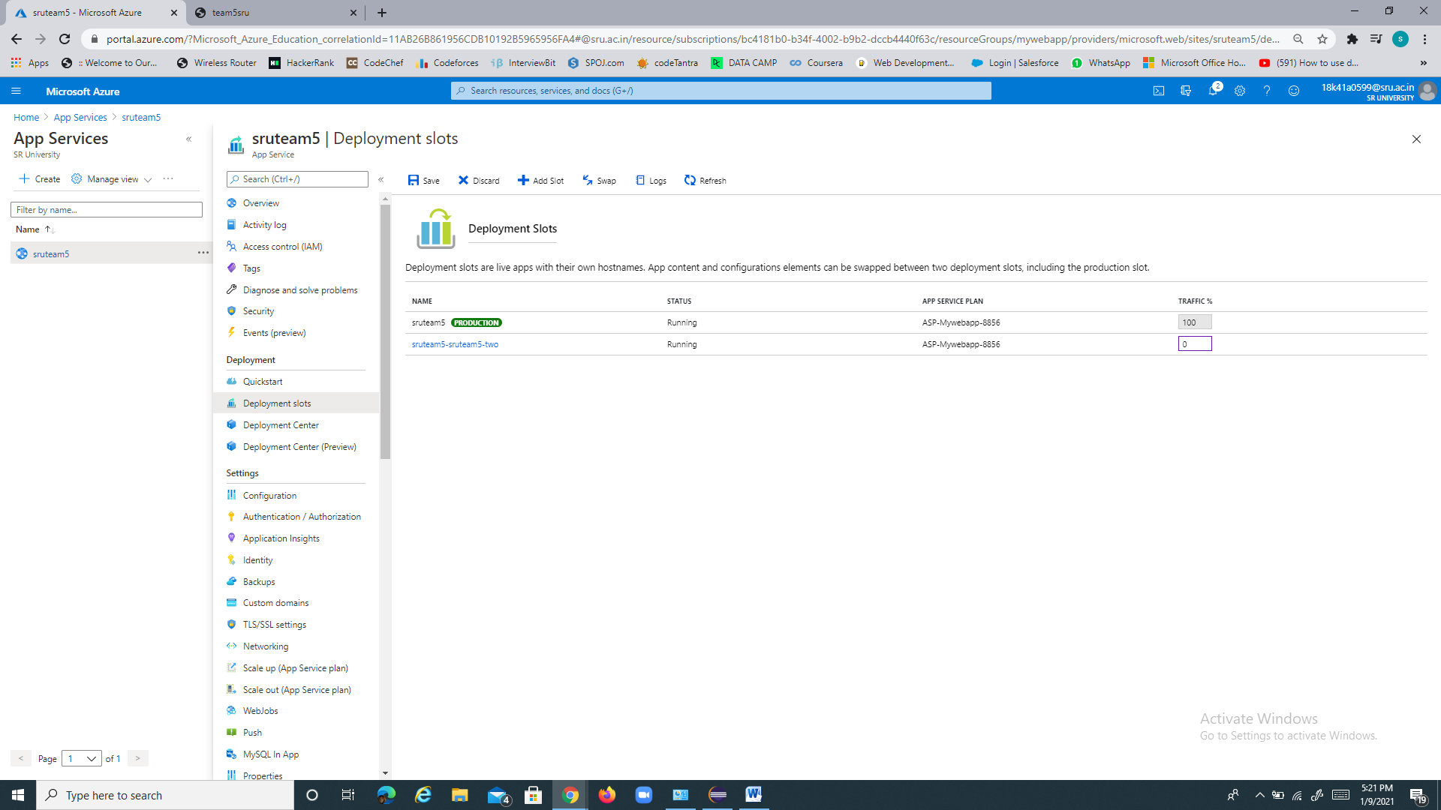

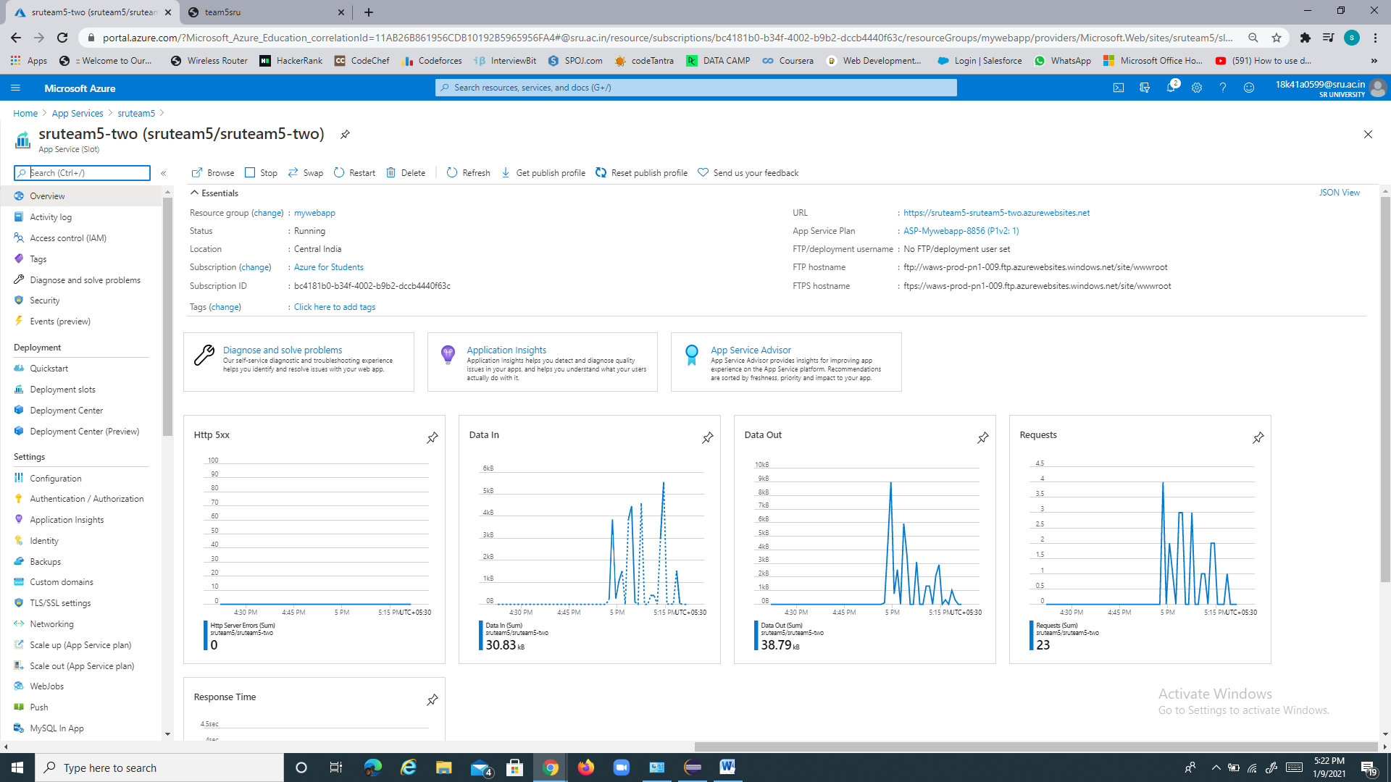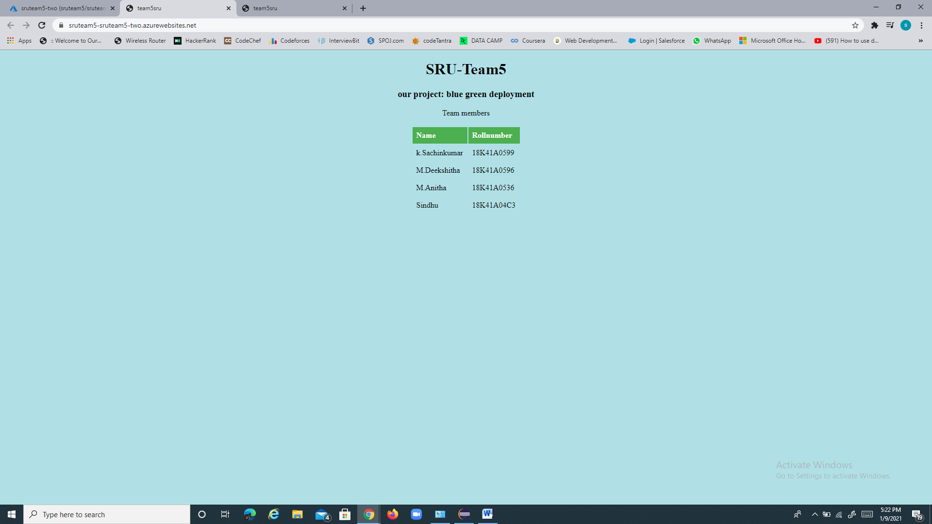

Webapp link : [sruteam5-two](https://sruteam5-sruteam5-two.azurewebsites.net/)

Task-4

Distribute half of the traffic to each slot.

We have distributed 50% traffic to each slot

