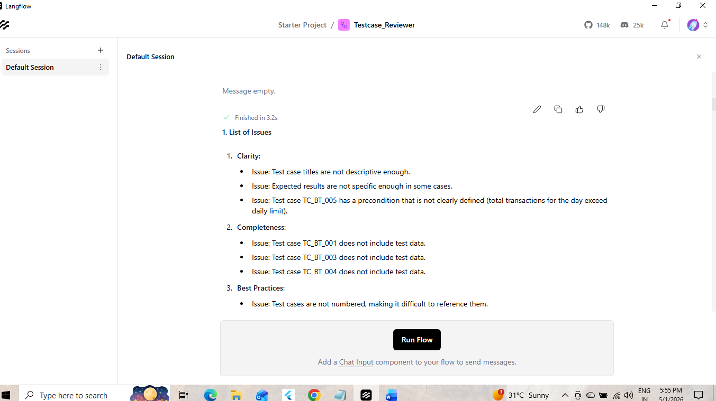

**1. List of Issues**

1. **Clarity**:
- Issue: Test case titles are not descriptive enough.
- Issue: Expected results are not specific enough in some cases.
- Issue: Test case TC_BT_005 has a precondition that is not clearly defined (total transactions for the day exceed daily limit).
2. **Completeness**:
- Issue: Test case TC_BT_001 does not include test data.
- Issue: Test case TC_BT_003 does not include test data.
- Issue: Test case TC_BT_004 does not include test data.
3. **Best Practices**:
- Issue: Test cases are not numbered, making it difficult to reference them.
- Issue: Test steps are not atomic, making it difficult to execute and maintain the test cases.
- Issue: Test cases do not include environment/dependencies information.
4. **Maintainability**:
- Issue: Test cases are not well-structured, making it difficult to read and understand.
- Issue: Test cases do not include any information about the test design techniques used.
5. **Reusability**:
- Issue: Test cases are not designed to be reusable, making it difficult to execute them in different environments.

**2. Suggestions for Improvement**

1. **Clarity**:
- Suggestion: Use more descriptive titles for the test cases.
- Suggestion: Make expected results more specific and measurable.
- Suggestion: Define the precondition for TC_BT_005 more clearly.
2. **Completeness**:
- Suggestion: Include test data for all test cases.
- Suggestion: Include environment/dependencies information for all test cases.
3. **Best Practices**:
- Suggestion: Number the test cases for easier reference.
- Suggestion: Make test steps atomic and executable.
- Suggestion: Include environment/dependencies information for all test cases.
4. **Maintainability**:
- Suggestion: Use a consistent structure for all test cases.
- Suggestion: Include information about the test design techniques used.
5. **Reusability**:
- Suggestion: Design test cases to be reusable by using parameters and variables.

**3. Improved Version of the Test Case**

**Test Case 1: Verify Successful Fund Transfer within Daily Limit**

**Test Case ID:** TC_BT_001

**Title:** Verify Successful Fund Transfer within Daily Limit

**Objective:** To verify that a fund transfer is successful when the amount is within the daily limit.

**Preconditions:**

* User is logged in with an active account.
* Daily limit is set to 100,000 INR.
* Test data: Beneficiary account number = 1234567890, Beneficiary name = John Doe, Amount = 50,000 INR.

**Test Steps:**

1. Navigate to Fund Transfer.
2. Enter beneficiary details (Beneficiary account number = 1234567890, Beneficiary name = John Doe).
3. Enter amount (50,000 INR).
4. Submit transaction.

**Expected Results:**

* Transaction completes successfully.
* Confirmation is shown.

**Test Case 2: Verify Fund Transfer Failure due to Insufficient Balance**

**Test Case ID:** TC_BT_002

**Title:** Verify Fund Transfer Failure due to Insufficient Balance

**Objective:** To verify that a fund transfer fails when the account balance is insufficient.

**Preconditions:**

* User is logged in with an active account.
* Balance is 0 INR.
* Test data: Beneficiary account number = 1234567890, Beneficiary name = John Doe, Amount = 50,000 INR.

**Test Steps:**

1. Navigate to Fund Transfer.
2. Enter beneficiary details (Beneficiary account number = 1234567890, Beneficiary name = John Doe).
3. Enter amount (50,000 INR).
4. Submit transaction.

**Expected Results:**

* Transaction fails with insufficient balance error message.

**Test Case 3: Verify Fund Transfer Failure due to Invalid Beneficiary Details**

**Test Case ID:** TC_BT_003

**Title:** Verify Fund Transfer Failure due to Invalid Beneficiary Details

**Objective:** To verify that a fund transfer fails when the beneficiary details are invalid.

**Preconditions:**

* User is logged in with an active account.
* Test data: Beneficiary account number = 9876543210, Beneficiary name = Jane Doe, Amount = 50,000 INR.

**Test Steps:**

1. Navigate to Fund Transfer.
2. Enter beneficiary details (Beneficiary account number = 9876543210, Beneficiary name = Jane Doe).
3. Enter amount (50,000 INR).
4. Submit transaction.

**Expected Results:**

* Transaction fails with invalid beneficiary details error message.

**Test Case 4: Verify Successful Fund Transfer with OTP Authentication**

**Test Case ID:** TC_BT_004

**Title:** Verify Successful Fund Transfer with OTP Authentication

**Objective:** To verify that a fund transfer is successful when OTP authentication is used.

**Preconditions:**

* User is logged in with an active account.
* OTP is sent to registered mobile number.
* Test data: Beneficiary account number = 1234567890, Beneficiary name = John Doe, Amount = 50,000 INR, OTP = 123456.

**Test Steps:**

1. Navigate to Fund Transfer.
2. Enter beneficiary details (Beneficiary account number = 1234567890, Beneficiary name = John Doe).
3. Enter amount (50,000 INR).
4. Enter OTP (123456).
5. Submit transaction.

**Expected Results:**

* Transaction completes successfully.
* Confirmation is shown.

**Test Case 5: Verify Fund Transfer Failure due to Daily Limit Exceeded**

**Test Case ID:** TC_BT_005

**Title:** Verify Fund Transfer Failure due to Daily Limit Exceeded

**Objective:** To verify that a fund transfer fails when the daily limit is exceeded.

**Preconditions:**

* User is logged in with an active account.
* Daily limit is set to 100,000 INR.
* Total transactions for the day exceed daily limit.
* Test data: Beneficiary account number = 1234567890, Beneficiary name = John Doe, Amount = 150,000 INR.

**Test Steps:**

1. Navigate to Fund Transfer.
2. Enter beneficiary details (Beneficiary account number = 1234567890, Beneficiary name = John Doe).
3. Enter amount (150,000 INR).
4. Submit transaction.

**Expected Results:**

* Transaction fails with daily limit exceeded error message.

