1.Your application should be able to add roles in the database dynamically in the db.

POST : <http://localhost:8080/api/roles>

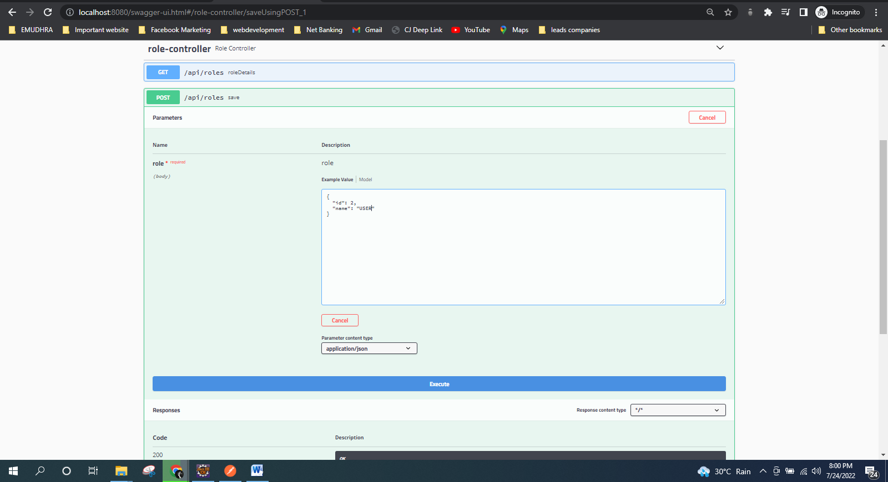

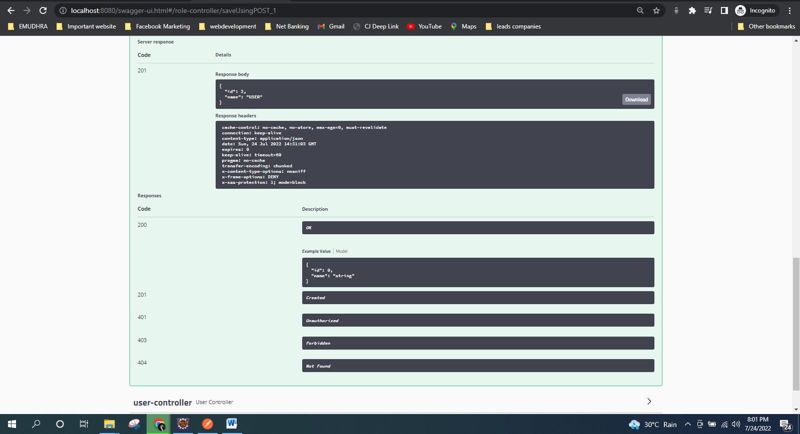

Ex-

{

"name":"USER"

}

2. Your application should be able to add Users in the db which can be used for authentication purposes.

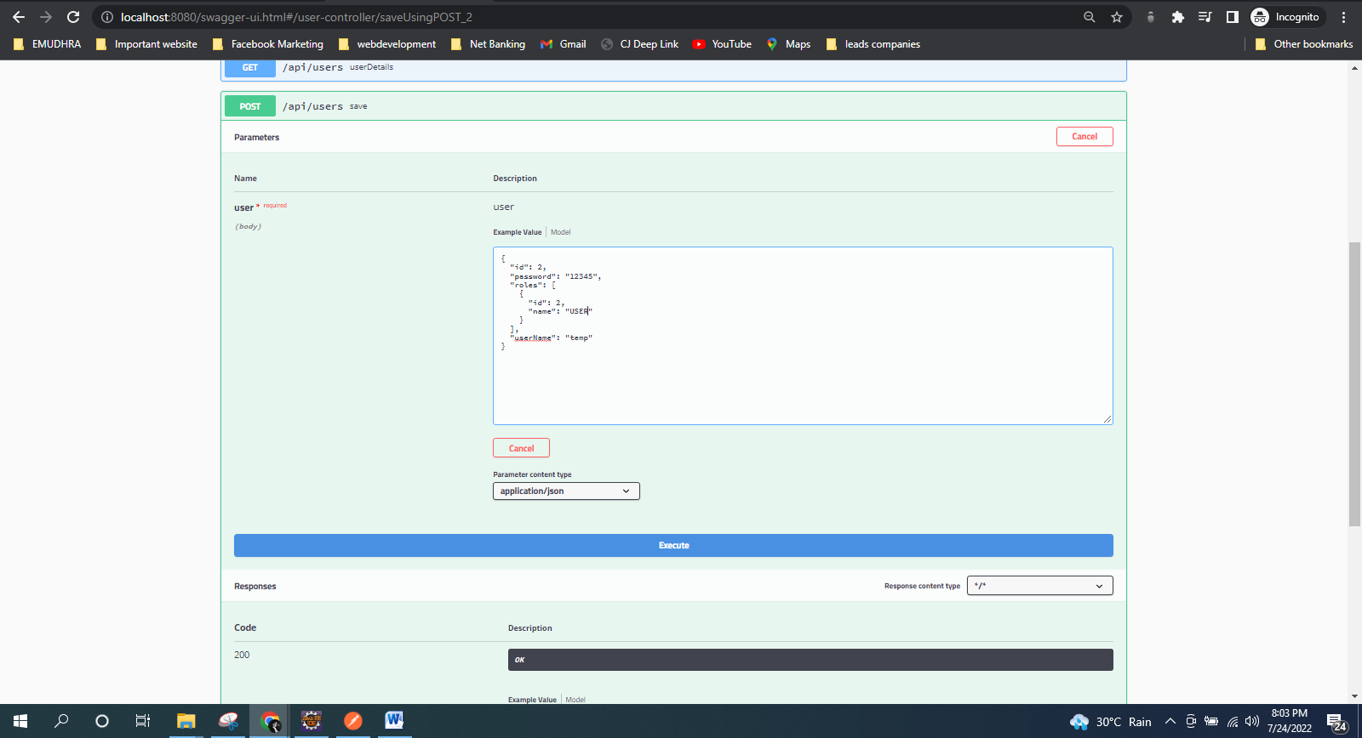

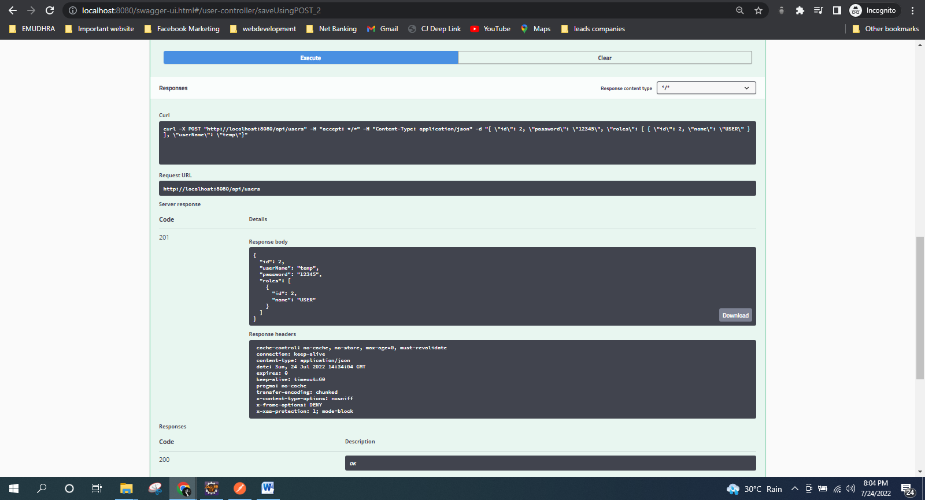

Ex-

{

"username":"temp",

"password":"12345",

"roles":[{

"id":2,

"name":"USER"

}]

}

3. Now Your application should be able to add employees data in the db if and only if the authenticated user is **ADMIN**-

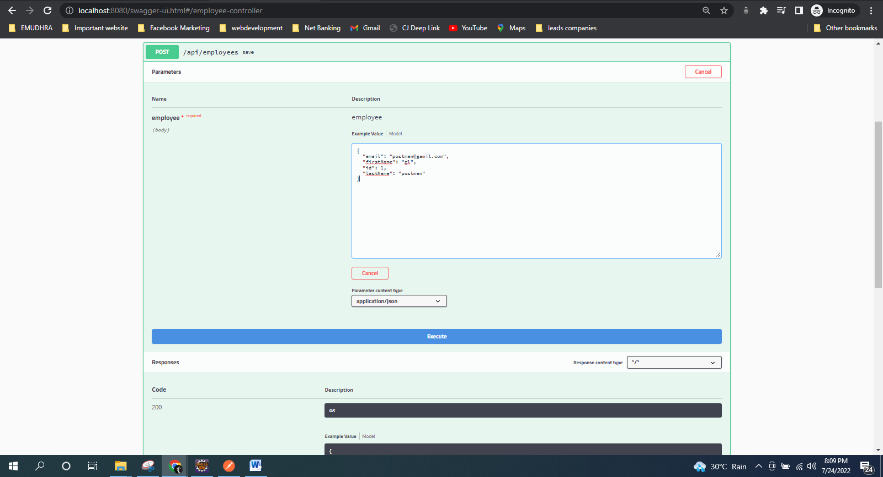

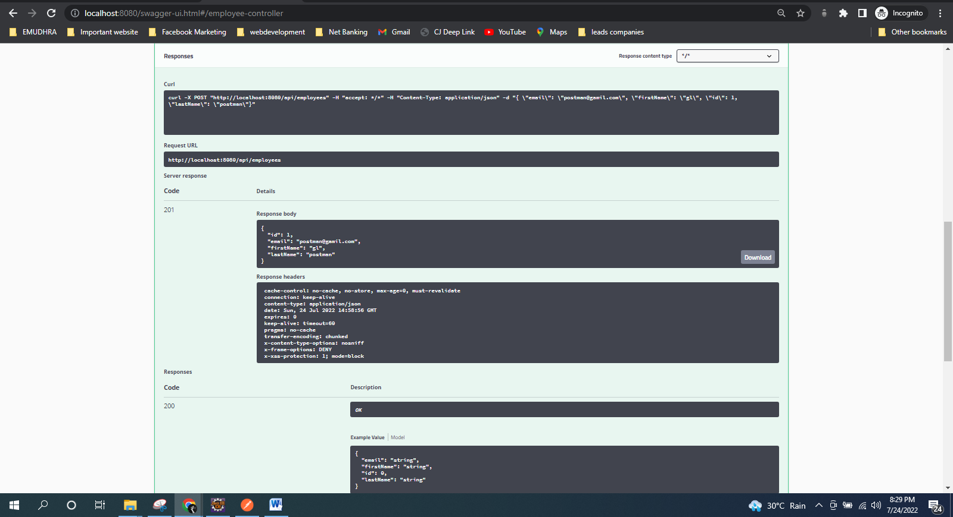

Ex-

{

"firstName":"gl",

"lastName":"postman",

"email":"postman@gamil.com"

}

4. Your application should provide an endpoint to list all the employees stored in the database.

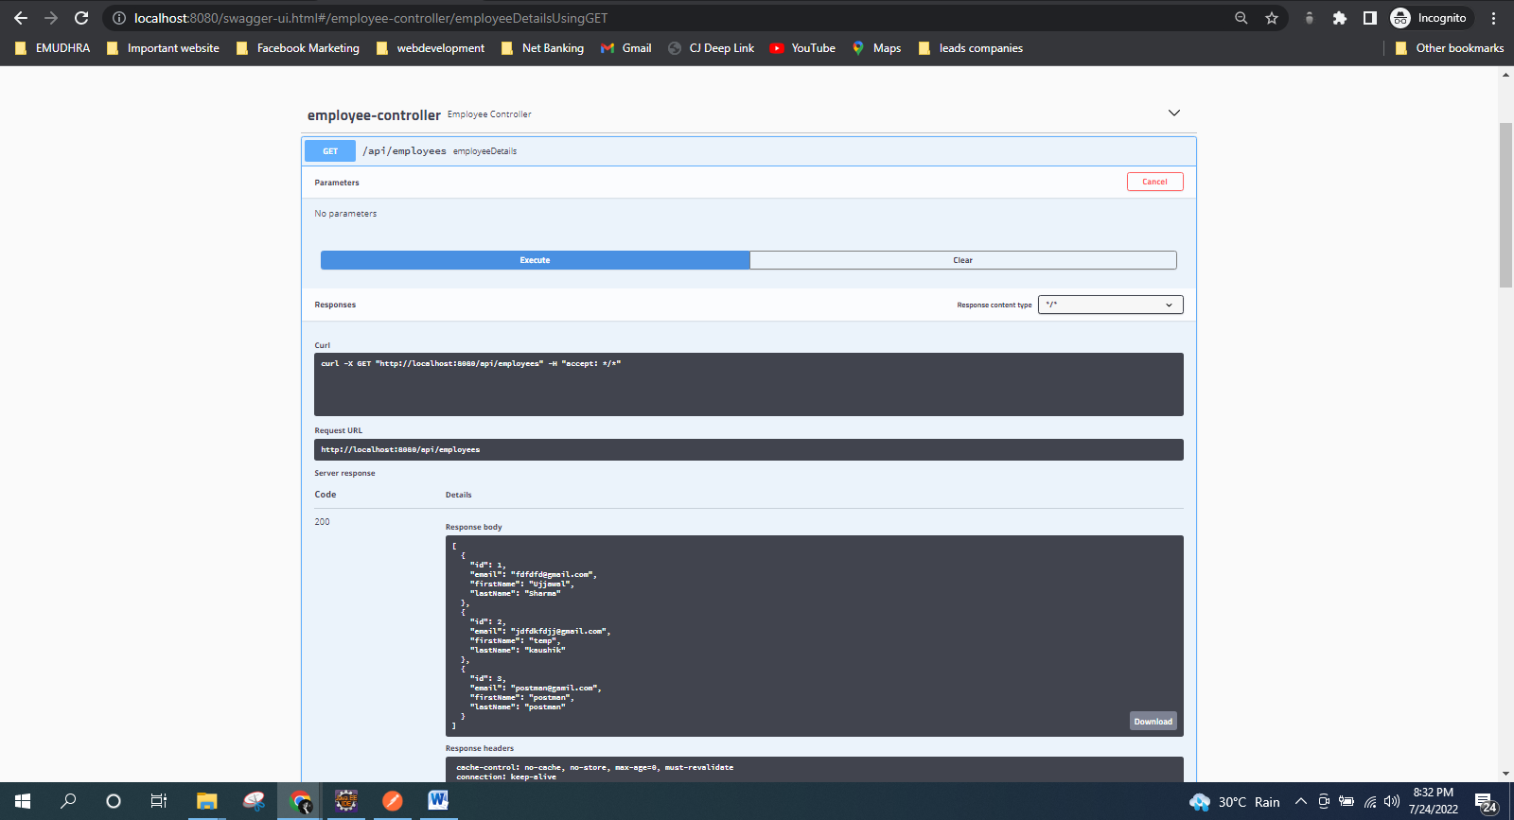

Ex-

Response Body-

[

{

"id": 1,

"firstName": "Ujjawal",

"lastName": "Sharma",

"email": "fdfdfd@gmail.com"

},

{

"id": 2,

"firstName": "temp",

"lastName": "kaushik",

"email": "jdfdkfdjj@gmail.com"

},

{

"id": 3,

"firstName": "postman",

"lastName": "postman",

"email": "postman@gamil.com"

}

]

5. Your application should provide endpoint to fetch or get an employee record specifically based on the id of that employee-

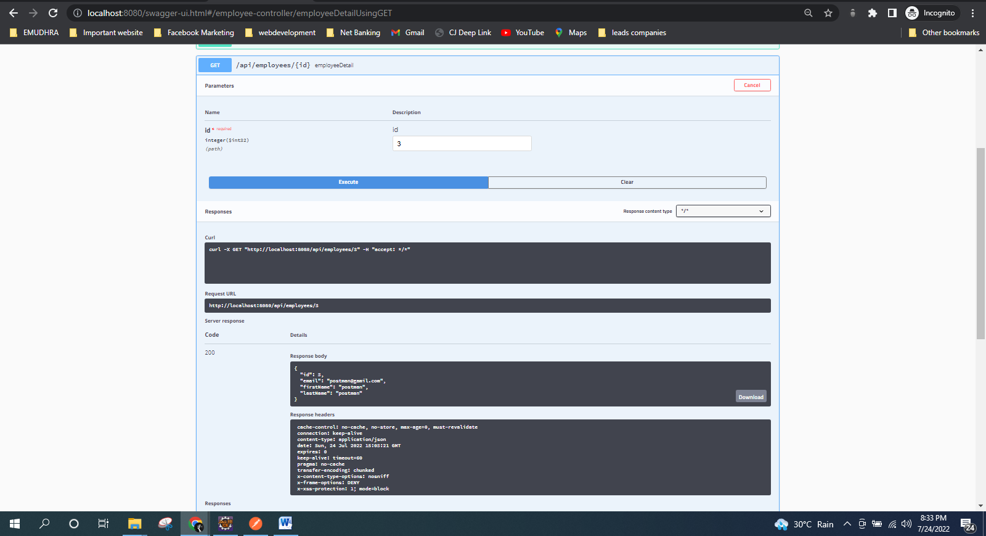

Ex- Url- <http://localhost:8080/api/employees/3>

Response Body-

{

"id": 3,

"firstName": "postman",

"lastName": "postman",

"email": "postman@gamil.com"

}

6. Your application should provide an endpoint to update an existing employee record with the given updated json object.

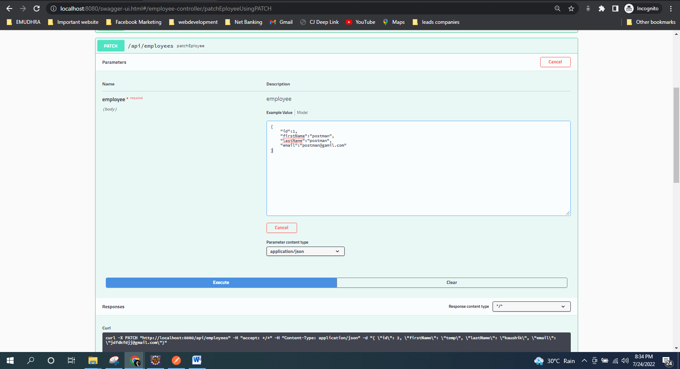

Ex-

Object to be updated(raw->Json)-

{

"id":1,

"firstName":"postman",

"lastName":"postman",

"email":"postman@gamil.com"

}

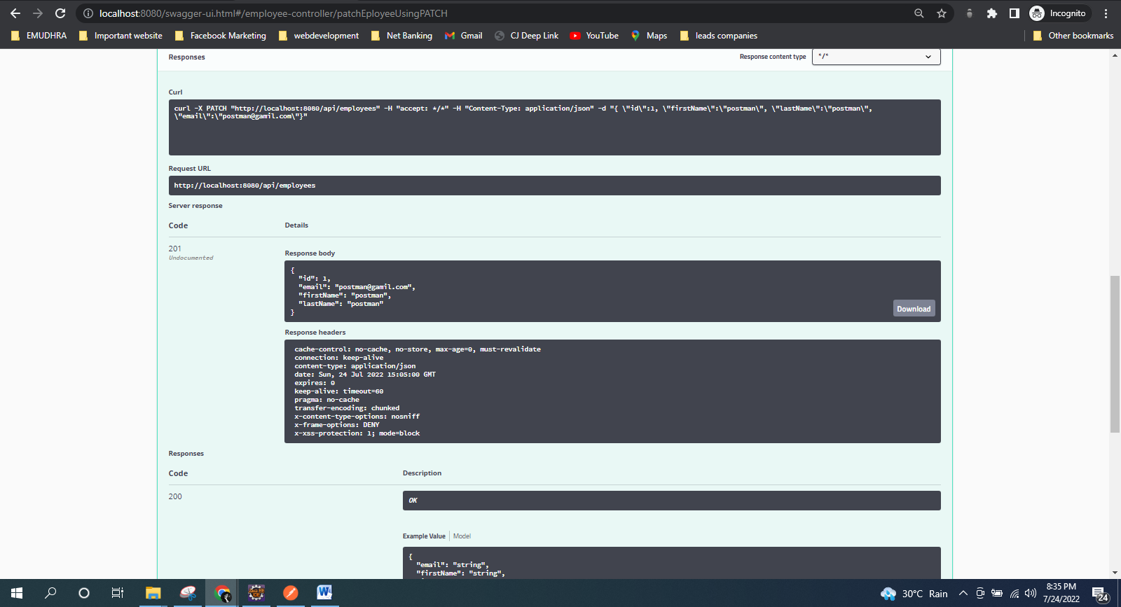

Response Body after updation-

{

"id": 1,

"firstName": "postman",

"lastName": "postman",

"email": "postman@gamil.com"

}

7. Your application should also provide an endpoint to delete an existing employee record based on the id of the employee-

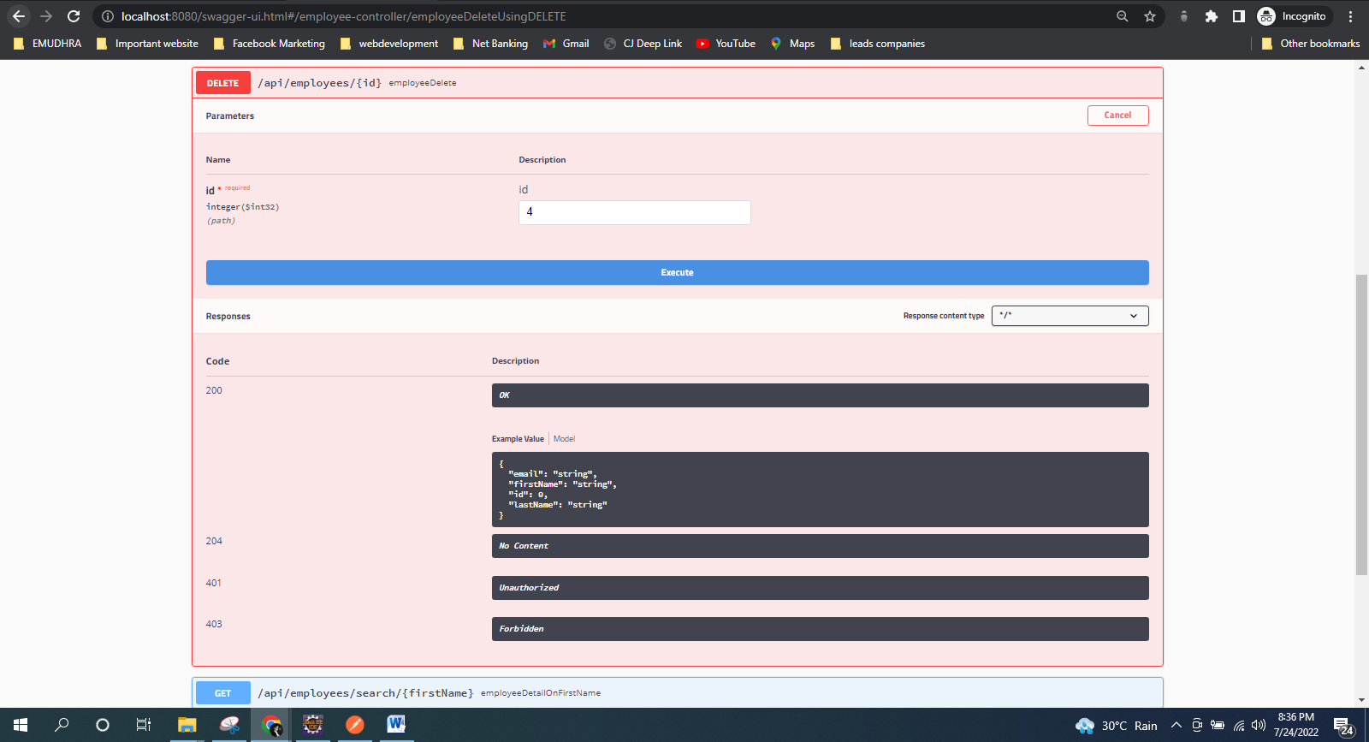

Ex-

Url- <http://localhost:8080/api/employees/4>

Response Body-

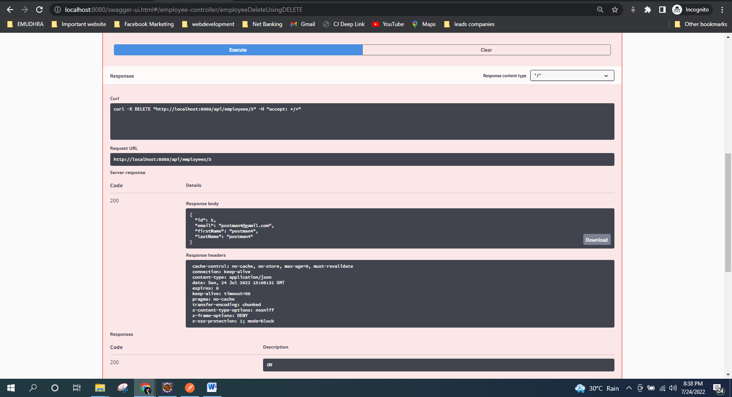

"Deleted employee id - 4”

8. Your application should provide an endpoint to fetch an employee by his/her first name and if found more than one record then list them all-

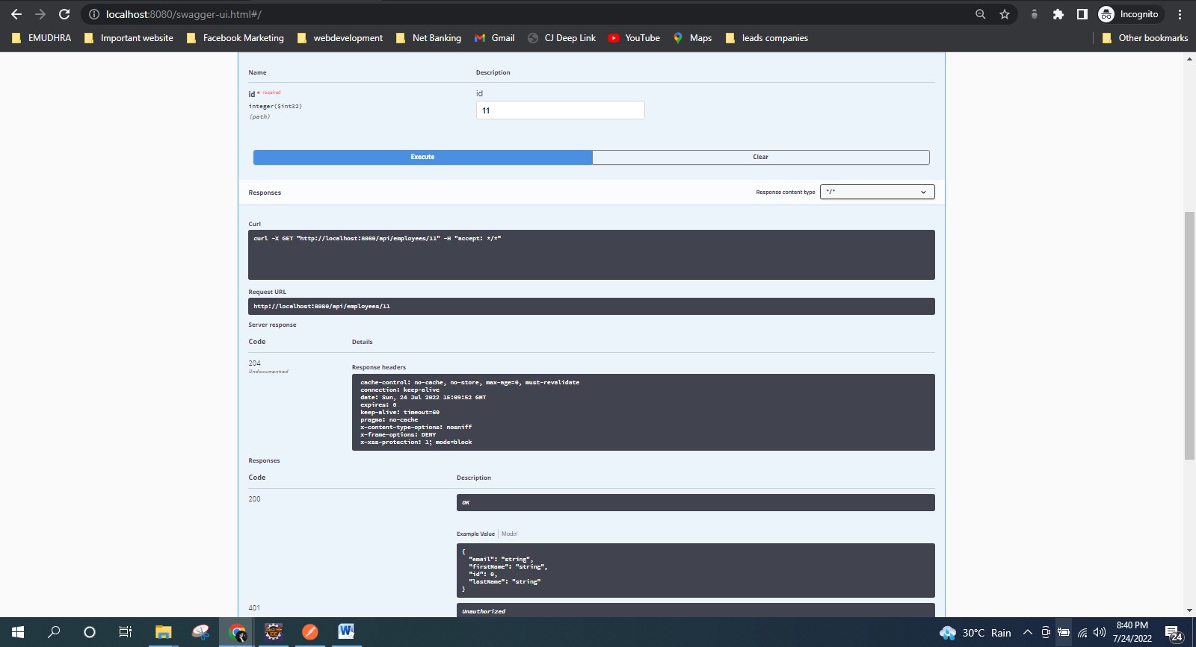

Ex-

Url- http://localhost:8080/api/employees/search/gl

Response Body-

[

{

"id": 11,

"firstName": "gl",

"lastName": "postman",

"email": "postman@gamil.com"

}

]

9. Your application should be able to list all employee records sorted on their first name in either ascending order or descending order .

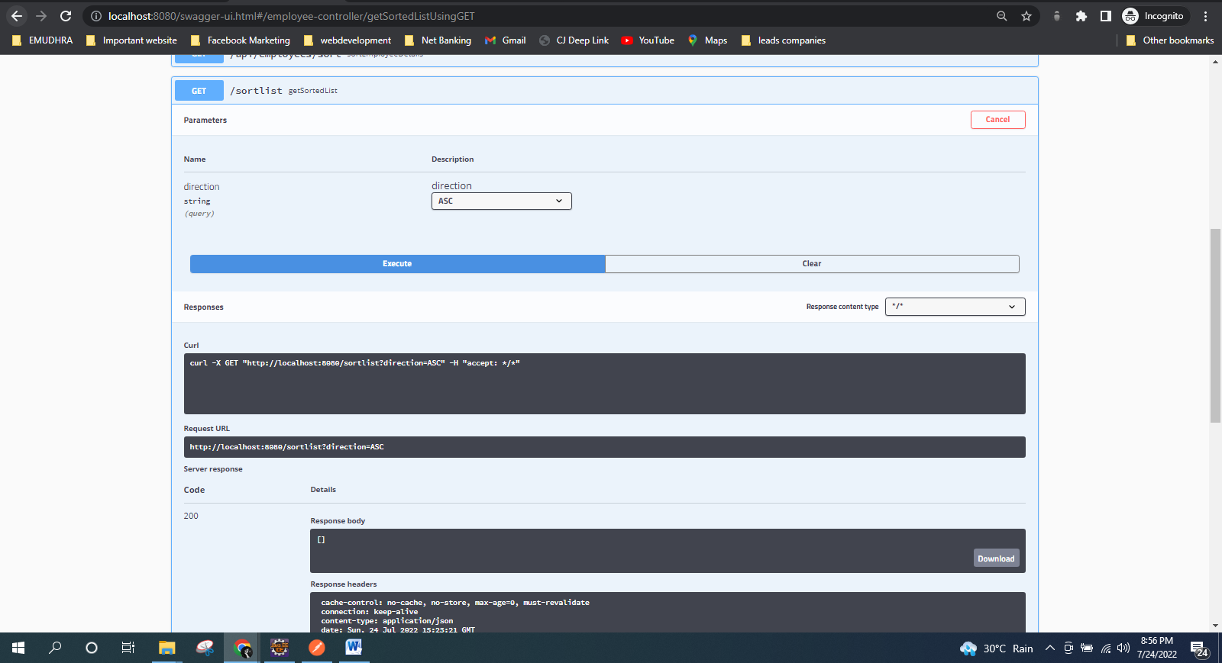

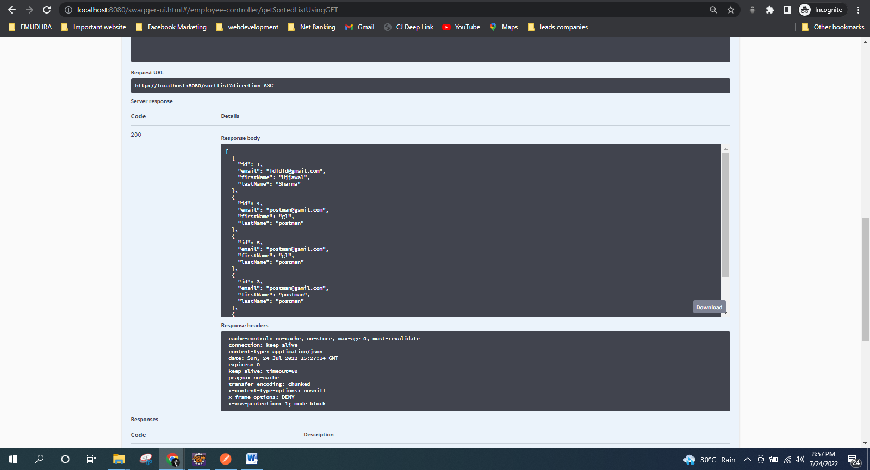

Ex-

Url- [http://localhost:8080/api/employees/sort?order=”asc](http://localhost:8080/api/employees/sort?order=%E2%80%9Dasc)”

OR

Url- <http://localhost:8080/api/employees/sort?order=”desc>”

