AI Marketing Agency Platform — Database Schema
Document control
Version | 2
Status | Approved
Approved by | Sachin Tripathi, platform owner, on 2026-10-04 ("database schema approved"). Phase 1 tables are approved to build; later-phase tables remain provisional until their own specs.
Date | 2026-10-04
Owner | Sachin Tripathi (platform owner)
Prepared by | Claude Code
Canonical source | docs/database/2026-10-04-database-schema.md. The Word file is generated from it.
Changes in version 2 | Owner decisions of 2026-10-04: the refinements in section 12 accepted; 90-day retention for job inputs and notifications confirmed; every cost recorded in both US dollars and Indian rupees (sections 2, 7.6 to 7.8).
Based on | Phase 1 spec version 4, Architecture version 2, Master PRD version 3, App flow version 2, Content guidelines version 2, Tech stack version 1. All approved.

Contents
1. Scope and status of each part
2. Conventions
3. Structure
4. Tables owned by libraries
5. Phase 1: tenancy and access
6. Phase 1: content and approvals
7. Phase 1: agents, jobs and cost
8. Phase 1: notifications, alerts and triggers
9. Phase 1: audit
10. Later phases (provisional)
11. Access, retention and operations
12. Where this document refines the approved Phase 1 spec
13. Decisions and open points

1. Scope and status of each part
This document describes the whole database: every schema, table, column, key, rule and access right.
Part | Level of detail | Status
Phase 1 tables (sections 5 to 9) | Every column, type, constraint, index and rule | Follows the approved Phase 1 spec. Approved to build.
Later-phase tables (section 10) | Table purpose, key columns and relationships | Provisional. Each phase's own spec finalises its tables before they are built. They are shown so the Phase 1 design is known to leave room for them.
Tables owned by libraries (section 4) | Named, not specified here | The sign-in and queue libraries generate their own tables. Their generated SQL is the source of truth.

Section 12 lists the places where this document refines the approved Phase 1 spec.

2. Conventions
Topic | Rule
Database | PostgreSQL 17.11, one database for the product
Identifiers | uuid, generated at random. Never sequential, so an ID reveals nothing and cannot be guessed.
Time | timestamptz, stored in UTC
Text | text. Email addresses use case-insensitive text.
Money | Whole numbers of millionths of a currency unit (bigint). No decimals, so no rounding errors. Every cost is stored three ways: the amount as charged with its currency, the US dollar amount and the Indian rupee amount, with the exchange rate used (section 7.8).
Fixed lists | Postgres enumerated types, listed in section 3.3
Structured values | jsonb, validated by the core service before it is stored
Names | Lower case with underscores; tables in the singular
Brand scope | Every business table has brand_id uuid not null
Deletion | Business rows are not deleted in normal operation. Removal happens only through the retention and deletion processes in section 11.
Schema changes | Numbered plain SQL files, applied by the migration role only

3. Structure

3.1 Schemas
Schema | Holds | Owned by
app | All business tables | Our migrations
auth | Users, sessions, second factor | The sign-in library; generated once, reviewed and committed as a migration
pgboss | Queue rows | The queue library
audit | The audit log and its export record | Our migrations
secrets | Encrypted platform tokens and data keys | Our migrations. Created in phase 3; no other role than the connection role can read it.

3.2 Rules for every brand-scoped table
- brand_id uuid not null, with a foreign key to app.brand.
- A unique key on (brand_id, id).
- Every foreign key to another brand-scoped table includes `brand_id`. A row in one brand cannot point at a row in another.
- Row-level security is enabled and forced.
- One policy with a read condition and a write condition, both: the row's brand_id equals the brand set for the current transaction.
The policy, identical on every brand-scoped table:
ALTER TABLE app.content_item ENABLE ROW LEVEL SECURITY;
ALTER TABLE app.content_item FORCE ROW LEVEL SECURITY;
CREATE POLICY brand_isolation ON app.content_item
USING (brand_id = current_setting('app.brand_id', true)::uuid)
WITH CHECK (brand_id = current_setting('app.brand_id', true)::uuid);
With no brand set, the setting is empty, the comparison is never true, and no row can be read or written.
The brand is set for one transaction only, which is what makes connection pooling safe:
BEGIN;
SELECT set_config('app.brand_id', '<brand uuid>', true); -- true = this transaction only
-- queries for that brand
COMMIT;
A foreign key that carries the brand:
FOREIGN KEY (brand_id, content_item_id)
REFERENCES app.content_item (brand_id, id)

3.3 Enumerated types
Type | Values
brand_status | onboarding, active, paused, offboarding, closed
membership_role | brand_admin, approver, sales_contact, viewer
content_kind | summary (phase 1 only), article, answer_page, social_post, carousel, short_video, long_video, email, ad, landing_page, reply, strategy_brief, campaign, correction
version_state | draft, in_checks, check_failed, awaiting_approval, approved, rejected, superseded, invalidated, scheduled, publish_unknown, published, withdrawn
check_kind | blocking, score
approval_decision | approved, rejected, changes_requested
run_state | created, running, succeeded, failed, needs_manual, cancelled, held
job_class | interactive, publishing, production, bulk
attempt_state | active, succeeded, failed, superseded
model_call_status | started, succeeded, failed, unknown
kill_scope | brand, channel, agent
action_state | pending, submitted, confirmed, failed, unknown
notification_state | queued, sent, delivered, failed
popup_choice | review_now, later
actor_kind | user, agent, system, n8n

4. Tables owned by libraries
Schema | Tables expected | Note
auth | user, session, account, verification, and the two-factor plugin's table | Generated by the sign-in library's generate command for version 1.7.2. The exact columns are whatever that command produces; they are reviewed and committed, and not redefined here. The application role cannot alter them.
pgboss | The library's job, queue, schedule and subscription tables | Created by the queue library at version 12.30.0. A queue row carries a job ID, a class and the brand's scheduling key, and nothing else.

Our tables refer to a user by auth.user's ID. We do not add columns to the library's tables.

5. Phase 1: tenancy and access
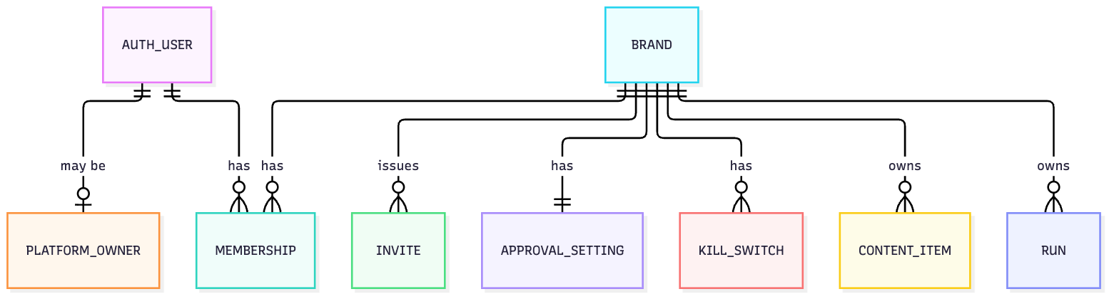

5.1 app.brand
One row per tenant.
Column | Type | Rules
id | uuid | Primary key
name | text | Not null
slug | text | Not null, unique. Used in dashboard addresses. Lower case letters, digits and hyphens.
status | brand_status | Not null, default onboarding
shadow_mode | boolean | Not null, default false
schedule_key | uuid | Not null, unique, random. The only brand information the queue sees.
created_at, updated_at | timestamptz | Not null

Row-level security: a row is visible when its id is the brand set for the transaction. The platform owner's list of all brands goes through an owner-view function.

5.2 app.platform_owner
Who is a platform owner. A separate table, so the sign-in library's tables are not altered.
Column | Type | Rules
user_id | uuid | Primary key; references auth.user
granted_at | timestamptz | Not null
granted_by | uuid | References auth.user; null for the first owner

Not brand-scoped. Readable only through a function that answers "is this user a platform owner?". Changed only by migration or the documented server-side procedure, and audited.

5.3 app.membership
Which user has which role in which brand.
Column | Type | Rules
id | uuid | Primary key
brand_id | uuid | Not null
user_id | uuid | Not null; references auth.user
role | membership_role | Not null
created_at | timestamptz | Not null
created_by | uuid | References auth.user

Unique on (brand_id, user_id): one role per user per brand. Index on user_id. At sign-in, a user's memberships across brands are read through a function that takes the signed-in user's ID, because no brand is set yet.

5.4 app.invite
Column | Type | Rules
id | uuid | Primary key
brand_id | uuid | Not null
email | case-insensitive text | Not null
role | membership_role | Not null
token_hash | bytea | Not null, unique. Only the hash of the token is stored.
expires_at | timestamptz | Not null. 72 hours after creation.
used_at | timestamptz | Null until accepted
invited_by | uuid | Not null; references auth.user
created_at | timestamptz | Not null

Accepting an invite is done by a function that looks the row up by token hash, since the person is not yet a member of any brand.

5.5 app.approval_setting
Column | Type | Rules
brand_id | uuid | Primary key
first_reminder_after | interval | Not null, default 24 hours
reminder_gap | interval | Not null, default 24 hours
reminder_count | smallint | Not null, default 3, between 1 and 5
updated_by | uuid | References auth.user
updated_at | timestamptz | Not null

Phase 3 adds the bulk-approval and calendar-period columns.

5.6 app.kill_switch
Column | Type | Rules
id | uuid | Primary key
brand_id | uuid | Not null
scope | kill_scope | Not null
target | text | The channel or agent name; null when scope is brand
active | boolean | Not null
set_by, set_at | uuid, timestamptz | Not null
released_by, released_at | uuid, timestamptz | Null while active

At most one active row per brand, scope and target (partial unique index where active). Released rows are kept as history.

6. Phase 1: content and approvals
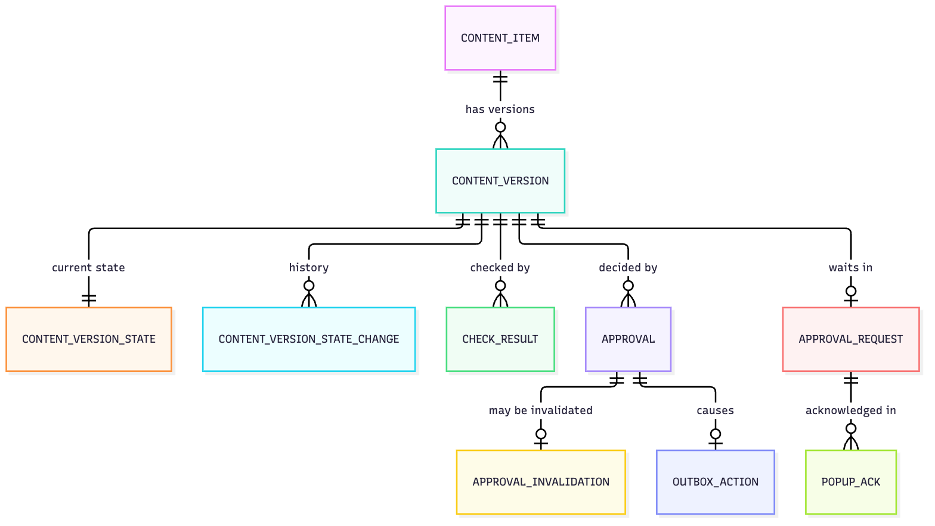

6.1 app.content_item
Column | Type | Rules
id | uuid | Primary key
brand_id | uuid | Not null
kind | content_kind | Not null
current_version_id | uuid | Null until the first version exists; references content_version with brand_id
created_at | timestamptz | Not null

6.2 app.content_version
The immutable record. No update and no delete, for any role.
Column | Type | Rules
id | uuid | Primary key
brand_id | uuid | Not null
content_item_id | uuid | Not null; references content_item with brand_id
number | integer | Not null, from 1. Unique with content_item_id.
payload_canonical | text | Not null. The canonical JSON, exactly as hashed.
hash | text | Not null. sha256: and 64 lower-case hexadecimal characters.
hash_scheme | text | Not null. cv1.
provenance | jsonb | Which agents, definition versions, run and source assets produced it. Outside the hash.
created_by_kind | actor_kind | Not null
created_by_user | uuid | Set when a person made the version
created_by_run | uuid | Set when an agent run made it
created_at | timestamptz | Not null

Triggers: one refuses any update or delete. One, on insert, recomputes the hash from payload_canonical and refuses the row if it differs:
'sha256:' || encode(sha256(convert_to(NEW.payload_canonical, 'UTF8')), 'hex')
Index on (brand_id, content_item_id, number).

6.3 app.content_version_state
The mutable lifecycle state of a version.
Column | Type | Rules
content_version_id | uuid | Primary key; references content_version with brand_id
brand_id | uuid | Not null
state | version_state | Not null
updated_at | timestamptz | Not null

Index on (brand_id, state), which the inbox uses.

6.4 app.content_version_state_change
Insert only.
Column | Type | Rules
id | uuid | Primary key
brand_id | uuid | Not null
content_version_id | uuid | Not null
from_state, to_state | version_state | from_state null for the first
cause | text | Not null. Why it changed.
actor_kind, actor_id | actor_kind, uuid | Who caused it
at | timestamptz | Not null

6.5 app.asset
Immutable. The bytes are in the asset store under the hash, not in the database.
Column | Type | Rules
id | uuid | Primary key
brand_id | uuid | Not null
sha256 | text | Not null. Hash of the stored bytes. Unique with brand_id.
byte_length | bigint | Not null
mime | text | Not null. Verified from the file's content.
storage_key | text | Not null. Where the bytes are.
ai_generated | boolean | Not null
created_at | timestamptz | Not null

6.6 app.check_result
One row per check or score on a version. Follows the content guidelines, section 14.
Column | Type | Rules
id | uuid | Primary key
brand_id | uuid | Not null
content_version_id | uuid | Not null
check_name | text | Not null. For example accuracy, safety, brand_voice.
kind | check_kind | Not null
passed | boolean | For blocking checks
score | smallint | For scores: 1 to 5
not_applicable | boolean | Not null, default false
not_applicable_reason | text | Required when not_applicable is true
confidence | smallint | 0 to 100
detail | jsonb | What was found
definition_version_id | uuid | The checker's agent definition version
created_at | timestamptz | Not null

A rule on the table: a blocking row has passed and no score; a score row has a score or is not applicable.

6.7 app.approval
Insert only. A decision on one exact version.
Column | Type | Rules
id | uuid | Primary key
brand_id | uuid | Not null
content_version_id | uuid | Not null
version_hash | text | Not null. Must equal the version's hash; checked by trigger.
hash_scheme | text | Not null
decision | approval_decision | Not null
decided_by | uuid | Not null; references auth.user
comment | text
decided_at | timestamptz | Not null

6.8 app.approval_invalidation
Insert only. An approval is valid when no row here refers to it.
Column | Type | Rules
id | uuid | Primary key
brand_id | uuid | Not null
approval_id | uuid | Not null, unique
reason | text | Not null
at | timestamptz | Not null

6.9 app.approval_request
One row per version waiting for a decision.
Column | Type | Rules
id | uuid | Primary key
brand_id | uuid | Not null
content_version_id | uuid | Not null, unique
requested_at | timestamptz | Not null
reminders_sent | smallint | Not null, default 0
last_reminder_at | timestamptz
escalated_at | timestamptz
escalated_to | uuid | References auth.user
overdue | boolean | Not null, default false
closed_at | timestamptz | Set when a decision is made

Partial index on (brand_id) where closed_at is null, for the reminder job; and where overdue, for the banner.

6.10 app.popup_ack
Column | Type | Rules
id | uuid | Primary key
brand_id | uuid | Not null
user_id | uuid | Not null
approval_request_id | uuid | Not null
choice | popup_choice | Not null
at | timestamptz | Not null

6.11 app.outbox_action
Written in the same transaction as the approval. In phase 1 its kind is none and it makes no outside call. Phase 3 adds the connection, command, schedule and platform reply columns.
Column | Type | Rules
id | uuid | Primary key
brand_id | uuid | Not null
kind | text | Not null
content_version_id | uuid
approval_id | uuid
state | action_state | Not null, default pending
idempotency_key | uuid | Not null, unique
created_at, updated_at | timestamptz | Not null

7. Phase 1: agents, jobs and cost
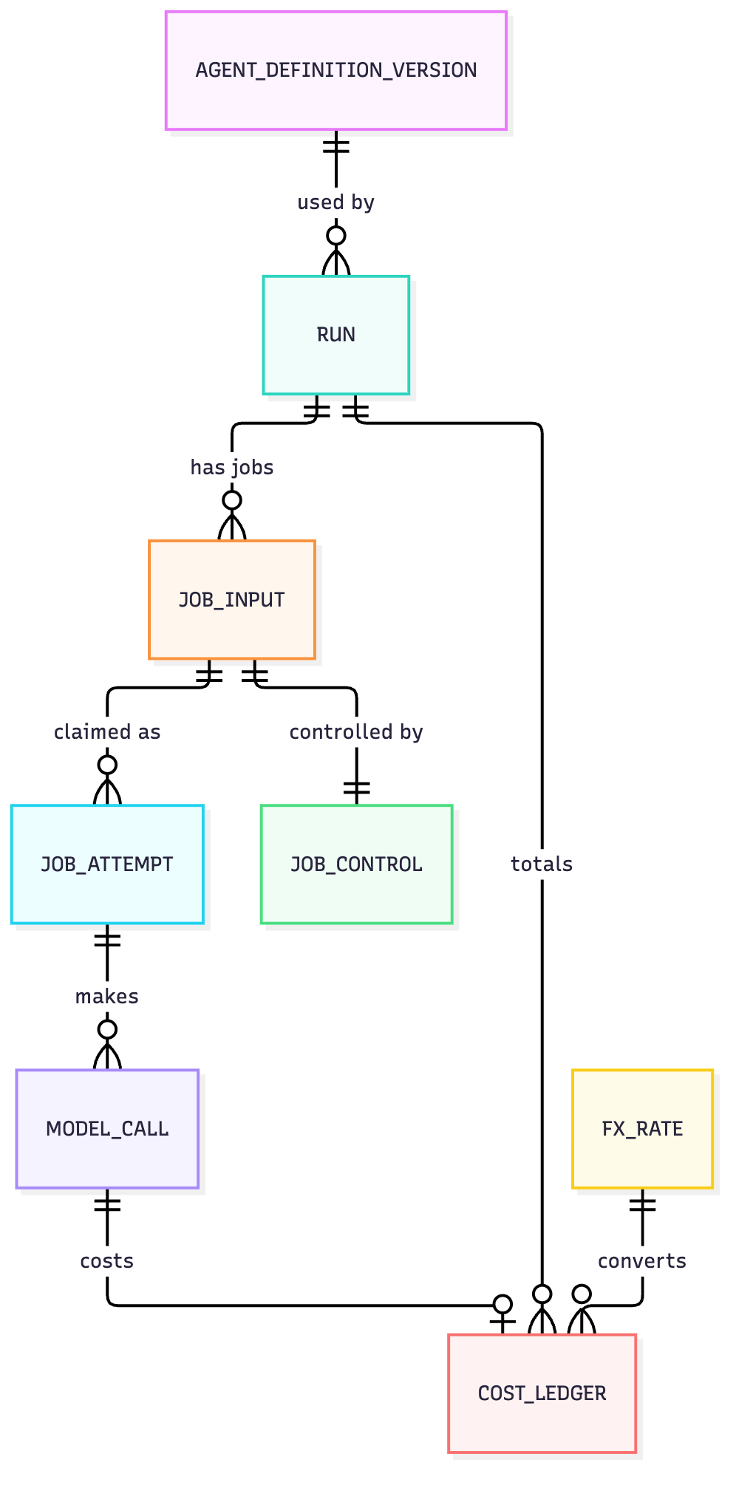

7.1 app.agent_definition_version
Not brand-scoped. Changed only by the release step.
Column | Type | Rules
id | uuid | Primary key
agent | text | Not null
version | integer | Not null. Unique with agent.
model | text | Not null
effort | text | Not null
files_hash | text | Not null. Hash of the definition's files in the repository.
live | boolean | Not null, default false
released_by, released_at | uuid, timestamptz | Set when made live
created_at | timestamptz | Not null

At most one live version per agent (partial unique index where live).

7.2 app.run
Column | Type | Rules
id | uuid | Primary key
brand_id | uuid | Not null
agent | text | Not null
definition_version_id | uuid | Not null
state | run_state | Not null
started_by_kind, started_by_id | actor_kind, uuid | Who started it
started_at, finished_at | timestamptz

7.3 app.job_input
What a job needs. The queue never holds this, and the queue role cannot read it.
Column | Type | Rules
job_id | uuid | Primary key. The same ID as the queue row.
brand_id | uuid | Not null
run_id | uuid | Not null
class | job_class | Not null
input | jsonb | Not null
saved_steps | jsonb | Not null, default empty list. Checkpoints.
result_hash | text | Set when a result is accepted
created_at | timestamptz | Not null

7.4 app.job_attempt
One row per claim of a job.
Column | Type | Rules
id | uuid | Primary key. The attempt ID carried in the token.
brand_id | uuid | Not null
job_id | uuid | Not null
attempt_number | integer | Not null. Unique with job_id.
worker_id | text | Not null
token_id | uuid | Not null, unique
state | attempt_state | Not null
started_at, ended_at | timestamptz

At most one active attempt per job (partial unique index where state is active).

7.5 app.job_control
Column | Type | Rules
job_id | uuid | Primary key
brand_id | uuid | Not null
cancel_requested | boolean | Not null, default false
held | boolean | Not null, default false
updated_at | timestamptz | Not null

7.6 app.model_call
The model-call ledger. One row per request sent to the provider, written before it is sent.
Column | Type | Rules
id | uuid | Primary key
brand_id | uuid | Not null
run_id, job_id, attempt_id | uuid | Not null
step | text | Not null
request_hash | text | Not null
status | model_call_status | Not null, default started
possible_duplicate | boolean | Not null, default false
provider_message_id, provider_request_id | text | Set on success
model | text | Not null
input_tokens, output_tokens, cache_read_tokens, cache_write_tokens | integer | Set on success
charged_micros, charged_currency | bigint, text | Set on success. The amount as the provider charges it, and its three-letter currency code.
usd_micros, inr_micros | bigint | Set on success. The same cost in US dollars and in Indian rupees.
fx_rate_id | uuid | The exchange rate used; references fx_rate
error | text | Set on failure
started_at, finished_at | timestamptz

Index on (job_id, step, request_hash) for the duplicate check, and on (status, started_at) for reconciliation.

7.7 app.cost_ledger
Column | Type | Rules
id | uuid | Primary key
brand_id | uuid | Not null
run_id | uuid
agent | text | Not null
deliverable | text | The kind of thing produced
model_call_id | uuid | Unique where set, so a call is costed once
charged_micros, charged_currency | bigint, text | Not null. As charged.
usd_micros, inr_micros | bigint | Not null. Both always filled.
fx_rate_id | uuid | Not null; references fx_rate
at | timestamptz | Not null

Index on (brand_id, at).

7.8 app.fx_rate
Not brand-scoped. The exchange rates used to record costs in both currencies.
Column | Type | Rules
id | uuid | Primary key
rate_date | date | Not null. Unique with the currency pair.
base_currency, quote_currency | text | Not null. USD and INR.
rate_micros | bigint | Not null. Rupees per dollar, in millionths.
source | text | Not null. Where the rate came from.
fetched_at | timestamptz | Not null

How the two amounts are kept
- A cost is recorded in the currency it was charged in. Model usage is charged in US dollars.
- The other currency is calculated once, when the cost is recorded, using that day's rate. Both amounts and the rate are stored.
- A stored amount is never recalculated. Past reports do not change when the exchange rate moves.
- One rate a day is stored. If the day's rate has not yet been fetched, the most recent one is used and the row records which.
- Reports, the cost screens and budgets show both currencies. A brand chooses which one leads.
- A cost charged in rupees, such as ad spend later, is stored the same way with the dollar amount calculated.

8. Phase 1: notifications, alerts and triggers

8.1 app.notification
Column | Type | Rules
id | uuid | Primary key
brand_id | uuid | Not null
user_id | uuid | Not null
kind | text | Not null. For example approval_waiting, reminder, overdue.
channel | text | Not null. Email or the second channel.
subject_kind, subject_id | text, uuid | What it is about
state | notification_state | Not null, default queued
attempts | smallint | Not null, default 0
provider_id | text | The provider's message ID, set on send
created_at, sent_at, delivered_at | timestamptz

8.2 app.alert
Column | Type | Rules
id | uuid | Primary key
brand_id | uuid | Null for a platform-level alert. Brand users never see those rows; the platform owner reads them through an owner-view function.
severity | smallint | Not null, 1 to 3
kind | text | Not null
detail | jsonb
raised_at | timestamptz | Not null
acknowledged_by, acknowledged_at | uuid, timestamptz
resolved_at | timestamptz

8.3 app.trigger_nonce
Not brand-scoped. Replay protection for n8n calls.
Column | Type | Rules
nonce | bytea | Primary key
received_at | timestamptz | Not null. Rows older than 10 minutes are deleted.

9. Phase 1: audit

9.1 audit.log
Insert only, for every role.
Column | Type | Rules
id | uuid | Primary key
chain_key | text | Not null. The brand's ID, or platform.
brand_id | uuid | Null for platform-level entries
seq | bigint | Not null. Unique with chain_key; no gaps.
at | timestamptz | Not null
actor_kind, actor_id | actor_kind, uuid | Not null kind
action | text | Not null
subject_kind, subject_id | text, uuid
before, after | jsonb
prev_hash | text | The previous entry's hash in the same chain
hash | text | Not null. Covers this entry's content, seq and prev_hash.

Appending takes a transaction-length lock on the chain, so two writers cannot extend the same entry. Triggers refuse update and delete. Only the audit-writer role can insert. Reads go through functions that apply the brand.

9.2 audit.export
Column | Type | Rules
id | uuid | Primary key
chain_key | text | Not null
through_seq | bigint | Not null
chain_hash | text | Not null
exported_at | timestamptz | Not null
location | text | Not null. Where the write-once copy is.

10. Later phases (provisional)
Each phase's spec finalises these. All follow the rules in section 3.2.

10.1 Phase 2: brand knowledge and evaluation
Table | Purpose and key columns
research_source | A source read during research: address, read at, result
profile_item | One item of the brand profile: key, value, status (found, assumed, unknown), source
verified_fact | Statement, fact hash, source, confirmed by, confirmed at, review date, status (active, expired, superseded)
questionnaire, question, answer | The tailored questionnaire and its answers; a question records why it is asked
agent_question | A question an agent raised mid-work, and its answer
safety_rule | Forbidden topic, claim or word; competitor not to be named; tone limit; pause date
evaluation_set, evaluation_case | The cases an agent version must pass, including hostile ones
evaluation_run, evaluation_result | A run of an agent version against a set, and each case's outcome

The strategy brief is a content_item of kind strategy_brief, so it is approved against an immutable version like everything else.

10.2 Phase 3: connections, publishing and compliance
Table | Purpose and key columns
connection | A brand's link to an outside account: platform, account type, outside account ID, permissions, status, expiry
secrets.connection_token | The encrypted tokens for a connection
secrets.data_key | The brand's data key, encrypted by the master key
approved_domain | A domain content may link to
campaign | Objective, audience, channels, dates, targets
calendar_slot | A planned publication: item, channel, time
outbox_action (extended) | Adds connection, command, scheduled time, provider idempotency key, platform post ID
action_attempt | Each call made for an action, with the platform's reply
reconciliation_result | What the platform showed when asked about an unknown action
manual_resolution | A person's decision on an unresolved action
platform_limit_counter | Usage against each platform's limits, per connection
compliance_profile, compliance_profile_version | Market, channel, content type, rules, sources, review date, legal approver, status
consent_record | A person's consent to appear or be quoted: scope, given at, withdrawn at
licence_record | The right to use an asset or music: scope, expiry
offer, product | Offers with end dates; products with status
live_content_review | A review of published content after a trigger: trigger, item, outcome (corrected, removed, retained), reason, decided by
search_snapshot, ai_answer_check | Search performance and AI-answer mentions over time

The hashed content payload gains references to offers, products and the compliance profile version, so affected live content can be found.

10.3 Phase 4: leads and sales
Table | Purpose and key columns
lead | A person: name, phone, email, lead type, status, owner
consent | A lead's consent: purpose, source, time
touch | A recorded interaction with its source and tags
conversation, message | A thread with a lead and its messages
approved_answer | An answer routine replies may use
pipeline_stage, opportunity, stage_change | The pipeline per lead type and movement through it
partner, partner_routing, partner_outcome | Partners, a lead routed to one, and the outcome reported through a single-purpose link (token hash stored)
booking | An appointment made for a lead
webhook_event | Each inbound platform event's ID, for replay protection
data_request | A request to export or delete a person's data, and its completion

10.4 Phase 5 and later
Table | Purpose | When
metric_snapshot | A metric's value for a brand and period | Phase 5
attribution_result | Which touches a lead or sale is credited to | Phase 5
report | A generated report | Phase 5
incident, escalation | Incident records and escalations | Phase 3
budget, ad_campaign, ad_change | Paid media caps and changes | After pilot
plan, subscription, invoice, contract | Billing and agreements | For sale

11. Access, retention and operations

11.1 What each database role can do
Role | app business tables | auth | pgboss | audit | secrets
Migration | Create and alter; used only at deployment | Create and alter | Create and alter | Create and alter | Create and alter
Application | Read and write, through row-level security. Cannot alter tables. | Read and write | Create jobs only | None | None
Queue (workers) | None | None | Claim and update jobs | None | None
Audit-writer | None | None | None | Insert only | None
Owner-view | Read across brands through named functions only | None | Read | Read through functions | None
Read-only | Read, through row-level security | None | None | None | None
Connection (phase 3) | Outbox and connection tables only | None | Claim publishing jobs | None | Read and write

No run-time role can bypass row-level security, and none owns a table.

11.2 Rules enforced by the database itself
Rule | How
A row cannot belong to, or be moved to, another brand | Forced row-level security with a write condition
A row cannot reference another brand's row | Foreign keys that include brand_id
A content version never changes | Trigger refusing update and delete
A version's hash matches its content | Trigger recomputing the hash on insert
An approval names the real hash of its version | Trigger on insert
The audit log is never changed | No update or delete rights, and a trigger
One live definition per agent; one active attempt per job; one active kill switch per scope | Partial unique indexes
A model call is costed once | Unique model_call_id in the cost ledger

11.3 Retention
The figure marked "proposed" comes from the PRD's recommended defaults and is not yet confirmed.
Data | Kept for | Then
Content versions, approvals, state history | The life of the brand | Deleted at offboarding, after the retention period
Audit log | 2 years (proposed) | Deleted; the exported copy follows the same period
Job inputs and attempts | 90 days after the job ends (confirmed by the owner) | Deleted; the run and its cost remain
Model-call ledger and cost ledger | The life of the brand | Kept for billing and reconciliation
Notifications | 90 days (confirmed by the owner) | Deleted
Trigger nonces | 10 minutes | Deleted
Lead data (phase 4) | To be set by legal review | Deleted or anonymised
Sessions | Until expiry | Deleted by the sign-in library

11.4 Backups
One daily encrypted backup covers all schemas together, so sign-in, queue, business data and audit are restored to the same moment. A restore is tested as part of launch gate 0.

12. Where this document refines the approved Phase 1 spec
These are small additions or changes made while specifying columns. The owner accepted them on 2026-10-04. Where they differ from section 5 of the Phase 1 spec, this document is the one to build from.
# | Refinement | Reason
1 | Platform owner is a row in app.platform_owner, not a flag on the user | Avoids altering the sign-in library's tables
2 | app.brand gains slug | Dashboard addresses use /b/{brand}
3 | app.alert is added | The approved app flow has an Alerts and incidents screen in phase 1
4 | app.check_result gains kind, not_applicable, its reason, and confidence | The approved content guidelines separate blocking checks from scores and add an N/A state
5 | app.asset gains ai_generated and storage_key | The guidelines require generated visuals to be labelled
6 | Costs are stored as whole millionths of a currency unit, in both US dollars and Indian rupees, with the exchange rate used | Avoids rounding errors; the owner asked for both currencies
7 | app.notification records the channel and delivery time | Alert delivery must be confirmed, not only attempted
8 | A secrets schema is reserved for phase 3 | Keeps tokens out of reach of every role but one
9 | app.fx_rate is added | Needed to record each cost in both currencies

13. Decisions and open points
Decided by the owner on 2026-10-04
# | Point | Decision
1 | The refinements in section 12 | Accepted
2 | Retention for job inputs and notifications | 90 days
3 | Currency for cost records | Both US dollars and Indian rupees

Still open
# | Point
4 | The source of the daily dollar-to-rupee rate. It should be a published reference rate; the source is chosen and recorded when Phase 1 is built.
5 | Audit-log retention of 2 years is still a proposal, subject to legal review (owner item F2)
6 | Lead-data retention and storage location (owner items F2 and F3) decide parts of phase 4's tables

