CSS Box Model  **every element in web design is a rectangular box.**

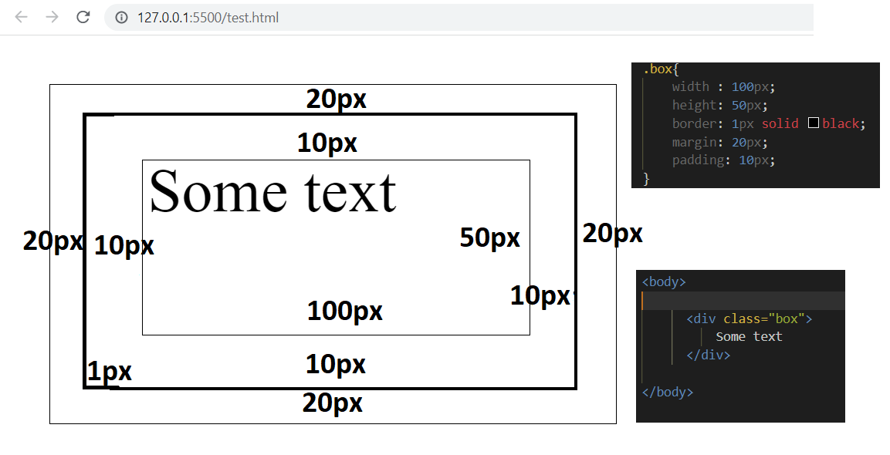When you hover on this div element the size will be 122 * 72

Width = 122 = 100(width)+10(left padding) +10(right padding) + 1(left border) +1(right border)

Height = 72 = 50 (height) + 10 (top padding) + 10(bottom padding)+ 1(top border)+ 1 (bottom border)

-----------------------------------------------------------------------------------------------------------------------------------

HTML elements have default CSS properties

body : display: block , margin: 8px

Left margin and top margin here is 8px

----------------------------------------------------------------------------------------------------------------------------------

When body margin is made 0

There is no area outside the border

Few things about div element

 .container {

       width: 100%;

       height: 400px;

       background-color: red;

       border: 1px solid black;

   }

<body>

    <div class="container">

    </div>

</body>



This will create a div with default display:block CSS property and taking full width in the browser .

Height being 400px and margin of 8px inherited from body default CSS margin property

<body>

    <div class="container">

    </div>

    <span>Hello</span>

    <span>World</span>

    <div>Another div </div>

    <span>Another span</span>

</body>

Height changed to 40 px

Span is an inline element. Since div is a block level element you will see Hello World displayed in the next line and Hello World is printed in the same line as they are include in span tag .

Another div and Another span is printed in the next line for the same reason .

Positioning elements

Inline and block

<span>Hello</span>

   <div class="container">

</div>

Inline and inline

<body>

   <span>Hello</span><span>World</span>

</body>

Block and inline

<body>

   <div class="container">

   </div>

   <span>Hello</span><span>World</span>

</body>

Block and block

<body>

   <div class="container">

   </div>

   <div class="container">

   </div>

</body>

Effect of margin,padding,width,height,border on some elements

<body>

        <h2>Hello World</h2>

</body>

 h2{

        background-color: green;

        margin: 10px 10px 10px 10px;

        border: 1px solid black;

        padding: 10px 10px 10px 10px;

        color: white;

        width: 150px;

   }

Changing margin-top – pushes the element down creating a transparent area of 50px

Changing margin-left to 100 – pushes the element towards right creating a transparent area of 100px

Changing margin-right doesn’t effect the position since it already has a transparent area

that is equal to entire device width – margin+left+2*border +2*padding+width .

Changing margin-bottom doesn’t effect the position of the element but it pushes the element just below it by so many units

<body>

        <h2>Hello World</h2>

        <span>start from 159px</span>

</body>

Adding a span element to prove it pushes the element down by 70 px

Span start from 159 px because the top space is 10+1+10+27+10+1+100

Updating padding

Update padding-left

  h2{

      background-color: green;

      margin: 10px 10px 10px 10px;

      border: 1px solid black;

      padding: 10px 10px 10px 10px;

      color: white;

      width: 200px;

   }

<body>

   <h2>Hello World</h2>

</body>

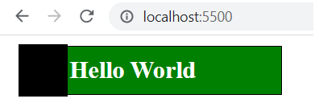

The highlighted area is 50px . This increases the overall width of the element by 50 px. The position of the element is unaffected

With 10px padding . The space between left border and H is 10px.

Adding padding-top and padding-bottom of 50 px

The overall height of the element is increased by 100 pxs.Then position of the element is unaffected

Summary : Margin changes the position of the element because it has to create transparent space around an element.

Padding can change the height and width of an element . The position is unaffected . But the content inside the element gets shifted as we increase/decrease the padding .

Understanding the effects on inline element span

<body>

   <span>Hello World</span><span>Hello World</span>

</body>

  span{

      background-color: green;

      margin: 0px 0px 0px 0px;

      border: 1px solid black;

      padding: 0px 0px 0px 0px;

      color: white;

   }

Notice there is no space between span tags in the html script because that would take up some space in the browser

body{

        margin: 0;

   }

   span{

      background-color: green;

      margin: 0px 50px 50px 50px;

      border: 1px solid black;

      padding: 0px 50px 50px 50px;

      color: white;

   }

<body>

   <span>Hello World</span><span>Hello World</span>

</body>

Padding-left = 50px has moved the Hello World text by 50 pxs

Padding-right = 50px has created a transparent area of 50px after Hello World

Padding-bottom=50px increased the height by 50px creating a transparent space below Hello World.

The content “Hello World” is taken as a point of reference

This increases the overall width by 100px and height by 50px. Padding-top has no effect on inline elements.

Margin-left=50px shifts the first span by 50px to right or it creates a transparent space of 50px. This will also shift the next span element by 50 px.

Margin-right=50px will create a transparent space of 50px towards the right section.This will also shift second span element by 50px.

Margin-bottom has no effect. Margin-top has no effect on the positioning.

This has shifted the span position and created a space of 100 px between the 2 elements.

 body{

        margin: 0;

   }

   div{

      background-color: green;

      border: 1px solid black;

      color: white;

      margin-top: 10px;

      margin-bottom: 10px;

   }

Margin-top and margin-bottom is 10px. It doesn’t add up both but there is an overlap so the space created between div elements is 10px and not 20px.

Don’t need an explanation to understand the effects of margin and padding on div elements. Go by your intuition .

   body{

        margin: 0;

   }

   div{

      background-color: green;

      border: 1px solid black;

      color: white;

      margin-top: 10px;

      margin-bottom: 10px;

   }

Observe and understand how it works

Center align a div

1)

.center {

  margin: auto;

  width: 60%;

  border: 1px solid #73AD21;

  text-align: center;

}

<body>

<div class="center">

  <p>Hello World!</p>

</div>

</body>

Margin:auto will apply margin-left and margin-right rules and center div horizontally

text-align will center the contents inside the div

2)

<style>

.center {

  display: flex;

  justify-content: center;

  align-items: center;

  height: 200px;

  border: 3px solid green;

}

</style>

</head>

<body>

<div class="center">

  <p style="border: 1px solid black;">This is box 1</p>

  <p style="border: 1px solid black;">This is box 2</p>

  <p style="border: 1px solid black;">This is box 3</p>

</div>

CSS Specificity rank for determining what CSS rules must be applied on an element when there are multiple rules

<style>

.center {

  width: 100px;

  height: 100px;

  background-color: red;

}

div{

   width: 100px;

  height: 100px;

  background-color: green;

}

#div{

   width: 100px;

  height: 100px;

  background-color: yellow;

}

#div{

   width: 100px;

  height: 100px;

  background-color: white;

}

</style>

</head>

<body>

<div class="center" id="div" style="background-color: blueviolet;">

</div>

Div will have blueviolet background

<style>

.center {

  width: 100px;

  height: 100px;

  background-color: red;

}

div{

   width: 100px;

  height: 100px;

  background-color: green;

}

#div{

   width: 100px;

  height: 100px;

  background-color: yellow;

}

#div{

   width: 100px;

  height: 100px;

  background-color: grey;

}

</style>

</head>

<body>

<div class="center" id="div">

</div>

Div has grey background because id has highest priority and grey div comes last in the order. First being yellow

<style>

.center {

  width: 100px;

  height: 100px;

  background-color: red;

}

div{

   width: 100px;

  height: 100px;

  background-color: green;

}

</style>

</head>

<body>

<div class="center" id="div">

</div>

Div will be red

Type selector (div here) has least priority