

Sri Lanka Institute of Information Technology

DS Assignment 2 - Fast Food Online

Module: Distributed Systems
Assignment: 2 - Rest API

Report

Software Engineering Weekend Batch

Submitted by:

IT17152938 : Sachin Kumara Liyanage

Contents
Introduction 3
Architecture 5
Workflow 7
Appendix 8
Backend 8
Train details gateway 8
Gov Employee gateway 13
Dialog payment gateway 16
Sampath gateway 18
SMS gateway 20
Email gateway 22
FrontEnd 25

Introduction

This report is for the 2nd assignment of DS module which is about implementing a scenario similar to an online train ticket reservation application which lets customers buy train ticket and pay for them by using a credit/debit card or add the amount to the Dialog bill. The application is a combination of a website(frontend) and a REST API (backend) which is accompanied by a MongoDB database.

1. Website
This is a collection basic HTML + JavaScript + CSS pages that use Bootstrap for look & feel, Ajex library for sending HTTP requests to the REST service, and jQuery library for dynamically changing the content of the web page.
2. REST API
This is implemented based on REST principles by using Spring Boot framework with Java and runs on its own embedded server instance and exposes a number of services over HTTP.

Following is the sequence of fetching food items by the frontend(using Ajex).

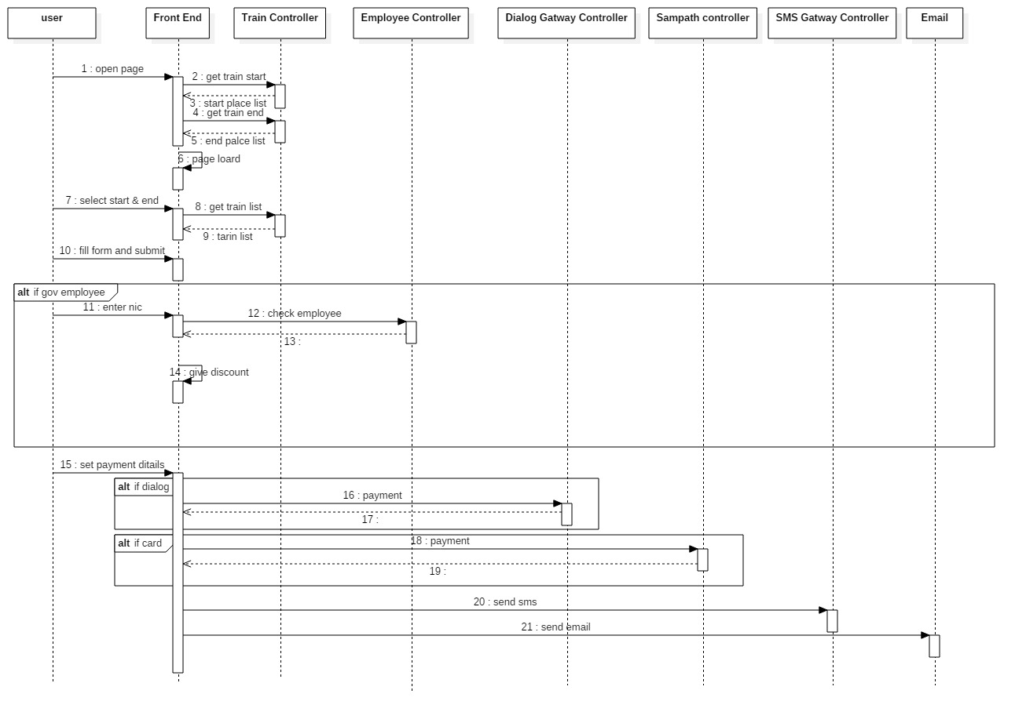
Fig 1:
ticket reservation by Ajex

Architecture

The backend is designed with SOA principles and Rest principles. All of the functionality is provided as a set of a API requests/responses. This allows us to modify the internal
mechanisms without changing the frontend too much. All of the functions are divided
into 6 categories:

- Train details gateway
- Gov Employee gateway
- Dialog payment gateway
- Sampath gateway
- SMS gateway
- Email

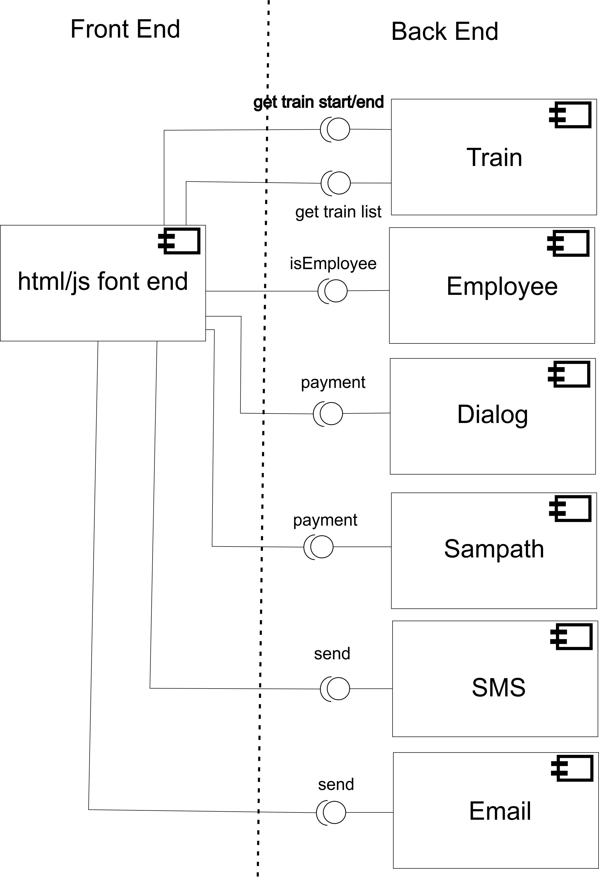
Fig 2:
High Level Design diagram of the overall system.

Workflow

Fig 3:
Work flow in system.

Appendix

Backend

Train details gateway

Application.properties

server.port=8183
spring.data.mongodb.host=localhost
spring.data.mongodb.port=27017
spring.data.mongodb.database=Train

Train domain

package com.train.details.train.domain;

import org.springframework.data.annotation.Id;
import org.springframework.data.mongodb.core.mapping.Document;

@Document("train")
public class Train {

@Id
private String id;
private String name;
private String starttime;
private String endtime;
private String startlocation;
private String endlocation;
private double firstclass;
private double secondclass;
private double thirdclass;
public String getId() {
return id;
}
public void setId(String id) {
this.id = id;
}
public String getName() {
return name;
}
public void setName(String name) {
this.name = name;
}
public String getStarttime() {
return starttime;
}
public void setStarttime(String starttime) {
this.starttime = starttime;
}
public String getEndtime() {
return endtime;
}
public void setEndtime(String endtime) {
this.endtime = endtime;
}
public String getStartlocation() {
return startlocation;
}
public void setStartlocation(String startlocation) {
this.startlocation = startlocation;
}
public String getEndlocation() {
return endlocation;
}
public void setEndlocation(String endlocation) {
this.endlocation = endlocation;
}
public double getFirstclass() {
return firstclass;
}
public void setFirstclass(double firstclass) {
this.firstclass = firstclass;
}
public double getSecondclass() {
return secondclass;
}
public void setSecondclass(double secondclass) {
this.secondclass = secondclass;
}
public double getThirdclass() {
return thirdclass;
}
public void setThirdclass(double thirdclass) {
this.thirdclass = thirdclass;
}

}

TrainController

package com.train.details.train.controller;

import java.util.ArrayList;
import java.util.List;
import java.util.UUID;

import org.springframework.beans.factory.annotation.Autowired;
import org.springframework.data.mongodb.core.aggregation.Aggregation;
import org.springframework.data.mongodb.core.aggregation.AggregationResults;
import org.springframework.data.mongodb.core.aggregation.TypedAggregation;
import org.springframework.http.HttpStatus;
import org.springframework.http.ResponseEntity;
import org.springframework.web.bind.annotation.CrossOrigin;
import org.springframework.web.bind.annotation.PathVariable;
import org.springframework.web.bind.annotation.RequestBody;
import org.springframework.web.bind.annotation.RequestMapping;
import org.springframework.web.bind.annotation.RequestMethod;
import org.springframework.web.bind.annotation.RestController;
import org.springframework.data.mongodb.core.MongoTemplate;
import static org.springframework.data.mongodb.core.aggregation.Aggregation.group;
import static org.springframework.data.mongodb.core.aggregation.Aggregation.newAggregation;
import static org.springframework.data.mongodb.core.aggregation.Aggregation.project;

import com.train.details.train.domain.Train;
import com.train.details.train.repository.TrainRepository;

@RestController
@RequestMapping(value = "/trains")
@CrossOrigin(origins = "*")
public class TrainController {

@Autowired
TrainRepository trainRepository;

@Autowired
MongoTemplate mongoTemplate;

@RequestMapping(value = "/details", method = RequestMethod.GET)
public List<Train> getTrain() {
return trainRepository.findAll();
}

@RequestMapping(value = "/details", method = RequestMethod.POST)
public ResponseEntity<?> addTrain(@RequestBody Train train) {

train.setId(UUID.randomUUID().toString());
trainRepository.save(train);
return new ResponseEntity<>(null, HttpStatus.CREATED);
}

@RequestMapping(value = "/details/{start}/{end}", method = RequestMethod.GET)
public List<Train> getTrainLocation(@PathVariable("start") String start, @PathVariable("end") String end) {
return trainRepository.findByStartlocationAndEndlocation(start, end);
}

@RequestMapping(value = "/details/{type}", method = RequestMethod.GET)
public List getTrainstart(@PathVariable("type") String type) {
Aggregation aggr = newAggregation(group(type));
AggregationResults<Train> re = mongoTemplate.aggregate(aggr, "train", Train.class);

List lo = new ArrayList();

for (Train var : re) {
lo.add(var.getId());
}
return lo;
}

@RequestMapping(value = "/{id}",method=RequestMethod.GET) public
Train getTrainLocation(@PathVariable("id") String id){

return trainRepository.findById(id).get(); }

}

TrainRepository

package com.train.details.train.repository;

import java.util.List;

import org.springframework.data.mongodb.repository.MongoRepository;
import org.springframework.data.mongodb.repository.Query;
import org.springframework.stereotype.Repository;

import com.train.details.train.domain.Train;

@Repository
public interface TrainRepository extends MongoRepository<Train ,String> {

public List<Train> findByStartlocationAndEndlocation(String start,String end);

/*
* @Query(value="SELECT * from train") public List<String> getTrainstart();
*/

}

Gov Employee gateway

Application.properties

server.port=8187
spring.data.mongodb.host=localhost
spring.data.mongodb.port=27017
spring.data.mongodb.database=Employee

Gov Employee domain

package gov.employee.check.domain;

import org.springframework.data.annotation.Id;
import org.springframework.data.mongodb.core.mapping.Document;

@Document("employee")
public class Employee {
@Id
private String id;
private String name;
private String nic;

public String getId() {
return id;
}
public void setId(String id) {
this.id = id;
}
public String getName() {
return name;
}
public void setName(String name) {
this.name = name;
}
public String getNic() {
return nic;
}
public void setNic(String nic) {
this.nic = nic;
}

}

Gov Employee Controller

package gov.employee.check.controller;

import java.util.List;
import java.util.UUID;

import org.springframework.beans.factory.annotation.Autowired;
import org.springframework.http.HttpStatus;
import org.springframework.http.ResponseEntity;
import org.springframework.web.bind.annotation.CrossOrigin;
import org.springframework.web.bind.annotation.PathVariable;
import org.springframework.web.bind.annotation.RequestBody;
import org.springframework.web.bind.annotation.RequestMapping;
import org.springframework.web.bind.annotation.RequestMethod;
import org.springframework.web.bind.annotation.RestController;

import gov.employee.check.domain.Employee;
import gov.employee.check.repository.Employeerepository;

@RestController
@RequestMapping(value = "/employee")
@CrossOrigin(origins = "*")
public class Employeecontroller {

@Autowired
Employeerepository employeerepository;

@RequestMapping(value = "/",method=RequestMethod.GET)
public List<Employee> showEmployee(){
return employeerepository.findAll();
}

@RequestMapping(value = "/add",method=RequestMethod.POST)
public ResponseEntity<?> addEmployee(@RequestBody Employee employee){
System.out.println("sachin");
employee.setId(UUID.randomUUID().toString());
employeerepository.save(employee);
return new ResponseEntity<>(null, HttpStatus.CREATED);
}

@RequestMapping(value = "/{nic}",method=RequestMethod.GET)
public Employee getnic(@PathVariable("nic") String nic ){
System.out.println(nic);
return employeerepository.findByNic(nic);
}

}

Gov Employee Repository

package gov.employee.check.repository;

import org.springframework.data.mongodb.repository.MongoRepository;

import gov.employee.check.domain.Employee;

public interface Employeerepository extends MongoRepository<Employee,String> {

public Employee findByNic(String nic);

}

Dialog payment gateway

Application.properties

server.port=8186

Dialog payment domain

package com.dialog.ezcash.domain;

public class Ezcash {
private String number;
private int pin ;
private double price;

public String getNumber() {
return number;
}
public void setNumber(String number) {
this.number = number;
}
public int getPin() {
return pin;
}
public void setPin(int pin) {
this.pin = pin;
}
public double getPrice() {
return price;
}
public void setPrice(double price) {
this.price = price;
}

public void print() {
System.out.println("number : "+this.number);
System.out.println("pin : "+this.pin);
System.out.println("price : "+this.price);
}
}

Dialog payment Controller

package com.dialog.ezcash.controller;

import org.springframework.http.HttpStatus;
import org.springframework.http.ResponseEntity;
import org.springframework.web.bind.annotation.CrossOrigin;
import org.springframework.web.bind.annotation.RequestBody;
import org.springframework.web.bind.annotation.RequestMapping;
import org.springframework.web.bind.annotation.RequestMethod;
import org.springframework.web.bind.annotation.RestController;

import com.dialog.ezcash.domain.Ezcash;

@RestController
@RequestMapping(value = "/epay")
@CrossOrigin(origins = "*")
public class Ezcashcontroller {

@RequestMapping(value = "/ezcach",method=RequestMethod.POST)
public ResponseEntity<?> makepayment(@RequestBody Ezcash pay){
pay.print();
String a="ok";
if("ok".equalsIgnoreCase(a)) {
return new ResponseEntity<>(null, HttpStatus.OK);
}

return new ResponseEntity<>(null, HttpStatus.FAILED_DEPENDENCY);

}

}

Sampath gateway

Application.properties

server.port=8185

Sampath domain

package com.sampath.payment.domain;

public class Payment {
private String number;
private String name;
private String exday;
private int cvv;
private double price;

public String getNumber() {
return number;
}
public void setNumber(String number) {
this.number = number;
}
public String getExday() {
return exday;
}
public void setExday(String exday) {
this.exday = exday;
}
public int getCvv() {
return cvv;
}
public void setCvv(int cvv) {
this.cvv = cvv;
}

public double getPrice() {
return price;
}
public void setPrice(double price) {
this.price = price;
}
public void print() {
System.out.println("number : "+this.number);
System.out.println("name : "+this.name);
System.out.println("exday : "+this.exday);
System.out.println("cvv : "+this.cvv);
System.out.println("price : "+this.price);
}

}

Sampath Controller

package com.sampath.payment.controller;

import org.springframework.http.HttpStatus;
import org.springframework.http.ResponseEntity;
import org.springframework.web.bind.annotation.CrossOrigin;
import org.springframework.web.bind.annotation.RequestBody;
import org.springframework.web.bind.annotation.RequestMapping;
import org.springframework.web.bind.annotation.RequestMethod;
import org.springframework.web.bind.annotation.RestController;

import com.sampath.payment.domain.Payment;

@RestController
@RequestMapping(value = "/sampath")
@CrossOrigin(origins = "*")
public class Paymentcontroller {
@RequestMapping(value = "/payment",method=RequestMethod.POST)
public ResponseEntity<?> makepayment(@RequestBody Payment pay){
pay.print();
String a="ok";
if("ok".equalsIgnoreCase(a)) {
return new ResponseEntity<>(null, HttpStatus.ACCEPTED);
}

return new ResponseEntity<>(null, HttpStatus.FAILED_DEPENDENCY);

}
}

SMS gateway

Application.properties

server.port=8184

SMS domain

package com.dialog.sms.sms.domain;

public class Sms {
private String no;
private String massage;
public String getNo() {
return no;
}
public void setNo(String no) {
this.no = no;
}
public String getMassage() {
return massage;
}
public void setMassage(String massage) {
this.massage = massage;
}

public void print() {
System.out.println("Phone no : "+this.no);
System.out.println("Message : "+this.massage);
}

}

SMS Controller

package com.dialog.sms.sms.controller;

import org.springframework.http.HttpStatus;
import org.springframework.http.ResponseEntity;
import org.springframework.web.bind.annotation.CrossOrigin;
import org.springframework.web.bind.annotation.RequestBody;
import org.springframework.web.bind.annotation.RequestMapping;
import org.springframework.web.bind.annotation.RequestMethod;
import org.springframework.web.bind.annotation.RestController;
import com.dialog.sms.sms.domain.Sms;

@RestController
@RequestMapping(value = "/dialog")
@CrossOrigin(origins = "*")
public class Smscontroller {

@RequestMapping(value = "/sms",method=RequestMethod.POST)
public ResponseEntity<?> sendSMS(@RequestBody Sms massage){
massage.print();
return new ResponseEntity<>(massage, HttpStatus.OK);
}

}

Email gateway

Application.properties

server.port=8188
spring.mail.host=smtp.gmail.com
spring.mail.port=587
spring.mail.username=lankanstwtravels@gmail.com
spring.mail.password=Stwtravel
spring.mail.properties.mail.smtp.auth=true
spring.mail.properties.mail.smtp.starttls.enable=true

Email domain

package com.mail.email.domain;

public class Email {
private String to;
private String sub;
private String body;

public String getTo() {
return to;
}
public void setTo(String to) {
this.to = to;
}
public String getSub() {
return sub;
}
public void setSub(String sub) {
this.sub = sub;
}
public String getBody() {
return body;
}
public void setBody(String body) {
this.body = body;
}

}

Email Controller

package com.mail.email.controller;

import javax.mail.MessagingException;
import javax.mail.internet.MimeMessage;

import org.springframework.beans.factory.annotation.Autowired;
import org.springframework.http.HttpStatus;
import org.springframework.http.ResponseEntity;
import org.springframework.mail.SimpleMailMessage;
import org.springframework.mail.javamail.JavaMailSender;
import org.springframework.mail.javamail.MimeMessageHelper;
import org.springframework.web.bind.annotation.CrossOrigin;
import org.springframework.web.bind.annotation.RequestBody;
import org.springframework.web.bind.annotation.RequestMapping;
import org.springframework.web.bind.annotation.RequestMethod;
import org.springframework.web.bind.annotation.RestController;

import com.mail.email.domain.Email;

@RestController
@RequestMapping(value = "/email")
@CrossOrigin(origins = "*")
public class Emailcontroller {

@Autowired
public JavaMailSender javaMailSender;

@RequestMapping(value = "/send",method=RequestMethod.POST)
public ResponseEntity<?> addEmployee(@RequestBody Email email) {
System.out.println("email come");
System.out.println(email.getTo());
System.out.println(email.getSub());
System.out.println(email.getBody());
try {
MimeMessage mime=javaMailSender.createMimeMessage();
MimeMessageHelper me= new MimeMessageHelper(mime,true);
me.setTo(email.getTo());
me.setSubject(email.getSub());
me.setText(email.getBody(),true);

javaMailSender.send(mime);
return new ResponseEntity<>(null, HttpStatus.OK);

} catch (Exception e) {
System.out.println(e);
}

return new ResponseEntity<>(null, HttpStatus.FORBIDDEN);

}
//https://myaccount.google.com/u/0/lesssecureapps
}

FrontEnd

<!DOCTYPE html>
<html lang="en">
<head>
<title>National Railway Booking</title>

<link rel="icon" type="image/png" href="images/icon.png"/>

<link rel="stylesheet" type="text/css" href="vendor/bootstrap/css/bootstrap.min.css">

<link rel="stylesheet" type="text/css" href="css/main.css">

<style type="text/css">
.a{
font-weight: 900;
color: #fff;
font-size: 26px;
}
</style>
</head>
<body onload="setStartAndEnd()">

<div class="bg-contact100" style="background-image: url('images/bg-01.jpg');">
<div class="container-contact100">
<div class="container">
<div align="center">
<img src="images/icon.png" width="10%" >
<h1 style="text-decoration: solid;font-size: -webkit-xxx-large;">National Railway Booking</h1>
</div>
<form style="padding-top: 40px">
<div class="form-row" >
<div class="form-group col-md-6 " id="divstart">

<select class="form-control" id="start" onchange="settrain()">
<option value="0">Start Location</option>
</select>
</div>
<div class="form-group col-md-6">

<select class="form-control" id="end" onchange="settrain()">
<option value="0">End Location</option>
</select>
</div>
</div>
<div class="form-group">
<select class="form-control" id="tr" onchange="setclassprice()">
<option value="0">Select Train</option>
</select>
</div>
<div class="form-group">

<select class="form-control" id="ti" onchange="setclassprice()">
<option value="0">Select Ticket</option>
</select>

</div>
<div class="form-group">

<input type="date" class="form-control" id="date">
</div>

<div class="form-group">

<input type="text" class="form-control" id="pno" >
</div>

<div class="form-group">

<input type="email" class="form-control" id="mail" >
</div>
<div class="form-row">

</div>
<div align="center">
<button type="button" class="btn btn-primary" onclick="submit2()" style="width: 100%">Submit</button>
</div>

</form>
</div>
</div>
</div>

<!--===============================================================================================-->
<script src="vendor/jquery/jquery-3.2.1.min.js"></script>
<!--===============================================================================================-->
<script src="vendor/bootstrap/js/popper.js"></script>
<script src="vendor/bootstrap/js/bootstrap.min.js"></script>

<script src="js/bootbox/bootbox.all.min.js"></script>

<script type="text/javascript">
var setrain;
function submit2() {
let st=document.getElementById("start").value;
let en=document.getElementById("end").value;
let id=document.getElementById("tr").value;
let ti=document.getElementById("ti").value;
let date=document.getElementById("date").value;
let pn=document.getElementById("pno").value;
let mail=document.getElementById("mail").value;
let nic=null;
let caname=null;
let ex=null;
let csv=null;
let cnum=null;

bootbox.confirm({

message: "is government employees",
buttons: {
cancel: {
label: '<i class="fa fa-times " ></i> No'
},
confirm: {
label: '<i class="fa fa-check "></i> yes'
}
},
callback: function (result) {
console.log('This was logged in the callback: ' + result);
if (result) {

bootbox.prompt("Enter Nic Number!", function(result){
if(result!=null && result!=''){

nic=result;
let ch=0;

$.ajax({
url: 'http://localhost:8187/employee/'+nic,
type: 'GET',
//contentType:'application/json',
//data: JSON.stringify(json3),
dataType: 'json',
success: function(response)
{

console.log(response);

ti=(ti/100)*95;

ch=1;

let la="<b>start : </b>"+st+"<br>"+"<b>End : </b>"+en+"<br> <b>date : </b>"+date+"<br><b>value : </b>"+ti+"<br>";

bootbox.prompt({
title: "Please select Payment method",
message: '',
inputType: 'radio',
inputOptions: [
{
text: 'Dialog',
value: '1',
},
{
text: 'Card',
value: '2',
}
],
callback: function (result) {
console.log(result);
let pno=null;
let pin=null;

if(result=='1'){
bootbox.prompt({
title: "Enter Phone no : ",
inputType: 'text',
callback: function (result) {
pno=result;
console.log(result);
bootbox.prompt({
title: "Enter pin no : ",
inputType: 'number',
callback: function (result) {
console.log(result);
pin=result;
var json = {number:pno,pin:pin,price:ti};
$.ajax({
url: 'http://localhost:8186/epay/ezcach',
type: 'POST',
contentType:'application/json',
data: JSON.stringify(json),

success: function(response)
{
console.log("epay done");
console.log(response);
var json2 = {no:pn,massage:'booking done'};

$.ajax({
url: 'http://localhost:8184/dialog/sms',
type: 'POST',
contentType:'application/json',
data: JSON.stringify(json2),
// dataType: 'json',
success: function(response)
{
console.log("sms done dialog em");
console.log(response);

var json3 = {to:mail,sub:'booking done dialog em',body:'<html><html><head></head><body>'+la+'</body></html>'};
console.log(json3);

$.ajax({
url: 'http://localhost:8188/email/send',
type: 'POST',
contentType:'application/json',
data: JSON.stringify(json3),
// dataType: 'json',
success: function(response)
{

console.log(response);

},
error: function(response) {
console.log(response);
}

});

},
error: function(response) {
console.log("sms fail");
console.log(response);
}

});

},
error: function(response) {
console.log("epay fail");
console.log(response);
}

});

}
});
}
});

}
else if(result=='2'){
bootbox.prompt({
title: "Enter card no : ",
inputType: 'text',
callback: function (result) {
cnum=result;
console.log(result);
bootbox.prompt({
title: "Enter csv no : ",
inputType: 'number',
callback: function (result) {
csv=result;
bootbox.prompt({
title: "Enter name in card : ",
inputType: 'text',
callback: function (result) {
caname=result;
bootbox.prompt({
title: "Enter exp date : ",
inputType: 'text',
callback: function (result) {
ex=result;
console.log(result);
pin=result;
var json = {number:cnum,name:caname,exday:ex,cvv:csv,price:ti};
console.log(json);
$.ajax({
url: 'http://localhost:8185/sampath/payment',
type: 'POST',
contentType:'application/json',
data: JSON.stringify(json),

success: function(response)
{
console.log("epay done");
console.log(response);
var json2 = {no:pn,massage:'booking done'};

$.ajax({
url: 'http://localhost:8184/dialog/sms',
type: 'POST',
contentType:'application/json',
data: JSON.stringify(json2),
// dataType: 'json',
success: function(response)
{
console.log("sms done");
console.log(response);

var json3 = {to:mail,sub:'booking done with card em',body:'<html><html><head></head><body>'+la+'</body></html>'};
console.log(json3);

$.ajax({
url: 'http://localhost:8188/email/send',
type: 'POST',
contentType:'application/json',
data: JSON.stringify(json3),
// dataType: 'json',
success: function(response)
{

console.log(response);

},
error: function(response) {
console.log(response);
}

});

},
error: function(response) {
console.log("sms fail");
console.log(response);
}

});

},
error: function(response) {
console.log("epay fail");
console.log(response);
}

});
}
});
}
});
}
});
}
});
//----
}
}
});

},
error: function(response) {
console.log(response);
bootbox.alert("NIC : "+nic+"number not in database try again");

}

});

//---------------------------------

//---------------------------------
}
});

}
else{
bootbox.prompt({
title: "Please select Payment method",
message: '',
inputType: 'radio',
inputOptions: [
{
text: 'Dialog',
value: '1',
},
{
text: 'Card',
value: '2',
}
],
callback: function (result) {
console.log(result);
let pno=null;
let pin=null;

if(result=='1'){
bootbox.prompt({
title: "Enter Phone no : ",
inputType: 'text',
callback: function (result) {
pno=result;
console.log(result);
bootbox.prompt({
title: "Enter pin no : ",
inputType: 'number',
callback: function (result) {
console.log(result);
pin=result;
var json = {number:pno,pin:pin,price:ti};
$.ajax({
url: 'http://localhost:8186/epay/ezcach',
type: 'POST',
contentType:'application/json',
data: JSON.stringify(json),

success: function(response)
{
console.log("epay done");
console.log(response);
var json2 = {no:pn,massage:'booking done'};

$.ajax({
url: 'http://localhost:8184/dialog/sms',
type: 'POST',
contentType:'application/json',
data: JSON.stringify(json2),
// dataType: 'json',
success: function(response)
{
console.log("sms done dialog non em");
console.log(response);

var json3 = {to:mail,sub:'booking done',body:'<html><html><head></head><body>'+la+'</body></html>'};
console.log(json3);

$.ajax({
url: 'http://localhost:8188/email/send',
type: 'POST',
contentType:'application/json',
data: JSON.stringify(json3),
// dataType: 'json',
success: function(response)
{

console.log(response);

},
error: function(response) {
console.log(response);
}

});

},
error: function(response) {
console.log("sms fail");
console.log(response);
}

});

},
error: function(response) {
console.log("epay fail");
console.log(response);
}

});

}
});
}
});

}
else if(result=='2'){
bootbox.prompt({
title: "Enter card no : ",
inputType: 'text',
callback: function (result) {
cnum=result;
console.log(result);
bootbox.prompt({
title: "Enter csv no : ",
inputType: 'number',
callback: function (result) {
csv=result;
bootbox.prompt({
title: "Enter name in card : ",
inputType: 'text',
callback: function (result) {
caname=result;
bootbox.prompt({
title: "Enter exp date : ",
inputType: 'text',
callback: function (result) {
ex=result;
console.log(result);
pin=result;
var json = {number:cnum,name:caname,exday:ex,cvv:csv,price:ti};
console.log(json);
$.ajax({
url: 'http://localhost:8185/sampath/payment',
type: 'POST',
contentType:'application/json',
data: JSON.stringify(json),

success: function(response)
{
console.log("epay done");
console.log(response);
var json2 = {no:pn,massage:'booking done'};

$.ajax({
url: 'http://localhost:8184/dialog/sms',
type: 'POST',
contentType:'application/json',
data: JSON.stringify(json2),
// dataType: 'json',
success: function(response)
{
console.log("sms done");
console.log(response);

var json3 = {to:mail,sub:'booking done with card non em',body:'<html><html><head></head><body>'+la+'</body></html>'};
console.log(json3);

$.ajax({
url: 'http://localhost:8188/email/send',
type: 'POST',
contentType:'application/json',
data: JSON.stringify(json3),
// dataType: 'json',
success: function(response)
{

console.log(response);

},
error: function(response) {
console.log(response);
}

});

},
error: function(response) {
console.log("sms fail");
console.log(response);
}

});

},
error: function(response) {
console.log("epay fail");
console.log(response);
}

});
}
});
}
});
}
});
}
});
//----
}
}
});

}
}
});

}

function setStartAndEnd() {
$.ajax({
url: 'http://localhost:8183/trains/details/startlocation',
type: 'GET',
// data: {billid:billid},
dataType: 'json',
success: function(response)
{

// console.log(response);
// console.log(response.length);
var select = document.getElementById("start");
for (var i = 0; i < response.length; i++) {
select.options[select.options.length] = new Option(response[i],response[i] );
}

},
error: function(response) {
console.log(response);
}

});
$.ajax({
url: 'http://localhost:8183/trains/details/endlocation',
type: 'GET',
// data: {billid:billid},
dataType: 'json',
success: function(response)
{

// console.log(response);
// console.log(response.length);
var select = document.getElementById("end");
for (var i = 0; i < response.length; i++) {
select.options[select.options.length] = new Option(response[i], response[i]);
}

},
error: function(response) {
console.log(response);
}

});
}

function settrain() {
let st=document.getElementById("start").value;
let en=document.getElementById("end").value;

if(st!=0 && en!=0){
$.ajax({
url: 'http://localhost:8183/trains/details/'+st+'/'+en,
type: 'GET',
// data: {billid:billid},
dataType: 'json',
success: function(response)
{

console.log(response);
// console.log(response.length);
var select = document.getElementById("tr");
for (var i = 0; i < response.length; i++) {
select.options[select.options.length] = new Option(response[i].name+' Start Time : '+response[i].starttime+' End Time : '+response[i].endtime, response[i].id);
}

},
error: function(response) {
console.log(response);
}

});
}

}

function setclassprice(){

let id=document.getElementById("tr").value;

$.ajax({
url: 'http://localhost:8183/trains/'+id,
type: 'GET',
// data: {billid:billid},
dataType: 'json',
success: function(response)
{

console.log(response);
setrain=response;
// console.log(response.length);
var select = document.getElementById("ti");

select.options[select.options.length] = new Option(' First class : '+response.firstclass, response.firstclass);
select.options[select.options.length] = new Option(' Second class : '+response.secondclass, response.secondclass);
select.options[select.options.length] = new Option(' third class : '+response.thirdclass, response.thirdclass);

},
error: function(response) {
console.log(response);
}

});
}
</script>

</body>
</html>

