# WD HTML5

1. What are the new tags added in HTML5?

* The following new tags in HTML5:

1. <article>
2. <aside>
3. <audio>
4. <canvas>
5. <datalist>
6. <details>
7. <figcaption>
8. <figure>
9. <footer>
10. <header>
11. <main>
12. <nav>
13. <progress>
14. <section>
15. <time>
16. How to embed audio and video in a webpage?

* Embed audio in HTML
* Syntax:

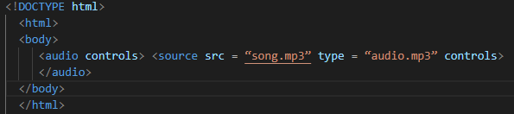

* Embed a video in HTML5
* Syntax:

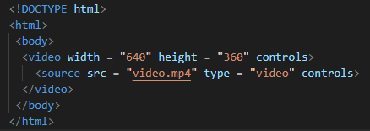

1. Semantic element in HTML5?

* The semantic element in HTML5:

1. <article>
2. <aside>
3. <details>
4. <figcaption>
5. <figure>
6. <footer>
7. <header>
8. <main>
9. <mark>
10. <nav>
11. <section>
12. <summary>
13. <time>
14. Canvas and SVG tags

* The HTML 5 <canvas> tag is used to draw graphics using scripting language like JavaScript.
* The <canvas> element is only a container for graphics, you must need a scripting language to draw the graphics.
* The <canvas> element allows for dynamic and scriptable rendering of 2D shapes and bitmap images.
* Syntax:



1. Svg in HTML5

* SVG stands for Scalable Vector Graphics.
* SVG defines vector-based graphics in XML format.
* SVG is used to define graphics for the Web page.
* It describes two-dimensional vector and mixed vector/raster graphics in XML.
* SVG images and their behaviors are defined in XML text files.
* SVG is mostly used for vector type diagrams like pie charts, 2-Dimensional graphs in an X, coordinate system etc.
* Syntax:

