# MODULE 06 – BOOTSTRAP

1. What are the advantages of Bootstrap?

* Bootstrap is a popular front-end framework for developing responsive and mobile-first websites. It offers several advantages that make it a preferred choice for many developers. Here are some of the key advantages of using Bootstrap:

1. Easy and Rapid Development: Bootstrap provides a comprehensive set of pre-designed CSS and JavaScript components, including navigation bars, buttons, forms, carousels, and more. These components can be easily integrated into your project, saving a significant amount of time and effort in coding and design.
2. Responsive Design: Bootstrap is built with a mobile-first approach, ensuring that your website or application will look and function well on various devices and screen sizes. It includes a responsive grid system that automatically adjusts the layout based on the device, making your site accessible and user-friendly across different platforms.
3. Consistent and Professional Design: Bootstrap offers a consistent and visually appealing design language. Its components follow predefined styles and guidelines, resulting in a polished and professional appearance. By using Bootstrap, you can achieve a cohesive design throughout your project without spending extensive time on custom design elements.
4. Browser Compatibility: Bootstrap is designed to be compatible with all modern web browsers, including Chrome, Firefox, Safari, and Internet Explorer. It takes care of cross-browser compatibility issues, ensuring that your website works consistently across different browsers without the need for extensive testing and troubleshooting.
5. Customizable and Extensible: While Bootstrap provides a default set of styles and components, it is highly customizable to meet specific project requirements. You can easily override default styles or create your own CSS classes to modify the appearance and behavior of Bootstrap components. Additionally, Bootstrap supports a wide range of third-party plugins and extensions, enabling you to extend its functionality as needed.
6. Documentation and Community Support: Bootstrap has extensive and well-documented resources, including official documentation, examples, and tutorials. The community around Bootstrap is also vast, with active forums, Stack Overflow threads, and developer communities. This wealth of support makes it easier to learn and troubleshoot any issues you may encounter while using Bootstrap.
7. Integration with JavaScript Libraries: Bootstrap includes a set of JavaScript plugins that enhance the functionality of your website. These plugins cover various aspects such as carousels, modals, dropdowns, tooltips, and more. By leveraging these built-in plugins, you can add interactive features to your site without the need for additional JavaScript coding.
8. What is a Bootstrap Container, and how does it work?

* Bootstrap, a container is a fundamental layout element that helps to organize and structure the content within a web page. It provides a responsive fixed-width container for the page content and plays a crucial role in achieving a consistent and responsive design across different devices.
* The container class in Bootstrap is represented by the CSS class container or container-fluid. Here's how each of them works:

1. Container: The container class creates a fixed-width container that adapts its width based on the screen size. It sets a specific maximum width for the content and centers it horizontally within the browser window. The width of the container remains fixed, but it adjusts its padding and margins to maintain a consistent layout on different screen sizes.
2. container-fluid: The container-fluid class creates a full-width container that spans the entire width of the viewport. It expands to fill the available horizontal space and adjusts its padding to maintain consistent spacing. Unlike the container class, the container-fluid class does not have a fixed maximum width, making it ideal for creating full-width or edge-to-edge designs.

* Example

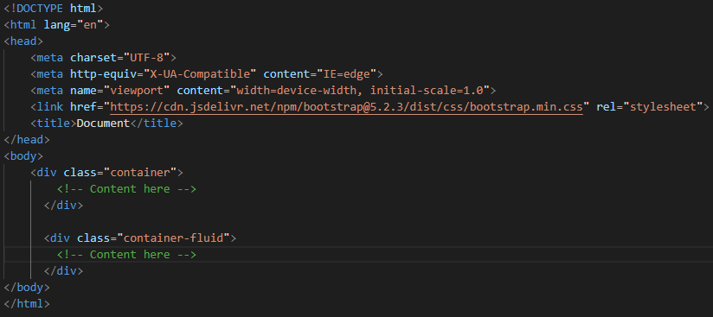

1. What are the default Bootstrap text settings?

* Bootstrap provides default text settings for headings, paragraphs, and other common text elements. The default font size for headings ranges from 1.5rem to 3.5rem, depending on the heading level. The default font size for paragraphs is 1rem, and the line height is 1.5. The default font family is "Helvetica Neue", Helvetica, Arial, sans-serif.

1. What do you know about the Bootstrap Grid System?

* The Bootstrap Grid System is a powerful and responsive layout system provided by the Bootstrap framework. It allows you to create a flexible grid-based structure for organizing and aligning content on a web page. The grid system consists of rows and columns, which provide a responsive and consistent layout across different devices and screen sizes.
* Here are some key features and concepts of the Bootstrap Grid System:

1. Rows: Rows are horizontal containers that hold columns. They are used to create horizontal groups of columns within a container. By default, rows have negative margins to compensate for the padding of columns and ensure proper alignment.
2. Columns: Columns are vertical containers within rows. They help distribute and organize content horizontally. Bootstrap uses a 12-column grid system, meaning that a row can be divided into up to 12 equal-width columns. You can specify the number of columns a particular element should occupy by applying predefined column classes such as col-, col-sm-, col-md-, col-lg-, or col-xl-, depending on the desired screen size.
3. Grid Classes: Bootstrap provides a set of CSS classes to define the width and behavior of columns at different breakpoints (screen sizes). The column classes are prefixed with col- for all screen sizes and can be further customized by appending a breakpoint suffix such as -sm-, -md-, -lg-, or -xl-. For example, col-sm-6 means the column will take up 6 out of 12 columns on small screens and above.
4. Responsive Behavior: The Bootstrap Grid System is responsive by default. It automatically adjusts the layout based on the screen size and ensures that content adapts to different devices. By defining different column classes for different breakpoints, you can create responsive designs that rearrange or stack content as the screen size changes.
5. Nesting: You can nest rows and columns within each other to create more complex and flexible layouts. This allows you to create multi-column sections within columns or create different layouts for different sections of your web page.
6. Offset and Ordering: Bootstrap provides additional classes to offset columns and change their ordering. The offset classes (offset-, offset-sm-, etc.) push columns to the right by a specified number of columns. The ordering classes (order-, order-sm-, etc.) control the visual order of columns.
7. What is the difference between Bootstrap 4 and Bootstrap 5

|  |  |  |
| --- | --- | --- |
| Basis of | BOOTSTRAP 4 | BOOTSTRAP 5 |
| Grid System | It has 5 tier (xs, sm, md, lg, xl). | It has 6 tier (xs, sm, md, lg, xl, xxl). |
| Color | It has limited colors. | Extra colors added with the looks, A card improved color palette. there are various shades available to choose. |
| Jquery | It has jquery and all related plugins. | Jquery is removed and switched to vanilla JS with some working plugins |
| Internet Explorer | Bootstrap 4 supports both IE 10 and 11. | Bootstrap 5 doesn’t support IE 10 and 11. |
| Form elements | Radio buttons, checkboxes have different look in different OS and browsers. The form uses whatever default browsers provide. | The look of form elements will not change, on different OS or browser. The forms can be customized and form controls can be added, they would not depend on browser. |
| Utilities API | We cannot modify utilities in bootstrap 4 | Bootstrap 5 gave freedom to modify and also create our own utility |
| Gutter | We use .glutter with fontsize in px | We use .g* with fontsize in rem |
| Vertical Classes | Columns can be positioned relative | Columns cannot be positioned relative |
| Bootstrap Icons | Bootstrap 4 doesn’t have its own SVG icons, we have to use font-awesome for icons. | Bootstrap 5 have its own SVG icons |
| Jumbotron | It supports. | It doesn’t support jumbotron. |
| Card deck | The card deck is used to create a set of cards with equal width and height. | Card deck class in removed in bootstrap |
| Navbar | We have inline-block property and we will get white dropdown as default for dropdown-menu-dark class. | Inline-block property is removed and we will get black dropdown as default for dropdown-menu-dark class. |
| Static Site Generator | Bootstrap 4 uses Jekyll software. | Bootstrap 5 uses Hugo software as it is fast static site generator. |
| flexbox grid | this makes easier to implement vertical designs, and the columns and rows can easily be implemented. the classes justify-center-content can directly be used to align according to the requirement. | advanced grid system is made available , also columns don’t have relative positions. |

1. What is a Button Group, and what is the class for a basic Button Group?

* A Button Group is a component in Bootstrap that allows you to group a set of buttons.
* Button groups allow multiple buttons to be stacked together on a single line. This is useful when you want to place items like alignment buttons together. You can add on optional JavaScript radio and checkbox style behavior with Bootstrap Button Plugin.
* Basic Button Group
* The following example use of class .btn-group
* In Bootstrap, the class used to create a basic button group is btn-group. This class is applied to a container element that wraps the individual buttons within the group. Here's an example of how to create a basic button group in Bootstrap:
* In the above example, the btn-group class is added to the <div> element, which acts as the container for the button group. The individual buttons (<button>) within the group can have their own styling classes, such as btn btn-primary in this case. You can apply different button styles (e.g., primary, secondary, success, etc.) to the buttons as needed.
* Adding Styles on Buttons: list of a style class in Bootstraps.
* .btn-default
* .btn-primary
* .btn-success
* .btn-info
* .btn-warning
* .btn-danger,
* Example:

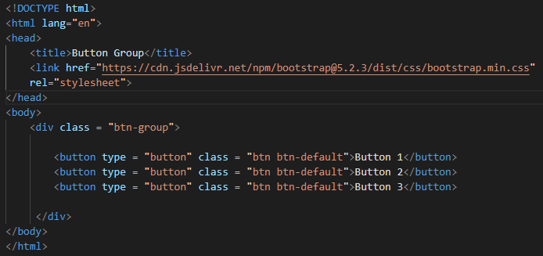

1. How can you use Bootstrap to make thumbnails?

* Bootstrap helps web developers to create thumbnails that are used to show linked images in grids with the pre-defined classes which help to reduce codes length. Thumbnails are created to provide a quick preview of images with small images.
* Thumbnail Image: A thumbnail is a small image that represents a larger image. Bootstrap has an easy way to do this with thumbnails. Bootstrap’s .thumbnail class is used to show linked images in grids (grid system), a thumbnail is created using class .thumbnail within the element <a>.
* A lot of sites need a way to lay out images, videos, text, etc, in a grid, and Bootstrap has an easy way to do this with thumbnails.
* Add an <a> tag with the class of .thumbnail around an image.
* This adds four pixels of padding and a gray border.
* On hover, an animated glow outlines the image.
* A thumbnail is a small image that represents a larger image, and is often recognized with a border around it:
* Example:

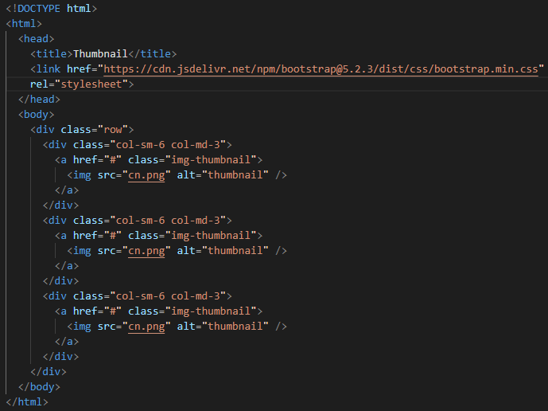

1. In Bootstrap 4, what is flexbox?

* The Flexible Box Layout Module, makes it easier to design flexible responsive layout structure without using float or positioning.
* Flexbox refers to the CSS Flexbox layout module that is utilized for creating flexible and responsive layouts.
* Flexbox is a powerful CSS feature that allows you to build dynamic and adaptive designs by distributing space, aligning content, and controlling the behavior of elements within a container.
* Flexbox introduces a new layout model that simplifies the process of creating complex and responsive layouts.
* It provides a flexible way to organize elements within a container, even when their sizes are unknown or dynamic. By utilizing flex containers and flex items, you can achieve vertical and horizontal alignment, control the order of elements, and distribute available space among the items.

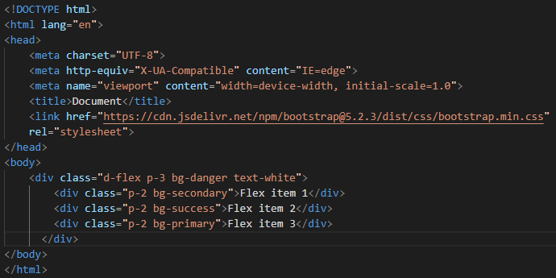

1. How can one create an alert in Bootstrap?

* Bootstrap, you can create alert messages to display important information, notifications, warnings, or error messages to the user. Bootstrap provides a predefined class called alert along with several contextual classes to style and customize the appearance of the alerts.
* Here's an example of how to create a basic alert in Bootstrap:
* Example:

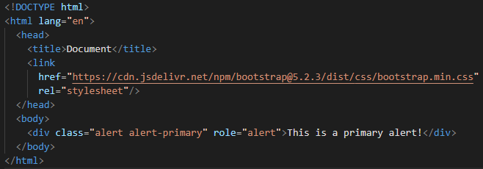

* Bootstrap provides several contextual classes that you can use to change the color and style of the alert. These classes include:
* alert-primary
* alert-secondary
* alert-success
* alert-danger
* alert-warning
* alert-info
* alert-light
* alert-dark

1. What is a bootstrap card and how would you create one?

