|  |  |
| --- | --- |
| https://lh6.googleusercontent.com/ENp5iVIZzIHv2b4n4mkS4vHt4UkEBlWYmz738CY-LLW4hqPglKHQ6jUh7UR0d4Ymmrr709Maa1nSxWlKGCsAkajArO1QhFOMQzxwHhEhk0zqlMRi4_H7oj2RIxwzkiz_qKiY_Giy | **Work Integrated Learning Programmes Division**  **M.Tech (Data Science and Engineering)** |

**Data Visualization & Interpretation   
(DSECL ZG555)**

**First Semester, 2021-22**

**Assignment 1 – PS4 - [PUBLIC GRIEVANCE ANALYSIS] - [Weightage 12%]**

1. **Problem Statement**

The Department of Administrative Reforms and Public Grievances (DARPG) received many (related to Central Government) grievances in the period from 2016-2019 across various Ministries/Departments through Centralized Public Grievance Redress and Monitoring System (CPGRAMS). Key objectives of this Department are to issue policy guidelines, monitor public grievances and improve public service delivery.

The Dataset below Contains Monthly Department-wise public grievance receipts and disposals through CPGRAMS.

Released Under: [National Data Sharing and Accessibility Policy (NDSAP)](https://data.gov.in/sites/default/files/NDSAP.pdf)

Contributor: [Ministry of Personnel, Public Grievances and Pensions](https://data.gov.in/ministrydepartment/ministry-personnel-public-grievances-and-pensions) [Department of Administrative Reforms and Public Grievances (DARPG)](https://data.gov.in/ministrydepartment/department-administrative-reforms-and-public-grievances-darpg)

[Data Set](https://data.gov.in/catalog/monthly-department-wise-public-grievance-receipts-and-disposals?filters%5Bfield_catalog_reference%5D=6690037&format=json&offset=0&limit=6&sort%5Bcreated%5D=desc)



You have been consulted to present these results to the **Ministry of Public grievances and pensions**. With the given context, you need to create a dashboard using TABLEAU. (Use the concepts learned in the class).

**The objectives include**

**Demonstrate the VISUALISATION CONTEXT**

1. **KNOW YOUR AUDIENCE(First question is answered for you)**
2. List the primary groups or individuals to whom you’ll be communicating.

**Ministry of Public grievances and pensions**

1. If you had to narrow that to a single person, who would that be?

**Govt of Uttar Pradesh has highest number of pending cases by volume and they were able to resolve 12.5% of cases whereas in year 2016 they could resolve on 6.9% of cases**

1. What does your audience care about?

**The audience is concerned with addressing public grievances and pension schemes with the right people. Identifying key issues, such as calculating and comparing the data of total receipts and total disposals to forecast the result, which is a summary of public grievances across departments and ways to improve public service delivery. The top ten underperformers who need to improve their grievance resolution rate, as well as the year-over-year trend of whether organisations are improving their resolution rate or not, must also be known. The audience should also be aware of whether public trust is increasing or decreasing as the number of grievances increases over the course of the year.**

1. What action does your audience need to take?

**The audience must concentrate on**

**i. People who had a successful outcome in the Grievance Resolution when compared to previous policies.**

**ii. The audience must monitor the resolution of public grievances in accordance with new policy guidelines.**

**iii. People over the age of 60 are receiving decisions about their pension.**

**iv. Provide proper Policy guidelines**

1. What is at stake? What is the benefit if the audience acts in the way you want them to? What are the risks if they don’t?

**The reputation of department, its credibility is on stake every time.**

**Engaging an audience successfully increases participation, improves learning, and increases satisfaction. Audiences who are engaged share their experiences on feedback forum. They become brand ambassadors, spreading the word about your services and policies and generating referrals and interest in future events.**

**If it is not possible to engage the audience, departments tend to fall quickly. The department will not gain a thorough understanding of its services. Because the audience is not fully engaged, they will be unable to provide feedback or suggestions for improvement.**

**As a result, the department will be in an ideal state of non-improvement, and the department's reputation will gradually deteriorate as a result.**

## WHAT?

* What is that you are trying to communicate? What questions are you trying to answer/display in your visualizations? Write these as specific questions. You need to come up with 3 questions at least, each of which will be answered using one Viz.

Three Questions :

Q1. **What are the top ten departments with highest number of pending cases?**

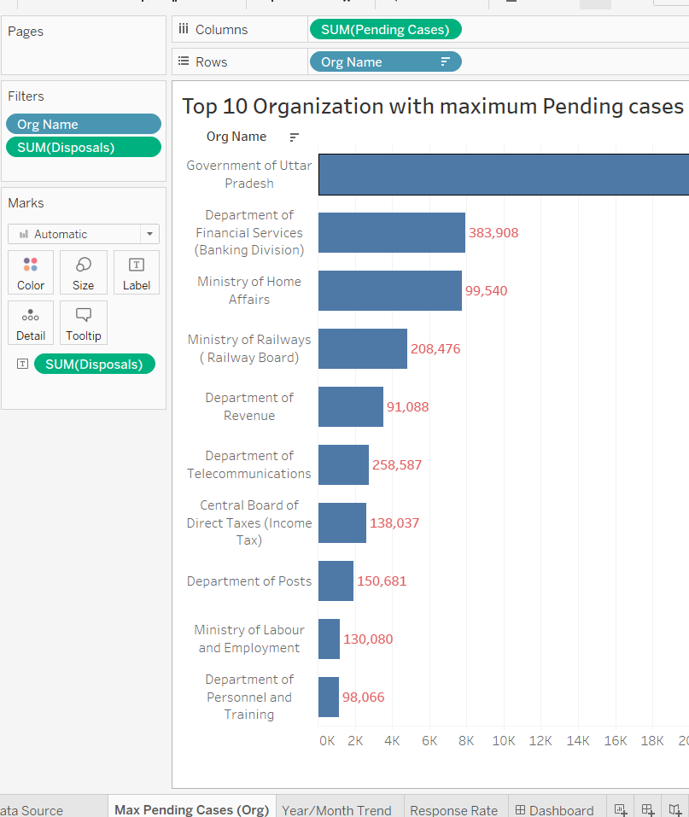

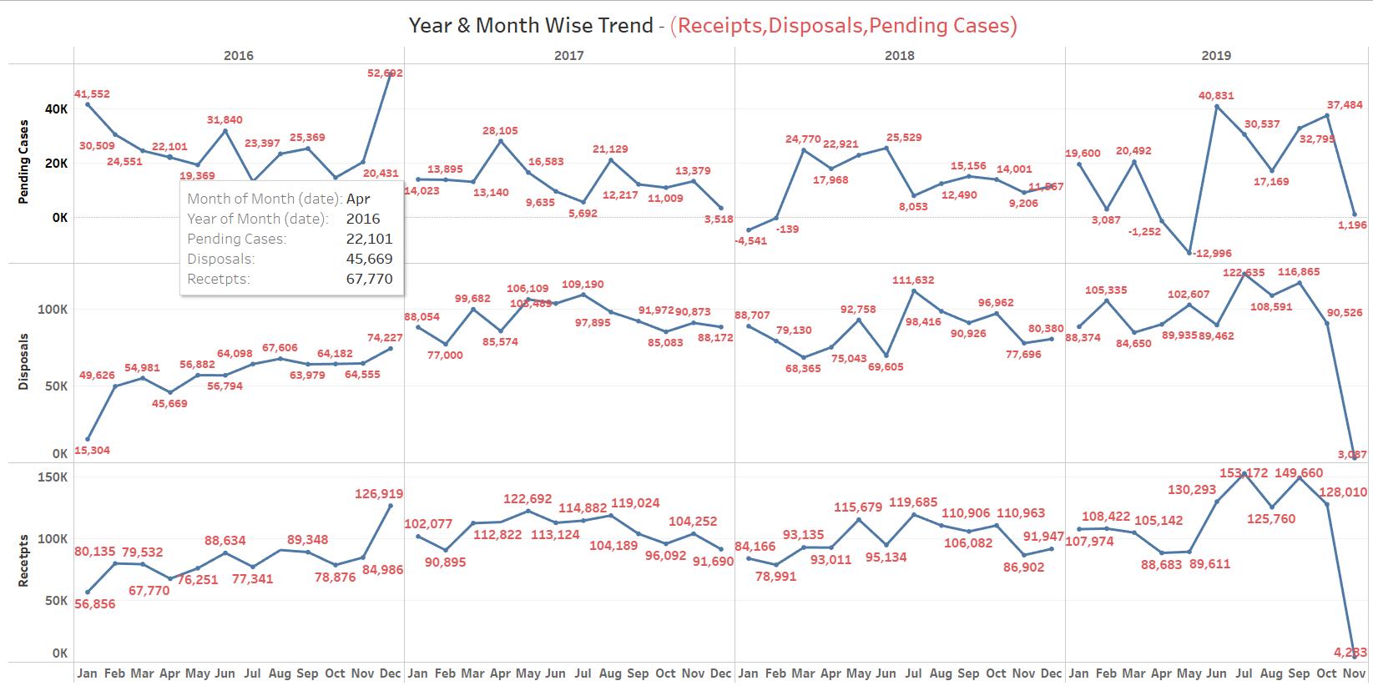 Q2. **What is the year-on-year and month-on-month trend for receipts, disposals and pending cases.**

Q3. **What is Rate of Resolution of cases year-on-year and month-on-month basis(Reponse rate = Disposal / Reciepts ) ?**

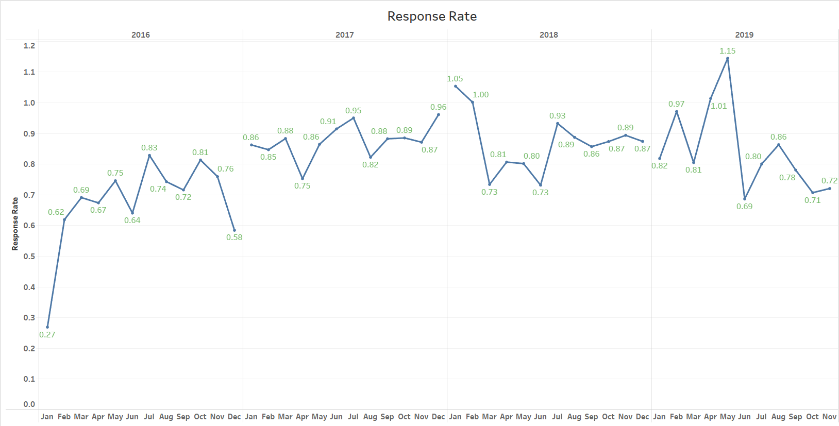

* **Data preparation needed to answer the specific queries must be done. : We have created three separate columns named Pending Cases, Response Rate and Date(01/MM/YYYY).**

1. **Present the BIG IDEA**.

* It should:

1. Express your point of view

Depicting key issues, such as calculating and comparing data on the sum of receipts and sum of disposals to forecast the result, which is a summary of public grievances across departments and ways to improve public service delivery. They also need to know the top ten underperformers who need to improve their grievance resolution rate, as well as the year-on-year trend of whether organisations are improving their resolution rate or not. The audience should also be aware of whether or not public trust is growing in light of the year-over-year increase in the number of grievances.

1. Explain what's at stake, and

The stakes are high because it improves transparency and accountability in central government systems. This can be used to significantly reduce corruption. It is also a measure of public trust in the public grievance redressal system and the efficacy of government organisations.

1. consist of a complete (and single!) sentence.

The Uttar Pradesh government has the most pending cases # **62.41K**

### HOW? (yet to be done)

* 1. Chart 1: What type of viz did you create? Why did you select the viz that you did? :

**We chose the Bar Graph for Max Pending Cases (Org) to identify the names of organisations that have the majority of cases in the pending state.**

* 1. Chart 2: What type of viz did you create? Why did you select the viz that you did?

**We used Skew Line Charts for Year/Month Trend to analyse the trend of Receipts, Disposals, and Pending Cases.**

* 1. Chart 3: What type of viz did you create? Why did you select the viz that you did?

**We plotted Discrete Line charts for Response Rate(Disposals / Receipts) to get better understanding of resolution of cases year-on-year / month-on-month basis**

* 1. For each of the Visualisation, identify at least 3 Gestalt principles employed.

**Graph 1 : Similarity , Symmetry & Order, Proximity**

**Graph 2 : Proximity, Continuation, Symmetry & Order**

**Graph 3 : Proximity, Continuation, Symmetry & Order**

* 1. For each of the Visualisation, mention how you strategically used pre-attentive attributes to draw the audience's attention.

Graph 1 : Color, Length

Graph 2 : Color, Length

Graph 3 : Color, Length

1. **Create your dashboard :** We have created dashboard in .twbx file extension.

## Deliverables

Zipped file containing

1. The word doc with answers to question 1 through 4 above.
2. The tableau workbook(.twbx) with 3 Sheets(Each sheet should have 1 visual) and 1 Dashboard comprising all three visuals.
3. The source file after preprocessing(if any).

The file name should be the respective group name.

## Deadline

* The strict deadline for submission of the assignment is **<December 26, 2021> EoD.**
* Late submissions won’t be evaluated.

## How to submit

* This is a group assignment.
* Each group consists of up to 3 members. All members of the group will work on the same problem statement.
* Each sub group should zip the deliverables and upload in CANVAS in respective locations under ASSIGNMENT Tab.
* Assignment submitted via means other than through CANVAS will not be graded.

## Evaluation

|  |  |  |
| --- | --- | --- |
| **Sl. No** | **Criteria** | **Description** |
| 1 | Know your audience.  (10%) | * Getting to know our audience and understanding their needs and what drives them is an important early part of the process for successfully communicating with data. |
| 2. | WHAT?  Effective Formulation of Contextual Questions  (25%) | * Identify what needs to be communicated very clearly and frame the questions accordingly justifying the context. |
| 3 | BIG IDEA (10%) | * The Big Idea can help us get clear and succinct on the main message we want to get across to our audience |
| 4 | Choice of appropriate visuals  (25%) | * Identify the appropriate visuals for communicating the message |
| 5 | No clutter in the visuals  (10%) | * The visuals presented should not have any unwanted elements that reduces the understanding of data |
| 6 | Audience attention  (10%) | * The visuals presented should have the right kind of visual cues that helps the audience to focus the attention wherever required. |
| 7 | Dashboard in Tableau  (10%) | * Use Principles of Effective Dashboard Design to come up with an interesting Dashboard |

**ALL GROUP MEMBERS WILL BE CREDITED THE SAME MARKS. ITS INDIVIDUAL’S RESPONSIBILITY TO ENSURE HIS/HER PARTICIPATION AS WELL AS TEAM’S RESPONSIBILITY TO ENSURE EVERYONE’S PARTICIPATION.**