

Assessment 3: HTML website design (4478/8936)
Type: Website
Weighting: 30%
Method: Independent
Length: 17 design specifications
Submission type: Zip compressed file including: Hypertext Markup Language (HTML5) code, CSS file, images and Word file

Report Page
Student ID: U3334431

Wireframe Designs:
- Wireframe Inspiration for Main and References pages
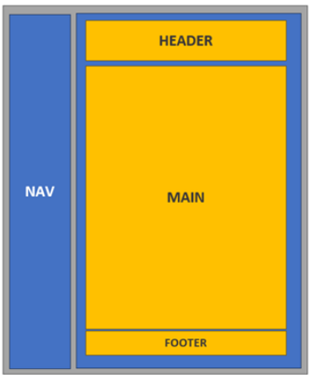

- Wireframe Inspiration For Speed, Vintage, References, MetaPage pages
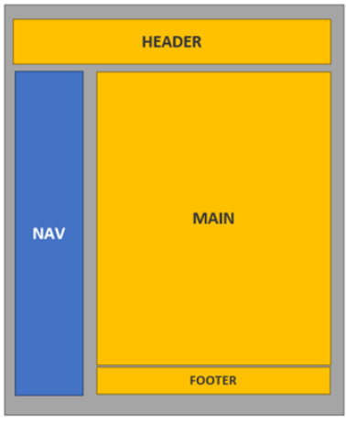

- Wireframe Contact Page
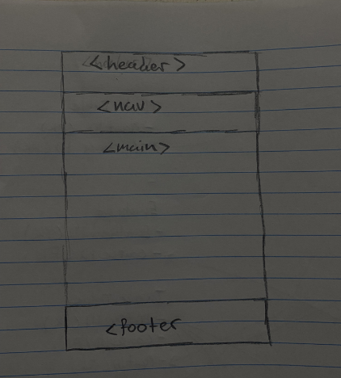
Wireframe Reference Page
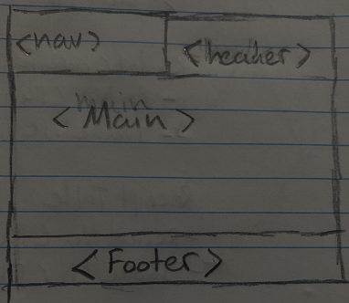

Wireframe for Reference Page
Webpage sitemap:

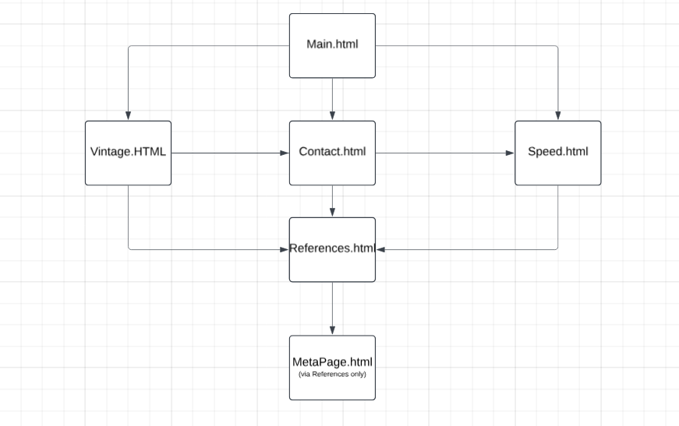

Reference list
ALI, A 2026, 1967 Impala Engine Options & Reliability: 250, 283, 327, 396 & 427 V8 Specs Explained., Vintagecrs.in, Blogger, viewed 22 April 2026, <https://www.vintagecrs.in/2026/03/1967-impala-engine-options-reliability.html?m>.
alibaba 2026, Wholesale 17x11 Rims Custom Forged Alloy Wheels | Alibaba.com, Alibaba.com, viewed 22 April 2026, <https://www.alibaba.com/showroom/17x11-rims.html>.
Bell, L 2023, The Challenger SRT Demon 170 Was Born From Spite, Road & Track, viewed 22 April 2026, <https://www.roadandtrack.com/news/a43411339/dodge-challenger-srt-demon-170-was-born-from-spite/>.
Bentley Motors 2025, Bentley is proud to announce that the new Continental GT Speed First Edition has been awarded Best Interior in the 2025 Robb Report ‘Best of the Best’ Awards. This honor marks another milestone in Bentley’s long-standing commitment to excellence in design, materials, and craftsmanship., Bentleymedia.com, Bentley Motors, viewed 22 April 2026, <https://www.bentleymedia.com/en/newsitem/1710>.
Bring Your Own Laptop 2020, Free Course: Beginner Web Design using HTML5, CSS3 & Visual Studio Code, YouTube, viewed 24 June 2020, <https://www.youtube.com/watch?v=C5QFHp1oAws>.
Dodge Garage 2026, 2023 Dodge Challenger SRT Demon 170, DodgeGarage.
Dorian, D 2021, 2022 Bentley Continental GT Review, Pricing, and Specs, Car and Driver.
GeeksforGeeks 2021, What is usually included in the header of an HTML document ?, GeeksforGeeks, viewed 27 April 2026, <https://www.geeksforgeeks.org/html/what-is-usually-included-in-the-header-of-an-html-document/>.
Gordon, K 2021, How to Draw a Wireframe (Even if You Can’t Draw), Nielsen Norman Group.
McAleer, B 2011, Cars & TV – ‘Supernatural’, Automotive Views, viewed 27 April 2026, <https://automotiveviews.com/2011/10/25/cars-tv-supernatural/>.
Mozilla Foundation 2025, : The Superscript element - HTML | MDN, Mozilla.org, viewed 22 April 2026, <https://developer.mozilla.org/en-US/docs/Web/HTML/Reference/Elements/sup>.
Popular Mechanics 2022, These Are the 40 Most Famous Movie Cars of All Time, Popular Mechanics.
Specialty Equipment Market Association 2023, Dodge Unveils 1,025hp 2023 Challenger SRT Demon 170, Specialty Equipment Market Association (SEMA), viewed 22 April 2026, <https://www.sema.org/news-media/enews/2023/12/dodge-unveils-1025hp-2023-challenger-srt-demon-170>.
The Impala 2011, Supernatural Wiki.
Top Gear 2025, Continental GT Coupe (2024), Top Gear.
TopGear 2019, Dodge Demon vs Lamborghini Aventador | Top Gear: Series 25, YouTube, viewed 29 January 2020, <https://www.youtube.com/watch?v=JhdRv3KNHXA>.
View Photos of the 2023 Dodge Challenger SRT Demon 170 2023, Car and Driver, viewed 27 April 2026, <https://www.caranddriver.com/photos/g43352673/2023-dodge-challenger-srt-demon-170-gallery/>.
W3Schools 2024, HTML Tutorial, W3schools.com.
Zal, P 2019, 1967 full-size_chevrolet_7gen performance 0-60, Quarter Mile, Top Speed, Mileage (cars offered since September 1966 for North America U.S.), www.automobile-catalog.com, viewed 22 April 2026, <https://www.automobile-catalog.com/performance/1967/399440/chevrolet_impala_sport_coupe_327_v-8_turbo-fire_275-hp_powerglide.html?>.

