Mini-Project Report

Design and Implementation of a 2-Bit Binary Ripple Carry Adder
Using Discrete Transistor Logic

Department of Electronics and Communication Engineering (ECE)

Sachin Nagaraj Mevundi – 1RF25EC054

Date:22 May 2026
1. Introduction
The objective of this mini-project is to design and physically construct a 2-bit binary ripple carry adder from scratch, utilizing discrete NPN Bipolar Junction Transistors (BJTs) rather than pre-packaged integrated circuits (ICs). This hardware is designed universally and strictly applies foundational semiconductor logic.
An adder is a fundamental digital logic circuit that performs the arithmetic addition of binary numbers. In modern computing, these circuits form the foundational building blocks of the Arithmetic Logic Unit (ALU) within processors.
This project involves adding two 2-bit binary numbers: Operand A (A1A0) and Operand B (B1B0). To achieve this, the circuit requires two distinct stages:
- 1. A Half Adder or Full Adder for the Least Significant Bit (LSB): Computes A0 + B0.
- 2. A Full Adder for the Most Significant Bit (MSB): Computes A1 + B1, while also accounting for any "carry" generated by the LSB stage.
By designing this entirely from discrete BJT components, this project demonstrates a low-level understanding of semiconductor physics, boolean algebra, and digital logic topologies, bridging the gap between analog voltage manipulation and digital computation.

2. Working Principle and Theoretical Context

2.1 The "Ripple" Carry Architecture
To add multi-bit numbers, individual full adders are cascaded in series. The architecture is termed a "ripple carry" adder because the carry bit ripples from the LSB stage up to the MSB stage.
• The Cout of the 1st bit (LSB) becomes the Cin of the 2nd bit (MSB).
• Propagation Delay: The MSB stage cannot compute its final Sum and Cout until it receives the Cin from the LSB stage. In discrete transistor logic, this introduces a slight, measurable propagation delay as the voltage cascades through the transistor network.
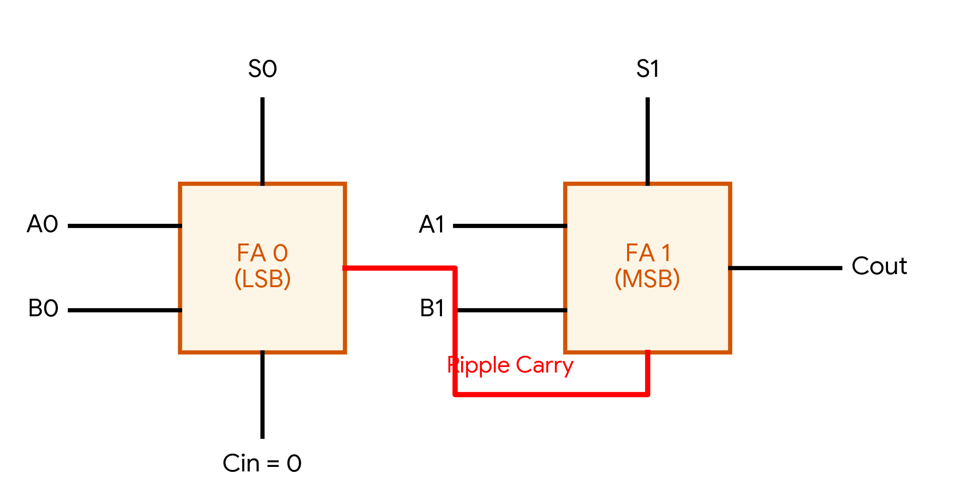

3. Circuit Architecture & Signal Integrity
3.1 Logical Block Diagrams
Before constructing the discrete transistor logic, the system's architecture is defined using standard logical block diagrams. The foundational component is the Half Adder, which is then cascaded with an OR gate to form the Full Adder structure.
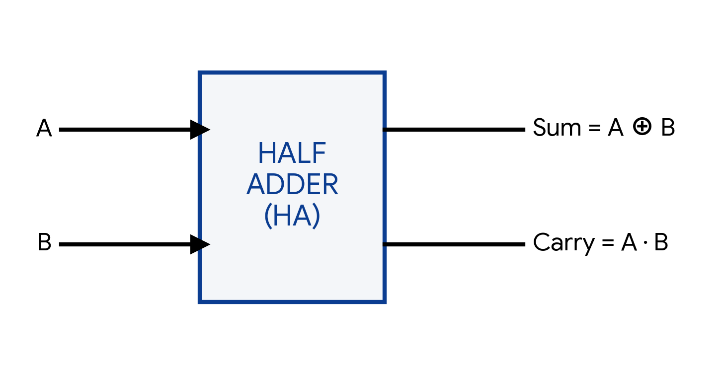
Figure 3.1.1: Half Adder Block Diagram
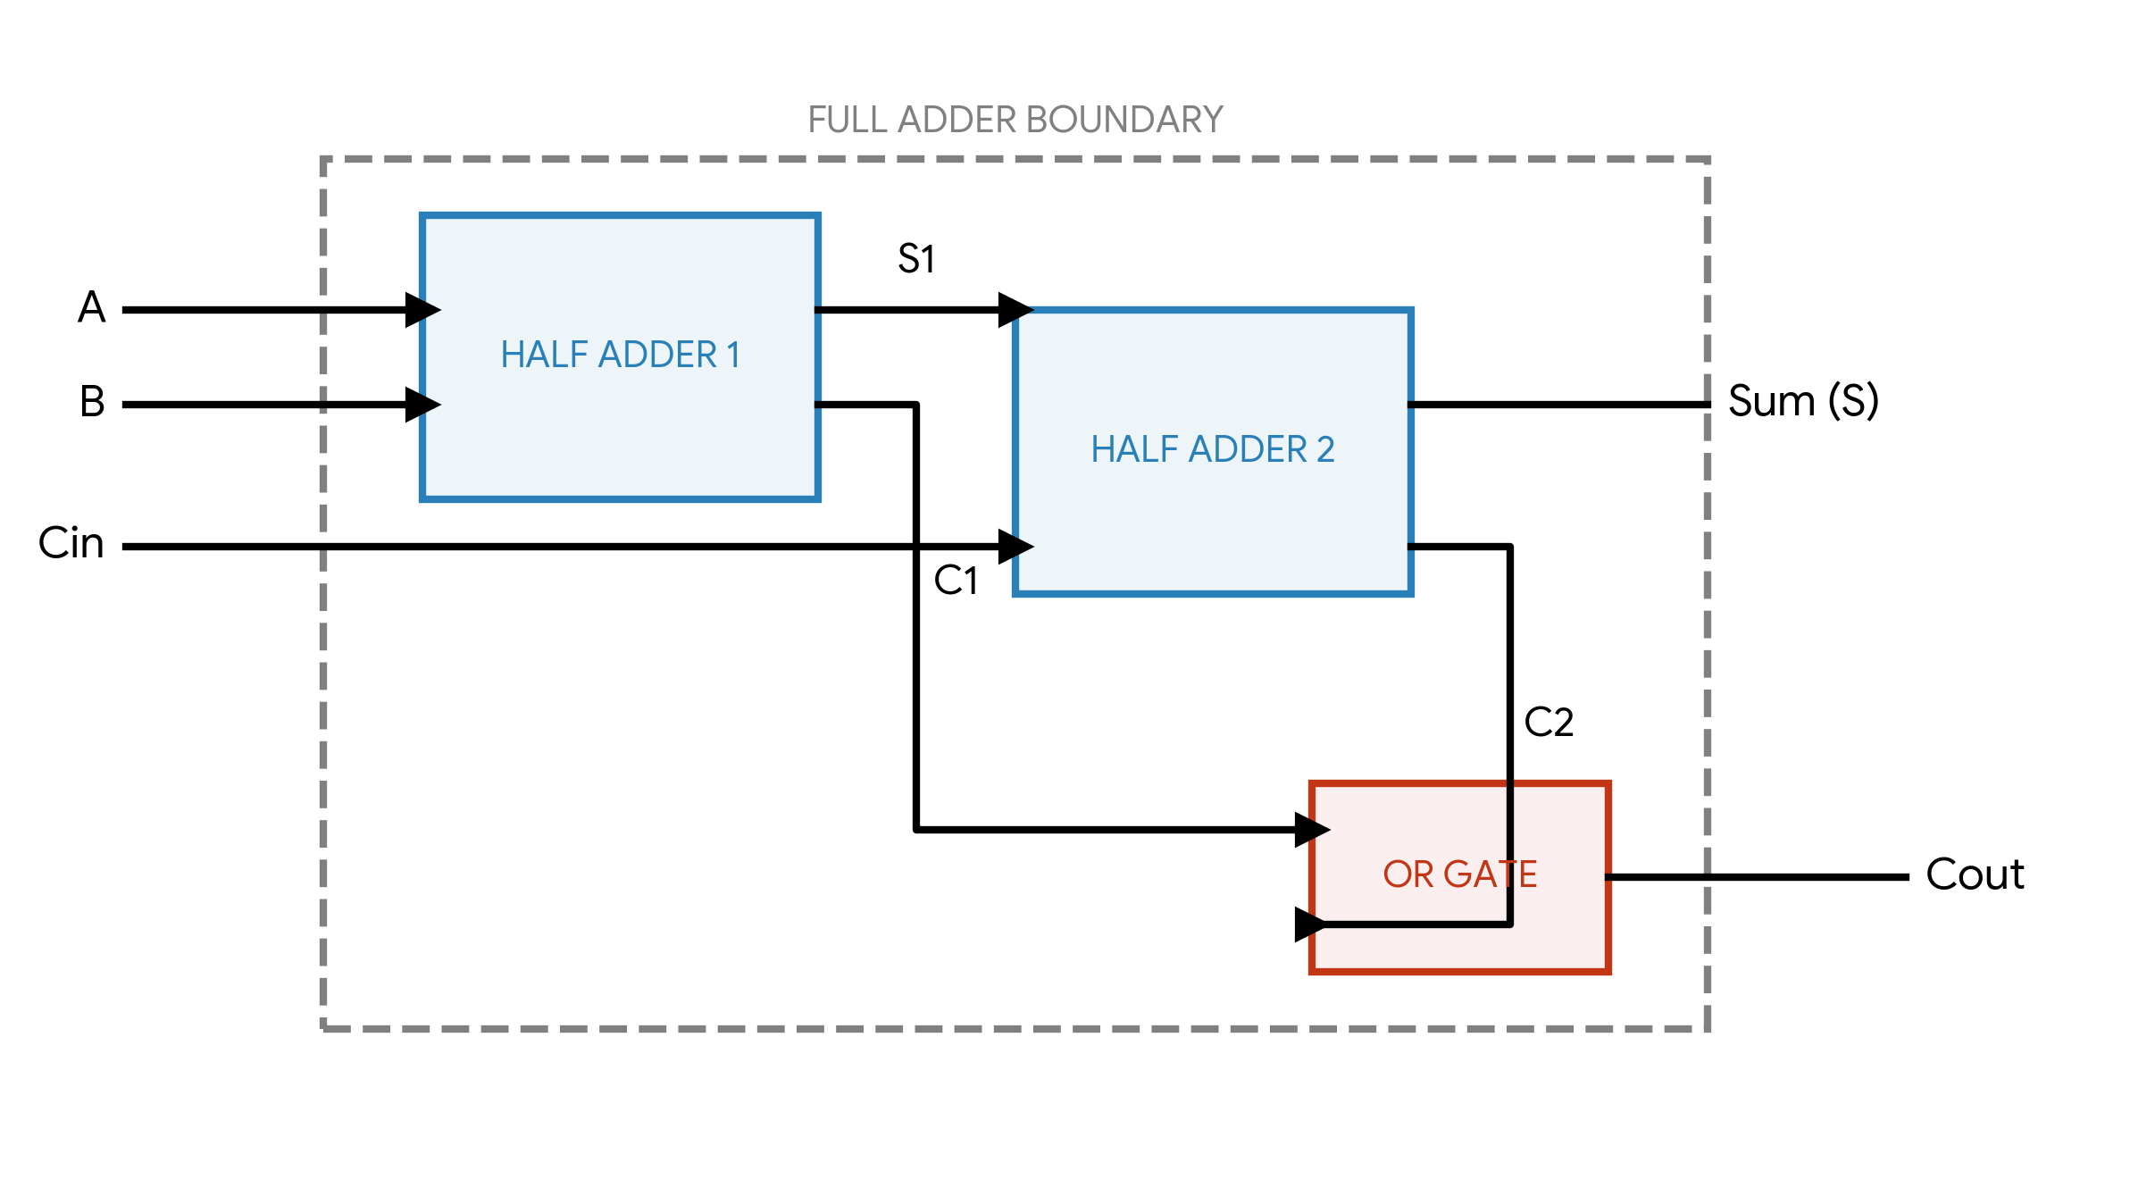
Figure 3.1.2: Full Adder Internal Architecture (Using Two Half Adders)

3.2 Discrete Transistor XOR Implementation
A critical component of the full adder is the XOR gate. Implementing this with discrete NPN transistors requires careful staging. Tying bases together indiscriminately results in short circuits and logic failures. The correct canonical implementation utilizes isolated bases driven through 10kΩ resistors, separated into three distinct stages:
• Stage 1 (Series NAND): Detects the (1,1) condition and acts as a block.
• Stage 2 (Ground Control): Acts as a switch. If both inputs are HIGH, this transistor turns OFF, severing the ground path for the final stage.
• Stage 3 (Parallel Output): Handles the OR condition (0,1 or 1,0). The final output is an active-low sink.

3.3 Inverter Bridge Topology
Because the discrete XOR gate produces an active-low output (0V indicates Logic 1), a single-transistor inverter (NOT gate) is required before cascading the signal into the next full adder stage. This restores the logic to standard active-high (+5V).

4. Components Used
The hardware was assembled using the following primary components. All discrete BJT components adhere to standard operating voltages (Vcc = 5V).
Component | Specification | Purpose
Transistors | BC548 (NPN) | Active switching elements forming all discrete logic gates (XOR, AND, OR, NOT).
Base Resistors | 10kΩ | Current limiting for the transistor base junctions to prevent damage.
Pull-up Resistors | 2.2kΩ / 1kΩ | Ensures specific circuit nodes default to a logic HIGH (+5V) when transistors are OFF.
Output Resistors | 220Ω | Current limiting to safely drive the indicator LEDs.
LEDs | Standard 5mm | Visual verification of the 2-bit Sum outputs and final Carry.
Power Supply | 5V DC | Main logic voltage (Vcc).
Prototyping | Breadboards, Jumpers | Physical routing and assembly of the discrete logic blocks.

5. Results
The constructed discrete transistor circuit successfully computes the arithmetic addition of two 2-bit binary numbers (A1A0 + B1B0).
The final output is displayed via three LEDs representing the sum bits (S1, S0) and the final carry out (Cout). The hardware logic exactly matches the theoretical truth table for 2-bit addition. Below is a subset of the tested operational states:
Operand A (A1 A0) | Operand B (B1 B0) | Expected Output | Actual Hardware Indication
00 (Dec: 0) | 01 (Dec: 1) | 001 (Dec: 1) | S0 ON, S1 OFF, Cout OFF
01 (Dec: 1) | 01 (Dec: 1) | 010 (Dec: 2) | S0 OFF, S1 ON, Cout OFF
10 (Dec: 2) | 01 (Dec: 1) | 011 (Dec: 3) | S0 ON, S1 ON, Cout OFF
11 (Dec: 3) | 01 (Dec: 1) | 100 (Dec: 4) | S0 OFF, S1 OFF, Cout ON
11 (Dec: 3) | 11 (Dec: 3) | 110 (Dec: 6) | S0 OFF, S1 ON, Cout ON
Hardware testing confirmed that the 3-stage XOR configuration successfully computed the sum logic without shorting, and the intermediate inverter successfully corrected the voltage logic from active-low to active-high, allowing the carry bit to ripple seamlessly.

6. Applications
While industrial electronics rely on highly miniaturized silicon ICs, constructing and analyzing discrete adders holds significant practical and educational value:
- 1. Foundational Processor Architecture: Adders are the core component of Arithmetic Logic Units (ALUs) utilized in all microprocessors, from simple microcontrollers to advanced CPUs.
- 2. Custom Embedded Hardware: Discrete logic is deployed in specialized environments (e.g., high-radiation aerospace applications or high-voltage industrial controls) where standard IC logic families are highly susceptible to failure.
- 3. Digital Signal Processing (DSP): Hardware-level adders are crucial for executing the rapid arithmetic required in real-time audio, video, and communications filtering algorithms.
- 4. Hardware Emulation and Education: Constructing logic gates from discrete components provides an essential understanding of semiconductor switching times, propagation delays, and logic thresholds, which are vital concepts in VLSI (Very Large Scale Integration) design.

