Proposal: A comparative study of Forest Fire prediction using Machine Learning models*

*For the fulfillment project proposal of AT82.01 Computer Programming for Data Science and Artificial Intelligence course by Dr. Chantri Polprasert

1st Sachin Malego

Department of Data Sciences and Artificial Intelligence

Asian Institute of Technology

Pathum Thani, Thailand

st125171@ait.asia

2nd Sila N Mahoot

Data Sciences and Artificial Intelligence

Asian Institute of Technology

Pathum Thani, Thailand

st125127 @ait.asia

**Abstract**

Forest fires are one of the most pressing incidents that have a significant impact to both the environment and human life, making early prediction is crucial for minimizing the damage. This proposal presents a comparative study of various machine learning models for forest fire prediction leveraging the historical data from various dataset. Techniques such as XGBoost, KNN, Decision Tree, Random Forest, and Linear and Logistic Regression are explored, with models evaluated based on accuracy and other performance metrics. The study highlights the strength and weakness of each approach with geographic maps of the country, demonstrating that machine learning can significantly enhance predictive capabilities, providing a valuable tool for fire prevention and disaster management. This project does not determine if a forest fire will take place or not, however we are predicting the confidence of the forest fire based on some attributes.

**Keywords**: Historical data, XGBoost, Decision Tree, Random Forest, Regression, Accuracy, Performance metrics, Confidence prediction, Geographic maps, Fire prevention, Disaster management

1. **Introduction**

With the high incident rates of forest fires, its prediction holds a significant environmental and scientific importance.[1] In recent years, forest fires have emerged as a critical concern, posing a recurring threat to vast forested areas worldwide. Observing the data from Nepal alone, it has experienced 965 forest fire incidents in the last one year (08-10-2023 to 07-10-2024) with an estimated economic loss of around USD. 644,696. Such is not only the scenario of Nepal but at a global level. Here in this project, we review such dataset of forest fire from Forest fire dataset of Algeria, and Portugal and run different models to make the best possible prediction.

* 1. *Background*

Forest fire forecasting is critical for mitigating the environmental, economic, and public health impacts of wildfires. According to existing literature, forest fire prediction methods can be broadly categorized into three main approaches: physics-based models, statistical models, and machine learning models.[2] Physics-based models rely on simulating fire behavior based on physical laws, such as fluid dynamics and thermodynamics. Statistical models focus on identifying correlations between past fire events and contributing factors, often using regression techniques. However, machine learning (ML) models have recently gained prominence due to their ability to learn complex, non-linear relationships from large datasets, making them highly suitable for dynamic and uncertain phenomena like forest fires.

This project leverages data-driven algorithms in the machine learning domain to predict the likelihood of forest fire occurrences. Our goal is to train ML models on historical weather and environmental data and use these models to predict fire risks based on current conditions. The data, sourced from regions in Portugal and Algeria, contains key variables such as temperature, relative humidity, wind speed, and climate events like El Niño. These variables are integral to capturing the complex interplay of factors that contribute to fire ignition and spread.

Before delving into the technicalities of forest fire prediction, it's crucial to explore the climatic conditions that exacerbate wildfire risks. El Niño is a particularly significant factor, characterized by the abnormal warming of sea surface temperatures in the central and eastern Pacific Ocean. Although El Niño is a Pacific-based event, it has far-reaching implications for global weather patterns, leading to drier or wetter conditions in various regions, including Europe and North Africa. In both Portugal and Algeria, El Niño can disrupt typical weather patterns, resulting in reduced rainfall, prolonged dry spells, and increased temperatures - conditions that are conducive to the ignition and spread of forest fires.

In addition to El Niño, several other environmental and climatic variables influence fire risk, including rainfall patterns, wind speed, relative humidity, fine fuel moisture, duff moisture, and drought conditions. These factors, when integrated into machine learning models, can provide a powerful predictive tool for early fire detection and risk assessment.

* 1. *Objective*

The objective part in these answers the why part of need of forest fire prediction. The objective of forest fire prediction is to improve early detection and risk assessment, a crucial need globally. Despite the experience of forest departments, human limitations in processing multiple variables hinder accurate predictions. Hence in such situations Machine learning can analyze numerous factors simultaneously, making fire prediction more efficient and effective. The major objectives of this project are:

1. Evaluate Model Performance: Compare the accuracy, precision, recall, F1 score and overall predictive performance of various machine learning models in predicting forest fires.
2. Identify Key Features: Analyze the importance of various environmental and weather-related factors (e.g., temperature, humidity, wind speed, El Niño) across different models to identify which features contribute most to fire prediction accuracy.
3. Assess Generalization Capability: Investigate how well each machine learning model generalizes to unseen data, particularly when predicting forest fires in different geographic regions or under varying climate conditions.
4. Model Interpretability and Usability: Evaluate the interpretability of each model, determining how easily stakeholders (e.g., forest management agencies) can understand and utilize the model's predictions for decision-making.
5. Predictive Alerts for Health Precautions: Evaluate how machine learning models can provide early fire risk alerts, enabling timely health interventions, such as air quality warnings or evacuation notices, to protect vulnerable populations (e.g., children, elderly, people with pre-existing conditions).
6. Air Quality and Environmental Health: Investigate how machine learning-driven forest fire predictions can contribute to improving air quality by preventing large-scale fires that release pollutants like carbon monoxide and nitrogen oxides, which have harmful effects on the environment.
7. Support Sustainable Forest Management: Explore how machine learning predictions can aid in sustainable forest management by allowing for preemptive actions like controlled burns or forest thinning to mitigate the severity of future fires, reducing long-term environmental damage.
   1. *Business Understanding*

With climate change intensifying conditions such as droughts, and unpredictable weather patterns, forest fires are becoming more frequent and destructive. Effective prediction is crucial but challenging due to the complexity of interacting factors.

This project will focus on forest fire prediction in regions prone to fires, specifically Portugal and Algeria. It will utilize weather and environmental data from these regions and compare multiple machine learning models to assess their performance in predicting fire occurrences. The project will evaluate the impact of different variables such as temperature, humidity, wind, and the presence of El Niño on fire risk prediction.

* 1. *Impact*

The proposed study on forest fire prediction using machine learning models has the potential to generate significant and far-reaching impacts across multiple sectors. These impacts can be categorized as environmental, social, economic, technological, policy-related, and scientific, all contributing to a more informed and effective approach to forest fire management.

The comparative study of forest fire prediction using machine learning models has the potential to significantly impact environmental conservation, public safety, economic stability, technological progress, policy development, and scientific advancement. By addressing a critical global challenge, this research will contribute to a safer and more resilient world in the face of increasing forest fire risks due to climate change.

1. **Problem Statement**

The increasing frequency and intensity of forest fires due to climate change pose significant threats to ecosystems, human health, and economies worldwide. To address this pressing issue, there is a need to develop accurate predictive models that can forecast forest fire occurrences based on historical data and environmental conditions. This study aims to investigate the relationships between various factors contributing to forest fires, including:

* **Temporal Trends**: Analyzing seasonal, and monthly trends in forest fire occurrences to identify patterns and peak risk periods.
* **Correlations Between Environmental Parameters:** Examining the correlations between key weather parameters (e.g., temperature, humidity, wind speed) and the incidence of forest fires to understand how these factors influence fire risk.
* **Impact of Climate Phenomena**: Assessing the effects of significant climate phenomena, such as El Niño, on forest fire occurrences, providing insights into how broader climatic trends affect fire behavior.
* **Comparative Analysis of Machine Learning Models**: Evaluating the performance of different machine learning algorithms in predicting forest fire risk, determining which model offers the best accuracy and reliability for real-time decision-making.
* Visualization: Visualize impact areas in maps for precition and effective decision making.

By comprehensively analyzing these elements, the project seeks to enhance forest fire prediction capabilities, enabling more effective prevention and response strategies to mitigate the environmental and societal impacts of forest fires. The main goal of this project is to create a reliable machine learning model that can predict the chances of forest fires based on weather and environmental data. By using data from Portugal and Algeria, this project aims to solve the problems with traditional prediction methods and provide a tool to help authorities make better decisions for preventing and managing fires. The challenge is to make a model that can handle different weather patterns and conditions, ultimately helping reduce the damage caused by forest fires.

1. **Related Works**

The project goal is to train the model to be able to predict the forest fire. Here the focus is on the use of different factors along with climate change phenomenon of El Niño to generalize and predict the fire occurrence scenario for better decision making.

Jing et al., in the research paper “***Toward a more resilient Thailand: Developing a machine learning-powered forest fire warning system***” describes a machine learning-based forest fire warning system in Thailand. It uses satellite data and gas measurements to predict forest fires, with models like linear classifiers, gradient boosting classifiers, and neural networks.[3] The XGBoost model had the best performance with an accuracy of 99.6%. Our project aims to improve this approach by adding climate factors like El Niño and testing more models across different regions.

Abdelhamid Zaidi in the paper “***Predicting wildfires in Algerian forests using machine learning models***” focuses on developing a predictive system for forest fires in Algeria, a region that has seen an increase in fire occurrences over recent years.[4] The study aims to create an accessible, low-budget system for predicting wildfires based on climatic data and machine learning algorithms. The research highlights the challenges faced in forest fire prediction, such as the complexity of fire behavior, the need for substantial and accurate datasets, and the necessity for models to be adaptable to various conditions. The author utilizes machine learning algorithms, to analyze weather data and predict potential fire occurrences. The study concludes that a well-designed machine learning-based system could significantly benefit local authorities and the general public by enabling early fire detection and facilitating timely interventions.

In another paper from IEEE Viswa et al., “***Comparison of Forest Fire Prediction System using Machine Learning Alogrithms***”presents a comparative analysis of various machine learning algorithms for predicting forest fires. It emphasizes the importance of early detection in minimizing the devastating effects of wildfires on ecosystems and human settlements.[5] The study evaluates the performance of different algorithms based on accuracy, precision, recall, and other relevant metrics. The conclusion iterates the importance of machine learning in forest fire prediction and suggests future research directions, including the integration of additional data sources and advanced algorithms.

1. **Datasets**
   1. *Description*

In this project, we are using three main datasets from Kaggle and other public sources. These datasets represent key information about forest fire occurrences and influencing factors. We are also adding weather and climate data to provide more context.

* Forest Fires Dataset – Algeria
* Forest Fires Dataset – Portugal
* El Niño Data

The dataset is in EXCEL spreadsheet format.

* 1. *Features*

The dataset contains following features:

*Algerian Forest Fires Dataset*:

* Date: The date of the observation.
* Temperature: Daily average temperature in degrees Celsius.
* Humidity: Daily average relative humidity as a percentage.
* Wind Speed: Daily average wind speed in km/h.
* Rainfall: Daily rainfall in mm.
* Region: The specific region in Algeria where the data was collected.
* Fire Occurrence: Binary indicator (Yes/No) for whether a fire occurred.

*Forest Fires Dataset - Portugal*:

* Date: The date of the observation.
* Temperature: Daily average temperature in degrees Celsius.
* Humidity: Daily average relative humidity as a percentage.
* Wind Speed: Daily average wind speed in km/h.
* Rainfall: Daily rainfall in mm.
* FFMC (Fine Fuel Moisture Code): Index representing the moisture content of surface litter.
* DMC (Duff Moisture Code): Index indicating the moisture content of loosely compacted organic layers.
* DC (Drought Code): Index indicating long-term drying conditions.
* ISI (Initial Spread Index): Index for predicting the rate of fire spread.
* Fire Occurrence: Binary indicator (Yes/No) for whether a fire occurred.

*Weather and Environmental Data*:

* Temperature: Daily average temperature in degrees Celsius.
* Humidity: Daily average relative humidity as a percentage.
* Wind Speed: Daily average wind speed in km/h.
* Precipitation: Daily rainfall in mm.

*El Niño Data (Sea Surface Temperature)*:

* Niño 3.4 Index: Represents sea surface temperature anomalies in the central equatorial Pacific, which is a critical indicator of El Niño events.

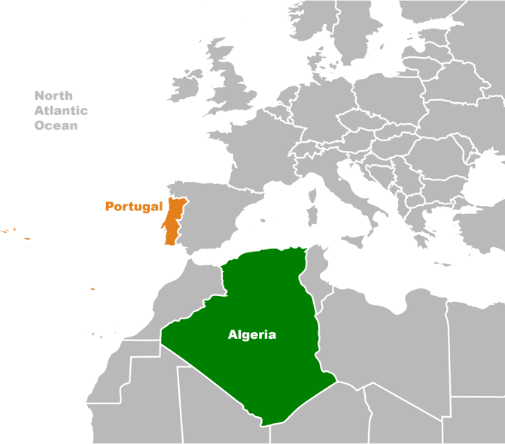

Figure 1: Areas of interest

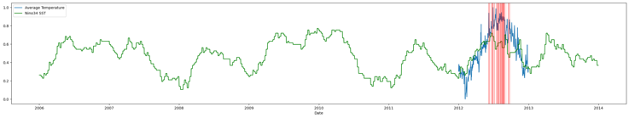

Figure 2: El Nino occurrence and average temperature

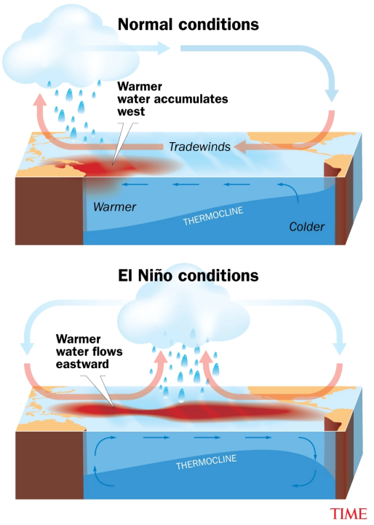

Figure 3: Understanding El Niño

(Image source: https://www.linkedin.com/pulse/understanding-el-ni%C3%B1o-climate-phenomenon-global-moshiur-rahman/)

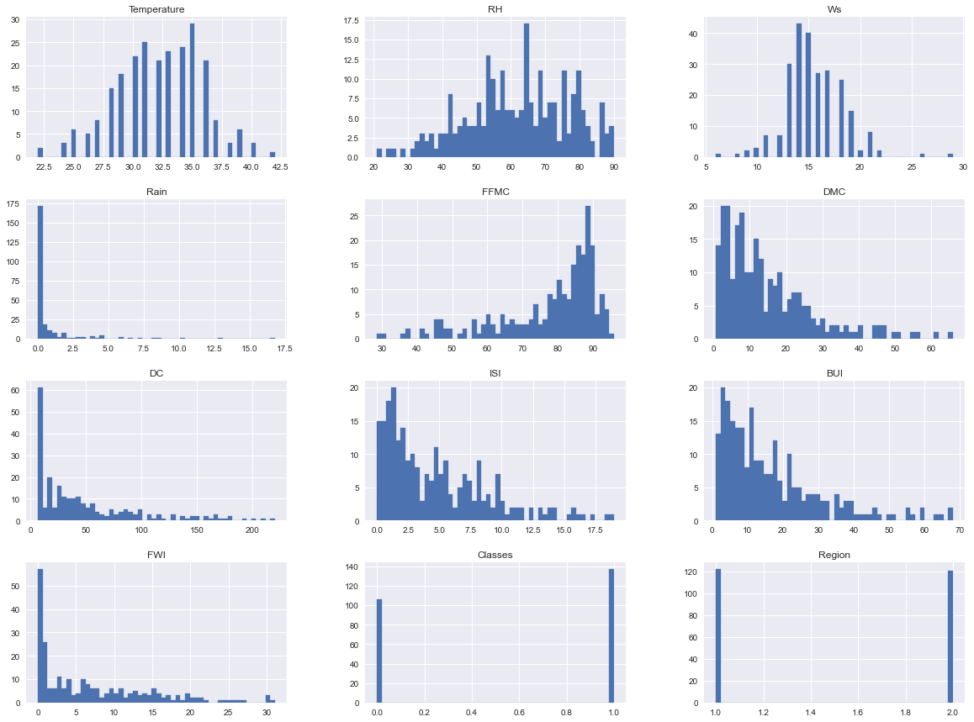

Figure 4: Density plot of Fire dataset Algeria [ 6A]

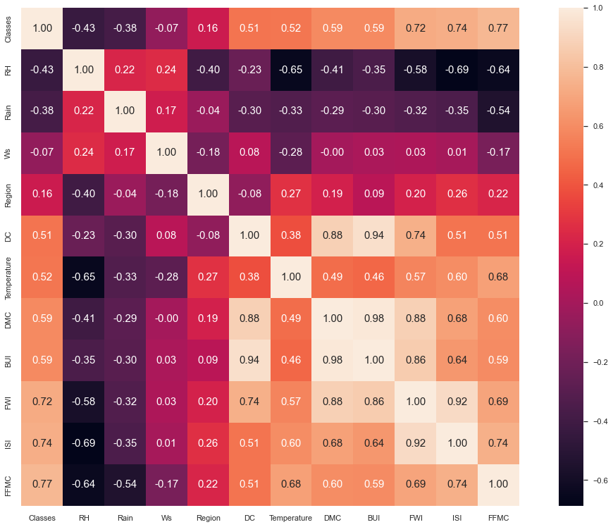

Figure 5: Multicollinearity check in Algerian dataset

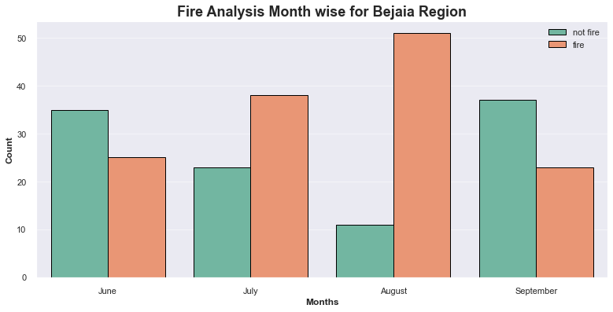

Figure 6: Monthly Fire Analysis

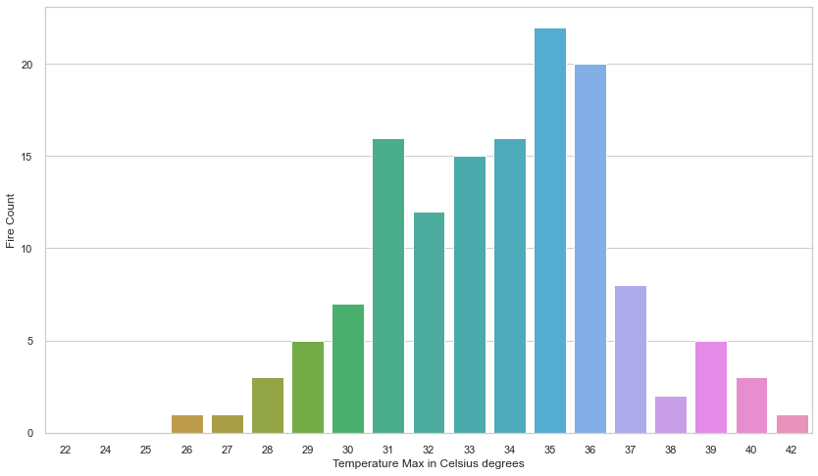

Figure : Temperature data representation for Algerian dataset

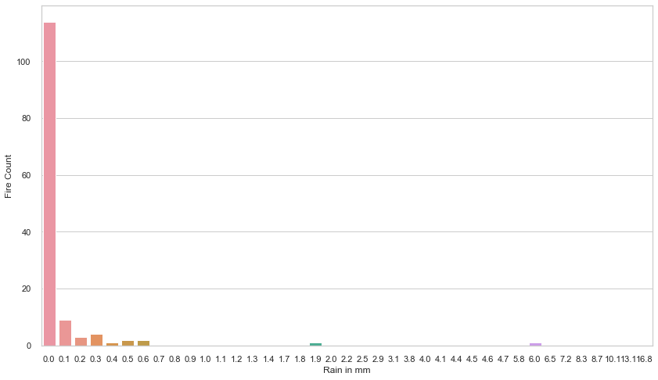

Figure 8: Rain in mm

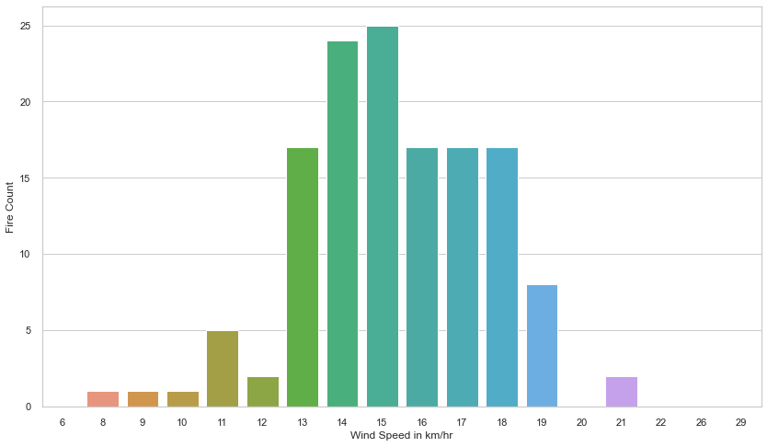

Figure 9: Wind Speed

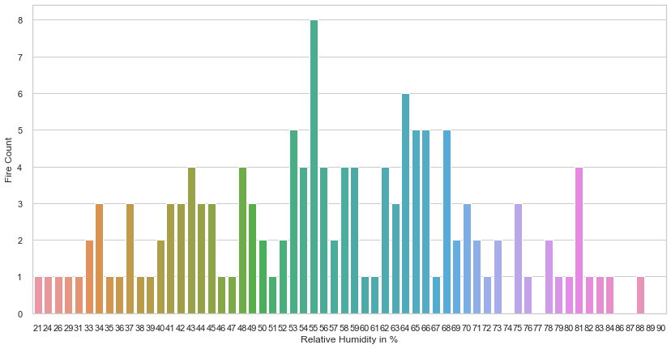

Figure 10: Relative Humidity

1. **Methodology**
   1. *Data Acquisition*

The data for this project was collected from publicly available sources on Kaggle and other weather data platforms. The main datasets are the Algerian Forest Fires Dataset and the Forest Fires Dataset - Portugal, which have valuable information on past forest fires and weather conditions. The data is provided in CSV format, making it easy to load and work with using Python libraries like Pandas.

We also got weather data for Algeria and Portugal from Meteostat and Weather Underground. Meteostat provides historical weather metrics, while Weather Underground allows us to gather more recent daily weather data using web scraping. This weather data is very important for understanding the factors that contribute to forest fires.

To understand the role of climate events like El Niño, we also used El Niño sea surface temperature data from the Climate Prediction Center (CPC). This helps us see how larger climate patterns might influence forest fire occurrences. All the data was downloaded or accessed through APIs, then integrated for further exploration and analysis.

* 1. *Exploratory Data Analysis*

Exploratory Data Analysis (EDA) helps us understand the patterns and relationships in our data. For this project, we are doing EDA on the Algerian and Portugal datasets, as well as weather and El Niño data, to find trends that might predict forest fires.

The following steps and best practices will be applied during the EDA process:

1. Data Cleaning  
   We will check for missing values, mistakes, and inconsistencies. Missing data will either be filled in or removed based on its importance.
2. Data Transformation  
   We will turn date features into more useful information, like year or month, to help find seasonal trends.
3. Data Visualization  
   We will use different types of plots to understand the data better:
   1. Line Plots to show trends over time, like changes in temperature and humidity.
   2. Histograms to show how individual features are distributed.
   3. Scatter Plots to look at relationships between key features, like temperature and fire occurrences.
   4. Correlation Heat Maps to find which features are most important for predicting fires.
   5. Box Plots to find and deal with outliers in the data.

EDA will give us important insights that will help us prepare the data, choose features, and build better models.

* 1. *Pre-processing*

Data preprocessing is important for making sure our datasets are clean and ready for training. Here are the steps we will take:

1. Handling Missing Values: Missing values will be filled in or removed, depending on their impact.
2. Encoding Categorical Variables: We will turn categorical features, like region, into numerical data using one-hot or label encoding.
3. Feature Scaling: We will normalize or standardize features like temperature and wind speed to make sure they're on a similar scale.
4. Date Feature Extraction: Dates will be transformed to get useful information like month or day of the week.
5. Handling Outliers: We will find and handle outliers so they don't affect our model badly.
6. Data Integration: We will combine all datasets—fire data, weather data, and El Niño data—into one comprehensive dataset for modeling.
7. Feature Engineering: We will create new features that could improve the model's performance, like combining temperature, humidity, and wind speed.
8. Data Balancing: Since forest fires are rare, we will balance the dataset so the model can learn well from both fire and non-fire cases.
9. Splitting Data: The data will be split into training, validation, and test sets to make sure our model performs well on new data.

These preprocessing steps will help make sure our data is suitable for training a reliable machine learning model.

* 1. *Modeling*

To find the best model for predicting forest fires, we will use cross-validation and grid search to compare different machine learning algorithms and tune their settings. Cross-validation will help make sure the models can work well on new data, and grid search will help find the best settings for each model.

1. Random Forest and XGBoost are good options because they handle many features and complex relationships well.
2. Gradient Boosting is also strong for modeling interactions between features.
3. Regression models will be used as a simple baseline model to compare with the others.

We will compare these models based on accuracy, precision, recall, and F1 score, then choose the best one for predicting forest fires.

* 1. *Training*

Training the model means using the training data to teach the model how to predict forest fires. We will use the scikit-learn library to train our models. The model will learn by finding the relationships between input features, like temperature and wind speed, and the target feature, fire occurrence.

Steps in Training:

1. Model Initialization: Start the model with the best settings found in grid search.
2. Fitting the Model: Train the model with the .fit() method.
3. Monitoring Performance: Keep track of how well the model is learning by checking the loss function and metrics like accuracy.
4. Addressing Overfitting: Use methods like early stopping to prevent the model from overfitting.

After training, we will evaluate the model with the validation set. If needed, we will adjust the settings to improve performance, then test the final model with new data.

* 1. *K-Fold Cross Validation and Grid Search*

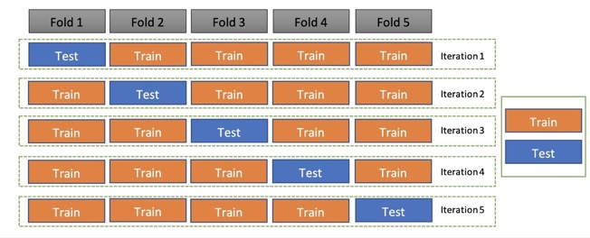

Figure 11; K-Fold Cross Validation

(Image Source: sqlrelease.com)

* 1. *Evaluation*

We will evaluate the model to make sure it accurately predicts forest fires. We will use these metrics:

1. Accuracy: How often the model makes the correct prediction.
2. Precision: How often the model correctly predicts a fire when it says there is one.
3. Recall: How many actual fires the model is able to predict.
4. F1 Score: A balance between precision and recall.

These metrics will help us understand how well the model works and what areas need improvement.

* 1. *Deployment*

The forest fire prediction model will be deployed using Azure Machine Learning for hosting and Dash for the web-based interface. Azure Machine Learning provides a safe and scalable way to host machine learning models. Here are the steps for deployment:

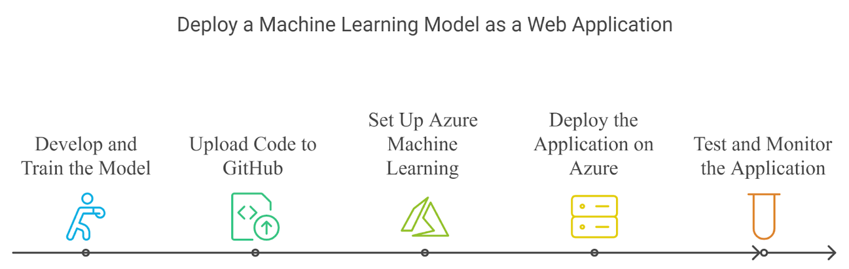

Figure 12: Deploy a Machine Learning Model as a Web Application

1. Create Prediction Model and Web Application Locally
2. Develop ML Model (model.py): Build the model in a Python script named model.py.
3. Convert Model to Deployable Format: Save the trained model using pickle or joblib to prepare it for deployment.
4. Create Dash Web Application (app.py): Make a Dash web app that lets users input data and see predictions, including maps showing fire risk.
5. Upload Code to GitHub  
   The relevant codes, including the model.py and app.py scripts, along with dependencies, will be uploaded to GitHub for version control and collaboration.
6. Azure Machine Learning Setup
7. Create Azure Account: Use Azure to access Machine Learning services.
8. Register Model on Azure: Register the model in Azure to manage it easily.
9. Create an Inference Endpoint: Create an endpoint that the Dash app can use to get predictions from the model.
10. Containerize the Model: Use Docker to containerize the model, making it easier to deploy.
11. Deploy Dash Application on Azure Web App
12. Create Azure Web App Service: Use Azure App Service to host the Dash app.
13. Configure Azure App Service: Connect the web app to the model endpoint.
14. Clone Repository and Deploy: Clone the GitHub repository to Azure and deploy the app.
15. Testing and Monitoring
16. Test the Deployment: Make sure the deployed app works well and interacts properly with the model.
17. Monitor the Application: Use Azure's monitoring tools to track performance and fix any issues.

By using Azure Machine Learning and Dash, we will make the forest fire prediction system accessible online. This system will help users input data and see predictions in real time, including maps that show areas at risk of forest fires.

1. Preliminary Results

* **Temperature** Highest Fire counts happened between **30-37 degree Celsius**
* **Rain** Highest Fire counts happened when there was no rain to very less rain ie. **0.0 to 0.3.**
* **Wind Speed highest Fire count happened when the wind speed were between 13 to 19 Km/hr.**
* **Relative Humidity highest fire count happened when the RH is between 50 to 80%.**
* **Fine Fuel Moisture Code (FFMC) index which ranges between 28.6 to 92.5, here above 75 has higher chance of Forest fires.**
* **Duff Moisture Code (DMC) index which ranges between 1.1 to 65.9, here 1.1-10 has lower chance of Forest fires whereas above 10-30 DMC has very high evidence of Forest fires in past.**
* **Drought Code (DC) index which ranges between 7 to 220.4, here 0-25 is safe and has lower chance of Forest fires whereas range above 25 DC has higher chance of forest fires.**
* **Initial Spread Index (ISI) index which ranges between 0 to 18, here 0-3 has lower Forest fires and above 3 ISI has higher chance of Forest fires.**
* **Buildup Index (BUI) index which ranges between 1.1 to 68, here 1.1 to 10 has lower Forest fire chance and above 10 BUI has higher chance of forest fires.**
* **Fire Weather Index (FWI) Index which ranges between 1 to 31.1, here 0-3 has lower chance of Forest fires and 3-25 FWI has higher chance of forest fires.**

1. **References**
2. Sanjeev Sharma, Puskar Khanal 2024. Forest Fire Prediction: A Spatial Machine Learning and Neural Network Approach. *Fire*, Available at: <https://www.mdpi.com/2571-6255/7/6/205> [Accessed 7 Oct. 2024].
3. Abdelhamid Zaidi, 2023. Predicting wildfires in Algerian forests using machine learning models. *Heliyon*. Available at: <https://www.sciencedirect.com/science/article/pii/S2405844023052726> [Accessed 7 Oct. 2024]
4. Tang, J. et al. (2024). Toward a more resilient Thailand: Developing a machine learning-powered forest fire warning system', *Heliyon*. Available at: <https://www.sciencedirect.com/science/article/pii/S2405844024100527?via%3Dihub> [Accessed 7 Oct. 2024]
5. Zaidi, A. (2023). Predicting wildfires in Algerian forests using machine learning models. *Heliyon*. Available at: <https://www.sciencedirect.com/science/article/pii/S2405844023052726?via%3Dihub> [Accessed 7 Oct. 2024]
6. Bharathi, V. and PeddaReddy, C. (2023). Comparison of forest fire prediction system using machine learning algorithms, in *Proceedings of the 2023 3rd International Conference on Advance Computing and Innovative Technologies in Engineering (ICACITE)*, Greater Noida, India. Available at: <https://ieeexplore.ieee.org/document/10182818> [Accessed 7 Oct. 2024]
7. Dataset:
   1. Algerian Fores Fires Dataset: <https://www.kaggle.com/datasets/nitinchoudhary012/algerian-forest-fires-dataset>
   2. Forest fires Dataset Portugal: <https://www.kaggle.com/datasets/ishandutta/forest-fires-data-set-portugal>