Facebook History

As a ClickAd customer, I want this program to work and agree to ClickAd Support creating a new Campaign for us. However, we would still like to know what we may have done wrong to cause the current problem of not being able to create the initial ad. I can only assume that we entered incorrect info to cause the problem and since we are not familiar with creating a video as requested, I can provide text and screenshots to assist in understanding what went wrong.

A while back, when I was learning about Facebook, I created a number of FB accounts, but did not know the difference and how to use the “profile” and “pages” and difference between the 2. Last year, we paid several thousand dollars for courses, which turned out to be very poor in support and appeared to only want money. Here is how things went ……

Created FB account for my company, Kimlou Global: facebook.com/kimloubiz

When I click on “f” in upper left corner, this page displays. What is the difference between these 2 displays?

Amidst all the questions to my FB marketing program vendors, I unknowing created a number of “Pages”, but still did not know how to use them. Here is the screenshot AFTER I click on the “Pages” icon on the left menu.

(Note the URL). Still, I do not know what was created and how to use these pages. However, the one that I was most interested in and tried to create in ClickAd is “Living Healthy Now”.

By clicking on either “Living Healthy Now” image links in the left menu under “Pages” or the above, the below “Manage Page” page opens. The URL is “https://facebook.com/livinghealthnow”. By luck, I learned how to add the button and large banner to this page. This page is the one we tried to utilize in creating the Clickad, with concentration on “Weight Loss”.

I have several products I wanted to promote, which were provided through Clickbank. The initial promo link is <http://kimlou.1keto.hop.clickbank.net/?pid=sku3>, which I cloaked and entered into ClickAd ad <http://CashCircuit.com/ur/?b=1112>.

From the above, I created the ad for this product in ClickAd, which is the one that has caused the problems and to which I am seeking a resolution. As stated, I would not oppose ClickAd support creating another ad, but I would like to know what I did wrong with my own creations so that I do not replicate the problem. The following represent the pages I used to try to add to the “Living Healthy Now” ad I created …..

Dashboard Page

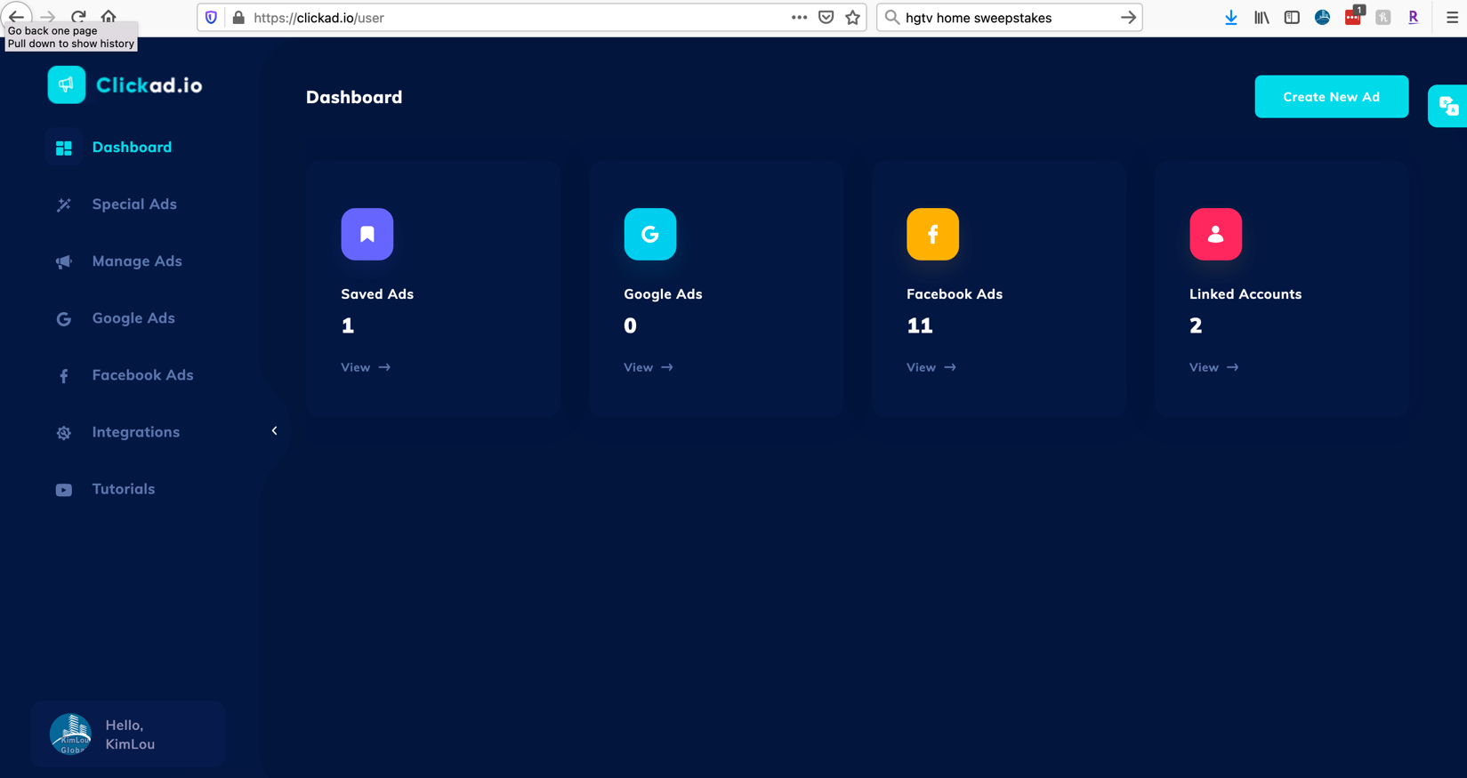

Facebook Integration (Used facebook.com/kimloubiz to integrate)

After Facebook Integration, went to Manage Ads page.

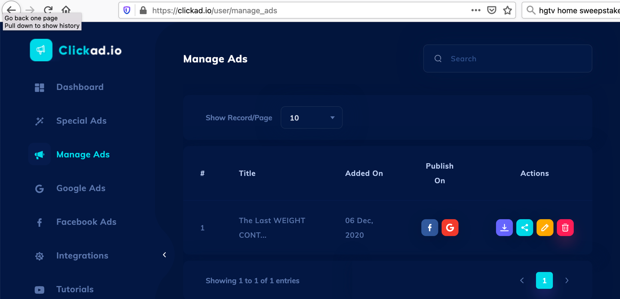

After Manage Ads page, selected “f” under “Publish On” & below Adset 1 page appeared. I inserted info down to Facebook Campaign, where I hit the scroller and selected “Create New Campaign”.

The “Create Campaign” page appeared & I inserted the Campaign Name “Keto Weight Planning”. Then I opened the “Special Ad Category” tried entering all of the options

I settled on entering “None”, clicked on the “Create New”, and the error message appeared from the upper right side for a moment and then disappeared. The error message said “Yikes, something went wrong, please try again.

It appears that each time I hit “Create New”, the error message appeared, but unknown to me, a new “Draft was created numerous times by the below image although a lot more were created. I tried to delete all of the Drafts, but there was no delete option, only an edit button.Graphical user interface, application
