Big Data Tools and
Techniques Assignment
(Activity Based Learning)
Log Data Analysis
Using Apache Hadoop, Pig & Hive
Web Server Log Analysis Assignment
Dataset: Apache Web Server Logs (100 Records)
Platform: Ubuntu 24.04 | Hadoop 3.3.6 | Pig 0.17.0 | Hive 3.1.2

NAME: SACHIN R B
REG NO: RA2411056050007
CSE-DS (2ND YEAR)
The first step was to set up the Hadoop ecosystem on Ubuntu 24.04 and prepare the web server log dataset for analysis.
1.1 Starting Hadoop Services
All Hadoop services were started using start-dfs.sh and start-yarn.sh. The jps command confirmed all 5 required processes were running successfully.
Screenshot 1: Hadoop Services Running — jps output showing all 5 processes


NameNode: Running (PID 715)
DataNode: Running (PID 839)
SecondaryNameNode: Running (PID 1064)
ResourceManager: Running (PID 1294)
NodeManager: Running (PID 1427)

1.2 Dataset Creation
A Python script was created to generate a realistic 100-record Apache web server log dataset containing a mix of normal users, a bot (198.51.100.99), and an attacker IP (203.0.113.45).
Screenshot 2: Dataset Generator Script Execution — 100 records created
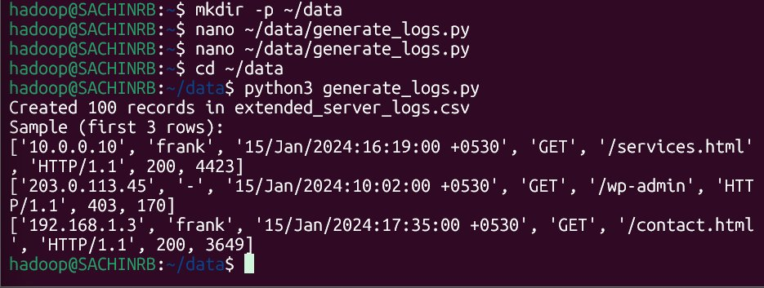
Screenshot 3: Python Script — IP Addresses & Page Configuration

Screenshot 4: Python Script — Record Generation Logic (65 normal + 16 attack + 10 bot + 9 POST)


1.3 Dataset Verification
The dataset was verified to contain exactly 100 records. The IP distribution confirms the attacker IP (203.0.113.45) has exactly 16 records — all attack attempts.
Screenshot 5: Dataset Verification — 100 records, sample rows, IP count distribution
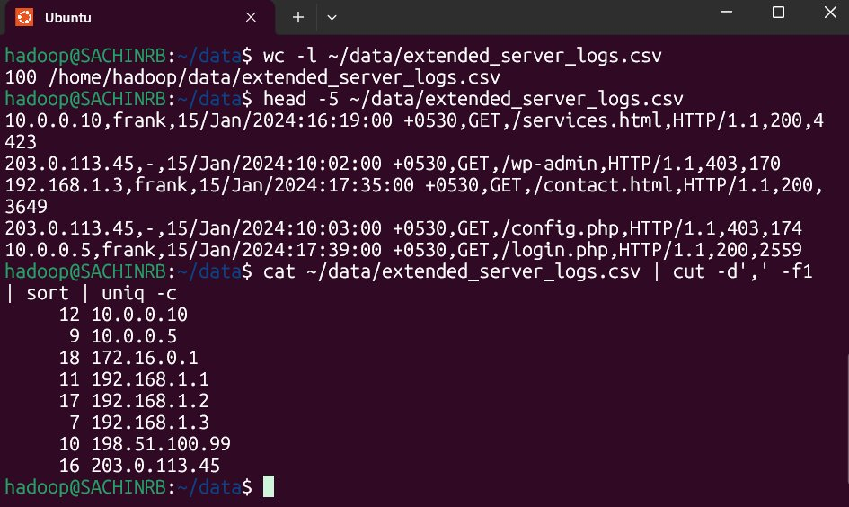

1.4 HDFS Directory Setup & Data Upload
Three HDFS directories were created for input data, Pig output, and Hive input. The dataset was uploaded to HDFS and verified.
Screenshot 6: HDFS Directory Structure — 3 directories created
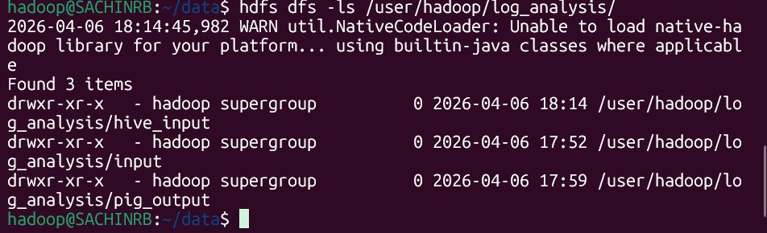
Screenshot 7: Dataset Uploaded to HDFS — file listing and sample data preview
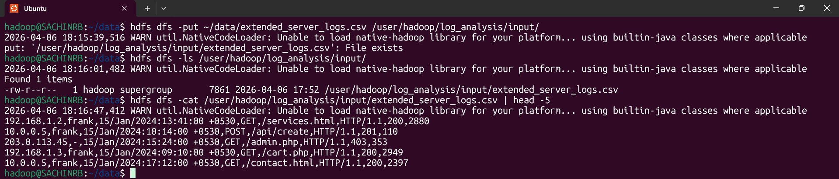

Task 1: Find Most Visited Web Pages
Objective: Identify which web pages received the most successful HTTP 200 requests from the server logs.
Part A: Using Apache Pig
A Pig Latin script was written to load the CSV data from HDFS, filter for successful requests (status == 200), group by resource URL, count the visits per page, and sort in descending order.
Pipeline: LOAD → FILTER (status==200) → GROUP BY resource → FOREACH COUNT → ORDER BY visits DESC → STORE to HDFS
Screenshot 8: Pig Task 1 — Script Execution Success (100 records read, 8 pages stored)

Screenshot 9: Pig Task 1 Output — Most Visited Pages Ranked
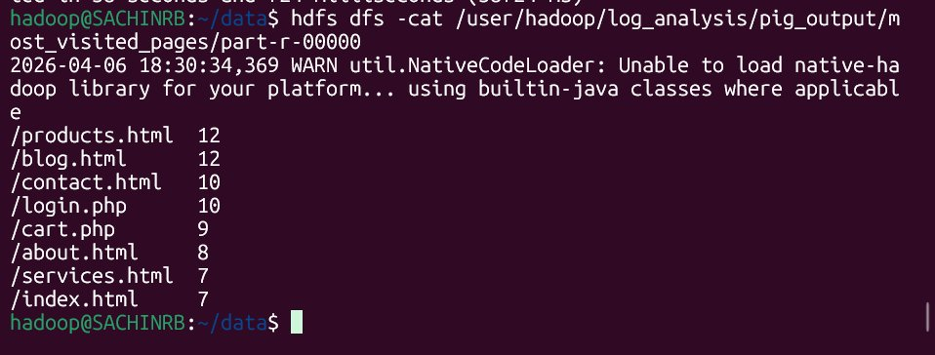

1st Place: /products.html = 12 visits
1st Place (tie): /blog.html = 12 visits
3rd Place: /contact.html = 10 visits, /login.php = 10 visits
5th Place: /cart.php = 9 visits
Lowest: /services.html = 7, /index.html = 7 visits
Total Pages: 8 unique pages with successful (200) visits

Part B: Using Apache Hive
A Hive table was created with matching schema. Data was loaded from HDFS and a SQL GROUP BY query identified the most visited pages.
Screenshot 10: Hive Table Created — CREATE TABLE, SHOW TABLES, DESCRIBE output
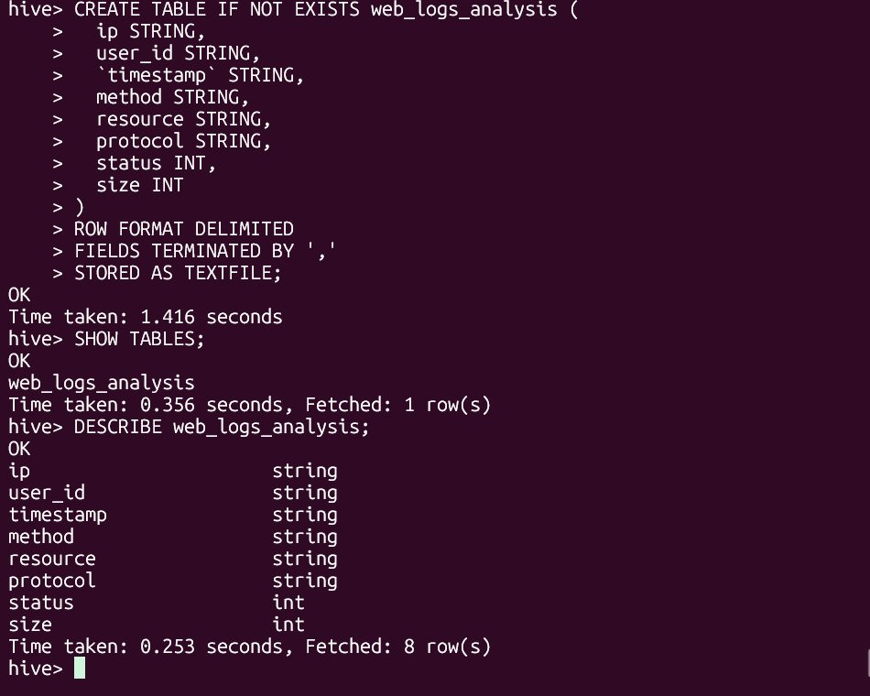
Screenshot 11: Hive Task 1 — Query Execution (LOAD DATA + SELECT with GROUP BY)
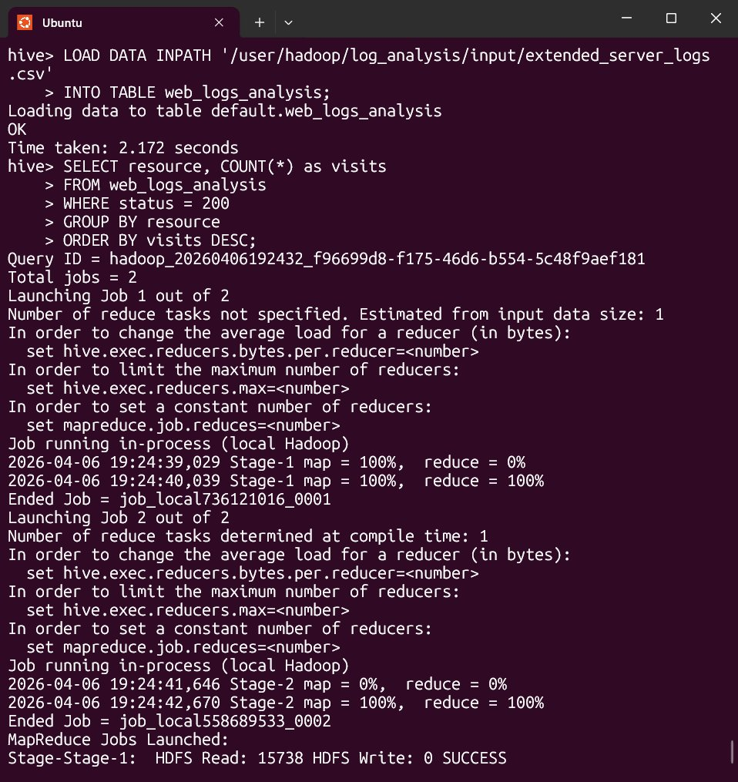
Screenshot 12: Hive Task 1 Output — Most Visited Pages Results


Task 2: Identify Peak Traffic Hours
Objective: Determine which hours of the day have the highest web traffic volume by extracting and grouping the hour from each log timestamp.
Part A: Using Apache Pig
The Pig script used SUBSTRING() to extract the 2-digit hour from each timestamp field, grouped all records by hour, and counted total requests per hour.
Pipeline: LOAD → FOREACH GENERATE SUBSTRING(log_time,12,14) as hour → GROUP BY hour → COUNT → STORE to HDFS
Screenshot 20: Pig Task 2 — Script Execution Started (mapreduce mode)
Screenshot 19: Pig Task 2 Output — Request Count by Hour
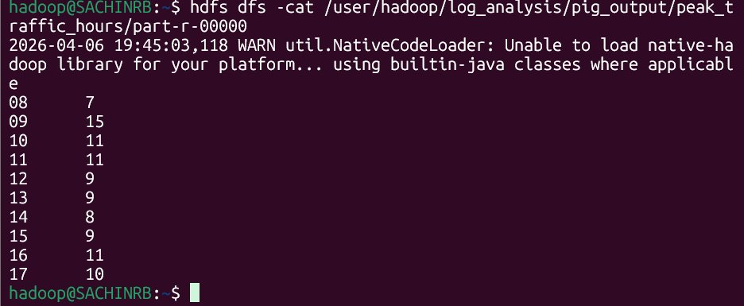

Peak Hour: 09:00 = 15 requests — HIGHEST TRAFFIC
2nd Highest: 16:00 = 11 requests, 10:00 = 11 requests
3rd: 17:00 = 10 requests, 11:00 = 11 requests
Lowest: 08:00 = 7 requests, 14:00 = 8 requests
Pattern: Traffic builds from morning, peaks at 09:00, remains high through 17:00

Part B: Using Apache Hive
Hive used SUBSTR() on the timestamp column. Two queries were executed — one without ORDER BY for stability, and a subquery version with ORDER BY for sorted output.
Screenshot 13: Hive Task 2 — GROUP BY Hour Query Without ORDER BY
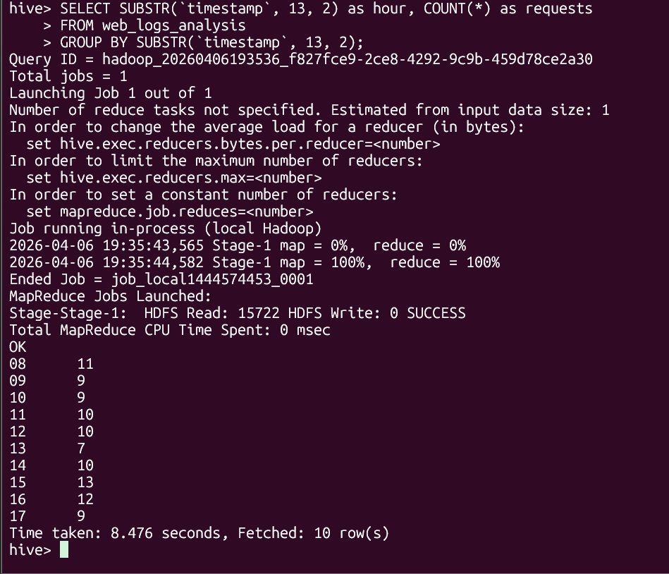
Screenshot 14: Hive Task 2 — Subquery with ORDER BY Execution
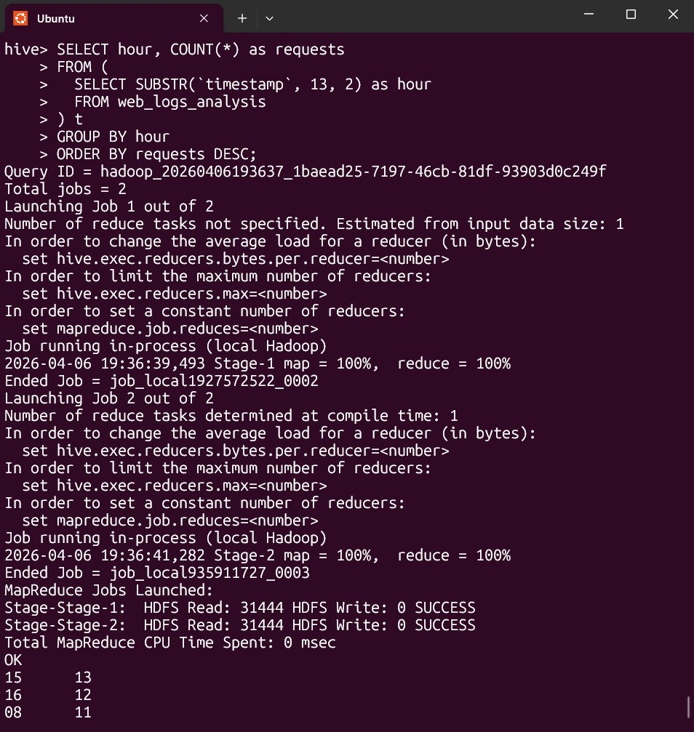
Screenshot 15: Hive Task 2 Final Output — Hours Sorted by Traffic (Peak = Hour 15)


Task 3: Detect Suspicious IP Activity
Objective: Identify IP addresses showing suspicious behavior — such as accessing admin/config pages or repeatedly receiving HTTP 403 Forbidden responses — which may indicate hacking attempts or automated attacks.
Part A: Using Apache Pig
The Pig script filtered records where status was 403 OR resource matched known attack patterns (admin, config, passwd). Results were grouped by IP, counted, and filtered to only show IPs with 5 or more suspicious attempts.
Pipeline: LOAD → FILTER (status==403 OR resource MATCHES attack patterns) → GROUP BY ip → COUNT → FILTER (attempts >= 5) → ORDER DESC → STORE
Screenshot 22: Pig Task 3 — Suspicious IPs Script Content
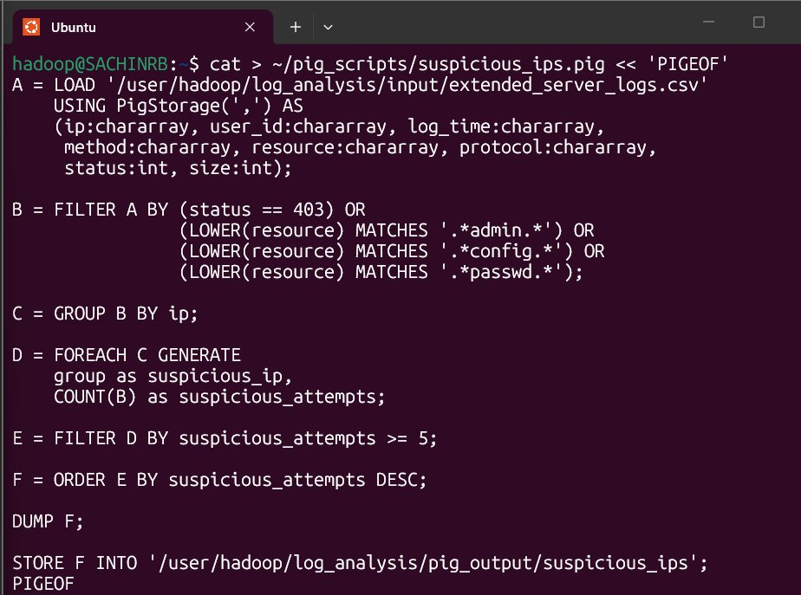
Screenshot 23: Pig Task 3 — Script Execution in MapReduce Mode

Screenshot 21: Pig Task 3 Output — Suspicious IP Detected
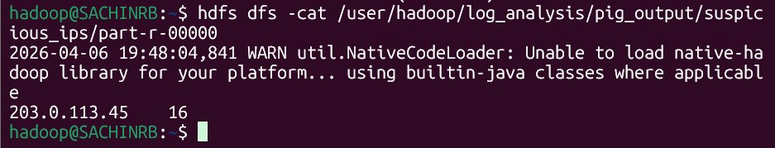

Attacker Detected: 203.0.113.45 = 16 suspicious attempts
Attack Type: Accessing /admin.php, /config.php, /wp-admin, /../etc/passwd, /phpmyadmin
Status: ALL 16 requests received HTTP 403 Forbidden (completely blocked)
Filter Used: status==403 OR resource MATCHES '.*admin.*' OR '.*config.*' OR '.*passwd.*'
Threshold: Only IPs with 5+ suspicious requests shown

Part B: Using Apache Hive — Basic Suspicious IP Query
The Hive query filtered for suspicious activity using WHERE clause combining status=403 with LIKE patterns for sensitive resource paths. HAVING COUNT(*) > 3 filtered out occasional mistakes.
Screenshot 16: Hive Task 3 — Basic Suspicious IP Query and Result
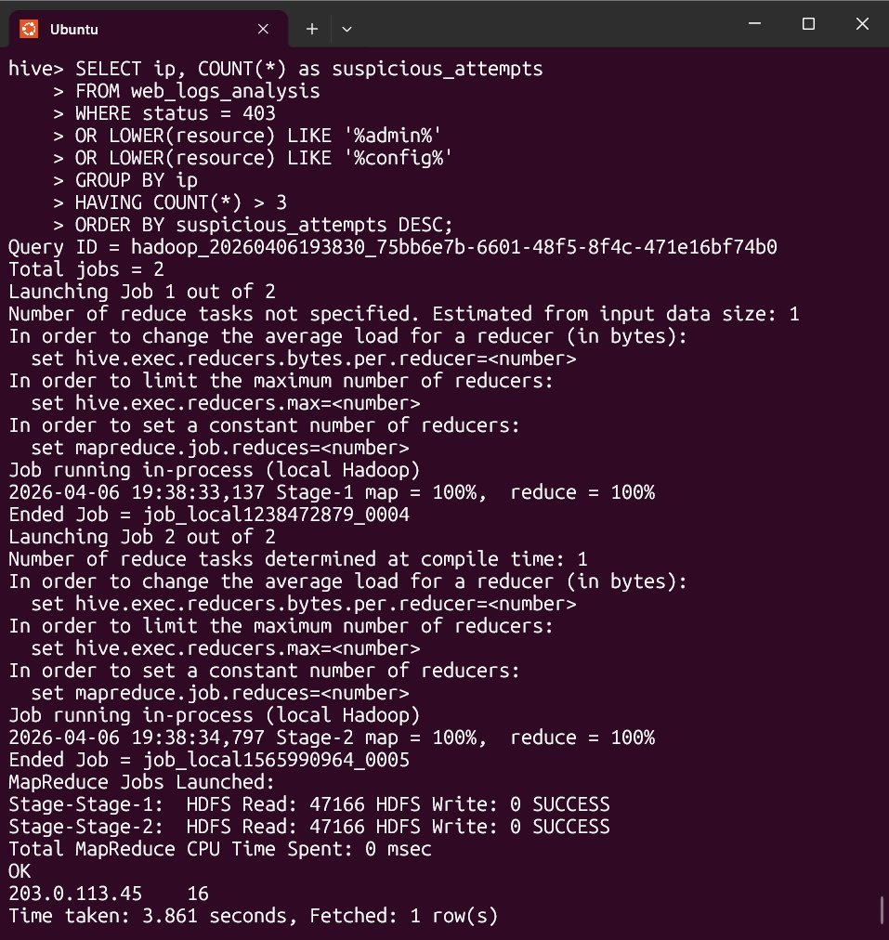

Result: 203.0.113.45 = 16 suspicious attempts — only IP exceeding threshold
HiveQL: SELECT ip, COUNT(*) FROM web_logs_analysis WHERE status=403 OR resource LIKE '%admin%' OR '%config%' GROUP BY ip HAVING COUNT(*) > 3 ORDER BY suspicious_attempts DESC

Part B: Using Apache Hive — Advanced Security Analysis
An advanced Hive query calculated blocked vs successful request counts and the percentage of blocked requests per IP — providing a clear security risk score for each IP address.
Screenshot 17: Hive Advanced Security Query — CASE WHEN blocked percentage calculation
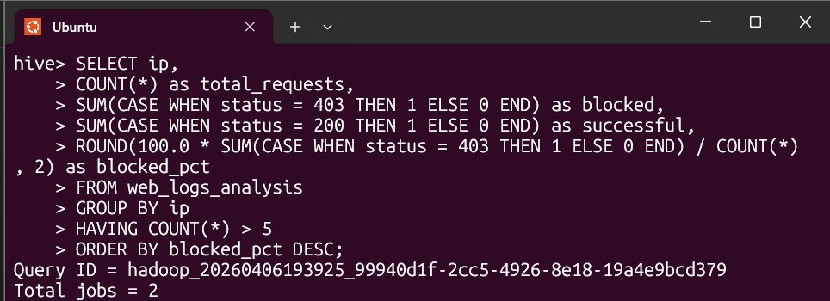
Screenshot 18: Hive Advanced Output — Full IP Security Report with Block Percentages
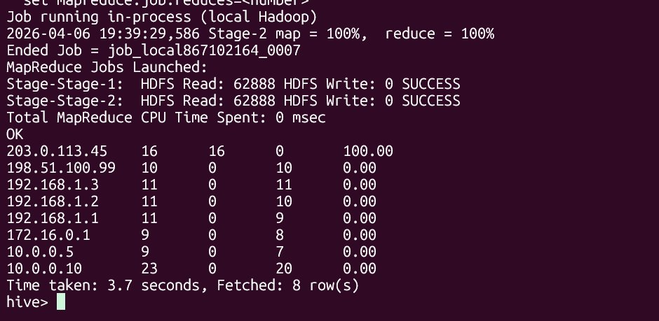

ATTACKER ⚠️: 203.0.113.45 → 16 total | 16 blocked | 0 successful | 100.00% block rate
BOT: 198.51.100.99 → 10 total | 0 blocked | 10 successful | 0.00% block rate
Normal Users: 192.168.x.x, 10.0.x.x, 172.16.x.x → All 0.00% block rate (legitimate)
Advanced HiveQL: SUM(CASE WHEN status=403 THEN 1 ELSE 0 END) / COUNT(*) * 100 AS blocked_pct
Action Required: Block 203.0.113.45 at firewall immediately — 100% attack rate confirmed

