**Bike sharing Assignment Solution**

**Assignment-based Subjective Questions**

**Q1) From your analysis of the categorical variables from the dataset, what could you infer about their effect on the dependent variable?**

# Ans: what is categorical variable :The data which represented as categorical format which can be object type and can able to classified into categories

# Month_wise_demand

Demand increases in the month of 3 Demand decreases in the month of 7 , 8,11,12

* **Atmosphere_wise_Demand**

Demand decreases if there is windspeed , in the spring season i.e in the rainy season people avoided to buy at rent also snow Thunderstorm , Mist cloudy,clear weather is optimal for bike renting as temperature is optimal humidity is less

* **Day_wise_Demand**

Demand decreases when there Sunday, and if it is holiday we can say that people more likely rented bike for work purpose. surprisingly Tuesday also has less demand for bike ,On holiday we can say that people usually love to spend their time at home or rather prefer private vehicle for travelling or wandering

* Fall has the highest median ,which is expected as weather conditions are most optimal to ride bike followed by summer
* Median bike rents are increasing on as year 2019 has a higher median than 2018 ,it might be due to the fact that bike rental getting popular and people are becoming more aware about environment.
* Overall spread in the month plot is reflection of season plot as fall months have higher median

**Q2) Why is it important to use drop_first=True during dummy variable creation?**

Ans:

**A variable with N level can be represented by N-1 dummy variable**

drop_first=True is important to use, as it helps in reducing the extra column created during dummy variable creation. Hence it reduces the correlations created among dummy variables.

**Example1**:

Let’s say we have 3 types of values in Categorical column and we want to create dummy variable for that column. If one variable is not furnished and semi_furnished, then It is obvious unfurnished. So we do not need 3rd variable to identify the unfurnished.

**Example2:**

drop_first=True drops the first column during dummy variable creation. Suppose, you have a column for gender that contains 4 variables- "Male", "Female", "Other", "Unknown". So a person is either "Male", or "Female", or "Other". If they are not either of these 3, their gender is "Unknown".

**Q3) Looking at the pair-plot among the numerical variables, which one has the highest correlation with the target variable**?

Ans: Looking at the pair-plot among the numerical variables, **temp** variable has the highest correlation with the target variable and it is **0.63**

**Q4) How did you validate the assumptions of Linear Regression after building the model on the training set**

**Ans:** By plotting the residual distribution .it came out to be normal distribution with mean **value 0.**

**Q5) Based on the final model, which are the top 3 features contributing significantly towards explaining the demand of the shared bikes?**

**Ans:** Based on the final model, following are the top 3 features contributing significantly towards explaining the demand of the shared bikes

* Positively correlated Variable:

1. Yr=0.2417
2. Atemp=0.4678

* Negatively correlated Variable(strongly weakly correlated viable)

1. weathersit_Light rain_Light snow_Thunderstorm = - 0.2697

**General Subjective Questions**

**Q1)** Explain the linear regression algorithm in detail

# Ans: Regression

Regression analysis is one of the most important fields in statistics and machine learning. There are many regression methods available. Linear regression is one of them.

**What Is Regression?**

Regression searches for relationships among variables.

For example, you can observe several employees of some company and try to understand how their salaries depend on the **features**, such as experience, level of education, role, city they work in, and so on.

This is a regression problem where data related to each employee represent one **observation**. The presumption is that the experience, education, role, and city are the independent features, while the salary depends on them.

Similarly, you can try to establish a mathematical dependence of the prices of houses on their areas, numbers of bedrooms, distances to the city center, and so on.

Generally, in regression analysis, you usually consider some phenomenon of interest and have a number of observations. Each observation has two or more features. Following the assumption that (at least) one of the features depends on the others, you try to establish a relation among them.

In other words, you need to find a function that maps some features or variables to others sufficiently well. The dependent features are called the **dependent variables**, **outputs**, or **responses**.

The independent features are called the **independent variables**, **inputs**, or **predictors**.

Regression problems usually have one continuous and unbounded dependent variable. The inputs, however, can be continuous, discrete, or even categorical data such as gender, nationality, brand, and so on.

It is a common practice to denote the outputs with 𝑦 and inputs with 𝑥. If there are two or more independent variables, they can be represented as the vector 𝐱 = (𝑥₁, …, 𝑥ᵣ), where 𝑟 is the number of inputs.

**When Do You Need Regression?**

Typically, you need regression to answer whether and how some phenomenon influences the other or how several variables are related. For example, you can use it to determine if and to what extent the experience or gender impact salaries.

Regression is also useful when you want to forecast a response using a new set of predictors. For example, you could try to predict electricity consumption of a household for the next hour given the outdoor temperature, time of day, and number of residents in that household.

Regression is used in many different fields: economy, computer science, social sciences, and so on. Its importance rises every day with the availability of large amounts of data and increased awareness of the practical value of data.

SLR=Y=mX+C

Where Y =response variable /dependent variable/Output variable

X=Predicted variable/independent variable/Input variable

m=Slope or Coefficient

C=constant or intercept

MLR=mX1+mX2+Mx3 +c

**Algorithm:**

**STEP 1: Identify X and Y**

**STEP 2: Split the data into training data(~80%OR 70%) and test data(20%OR 30%)**

**STEP 3: Build the model on Training data**

**STEP 4: Find the values of Slope, intercept, R Square**

**STEP 5: Predicting the values of test data**

**STEP 6: Find the value of RMSE (Root mean square error)**

**STEP 7: Predict your validation data or future data.**

**Q2)** Explain the Anscombe’s quartet in detail.

**Anscombe’s Quartet**can be defined as a group of four data sets which are **nearly identical in simple descriptive statistics**, but there are some peculiarities in the dataset that **fools the regression model**if built. They have very different distributions and **appear differently**when plotted on scatter plots.

It was constructed in 1973 by statistician **Francis Anscombe** to illustrate the **importance**of **plotting the graphs**before analyzing and model building, and the effect of other **observations on statistical properties**.There are these four data set plots which have nearly **same statistical observations**, which provides same statistical information that involves **variance**, and **mean**of all x,y points in all four datasets.

This tells us about the importance of visualising the data before applying various algorithms out there to build models out of them which suggests that the data features must be plotted in order to see the distribution of the samples that can help you identify the various anomalies present in the data like outliers, diversity of the data, linear separability of the data, etc. Also, the Linear Regression can be only be considered a fit for the **data with linear relationships**and is incapable of handling any other kind of datasets. These four plots can be defined as follows:

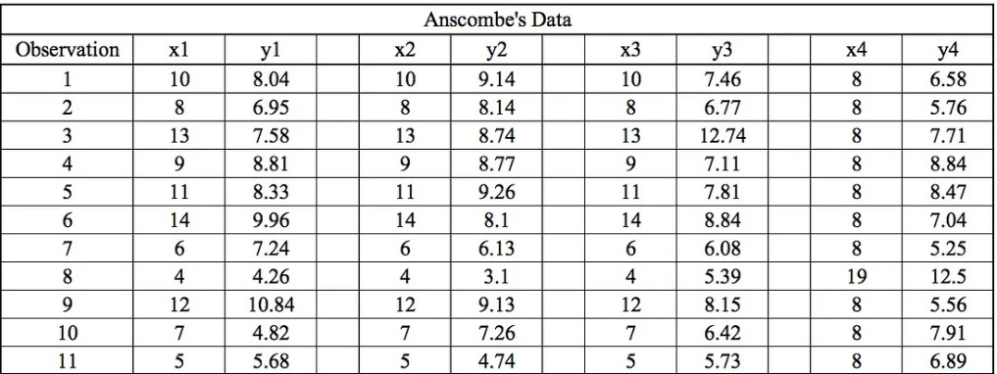

The statistical information for all these four datasets are approximately similar and can be computed as follows:

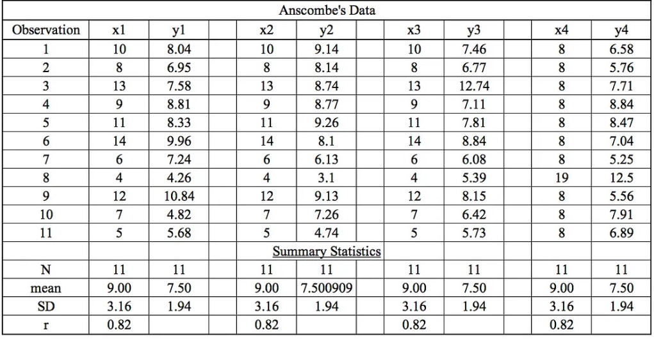

When these models are plotted on a scatter plot, all datasets generates a different kind of plot that is not interpretable by any regression algorithm which is fooled by these peculiarities and can be seen as follows:

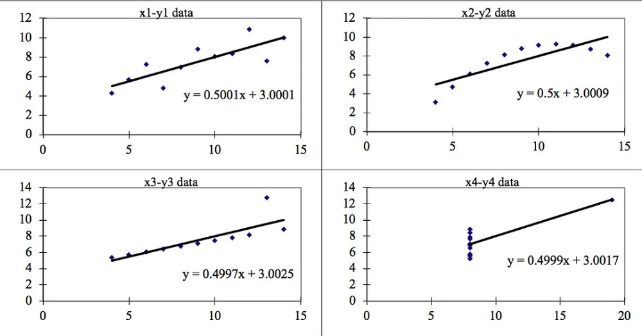

The four datasets can be described as:

1. **Dataset 1:**this **fits**the linear regression model pretty well.
2. **Dataset 2:** this **could not fit**linear regression model on the data quite well as the data is non-linear.
3. **Dataset 3:**shows the **outliers**involved in the dataset which **cannot be handled**by linear regression model
4. **Dataset 4:**shows the **outliers**involved in the dataset which **cannot be handled**by linear regression model

**Conclusion:**

We have described the four datasets that were intentionally created to describe the importance of data visualisation and how any regression algorithm can be fooled by the same. Hence, all the important features in the dataset must be visualised before implementing any machine learning algorithm on them which will help to make a good fit model.

**Q3) What is Pearson’s R?**

**Ans:** The **Pearson correlation coefficient (r)** is the most common way of measuring a linear correlation. It is a number between –1 and 1 that measures the strength and direction of the relationship between two variables.

|  |  |  |  |
| --- | --- | --- | --- |
| **Pearson correlation coefficient (r)** | **Correlation type** | **Interpretation** | **Example** |
| Between 0 and 1 | Positive correlation | **When one variable changes, the other variable changes in the same direction**. | Baby length & weight:  The longer the baby, the heavier their weight. |
| **0** | No correlation | There is **no relationship** between the variables. | Car price & width of windshield wipers:  The price of a car is not related to the width of its windshield wipers |
| Between -1 and 0  **i.e.-1<=x<=0** | Negative correlation | When one variable changes, the other variable changes in the **opposite direction**. | Elevation & air pressure:  The higher the elevation, the lower the air pressure. |

The Pearson correlation coefficient also tells you whether the slope of the line of best fit is negative or positive. When the slope is negative, r is negative. When the slope is positive, r is positive.

When r is 1 or –1, all the points fall exactly on the line of best fit:

When r is greater than .5 or less than –.5, the points are close to the line of best fit

**Q4) What is scaling? Why is scaling performed? What is the difference between normalized scaling and standardized scaling**

**Ans:** What?

It is a step of data Pre-Processing which is applied to independent variables to normalize the data within a particular range. It also helps in speeding up the calculations in an algorithm.

# Why?

Most of the times, collected data set contains features highly varying in magnitudes, units and range. If scaling is not done then algorithm only takes magnitude in account and not units hence incorrect modelling. To solve this issue, we have to do scaling to bring all the variables to the same level of magnitude.

It is important to note that **scaling just affects the coefficients** and none of the other parameters like **t-statistic, F-statistic, p-values, R-squared**, etc.

# Normalization/Min-Max Scaling:

* It brings all of the data in the range of 0 and 1. **sklearn.preprocessing.MinMaxScaler**helps to implement normalization in python.

**Formula=X-min(X)/max(X)-min(X)**

# Standardization Scaling:

* Standardization replaces the values by their Z scores. It brings all of the data into a standard normal distribution which has mean (**μ)** zero and standard deviation one (**σ**).
* **sklearn.preprocessing.scale** helps to implement standardization in python.
* One disadvantage of normalization over standardization is that it **loses** some information in the data, especially about **outliers**.

**Formula SD=X-mean(X)/Standard deviation of X**

**Q5 )You might have observed that sometimes the value of VIF is infinite. Why does this happen?**

Ans: VIF is calculated as 1/1-r2

If there is perfect correlation, then VIF = infinity. This shows a perfect correlation between two independent variables. In the case of perfect correlation, we get R2 =1, which lead to 1/(1-R2) infinity. To solve this problem we need to drop one of the variables from the dataset which is causing this perfect multicollinearity.

An infinite VIF value indicates that the corresponding variable may be expressed exactly by a linear combination of other variables (which show an infinite VIF as well).

**Q6)** What is a Q-Q plot? Explain the use and importance of a Q-Q plot in linear regression.

Ans:

Plots (Quantile-Quantile plots) are plots of two quantiles against each other. A quantile is a fraction where certain values fall below that quantile. For example, the median is a quantile where 50% of the data fall below that point and 50% lie above it. The purpose of Q Q plots is to find out if two sets of data come from the same distribution. A 45 degree angle is plotted on the Q Q plot; if the two data sets come from a common distribution, the points will fall on that reference line.

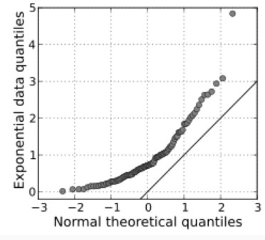

If the two distributions being compared are similar, the points in the Q–Q plot will approximately lie on the line y = x. If the distributions are linearly related, the points in the Q–Q plot will approximately lie on a line, but not necessarily on the line y = x. Q–Q plots can also be used as a graphical means of estimating parameters in a location-scale family of distributions.

A Q–Q plot is used to compare the shapes of distributions, providing a graphical view of how properties such as location, scale, and skewness are similar or different in the two distributions.