**12-08-24**

**Pipelines:- Assignment-1:-**

creating a pipelines , dev, tets, prod we have to clone it.

and creating branches then releasing it.

After creating webapp- in deployment – add a deployment slot as dev and test, then goto overview and copy paste the default domain link in browser

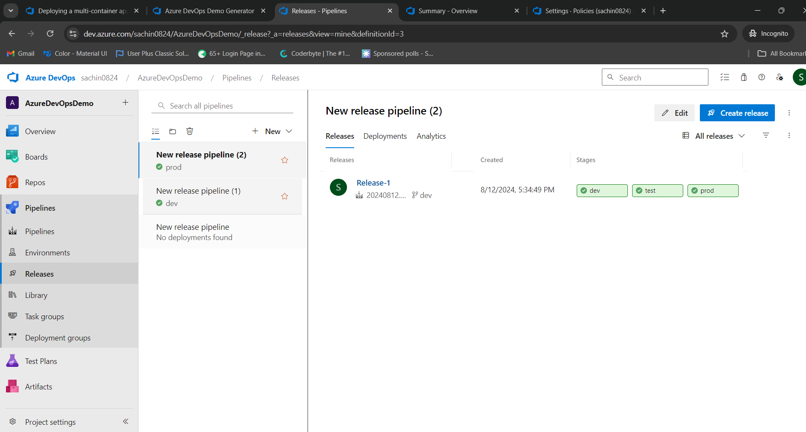

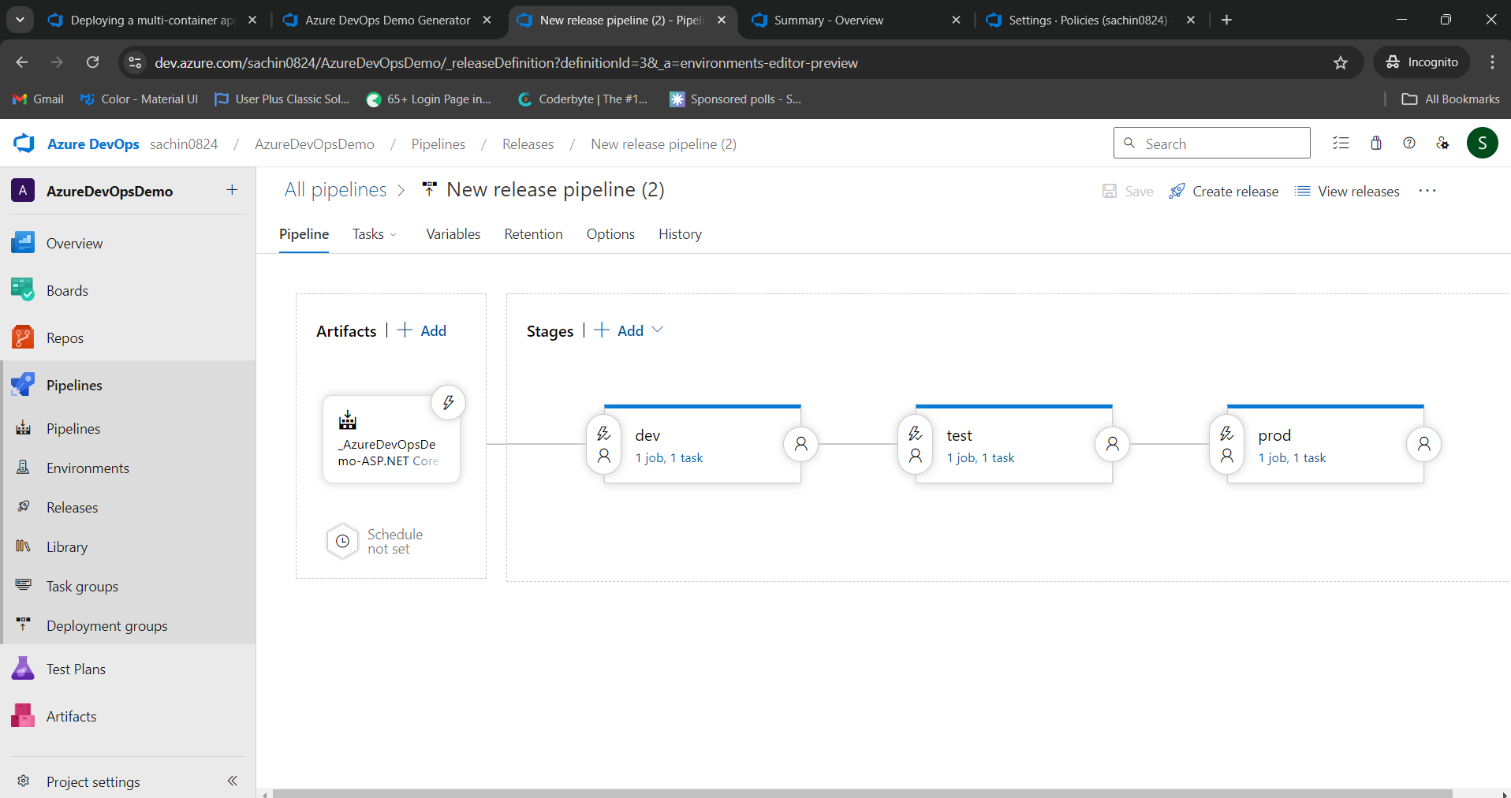

Test-output

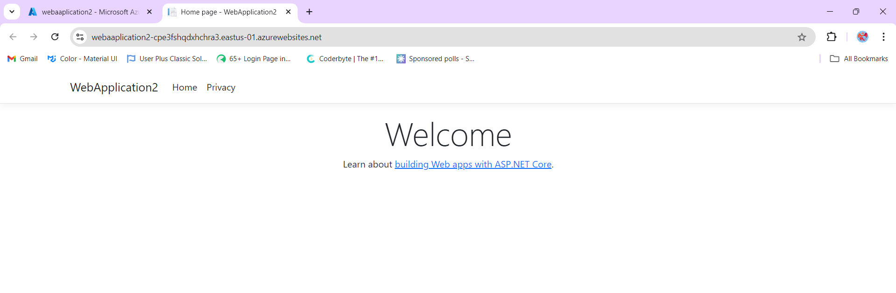

Prod-output

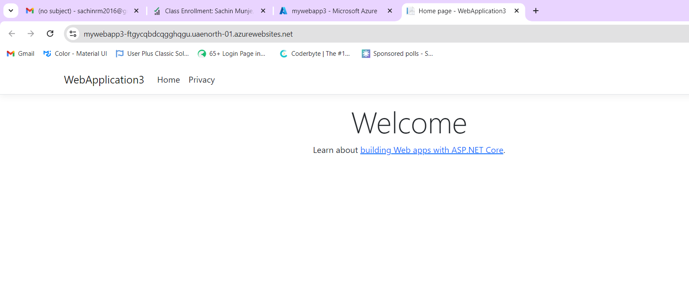

Dev-output

