**13-08-24**

**DOCKER**

**Assignment-2**

Code was written and deployed to docker….entered commands

1. Installed python 3.11 or 3.12

2. create a python file {sachinrm.py} program code: print("Sachin Munje")

3. Create a docker file

FROM python:latest

COPY sachinrm.py /

RUN pip install pandas

CMD ["python", "./sachinrm.py"]

4. Terminal Commands

docker build -t python- sachinrm .

docker run python- sachinrm

docker images (get the image id and copy it)

docker tag (imageid) (username)/python- sachinrm:latest

docker push (username)/python- sachinrm

has context menu

**DOCKER HUB:-**

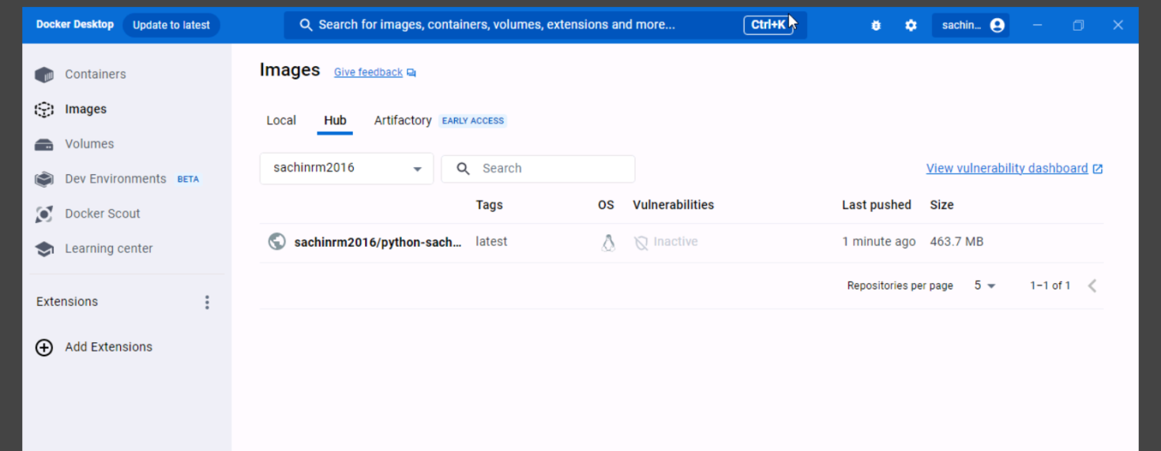

**VSCODE**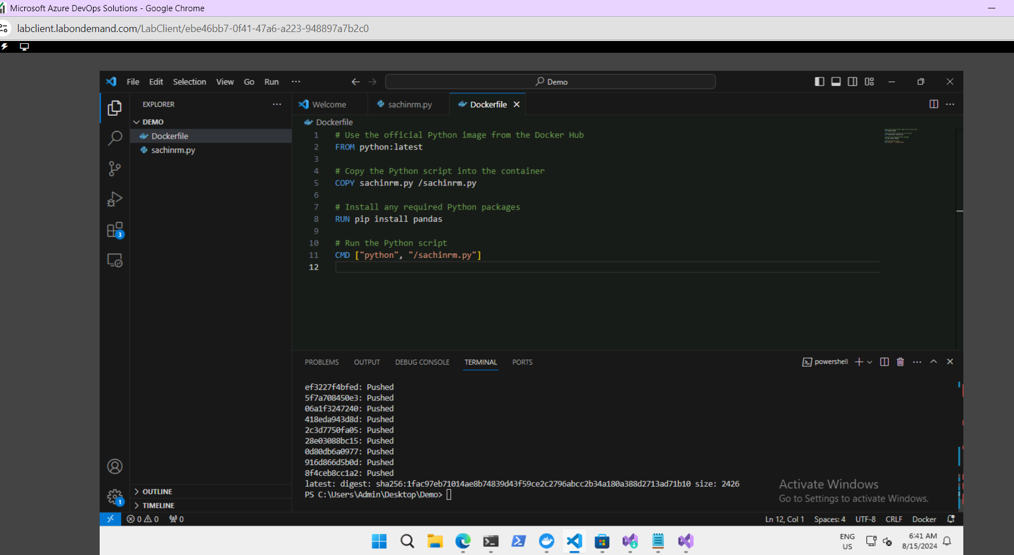

**2-CREATED A DOCKER WEBAPPLICATION AND DEPLOYED TO A WEBAPP AND THEN GOT THE OUTPUT.**

Open Visual Studio(Purple Icon)

Create a new project

Choose ASP.Net Core Web App

Enable Docker Checkbox

Click Create

Right click on your app name

Click on Publish

Chose target as Docker Container Registry

Choose Docker Hub

Enter Docker Hub username. Password is optional

Select Docker Desktop

Click Publish Button

Deoply web application

Choose Contaier as Publish on azure web app

Navigate to Container Tab on top

Click on Docker Hub or other registries

Enter the image name and tag that you 'll get from Docker hub

Create web app and share the URL

