Chapter 1
INTRODUCTION
- Floods are among the most destructive natural disasters, causing severe loss of life, property, and infrastructure every year. Early detection and timely warnings play a crucial role in minimizing flood damage and ensuring public safety. Traditional flood monitoring systems are often expensive, complex, and limited to large-scale deployments, making them unsuitable for small or remote areas.
- The objective of this project is to design and implement a low-cost, reliable, and real-time flood monitoring system using Arduino technology. The system continuously monitors water levels using an ultrasonic sensor and provides alerts when the water level crosses predefined thresholds. Visual information is displayed on an LCD screen, while an audible buzzer alerts users during critical flood conditions.
- By integrating simple hardware components with effective programming logic, the system offers an efficient solution for early flood detection. This project demonstrates how embedded systems and sensors can be applied to real-world environmental monitoring problems, making it suitable for educational, residential, and small-scale flood-prone applications.

  - Brief history of flood monitoring system
Early flood monitoring relied on manual observation of water levels using gauges and markers placed near rivers and dams. With technological advancements, automated systems using mechanical sensors and telemetry were introduced. Modern flood monitoring systems employ digital sensors, satellite communication, IoT platforms, and real-time data analytics to predict and monitor flood conditions more accurately.

  - Modern flood system
Modern systems use ultrasonic sensors, pressure sensors, wireless communication, cloud platforms, and mobile alerts. These systems provide real-time monitoring, data logging, and early warning notifications, significantly improving disaster preparedness and response capabilities.

Chapter 2
Problem Statement
2.1 Description
Floods often occur suddenly due to heavy rainfall, dam overflows, or poor drainage systems. Many flood-prone areas lack affordable and reliable monitoring systems that can provide early warnings. Manual monitoring methods are time-consuming, inaccurate, and dependent on human intervention, which can lead to delayed responses during emergencies.

2.2 Challenge Statement
The main challenge is to develop a cost-effective, easy-to-deploy flood monitoring system that can continuously measure water levels and provide timely alerts without requiring complex infrastructure or advanced technical expertise.
Chapter 3
3.1 Design Thinking Process
Empathize: Interaction with residents in flood-prone areas revealed the need for early alerts and simple monitoring solutions.
Define: The key requirement identified was real-time water level detection with clear alerts.
Ideate: Multiple ideas were explored, including camera-based and sensor-based systems.
Prototype: A hardware prototype using Arduino, ultrasonic sensor, LCD, and buzzer was developed.
Test: The system was tested under different water levels and successfully triggered alerts at critical thresholds.

3.2 Methodology
The system works by continuously measuring the distance between the ultrasonic sensor and the water surface. The Arduino processes this data to calculate water level. Based on predefined limits, the system updates the LCD display and activates the buzzer when danger levels are reached.
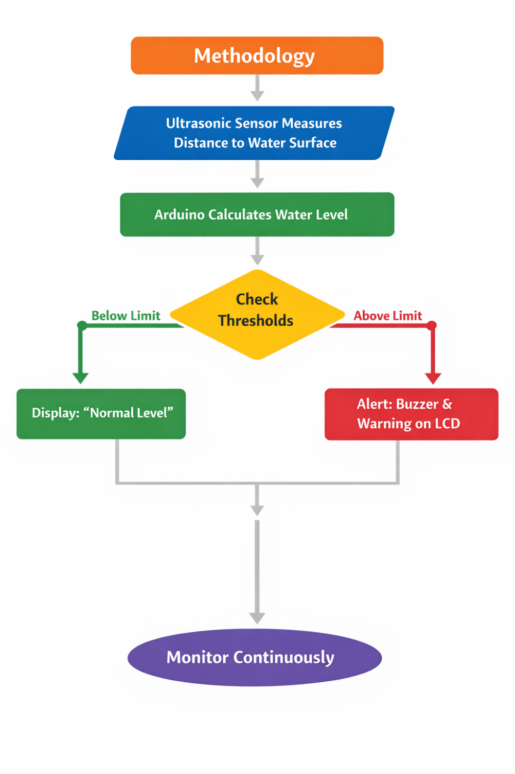

  - Prototype Description

3.3.1 Materials Used
• Arduino UNO – Main microcontroller for system control
• HC-SR04 Ultrasonic Sensor – Measures water level using ultrasonic waves
• I2C LCD Display (16×2) – Displays water level and alert status
• Buzzer – Provides audible warning during flood conditions
• Jumper Wires – For circuit connections
• Breadboard – For prototyping
• 5V Power Supply – Powers all components

3.3.2 System Diagram

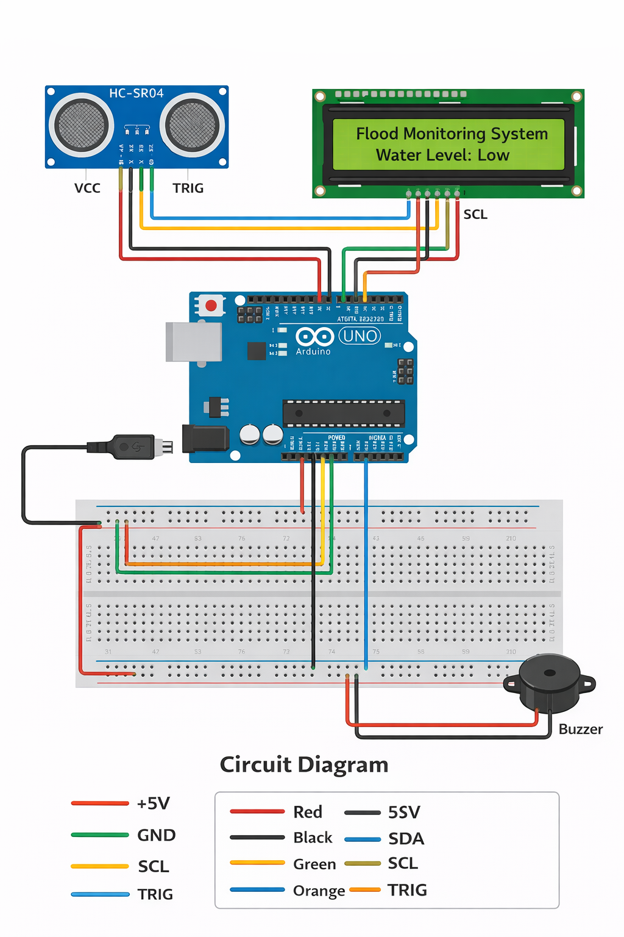

Chapter 4
Implementation
The system is implemented using Arduino programming. The code reads distance values from the ultrasonic sensor, converts them into water level readings, and compares them with predefined threshold values. Based on the condition, the LCD displays normal, warning, or danger messages, and the buzzer is activated during critical situations.
Arduino code:
#include <Wire.h>
#include <LiquidCrystal_I2C.h>
// LCD address (most common: 0x27 or 0x3F)
LiquidCrystal_I2C lcd(0x27, 16, 2);
// Ultrasonic pins
#define trigPin 9
#define echoPin 10
// Buzzer pin
#define buzzer 8

// Tank height in cm (change according to your tank)
const int tankHeight = 10;
void setup() {
pinMode(trigPin, OUTPUT);
pinMode(echoPin, INPUT);
pinMode(buzzer, OUTPUT);
lcd.init(); // Initialize LCD
lcd.backlight(); // Turn on backlight
lcd.setCursor(0, 0);
lcd.print("Water Level");
lcd.setCursor(0, 1);
lcd.print("Monitoring");
delay(2000);
lcd.clear();
}
void loop() {
long duration;
int distance;
int waterLevel;
int percentage;
// Trigger ultrasonic pulse
digitalWrite(trigPin, LOW);
delayMicroseconds(2);
digitalWrite(trigPin, HIGH);
delayMicroseconds(10);
digitalWrite(trigPin, LOW);
duration = pulseIn(echoPin, HIGH);
distance = duration * 0.034 / 2;
waterLevel = tankHeight - distance;
// Limit values
if (waterLevel < 0) waterLevel = 0;
if (waterLevel > tankHeight) waterLevel = tankHeight;
percentage = (waterLevel * 100) / tankHeight;
// Display on LCD
lcd.setCursor(0, 0);
lcd.print("Level: ");
lcd.print(percentage);
lcd.print("% ");
lcd.setCursor(0, 1);
if (percentage >= 70) {
lcd.print("Tank FULL ");
digitalWrite(buzzer, HIGH);
} else if (percentage >= 40) {
lcd.print("Tank MEDIUM ");
digitalWrite(buzzer, LOW);
} else {
lcd.print("Tank LOW ");
digitalWrite(buzzer, LOW);
}
delay(1000);
}

Chapter 5
Results and Analysis
User Testing & Observations
Sample:
Tested under controlled water level conditions.
Quantitative Results:
- Accurate water level detection
- Immediate alert generation at critical levels
- Stable and continuous operation
Qualitative Observations:
- Easy to understand display messages
- Loud and clear buzzer alert
- Reliable performance during repeated tests

Chapter 6
The Smart Flood Monitoring System successfully demonstrates a low-cost and efficient solution for early flood detection. By using simple sensors and Arduino technology, the system provides real-time monitoring and alerts, helping reduce potential flood damage. The project meets its objectives of accuracy, reliability, and ease of implementation.
Future Work
- Integration with IoT platforms for remote monitoring
- SMS or mobile app-based alert system
- Data logging for flood pattern analysis
- Solar power support for outdoor deployment

References
•Arduino Official Documentation – https://www.arduino.cc
• HC-SR04 Ultrasonic Sensor Datasheet
• Embedded Systems by Raj Kamal
• Flood Monitoring Techniques – Online Research Articles

