# SACHIN NEGI(BATCH-7)

# Documentation on lambda function

**Steps of creating lambda function**

* Goto AWS portal and search for lambda function, and click on create Lambda function.
* select author from scratch
* Now give basic information that includes:

1. Function name
2. Runtime: language you want to use to create a function (Python 3.9)
3. Architecture: x86_64

* Now Give advanced setting that includes:

1. Enables tags: (Name, owner, Purpose)

* Now Click on Create.

**Steps to add trigger and permission to trigger on your Lambda Function**

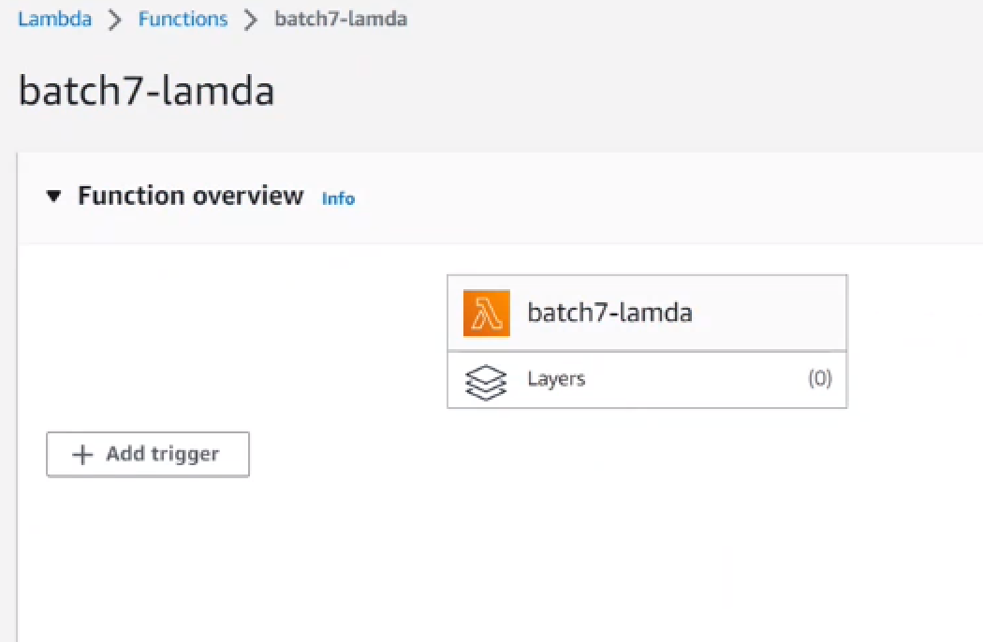

* Click on Add Trigger.

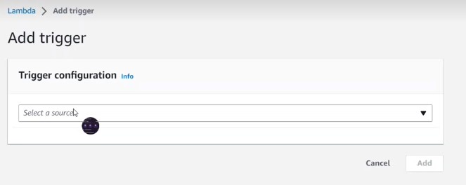

* Enter a source as S3

## Pre-requisite:

create a S3 bucket and the steps are as follow:

1. Goto Services, Select S3 then click on create bucket.
2. Give general configuration that includes:
3. Bucket name AWS region.
4. Now checkin the CheckBox of Acknowledge.
5. Add tags (name,owner, purpose)
6. Click on Create.

* Select the name of the bucket that you created.
* Now select event type (All object create event)
* Checkin the Checkbox of acknowlwdgement.
* Click on Add.

## Adding Permission to the triggers:

* goto Permission, than role name (Link), click on that and new screen will open.
* Click on add permission
* attach policy
* give amazonS3FullAccess.
* Click on button Add.

Since we added the trigger i.e. S3, now to trigger the function we have to upload something on th buket.

## Triggering the function:

* Open the code and type: print(event)

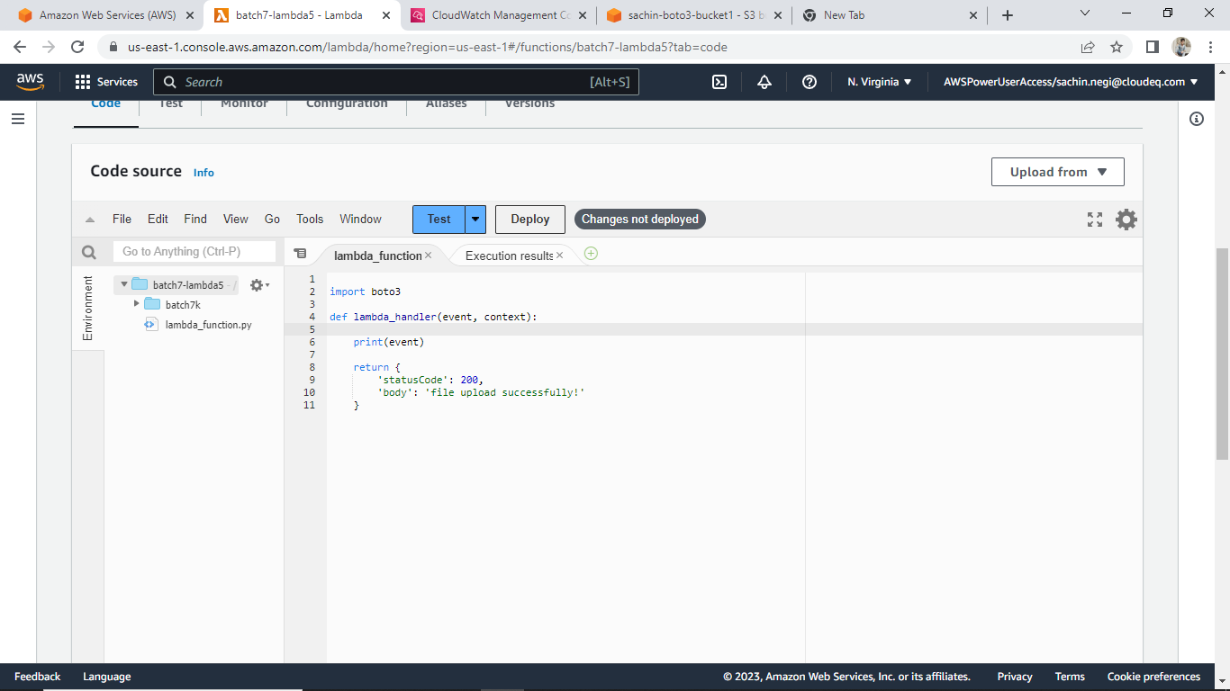

* Click on test
* New screen will display that will ask you to configure test event.
* select test event action as create new event.
* Give the event name.
* set event sharing setting as private.
* Give the key values and click on save.
* Click on Deploy
* Click on test.
* Now you can monitor the function at cloud watch under Monitor option.

**Adding destination to your lambda function**

* Click on add destination and gives the destination configuration.

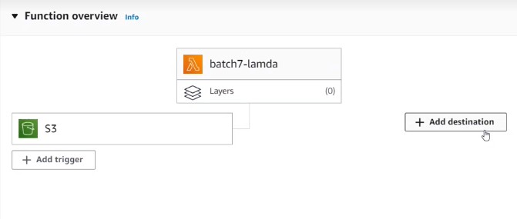

* Select the type of invocation i.e. SOURCE as Asynchronous invocation to map destination.
* Set condition for using destination as On Sucess
* Set Destination type as SNS. Goto AWS Services and select SNS and than goto TOPICS

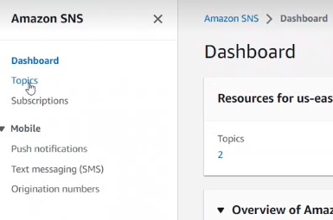

1. Click on create Topic and give details like:
2. Select type as Standard
3. Give Name of topic.
4. Add tags
5. Click Create and Add Subscription to it by clicking on Create subscription. Using this we can use SNS with other lambda services.

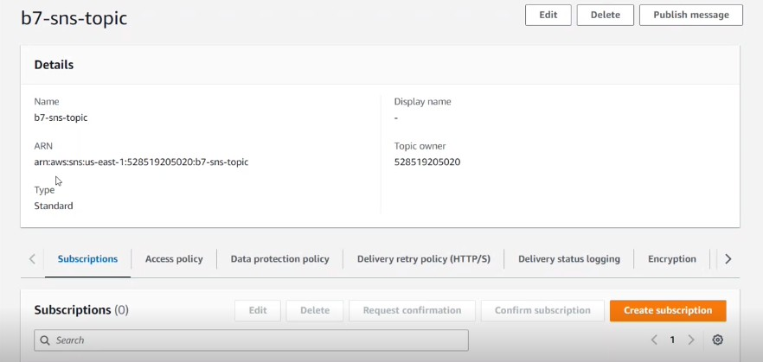

1. Now Select the protocol as EMAIL (as we want to receive the notification on our email.)
2. Give your email address in ENDPOINT.
3. Click Create Subscription.
4. You will receive a mail at your email address, do the confirmation and you are ready to go.

* Choose a destination from drop down list as name of your SNS topic
* Click on save.

**To invoke the lambda function using boto3**

* Create a lambda function which contains the action part.
* Then create another lambda function which will call the first lambda function using Boto3.
* When we run the 2nd lambda function, it will show that the execution is successful under the execution results tab.
* After that, goto the first lambda function and open the cloudwatch to check if the desired output is there or not.

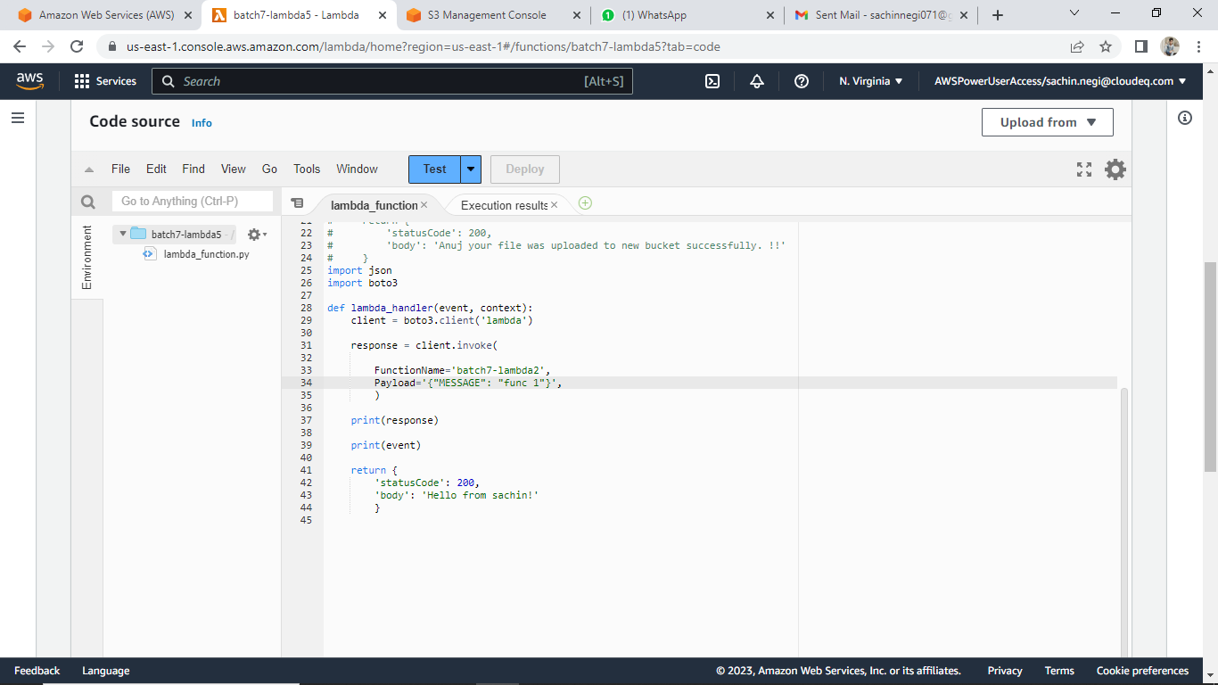

Enable policy AWSLambdaRole to invoke one lambda function in another lambda function.