SACHIN NEGI- Batch7

# create a lambda function which will invoke another lambda function

steps:

* Create a lambda function.
* Then create another lambda function which will call the first lambda function using Boto3.
* When we run the 2nd lambda function, it will show that the execution is successful under the execution results tab.

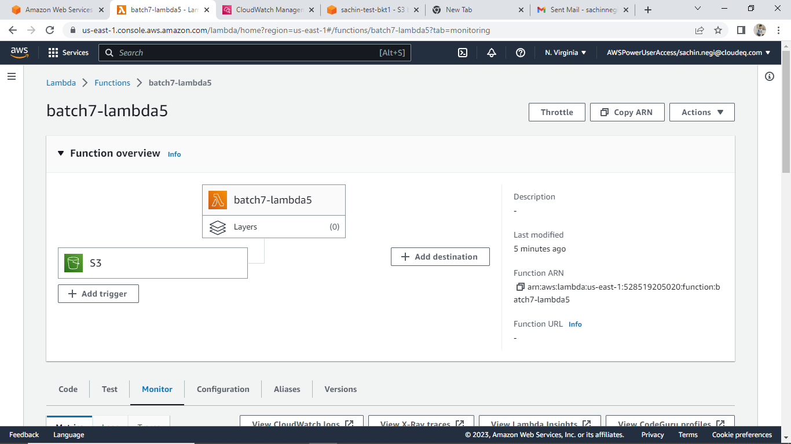

Invoking ‘batch7-lambda2’ function in ‘batch7-lambda5’ function with boto3 code.

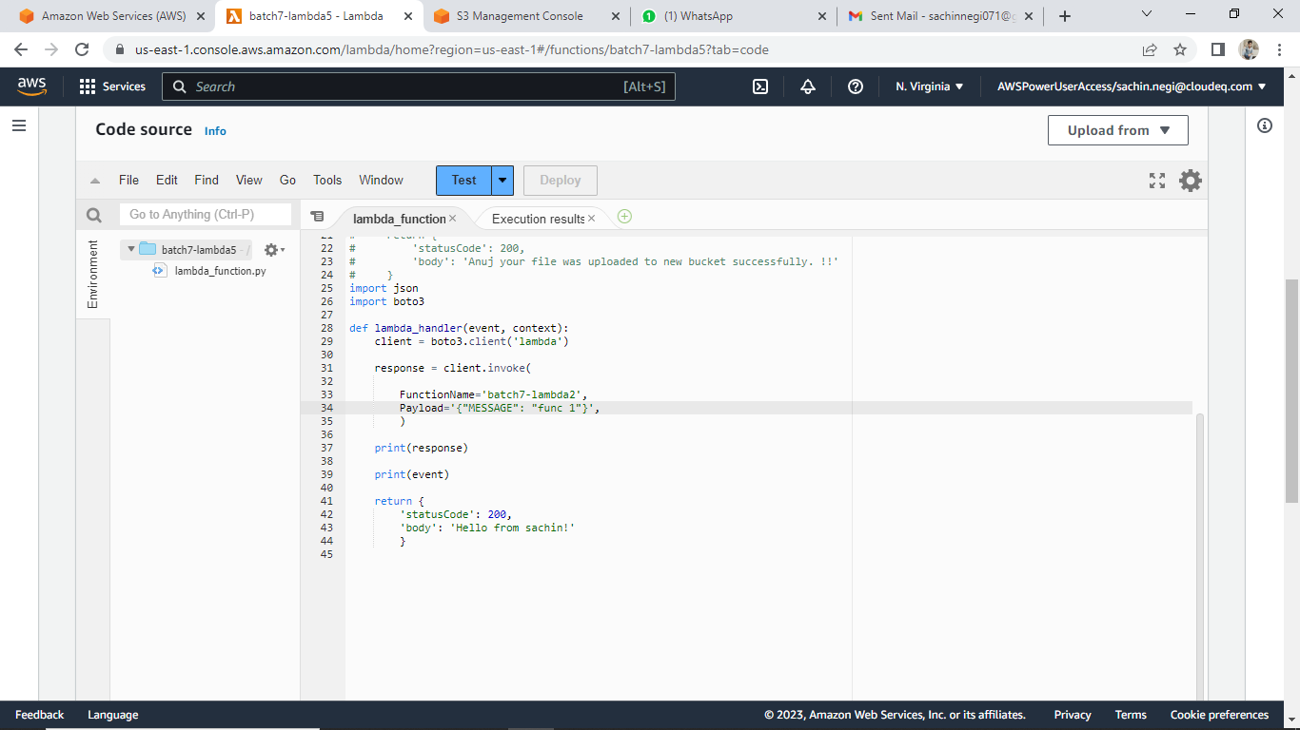

Cloudwatch page:

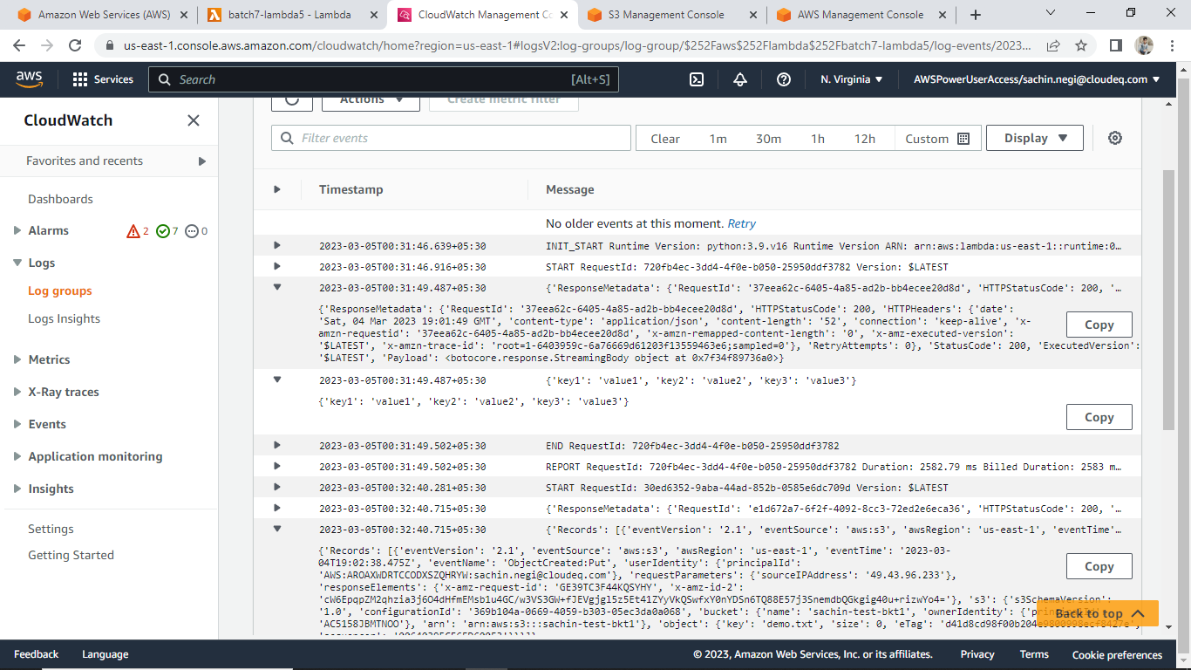

# create a lambda that will have 2 triggers -i) when object is uploaded in s3 bucket and ii) when object is deleted from s3 bucket. And have sns as destination and the result should display only the bucket name.

STEPS:

* + adding 2 trigger, one for uploading object in s3 bucket and another one is for deleted object from s3 bucket

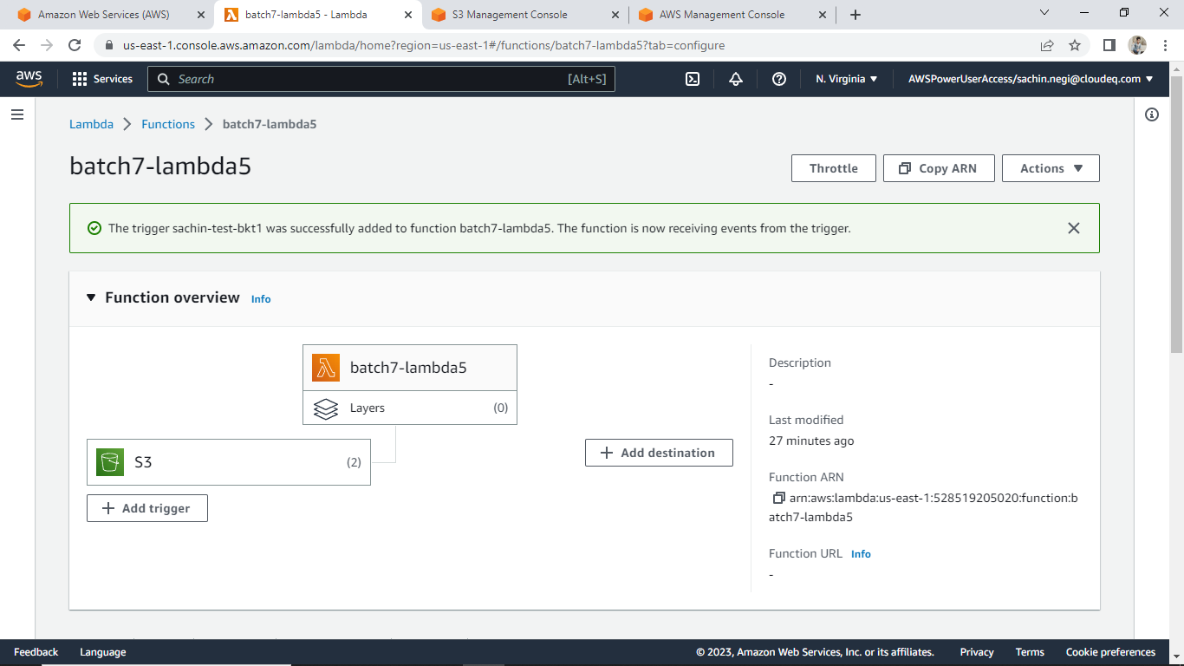

* + when object is uploaded in s3 bucket

Cloudwatch page:

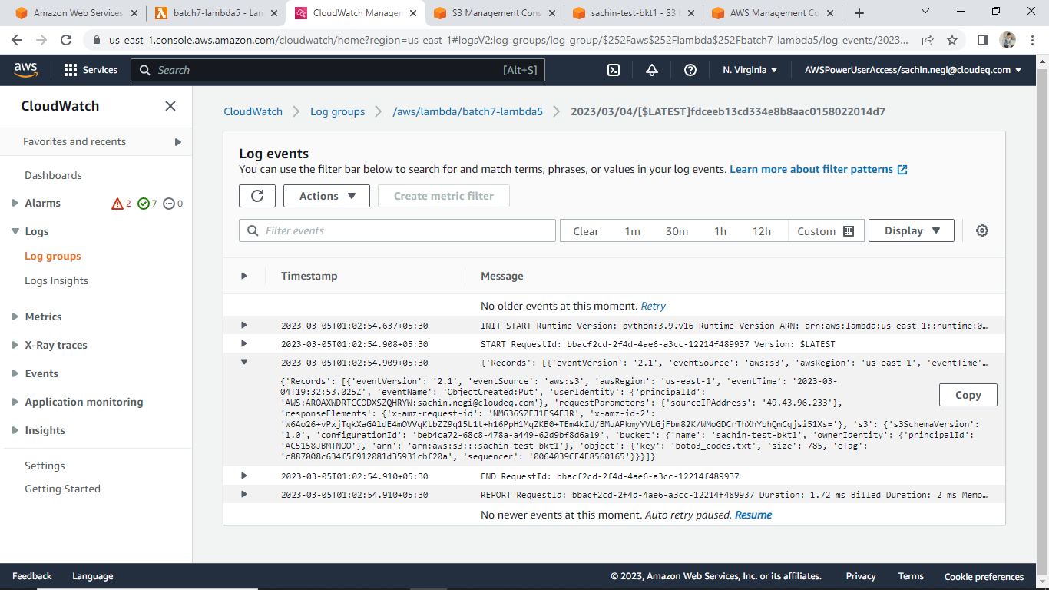

* + when object is deleted in s3 bucket

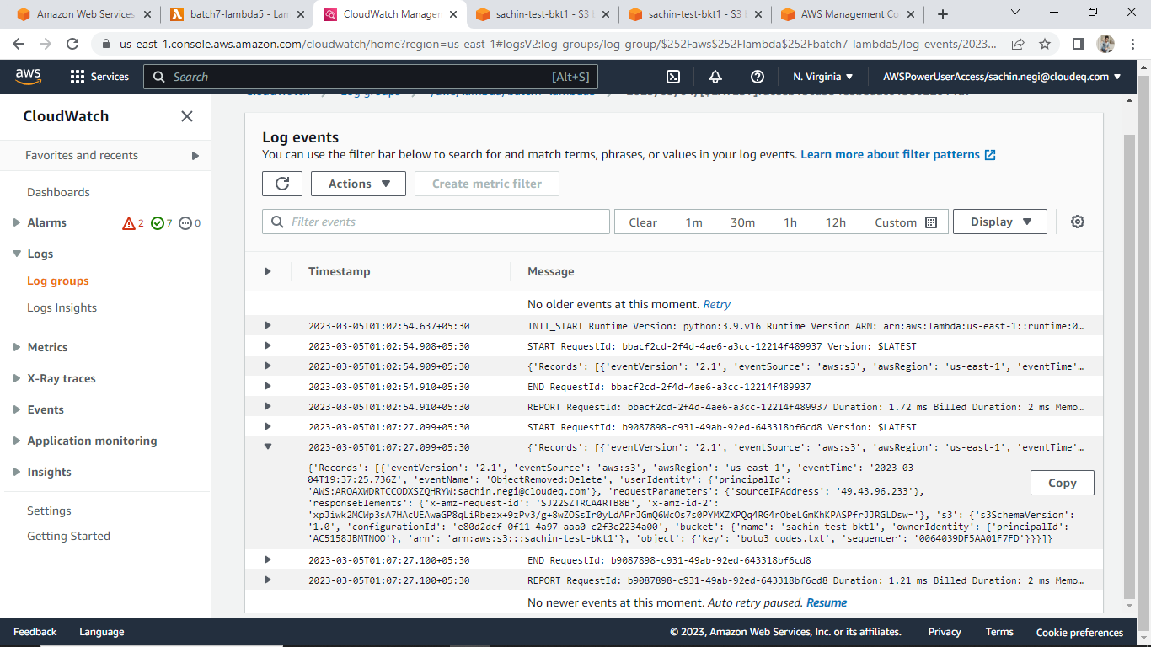

Creating sns-

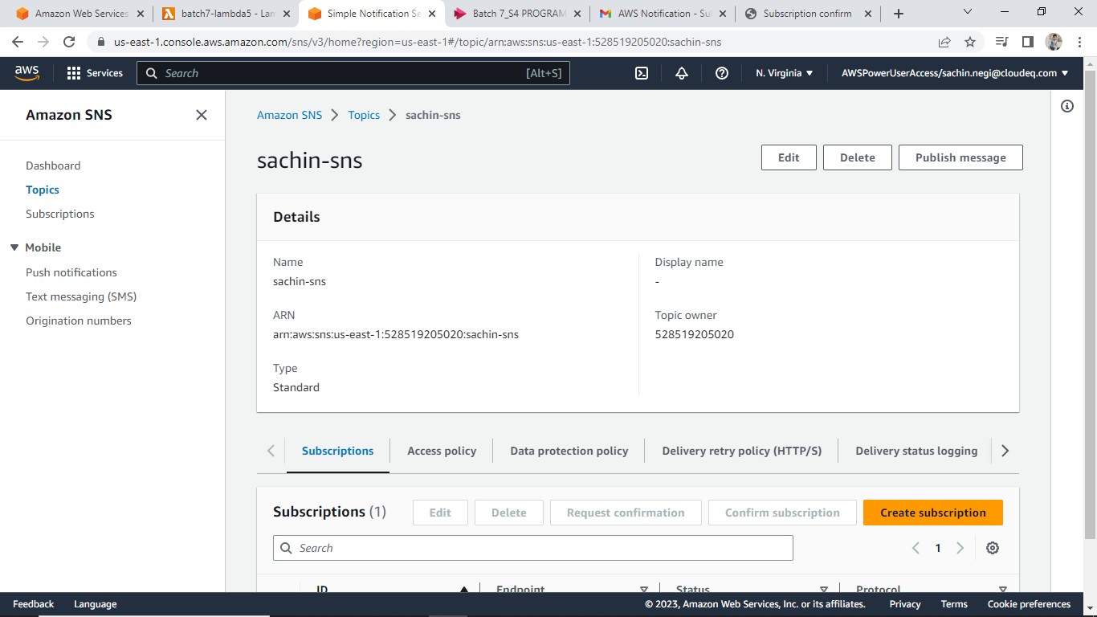

Receiving a email for confirm subscription.

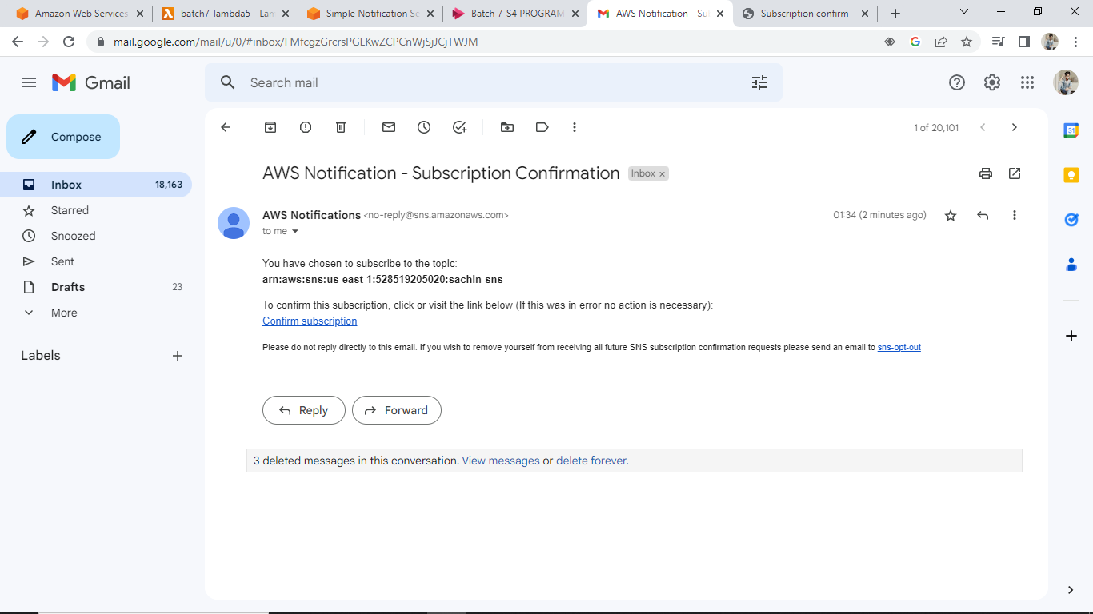

Add destination

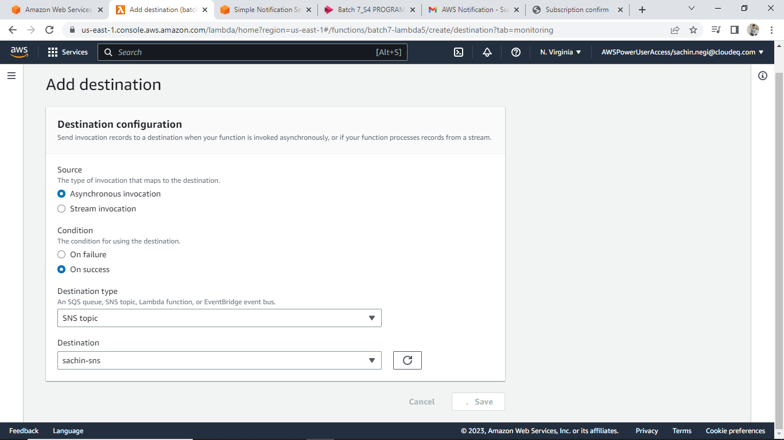

# create lambda function that will trigger when an object is uploaded in s3 bucket. Create a new bucket and upload the same object (used for for triggering) in new bucket using boto3.

1. lambda function that will trigger when an object is uploaded in s3 bucket

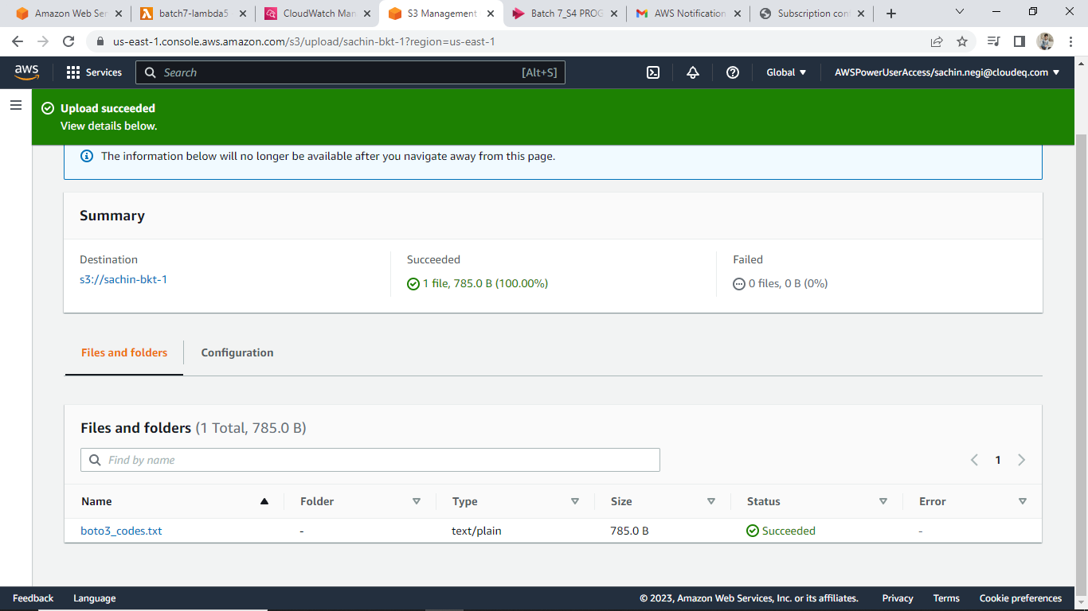

Cloudwatch page:

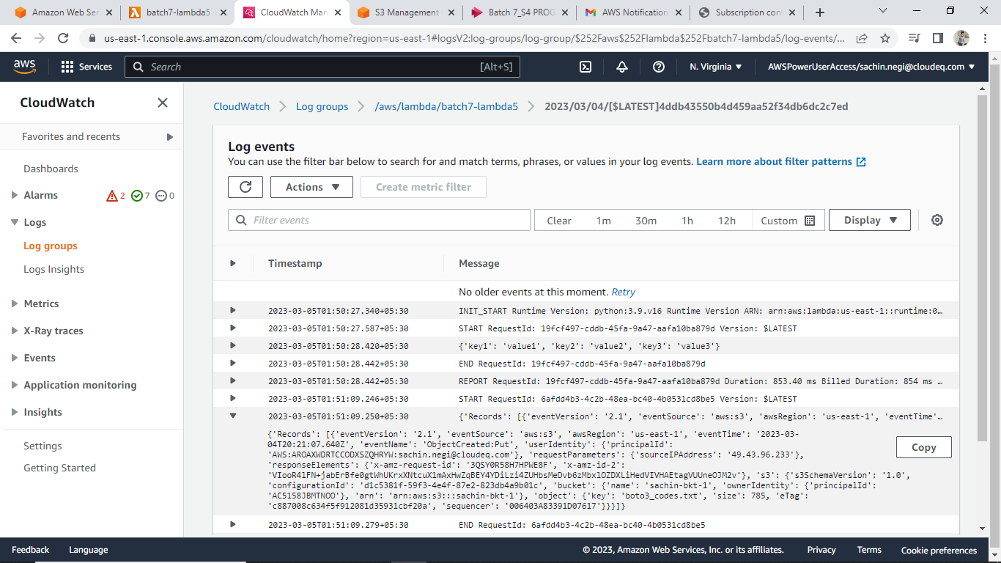

ii- now creating a new bucket and upload same object using boto3

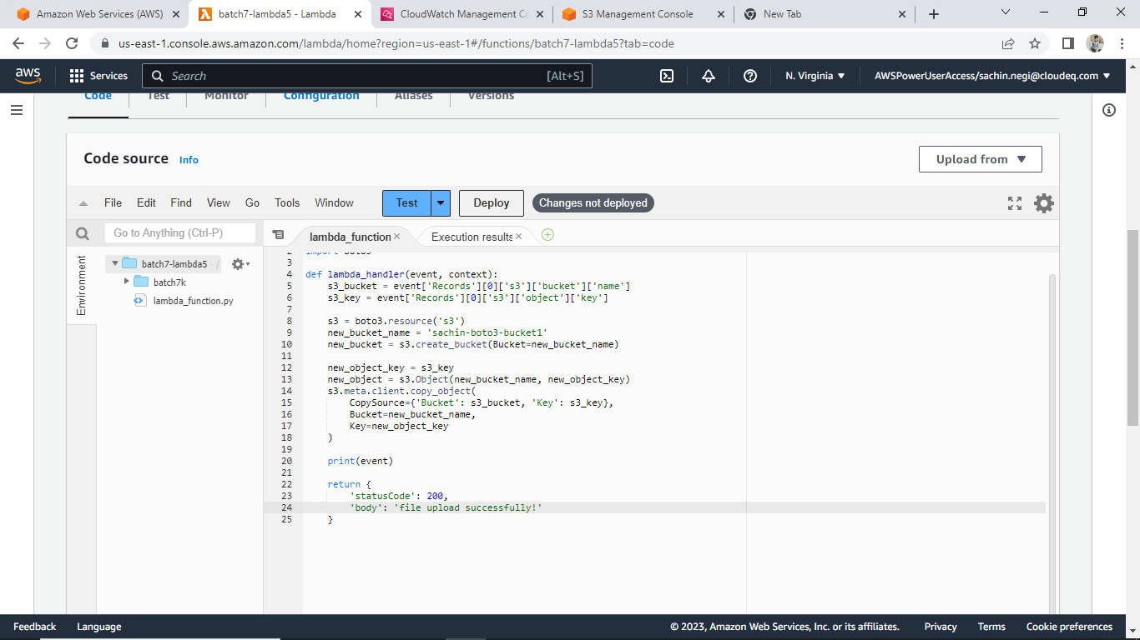

Bucket created !!

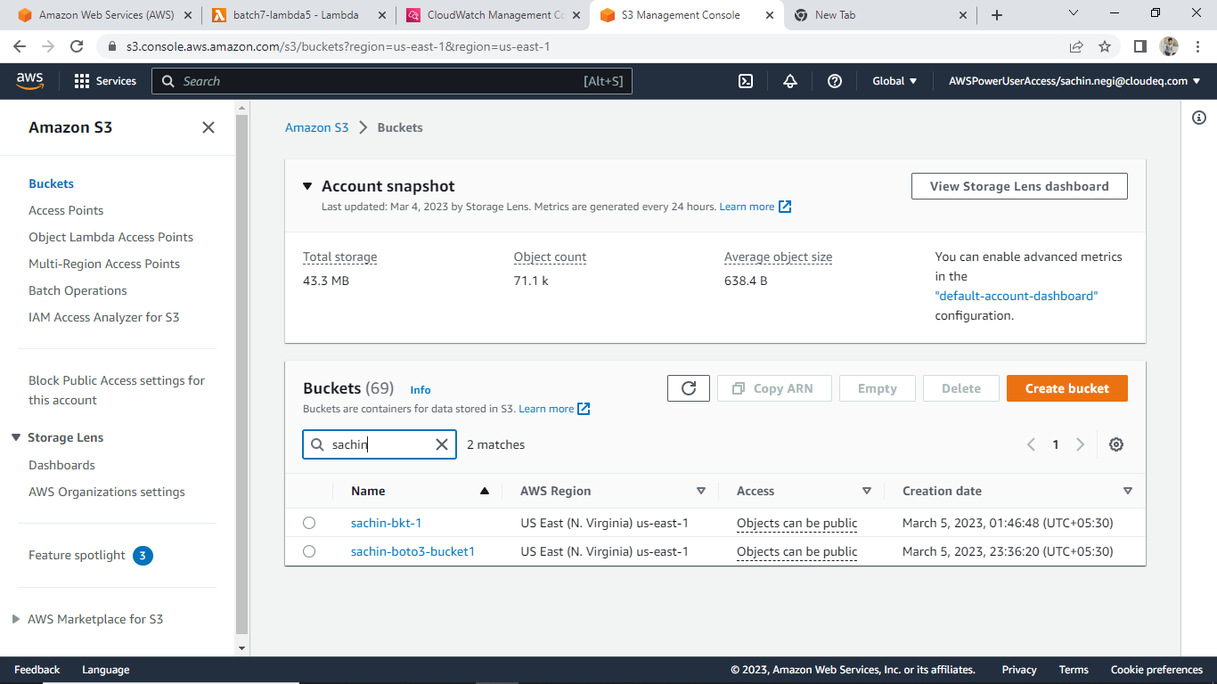

With same object -

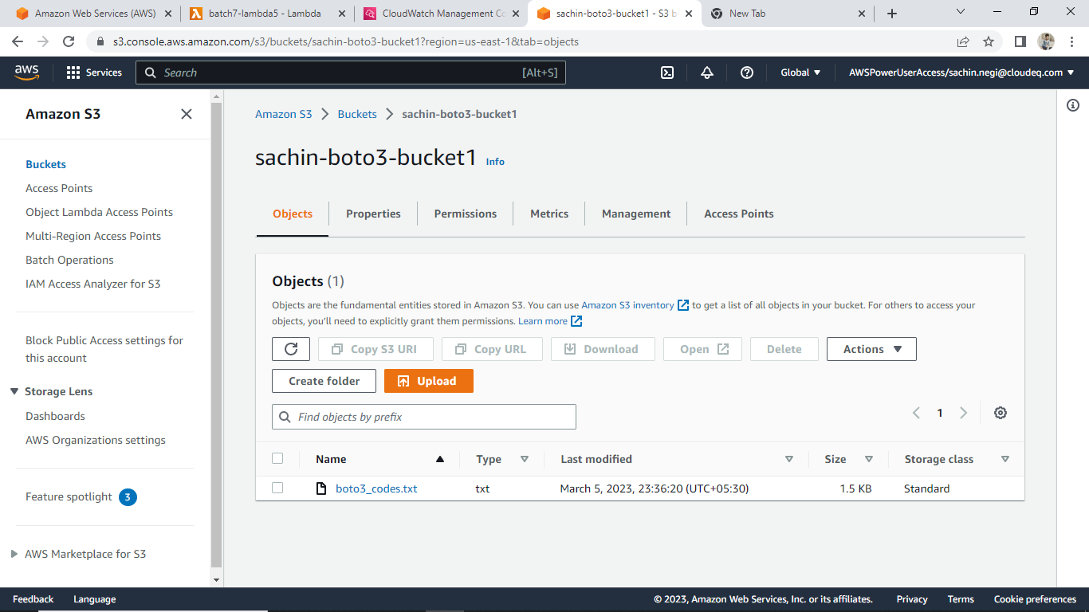

Cloudwatch page:

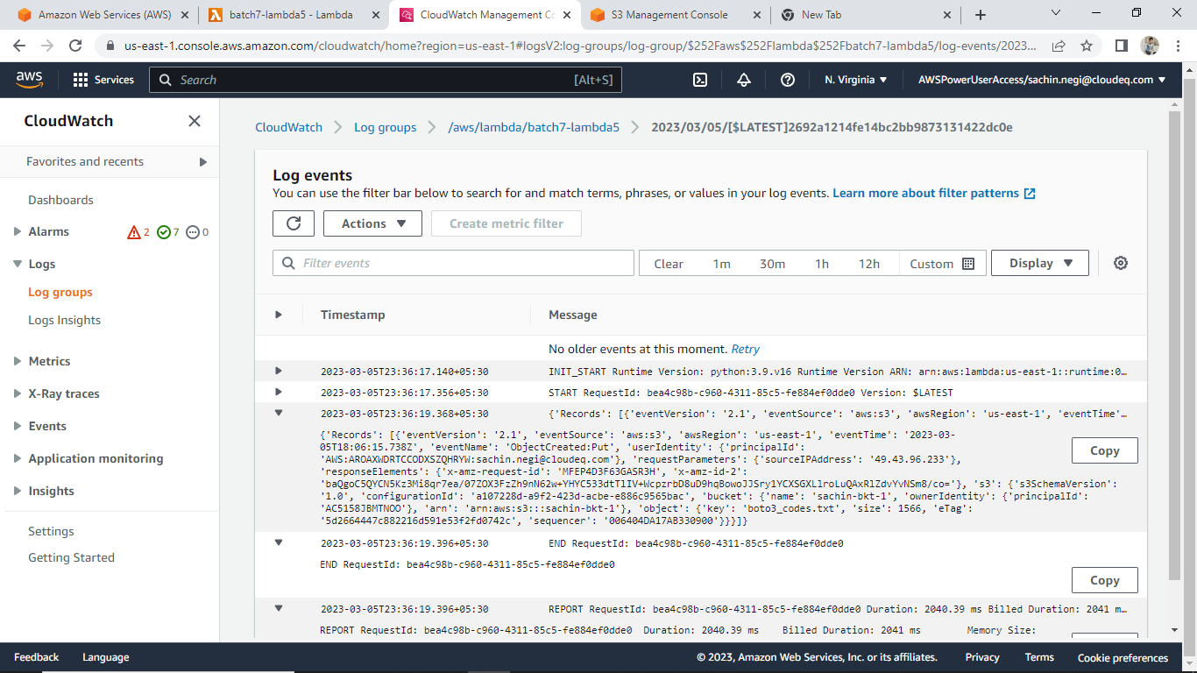

Thankyou