TABLE OF CONTENTS
Title Page 1
TABLE OF CONTENTS 3
CONTRIBUTORS 7
AUTHENTICATION STATEMENT 8
ABBREVIATIONS AND DEFINITIONS OF TERMS 9
1 EXECUTIVE SUMMARY 11
2 INTRODUCTION 11
3 OBJECTIVES 11
4 DATA 12
4.1 Description of the Analysis Data 12
4.2 Bioanalytical Methods 14
4.3 Preparation of Analysis Dataset and Source Data File 14
4.4 Derived Analysis Dataset 14
4.5 Handling of Missing and Erroneous Data 14
4.6 Handling of Observations Below the LLOQ 15
4.7 Handling of Outliers 15
4.8 Handling of Covariates 15
5 PRIOR KNOWLEDGE AND EXPERIENCE 15
5.1 Prior PK Experience 15
6 METHODS 16
6.1 Overview of the Analysis 16
6.2 Exploratory Data Analysis 16
6.3 Population PK Model Building 16
6.3.1 Structural Model Development 16
6.3.2 Between Subject Random Effect Model 16
6.3.3 Residual Variability Random Effect Model 16
6.3.4 Evaluation of Covariates 16
6.4 Model Evaluation 17
6.5 Simulations 17
6.5.1 Assessment of the Clinical Relevance of Identified Covariates 17
6.5.2 Exposure metrics 17
6.6 Hardware and Software Details 17
6.7 Deviations from Analysis Plan 17
7 RESULTS 17
7.1 Summary of Analysis Dataset 18
7.2 Exploratory Data Analysis 19
7.2.1 Covariates 19
7.2.2 Pharmacokinetics 24
7.3 Model Development 28
7.3.1 Base Model 28
7.3.2 Covariate Model 30
7.3.3 Final Model 31
7.3.4 Handling of Outliers 31
7.3.5 Sensitivity Analyses 32
7.4 Simulations/Predictions 32
7.4.1 Clinical Impact of Covariates 32
7.4.2 Exposures at X mg daily dosing 33
8 DISCUSSION 33
9 CONCLUSIONS 33
10 REFERENCES 34
11 Appendices 34

LIST OF TABLES
Table 1 Summary of Studies Included in the Population PK Analysis 13
Table 2 Summary of Analysis Dataset 18
Table 3 Summary of Covariates Overall and by {{S}} 20
Table 4 Summary of key models considered during model development 28
Table 5 Base Model Parameter Estimates 29
Table 6 Final Model Parameter Estimates 31
Table D1 Summary of available data by study and dose 38

LIST OF FIGURES
Figure 1 Distributions and Correlations of Continuous Covariates 20
Figure 3 Correlation between Continuous Covariates and Renal Function 21
Figure 4 Distributions and Correlations of Categorical Covariates 22
Figure 6 Concentrations versus Time after Dose by {{Study and Dose}} (log scale) 23

LIST OF APPENDICES
Appendix A Model Analysis Plan 35
Appendix B Dataset Specification 36
Appendix C Data Exclusions 37
Appendix D Additional Results 38

CONTRIBUTORS
The following personnel were significantly involved in the generation of this document:
Prepared by: | Name, Surname, (PhD),  Position,  AstraZeneca, City, Country
Reviewed by: | Name, Surname, (PhD), (one per relevant project member)  Position,  AstraZeneca, City, Country
Approved by: | Name, Surname, (PhD),  Position,  AstraZeneca, City, Country

AUTHENTICATION STATEMENT
Study Code(s):
Document Title: | {{Title of MAR}}

The analysis has been performed in accordance to the procedures described in the modeling analysis plan [add reference]. This modeling analysis report provides an accurate and complete record of the methods used and results obtained, and documentation of any deviations from this modeling analysis plan.
Signature: | See appended signature page
Approve Name, Surname (PhD),
Position,
AstraZeneca, City, Country
Date: | See appended signature page

ABBREVIATIONS AND DEFINITIONS OF TERMS
The following abbreviations and special terms are used in this report.
Abbreviation or special term | Explanation
α | Distributional rate constant
β | Terminal elimination constant
γ | Gamma constant
ε | Residual error on measurement
η | Between Subject random variability term in non-linear mixed effect analysis. The difference between the individual parameter estimates and the population parameter estimate.
θ | Fixed effect parameter in population PK analysis
σ² | Variance of the residual variability
ω² | Variance of the between subject random variability
AIC | Akaike information criterion
AUC_{0-x} | Area under the plasma concentration - time curve from time zero to time x
BID | bis in die (twice daily dosing)
BLQ | Below lower limit of quantification
BMI | Body mass index
BSV | Between subject variability
BWT | Body weight
C_{max} | Maximum plasma concentration
C_{trough} | Plasma concentration right before the next dose
CL/F | Apparent total body clearance of drug from plasma after extravascular administration
CI | Confidence interval
CMT | Compartment
CV | Coefficient of variation
CWRES | Conditional weighted residuals
DCO | Data cut off
DF | Degree of freedom
EBE | Empirical Bayes estimates
FOCE | First order conditional estimation method
IPRED | Individual predictions
IMP | Importance sampling
Ka | Absorption rate constant
LLOQ | Lower limit of quantification
MAP | Modeling analysis plan
MAR | Modeling analysis report
MDV | Missing dependent variable
OFV | Objective function value
n | A unitless number
NA | Not applicable
NONMEM | Nonlinear mixed-effects modelling software
popPK | Population pharmacokinetic(s)
PK | Pharmacokinetic(s)
PRED | Population predictions
Q/F | Apparent inter-compartmental clearance
QD | Once daily administration
RSE | Relative standard error
RV | Residual Variability
SAEM | Stochastic approximation expectation maximization
SCM | Stepwise covariate modeling
SD | Standard deviation
t_{1/2} | Terminal elimination half-life
t_{max} | Time to reach peak concentration
TV | Typical population value
Vc/F | Apparent volume of the central compartment
Vp/F | Apparent volume of the peripheral compartment
VPC | Visual predictive check
WRES | Weighted residuals

EXECUTIVE SUMMARY

INTRODUCTION

OBJECTIVES

DATA

Description of the Analysis Data

Table 1 Summary of Studies Included in the Population PK Analysis
Study number  (Phase/abbreviation)  Status  DCO | Study design | Study  Population | Dosage Regimen(s) and  Route of Administration | Participants  evaluable  for PK | PK sampling schedule
DxxxCxxxxx  (Phase 1/SAD)  Completed  DCO: dd/mm/yyyy | Investigator- and subject-blind, sponsor-open, randomized, placebo-controlled, single oral ascending dose study | Adult healthy volunteers | Single doses of X mg, Y mg, or Z mg. | 30 participants | pre-dose, 0.5, 1, 2, 3, 4, 6, 8, 12, 24, 36, 48, and 72 hours post-dose.
DxxxCxxxxx  (Phase 2b: Name)  Ongoing  DCO: dd/mm/yyyy | Randomized, Double-Blind, Placebo-Controlled, Multicenter, Parallel-Group, Dose-Ranging Study to Evaluate the Efficacy and Safety of AZD1234 as Compared to Placebo | Adult participants with [disease] | Once daily dosing of X mg, Y mg, or Z mg. | N_{total} = 300 participants.  X mg (N=100),  Y mg (N=100), or  Z mg (N=100) | At weeks 3 and 12: pre-dose.  At week 12, in a subset of the population (n=50 patients):  1, 2, 3, 4, 6, and 8 hours post-dose.
{{add any additional studies}}

Bioanalytical Methods

Preparation of Analysis Dataset and Source Data File
An analysis dataset {{ name of source data file }} was prepared according to AZ Clinical Data Standards. The programs were documented and archived to maintain an audit trail. Additional quality controls were performed by the pharmacometrician, according to AZ Clinical Data Standards. The dataset is described in the Pharmacometrics Data Specification (Appendix B).

Derived Analysis Dataset

Handling of Missing and Erroneous Data
The handling of missing or erroneous data was performed as outlined in the MAP.
A list of all omitted observations, along with the rational, is provided in Appendix C

Handling of Observations Below the LLOQ
Handling of concentrations below the lower limit of quantification (BLQ) was performed as outlined in the MAP.
<<text:add selected strategy and justification>>

Handling of Outliers
Handling of outliers was performed as outlined in the MAP.
<<text:Add specific considerations/strategies used>>
A list of all omitted observations, along with the rational, is provided in Appendix C

Handling of Covariates
Handling of covariates was performed as outlined in the MAP.

PRIOR KNOWLEDGE AND EXPERIENCE

Prior PK Experience
Prior PK experience is detailed Section {{4}} of the MAP (Appendix A).

METHODS

Overview of the Analysis
The analysis will be carried out in accordance with regulatory guidance and standards (Error! Reference source not found., Error! Reference source not found., Error! Reference source not found.) and follow best practices as outlined by Dykstra et al (Error! Reference source not found.).
The main analysis steps are outlined below and further detailed in Sections Error! Reference source not found., Error! Reference source not found. and Error! Reference source not found..
<<model run summary>>

Exploratory Data Analysis
<<image:model bootstrap plot>>

Model Evaluation
Model evaluation was performed as outlined in the MAP.

Simulations

Assessment of the Clinical Relevance of Identified Covariates

Hardware and Software Details
<<table:categorical covariate summary >>

Deviations from Analysis Plan
{{pa}}

RESULTS

Summary of Analysis Dataset
Table 2 summarizes the data used in the population PK analysis organized by <<text:dose>>. Summaries by {{Study and Dose}} are provided in Appendix D, Table D1.
Table 2 Summary of Analysis Dataset
 | Number |  |  |  | Percent
Dose | SUBJ | MISS | OBS | BLQ | OBS | BLQ
5 mg | 5 | 0 | 61 | 14 | 1.9 | 0.4
10 mg | 15 | 0 | 304 | 11 | 9.5 | 0.3
25 mg | 95 | 0 | 1832 | 43 | 57.1 | 1.3
50 mg | 10 | 0 | 240 | 0 | 7.5 | 0.0
75 mg | 10 | 0 | 240 | 0 | 7.5 | 0.0
100 mg | 15 | 0 | 315 | 0 | 9.8 | 0.0
150 mg | 5 | 0 | 75 | 0 | 2.3 | 0.0
200 mg | 5 | 0 | 75 | 0 | 2.3 | 0.0
All data | 160 | 0 | 3142 | 68 | 97.9 | 2.1
BLQ: below limit of quantification, LLOQ: lower limit of quantification, MISS: missing observations (non-BLQ), SUBJ: subjects, OBS: observations above the LLOQ
Source activity:
2026-03-02 11:43
Source code: eda-tables.R
Source file: results/table/eda/pk-data-sum-dose.docx

In total, {{n}} plasma/blood PK samples from {{n}} patients treated with AZDXXX across dose levels of {{XX mg}} to {{XX mg}} were available for inclusion in this analysis. {{Add any relevant observation across selected strata for table}}.

Exploratory Data Analysis

Covariates
Baseline covariates available in the dataset are summarized in Table 3. The correlations between continuous covariates are shown in Figure 1. The correlation between continuous and most relevant categorical covariates are shown in Figure 2 and Figure 3. Similar figures for the remaining available categorical covariates are Figure 4.
<<eta pairs>>

Table 3 Summary of Covariates Overall and by {{Study}}
 | Study
 | 101-DEMO-001 (n = 30) | 101-DEMO-002 (n = 50) | 201-DEMO-003 (n = 40) | 201-DEMO-004 (n = 40) | Overall (n = 160)
Sex
Male | 18 (60.0) | 26 (52.0) | 19 (47.5) | 17 (42.5) | 80 (50.0)
Female | 12 (40.0) | 24 (48.0) | 21 (52.5) | 23 (57.5) | 80 (50.0)
Child-Pugh score
Normal | 30 (100.0) | 50 (100.0) | 40 (100.0) | 10 (25.0) | 130 (81.2)
Score=1 | 0 (0.0) | 0 (0.0) | 0 (0.0) | 10 (25.0) | 10 (6.2)
Score=2 | 0 (0.0) | 0 (0.0) | 0 (0.0) | 10 (25.0) | 10 (6.2)
Score=3 | 0 (0.0) | 0 (0.0) | 0 (0.0) | 10 (25.0) | 10 (6.2)
Renal function
Normal | 30 (100.0) | 50 (100.0) | 10 (25.0) | 40 (100.0) | 130 (81.2)
Mild | 0 (0.0) | 0 (0.0) | 10 (25.0) | 0 (0.0) | 10 (6.2)
Moderate | 0 (0.0) | 0 (0.0) | 10 (25.0) | 0 (0.0) | 10 (6.2)
Severe | 0 (0.0) | 0 (0.0) | 10 (25.0) | 0 (0.0) | 10 (6.2)
Summary is count (percent)
n: number of subjects summarized; CP: Child-Pugh
Source activity:
2026-03-02 10:50
Source code: eda-tables.R
Source file: results/table/eda/cat-cov-sum-study.docx

Figure 1 Distributions and Correlations of Continuous Covariates
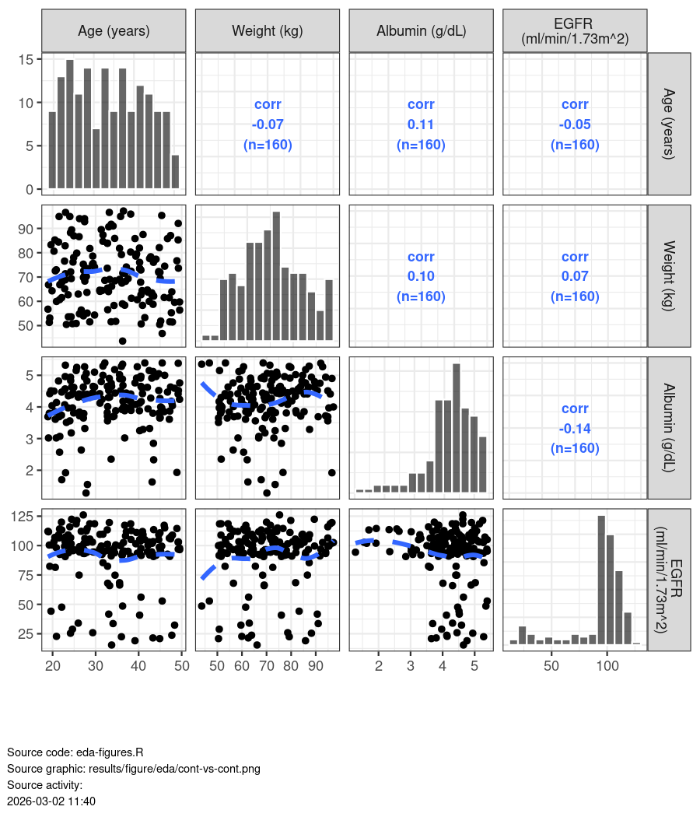
The diagonal plots show histograms of each covariate across <<studies>>. The lower plots are scatter plots with points coloured by study and a study-independent LOESS smoother. The upper plots show the Pearson’s correlation coefficient and number of underlying observations.

Figure 3 Correlation between Continuous Covariates and Renal Function
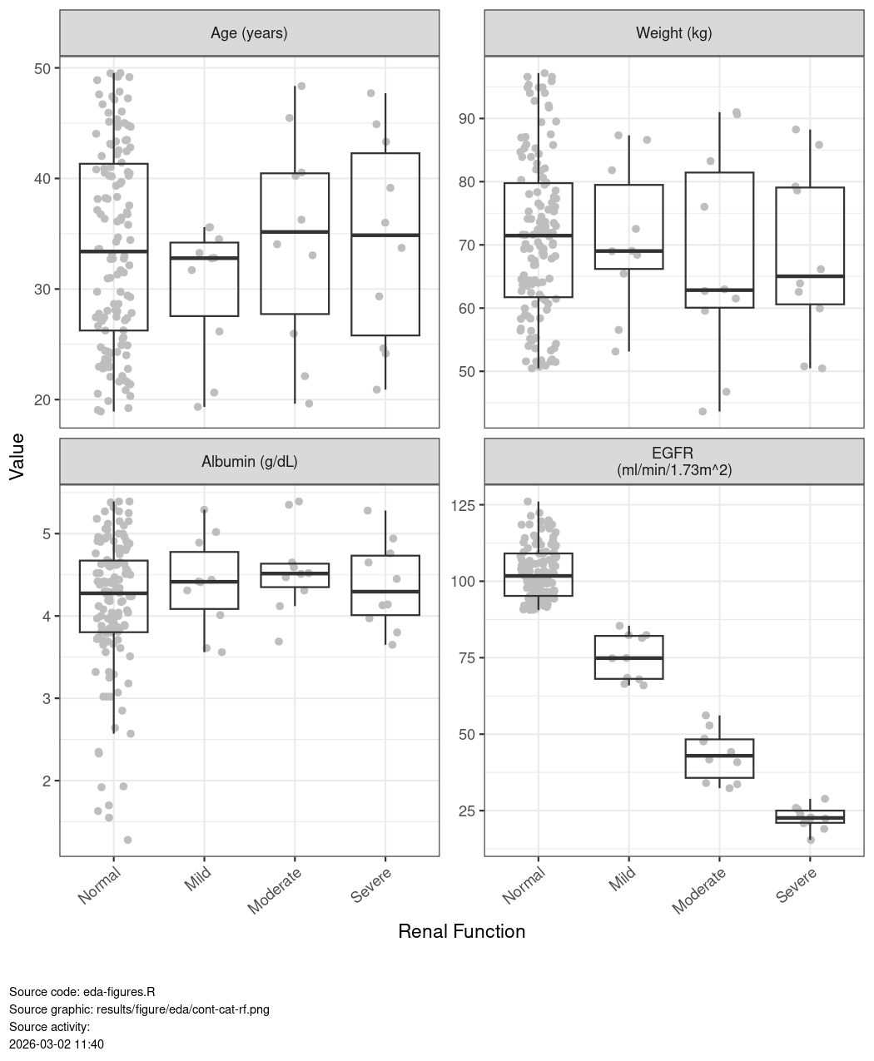
Box plots = median (line in boxes); hinges show interquartile range, and whiskers show max/min value (no more than 1.5 * interquartile range from the hinge). Grey points show the observed data (jittered).

Figure 4 Distributions and Correlations of Categorical Covariates
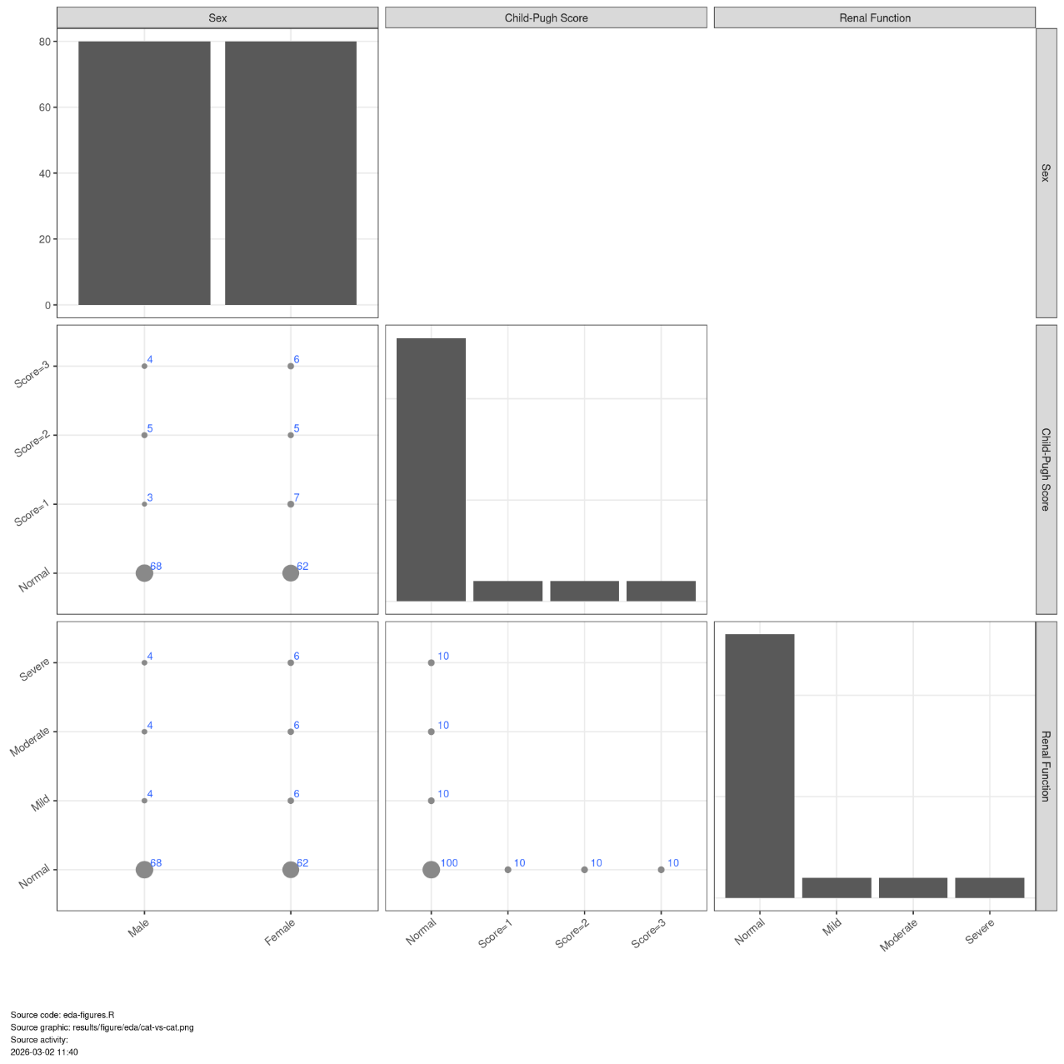
The diagonal plots show bar graphs with number of subjects in each category. The lower plots show points where the size of the point is related to the number of subjects in each category (larger size = more subjects) and the number of underlying observations (blue numbers).

Pharmacokinetics
AZD1234 concentration-time profiles showed a {{fast/slow}} absorption, followed by a exponential decay over time. The PK appears approximately dose-proportional with no obvious changes with time on treatment (Figure 5, Figure 6 and Figure 7).
Additional plots including graphs on the linear scale is provided in Appendix D (Figure D3 to Figure D5).
Figure 6 Concentrations versus Time after Dose by {{Study and Dose}} (log scale)
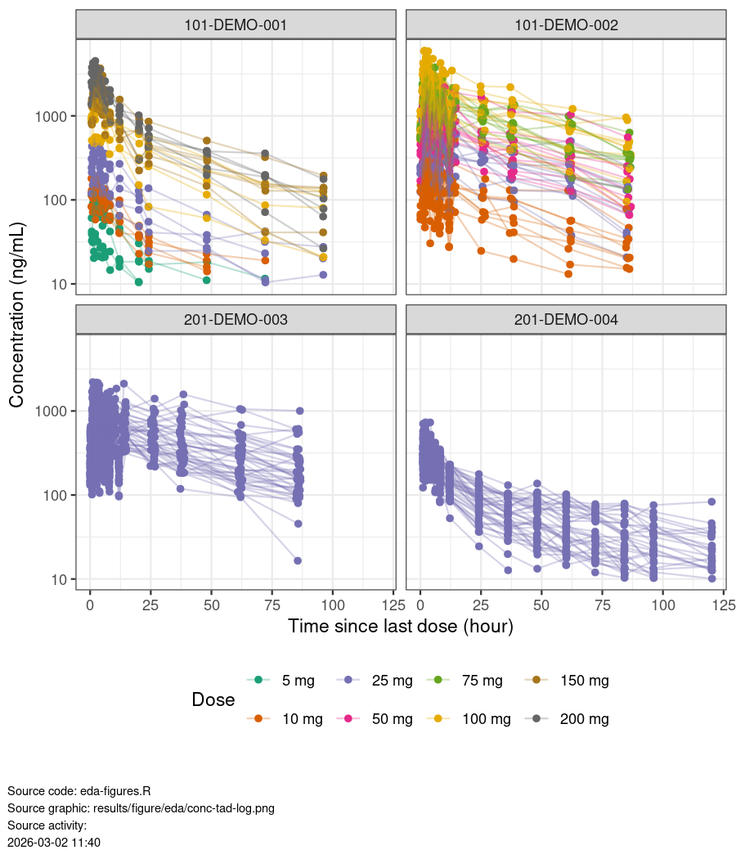
Spaghetti -plots of individual PK profiles. Points are observations, lines connect observations from the same participant. Point shape indicate data above or below the quantification limit (XX ng/mL, dashed line)

Model Development
A run summary of the key models is provided in Table 4.
Table 4 Summary of key models considered during model development
Run | Structure | OFV | Cond. no. | Covariates | Error | BSV
102 | Two-compartment model with first-order absorption and linear elimination. | 30998 | 30 | None | Proportional | KA, CL/F, V2/F with covariance
106 | Two-compartment model with first-order absorption and linear elimination. Effects of eGFR, age, and ALB on CL/F. | 30904 | 49 | Weight, albumin, age, and EGFR effects on CL/F. Weight effects on V2/F, Q/F, and V3/F. | Proportional | KA, CL/F, V2/F with covariance
BSV: between subject variability; OFV: objective function value; Cond. no.: condition number
Source code: run-log.R
Source file: results/table/model-run-log.docx

Base Model
  - Additional Exploratory Analyses
    - Available Data
Table D1 Summary of available data by study and dose
 | Number |  |  |  | Percent
Dose group | SUBJ | MISS | OBS | BLQ | OBS | BLQ
Study: 101-DEMO-001
5 mg | 5 | 0 | 61 | 14 | 13.6 | 3.1
10 mg | 5 | 0 | 65 | 10 | 14.4 | 2.2
25 mg | 5 | 0 | 73 | 2 | 16.2 | 0.4
100 mg | 5 | 0 | 75 | 0 | 16.7 | 0.0
150 mg | 5 | 0 | 75 | 0 | 16.7 | 0.0
200 mg | 5 | 0 | 75 | 0 | 16.7 | 0.0
Group Total | 30 | 0 | 424 | 26 | 94.2 | 5.8
Study: 101-DEMO-002
10 mg | 10 | 0 | 239 | 1 | 19.9 | 0.1
25 mg | 10 | 0 | 240 | 0 | 20.0 | 0.0
50 mg | 10 | 0 | 240 | 0 | 20.0 | 0.0
75 mg | 10 | 0 | 240 | 0 | 20.0 | 0.0
100 mg | 10 | 0 | 240 | 0 | 20.0 | 0.0
Group Total | 50 | 0 | 1199 | 1 | 99.9 | 0.1
Study: 201-DEMO-003
25 mg | 40 | 0 | 960 | 0 | 100.0 | 0.0
Group Total | 40 | 0 | 960 | 0 | 100.0 | 0.0
Study: 201-DEMO-004
25 mg | 40 | 0 | 559 | 41 | 93.2 | 6.8
Group Total | 40 | 0 | 559 | 41 | 93.2 | 6.8
BLQ: below limit of quantification, LLOQ: lower limit of quantification, MISS: missing observations (non-BLQ), SUBJ: subjects, OBS: observations above the LLOQ
Source activity:
2026-03-02 10:50
Source code: eda-tables.R
Source file: results/table/eda/pk-data-sum-dose-study.docx

- R environment and Package Details
<<block:testing>>

<<gof cwres >>

