 | Model Analysis Report
 | Drug Substance | hhh
 | Study Code | jjj
 | Edition | jjj
 | Date | jkjkhjk

Title Page

Population PK Model Analysis Report of {{specify relevant scope including patient population, age etc}}

Clinical Studies: {{list all clinical studies used}}
NOTE: This document follows AZ style format. Do not alter the format of the document. The text draft is provided as placeholders. The author of the document is responsible for the content.
For the author:
This template should be used when developing a new population PK model, including full model development, which could be done from a single study or a pooled dataset. If you have updated a previously developed model with new data (such as a Phase 3 update), use the template PopPK_ModelReport_ModelUpdate
The Study code(s) in the upper corner should contain the study analysed (e.g., D1234C00001). If analysis of a single study or focused on a single study, put that study code here. If analysis is of a pool, then put “Various” here and list the codes in the full title under “Clinical Studies:”.
Please note that the Study code and Date columns are bookmarks which automatically update the headers of the document.

For the author:
The top-level sections and flow of the report are mandatory. Subsections may be adapted, expanded or deleted, as appropriate. It is allowed to expand this MAR to describe a joint exposure-response (efficacy or safety) analysis; we currently do not have templated text for the efficacy/safety part. These subsections need to be added and populated manually.
Texts in these gray boxes are suggestions on the content of each section. Author should remove these texts while authoring the report.
Text within and/or highlighted in blue are example paragraphs and should be modified relevant to current analysis. Paragraph texts in black (not highlighted or within) are templated texts which should not be modified unless strictly necessary since they have corresponding sections in the templated analysis report and the TFLs are pre-coded within the MERGE popPK activity templates.

Where several options are provided, please choose which one to use and delete the other version. The option-specific text refers to the one paragraph including the [Option x: ]. Subsequent paragraphs below/above the option should be kept, irrespectively of which option you choose.

TABLE OF CONTENTS
For the author:
- Refresh all ToCs before finalization.
- All section titles ≤ level 2 should be in Title Case.
Title Page 1
TABLE OF CONTENTS 3
CONTRIBUTORS 7
AUTHENTICATION STATEMENT 8
ABBREVIATIONS AND DEFINITIONS OF TERMS 9
1 EXECUTIVE SUMMARY 11
2 INTRODUCTION 11
3 OBJECTIVES 11
4 DATA 12
4.1 Description of the Analysis Data 12
4.2 Bioanalytical Methods 14
4.3 Preparation of Analysis Dataset and Source Data File 14
4.4 Derived Analysis Dataset 14
4.5 Handling of Missing and Erroneous Data 14
4.6 Handling of Observations Below the LLOQ 15
4.7 Handling of Outliers 15
4.8 Handling of Covariates 15
5 PRIOR KNOWLEDGE AND EXPERIENCE 15
5.1 Prior PK Experience 15
6 METHODS 16
6.1 Overview of the Analysis 16
6.2 Exploratory Data Analysis 16
6.3 Population PK Model Building 16
6.3.1 Structural Model Development 16
6.3.2 Between Subject Random Effect Model 16
6.3.3 Residual Variability Random Effect Model 16
6.3.4 Evaluation of Covariates 16
6.4 Model Evaluation 17
6.5 Simulations 17
6.5.1 Assessment of the Clinical Relevance of Identified Covariates 17
6.5.2 Exposure metrics 17
6.6 Hardware and Software Details 17
6.7 Deviations from Analysis Plan 17
7 RESULTS 17
7.1 Summary of Analysis Dataset 18
7.2 Exploratory Data Analysis 19
7.2.1 Covariates 19
7.2.2 Pharmacokinetics 24
7.3 Model Development 28
7.3.1 Base Model 28
7.3.2 Covariate Model 30
7.3.3 Final Model 31
7.3.4 Handling of Outliers 31
7.3.5 Sensitivity Analyses 32
7.4 Simulations/Predictions 32
7.4.1 Clinical Impact of Covariates 32
7.4.2 Exposures at X mg daily dosing 33
8 DISCUSSION 33
9 CONCLUSIONS 33
10 REFERENCES 34
11 Appendices 34

LIST OF TABLES
Table 1 Summary of Studies Included in the Population PK Analysis 13
Table 2 Summary of Analysis Dataset 18
Table 3 Summary of Covariates Overall and by {{Study}} 20
Table 4 Summary of key models considered during model development 28
Table 5 Base Model Parameter Estimates 29
Table 6 Final Model Parameter Estimates 31
Table D1 Summary of available data by study and dose 38

LIST OF FIGURES
Figure 1 Distributions and Correlations of Continuous Covariates 21
Figure 2 Correlation between Continuous Covariates and Sex 22
Figure 3 Correlation between Continuous Covariates and Renal Function 23
Figure 4 Distributions and Correlations of Categorical Covariates 24
Figure 5 Concentrations versus Time by <Study and Dose>> (log scale) 25
Figure 6 Concentrations versus Time after Dose by {{Study and Dose}} (log scale) 26
Figure 7 Dose-normalized Concentrations versus Time by {{Study and Dose}} (log scale) 27
Figure 8 Correlation between Empirical Bayes Estimates and continuous covariates 30
Figure 9 Correlation Between Empirical Bayes Estimates and Categorical Covariates 30
Figure 10 Goodness 31
Figure 11 Estimates 31
Figure 12 Visual Predictive Check 31
Figure 13 Forest Plot 32
Figure 14 Individual Predicted Exposures versus Covariate 32
Figure D1 Histogram of concentration sample collection times coloured by analysis status 39
Figure D2 Correlation between Continuous Covariates and Child-Pugh Score 40
Figure D3 Concentrations versus Time by {{Study and Dose}} (linear scale) 41
Figure D4 Concentrations versus Time after Dose by {{Study and Dose}} (linear scale) 42
Figure D5 Dose-normalized Concentrations versus Time by {{Study and Dose}} (linear scale) 43
Figure D6 Predicted versus Observed Concentrations for Base Model 44
Figure D7 Evaluation of Residuals for Base Model 45
Figure D8 {{dose-normalized}}VPC of {{dose-normalized}} Concentration versus Time after dose by {{Study}} f or Base Model46
Figure D8 {{dose-normalized}}VPC of {{dose-normalized}} Concentration versus Time after dose by {{renal function}} f or Base Model47
Figure D9 Distribution and Correlation of Individual Random Effects for Base Model 48
Figure D10 Scatter Plot of Individual Random Effects for Ka versus Continuous Covariates for Base Model 49
Figure D11 Scatter Plot of Individual Random Effects for Vc/F versus Continuous Covariates for Base Model 50
Figure D12 Scatter Plot of Individual Random Effects for CL/F versus Continuous Covariates for Base Model 51
Figure D13 Distribution of Individual Random Estimates of Ka by Category of Categorical Covariates for Base Model 52
Figure D14 Distribution of Individual Random Estimates of Vc/F by Category of Categorical Covariates for Base Model 53
Figure D15 Distribution of Individual Random Estimates of CL/F by Category of Categorical Covariates for Base Model 54
Figure D16 Distribution and Correlation of Individual Random Effects for Final Model 59
Figure D17 Scatter Plot of Individual Random Effects for Ka versus Continuous Covariates for Final Model 60
Figure D18 Scatter Plot of Individual Random Effects for Vc/F versus Continuous Covariates for Final Model 61
Figure D19 Scatter Plot of Individual Random Effects for CL/F versus Continuous Covariates for Final Model 62
Figure D20 Distribution of Individual Random Estimates of Ka by Category of Categorical Covariates for Final Model 63
Figure D21 Distribution of Individual Random Estimates of Vc/F by Category of Categorical Covariates for Final Model 64
Figure D22 Distribution of Individual Random Estimates of CL/F by Category of Categorical Covariates for Final Model 65

LIST OF APPENDICES
Appendix A Model Analysis Plan 35
Appendix B Dataset Specification 36
Appendix C Data Exclusions 37
Appendix D Additional Results 38

CONTRIBUTORS
The following personnel were significantly involved in the generation of this document:
Prepared by: | Name, Surname, (PhD),  Position,  AstraZeneca, City, Country
Reviewed by: | Name, Surname, (PhD), (one per relevant project member)  Position,  AstraZeneca, City, Country
Approved by: | Name, Surname, (PhD),  Position,  AstraZeneca, City, Country

AUTHENTICATION STATEMENT
Study Code(s):
Document Title: | {{Title of MAR}}

The analysis has been performed in accordance to the procedures described in the modeling analysis plan [add reference]. This modeling analysis report provides an accurate and complete record of the methods used and results obtained, and documentation of any deviations from this modeling analysis plan.
Signature: | See appended signature page
Approve Name, Surname (PhD),
Position,
AstraZeneca, City, Country
Date: | See appended signature page

ABBREVIATIONS AND DEFINITIONS OF TERMS
For the author:
- Add abbreviations to the table as required by terms used in the text. Where appropriate, use abbreviations and definitions from the AZ glossary.
- Delete abbreviations not used in the text.
- Make sure the abbreviation table is sorted alphabetically (tip: copy table to Excel, sort and copy back)
The following abbreviations and special terms are used in this report.
Abbreviation or special term | Explanation
α | Distributional rate constant
β | Terminal elimination constant
γ | Gamma constant
ε | Residual error on measurement
η | Between Subject random variability term in non-linear mixed effect analysis. The difference between the individual parameter estimates and the population parameter estimate.
θ | Fixed effect parameter in population PK analysis
σ² | Variance of the residual variability
ω² | Variance of the between subject random variability
AIC | Akaike information criterion
AUC_{0-x} | Area under the plasma concentration - time curve from time zero to time x
BID | bis in die (twice daily dosing)
BLQ | Below lower limit of quantification
BMI | Body mass index
BSV | Between subject variability
BWT | Body weight
C_{max} | Maximum plasma concentration
C_{trough} | Plasma concentration right before the next dose
CL/F | Apparent total body clearance of drug from plasma after extravascular administration
CI | Confidence interval
CMT | Compartment
CV | Coefficient of variation
CWRES | Conditional weighted residuals
DCO | Data cut off
DF | Degree of freedom
EBE | Empirical Bayes estimates
FOCE | First order conditional estimation method
IPRED | Individual predictions
IMP | Importance sampling
Ka | Absorption rate constant
LLOQ | Lower limit of quantification
MAP | Modeling analysis plan
MAR | Modeling analysis report
MDV | Missing dependent variable
OFV | Objective function value
n | A unitless number
NA | Not applicable
NONMEM | Nonlinear mixed-effects modelling software
popPK | Population pharmacokinetic(s)
PK | Pharmacokinetic(s)
PRED | Population predictions
Q/F | Apparent inter-compartmental clearance
QD | Once daily administration
RSE | Relative standard error
RV | Residual Variability
SAEM | Stochastic approximation expectation maximization
SCM | Stepwise covariate modeling
SD | Standard deviation
t_{1/2} | Terminal elimination half-life
t_{max} | Time to reach peak concentration
TV | Typical population value
Vc/F | Apparent volume of the central compartment
Vp/F | Apparent volume of the peripheral compartment
VPC | Visual predictive check
WRES | Weighted residuals

EXECUTIVE SUMMARY
For the author:
This section includes an overview of the analysis including Objectives, Data, Model Development, Results and Conclusion
The primary audience for this section are non-technical readers, stakeholders, and excerpts from this section may be used in regulatory related summary documents.
Expected Content:
- Objectives of the analysis
- The key findings that affect drug use, labelling, or decision making
- A plain language summary of objectives, data, methodology, and conclusions
- Results presented as their effect on clinically relevant drug exposures or endpoints, not model parameters
- Model details such as structure or covariates should be avoided, or kept to a minimum if important for communicating conclusions
- Visual presentations of relevant results are acceptable, if key to decision making

INTRODUCTION
For the author:
This section should include essential background of the compound and an overview of the planned analysis. The primary audience for this section: non-technical reader, stakeholders.
Suggest to use the same text as in the MAP.

OBJECTIVES
For the author:
- Suggested to be non-technical, e.g. “to describe the PK properties of compound X in patients with Y”.
- Provide bullet points on objectives of the analysis
- Preferably, also include the objectives relative to “Simulation” and “Predictions”, i.e. not only descriptive objectives.
If developing a joint popPK E-R MAP, please include efficacy/safety objectives here as well.

DATA

Description of the Analysis Data
For the author:
This section should include information about the data to be used in the analysis.
- Provide a summary of the studies, including number of participants, number and timing of samples per participant and any information to distinguish different studies in the templated Table 1. Consider placing some information in Appendix A if too many studies (if all listed in main, please delete Appendix A).
- Essential information include description of studies, population/design, samples/participant(range), and sampling design information.
- The paragraph text should be minimal but may include e.g. the rational for the selection of the used data and/or explanations around study design(s) to provide context for the used modeling strategy.
- If developing a joint popPK E-R MAP, please add a separate table for E/S data (if different from PK).

Table 1 Summary of Studies Included in the Population PK Analysis
Study number  (Phase/abbreviation)  Status  DCO | Study design | Study  Population | Dosage Regimen(s) and  Route of Administration | Participants  evaluable  for PK | PK sampling schedule
DxxxCxxxxx  (Phase 1/SAD)  Completed  DCO: dd/mm/yyyy | Investigator- and subject-blind, sponsor-open, randomized, placebo-controlled, single oral ascending dose study | Adult healthy volunteers | Single doses of X mg, Y mg, or Z mg. | 30 participants | pre-dose, 0.5, 1, 2, 3, 4, 6, 8, 12, 24, 36, 48, and 72 hours post-dose.
DxxxCxxxxx  (Phase 2b: Name)  Ongoing  DCO: dd/mm/yyyy | Randomized, Double-Blind, Placebo-Controlled, Multicenter, Parallel-Group, Dose-Ranging Study to Evaluate the Efficacy and Safety of AZD1234 as Compared to Placebo | Adult participants with [disease] | Once daily dosing of X mg, Y mg, or Z mg. | N_{total} = 300 participants.  X mg (N=100),  Y mg (N=100), or  Z mg (N=100) | At weeks 3 and 12: pre-dose.  At week 12, in a subset of the population (n=50 patients):  1, 2, 3, 4, 6, and 8 hours post-dose.
{{add any additional studies}}

Bioanalytical Methods
For the author:
This section should include information describing the bioanalytical assay, focusing on aspects important for PK analysis.
- Please include high level information of the type of analysis, reference the report where the analysis is described and proved the LLOQs for PK concentrations.

Preparation of Analysis Dataset and Source Data File
An analysis dataset {{ name of source data file }} was prepared according to AZ Clinical Data Standards. The programs were documented and archived to maintain an audit trail. Additional quality controls were performed by the pharmacometrician, according to AZ Clinical Data Standards. The dataset is described in the Pharmacometrics Data Specification (Appendix B).

Derived Analysis Dataset
For the author:
Add description of any transformations performed on the source data file, if any, to arrive at the modelling dataset (e.g., binning of a continuous covariate into categories, logarithmic (or other) transformation, new variables, imputation, etc.)

Handling of Missing and Erroneous Data
For the author:
- Provide information on the rules for imputation of e.g. dose amount of time.
- Provide information on the rules for removal of data with missing information, removal of outliers together with the rationale for specific decisions made during the creation of the datasets.
- Provide listings of specific data points removed from the dataset (pre-modelling), and the reason for omission in the relevant appendix.
The handling of missing or erroneous data was performed as outlined in the MAP.
A list of all omitted observations, along with the rational, is provided in Appendix C

Handling of Observations Below the LLOQ
For the author:
Add description and justification of used LLOQ handling.
(MAP states: The selected strategy as well as a justification for its use will be provided in the MAR.)
Handling of concentrations below the lower limit of quantification (BLQ) was performed as outlined in the MAP.
{{add selected strategy and justification}}

Handling of Outliers
For the author:
Add description and justification of outlier handling.
(MAP states: As it is not possible to anticipate all possible cases of outliers, sensitivity analyses may be performed with and without the outlier data and all excluded outlier data will be listed in the MAR along with the rationale for exclusion.)
Handling of outliers was performed as outlined in the MAP.
{{Add specific considerations/strategies used}}
A list of all omitted observations, along with the rational, is provided in Appendix C

Handling of Covariates
For the author:
- Describe strategy for imputation when covariates are missing.
(MAP states: The used covariate imputation approach will be described in the MAR.)
Handling of covariates was performed as outlined in the MAP.

PRIOR KNOWLEDGE AND EXPERIENCE

Prior PK Experience
For the author:
This section is optional and can be removed if not deemed relevant.
Prior PK experience is detailed Section {{4}} of the MAP (Appendix A).

METHODS
For the author:
For all subsections across methods, please copy paste relevant text from the MAP. Make changes as necessary and detail which option that was used if several are provided in the MAP (e.g. specify transformations made and provide relevant functional forms).
Please remember to change to past tense where relevant.

Overview of the Analysis
The analysis will be carried out in accordance with regulatory guidance and standards (Error! Reference source not found., Error! Reference source not found., Error! Reference source not found.) and follow best practices as outlined by Dykstra et al (Error! Reference source not found.).
The main analysis steps are outlined below and further detailed in Sections Error! Reference source not found., Error! Reference source not found. and Error! Reference source not found..
<<Name:model run summary|Title:Model run summary table|Footnote:Summary of key model run outputs.|Files:106-pk-params.docx|Type:table>>

Exploratory Data Analysis
<<Name:model bootstrap plot|Title:Bootstrap diagnostic plot|Footnote:Bootstrap plot for final model assessment.|Files:106-bootstrap.png|Type:image>>

Model Evaluation
For the author:
For this subsection, please refer to the MAP. Add any relevant additional information, e.g. number of simulations/samples used in the VPCs and bootstraps.
Please remember to change to past tense where relevant.
Model evaluation was performed as outlined in the MAP.

Simulations

Assessment of the Clinical Relevance of Identified Covariates

Hardware and Software Details
<<Name:categorical covariate summary |Title:Categorical covariate summary|Footnote:Categorical covariate distribution by study.|Files:cat-cov-sum-study.docx|Type:table>>

Deviations from Analysis Plan
For the author:
This section describes and explains rationale for any deviations in the conduct of the analysis from the Model Analysis Plan, e.g., changes in response to data review, or challenges in the specified approach.
{{pa}}

RESULTS
For the author:
This section focuses on results from exploration of the data, development of models, and subsequent simulations/inferences. The primary audience for this section: technical reader, reviewers.
Expected content:
- Summary of the data and data exploration, with adequate graphical and tabular displays
- Description, diagnostics and qualification of key models including, but not limited to, the base and final models. The final model, model building steps, qualification, final parameter estimates, and deviations from planned analyses should be clear.
- Tables and/or figures should be included as appropriate to explain the course of model development.

Summary of Analysis Dataset
For the author:
- The primary audience for this section: technical reader, reviewers.
- Tables and/or figures should be included to help with readability and get in line with the objectives of this analysis.
- Summary of the data and data exploration, with adequate graphical and tabular displays
Table 2 summarizes the data used in the population PK analysis organized by {{Study and Dose}}. Summaries by {{Study and Dose}} are provided inAppendix D, Table D1.
Table 2 Summary of Analysis Dataset
 | Number |  |  |  | Percent
Dose | SUBJ | MISS | OBS | BLQ | OBS | BLQ
5 mg | 5 | 0 | 61 | 14 | 1.9 | 0.4
10 mg | 15 | 0 | 304 | 11 | 9.5 | 0.3
25 mg | 95 | 0 | 1832 | 43 | 57.1 | 1.3
50 mg | 10 | 0 | 240 | 0 | 7.5 | 0.0
75 mg | 10 | 0 | 240 | 0 | 7.5 | 0.0
100 mg | 15 | 0 | 315 | 0 | 9.8 | 0.0
150 mg | 5 | 0 | 75 | 0 | 2.3 | 0.0
200 mg | 5 | 0 | 75 | 0 | 2.3 | 0.0
All data | 160 | 0 | 3142 | 68 | 97.9 | 2.1
BLQ: below limit of quantification, LLOQ: lower limit of quantification, MISS: missing observations (non-BLQ), SUBJ: subjects, OBS: observations above the LLOQ
Source activity:
2026-03-02 11:43
Source code: eda-tables.R
Source file: results/table/eda/pk-data-sum-dose.docx

In total, {{XX mg}} plasma/blood PK samples from {{n}} patients treated with AZDXXX across dose levels of {{XX mg}} to {{XX mg}} were available for inclusion in this analysis. {{Add any relevant observation across selected strata for table}}

Exploratory Data Analysis
For the author:
Describe key information regarding the data to inform model development. Review and interpret available data, assessing the nature and quantity of data (balance between rich and sparse data, information on covariates)
- Focus on relevant features of the data, PK(PD), dosing and covariates to enable the reader a good understanding of the general behaviour (stratified by dose, time, time after dose, and key covariates).
- Correlation of covariates (correlation plots, between important covariates), if needed
- Typical outputs could be graphics, tabular summaries and simple statistical models.
- Retain high impact results in the main text, with supporting tables/figures in an appendix.
- Refer to GUID-0024307 General Considerations for Tables, Figures, Listings (TFL) for popPK reports from Clinical Pharmacology & Quantitative Pharmacology CPQP

Covariates
Baseline covariates available in the dataset are summarized in Table 3. The correlations between continuous covariates are shown in Figure 1. The correlation between continuous and most relevant categorical covariates are shown in Figure 2 and Figure 3. Similar figures for the remaining available categorical covariates are Figure 4.
<<Name:eta pairs|Title:ETA pairwise relationship plot|Footnote:Pairwise ETA relationship overview.|Files:cont-vs-cont.png|Type:image>>

Table 3 Summary of Covariates Overall and by {{Study}}
 | Study
 | 101-DEMO-001 (n = 30) | 101-DEMO-002 (n = 50) | 201-DEMO-003 (n = 40) | 201-DEMO-004 (n = 40) | Overall (n = 160)
Sex
Male | 18 (60.0) | 26 (52.0) | 19 (47.5) | 17 (42.5) | 80 (50.0)
Female | 12 (40.0) | 24 (48.0) | 21 (52.5) | 23 (57.5) | 80 (50.0)
Child-Pugh score
Normal | 30 (100.0) | 50 (100.0) | 40 (100.0) | 10 (25.0) | 130 (81.2)
Score=1 | 0 (0.0) | 0 (0.0) | 0 (0.0) | 10 (25.0) | 10 (6.2)
Score=2 | 0 (0.0) | 0 (0.0) | 0 (0.0) | 10 (25.0) | 10 (6.2)
Score=3 | 0 (0.0) | 0 (0.0) | 0 (0.0) | 10 (25.0) | 10 (6.2)
Renal function
Normal | 30 (100.0) | 50 (100.0) | 10 (25.0) | 40 (100.0) | 130 (81.2)
Mild | 0 (0.0) | 0 (0.0) | 10 (25.0) | 0 (0.0) | 10 (6.2)
Moderate | 0 (0.0) | 0 (0.0) | 10 (25.0) | 0 (0.0) | 10 (6.2)
Severe | 0 (0.0) | 0 (0.0) | 10 (25.0) | 0 (0.0) | 10 (6.2)
Summary is count (percent)
n: number of subjects summarized; CP: Child-Pugh
Source activity:
2026-03-02 10:50
Source code: eda-tables.R
Source file: results/table/eda/cat-cov-sum-study.docx

Figure 1 Distributions and Correlations of Continuous Covariates
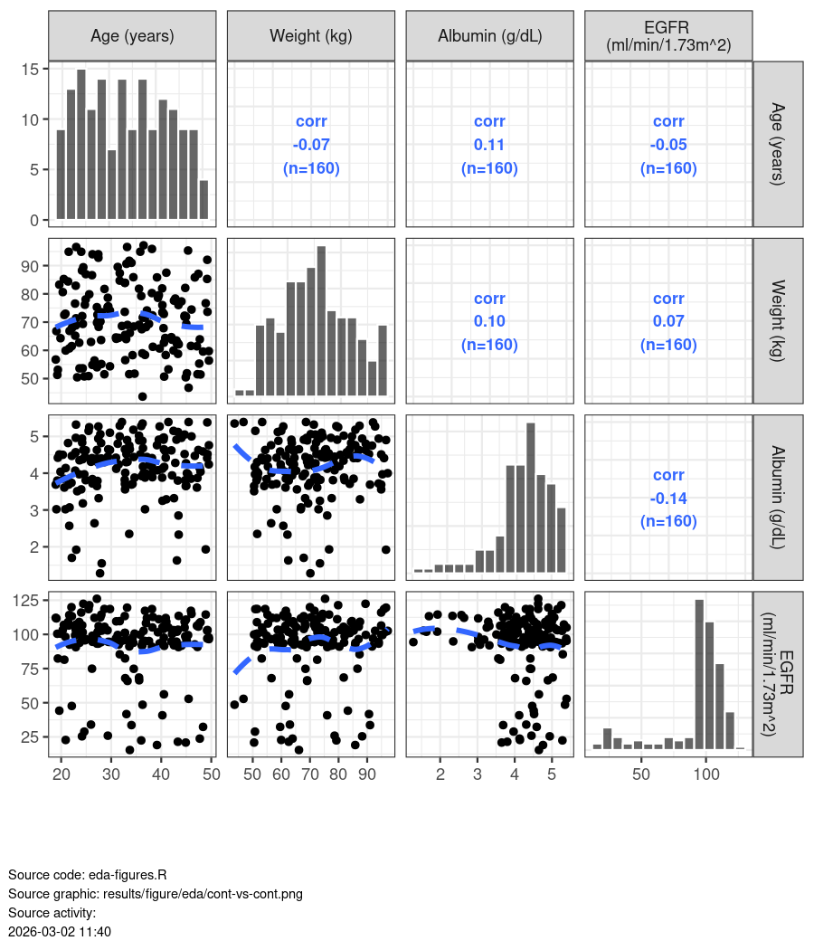
<<Name:studies|Title:Na Please whyyy|Footnote:List of studies included in analysis.|Files:pk-data-sum-dose-study.docx|Type:table>>

Figure 3 Correlation between Continuous Covariates and Renal Function
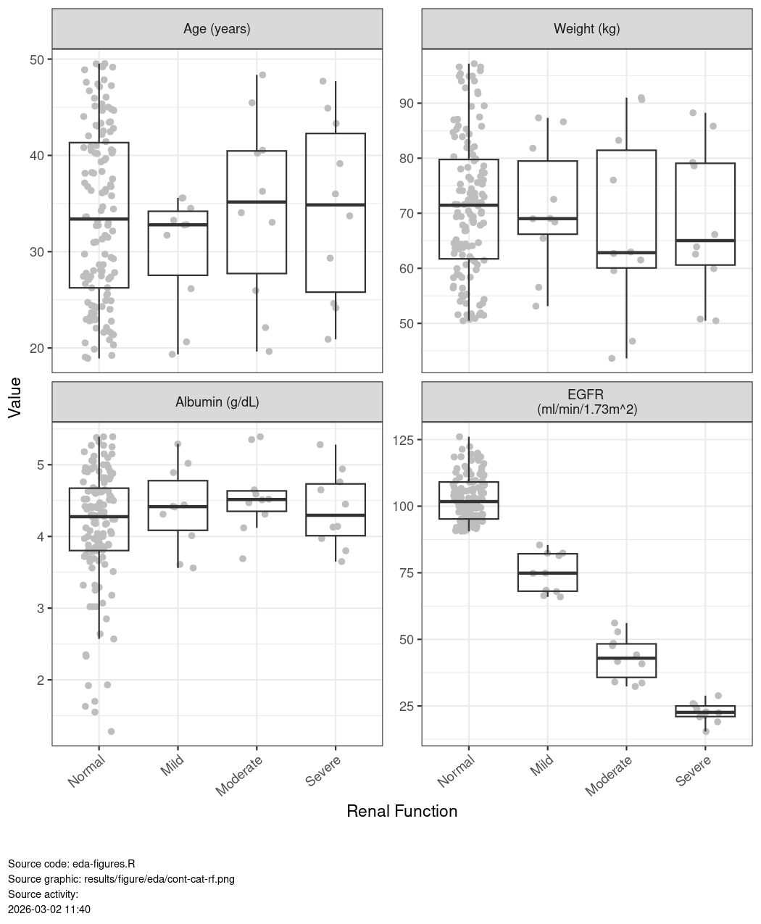
Box plots = median (line in boxes); hinges show interquartile range, and whiskers show max/min value (no more than 1.5 * interquartile range from the hinge). Grey points show the observed data (jittered).

Figure 4 Distributions and Correlations of Categorical Covariates
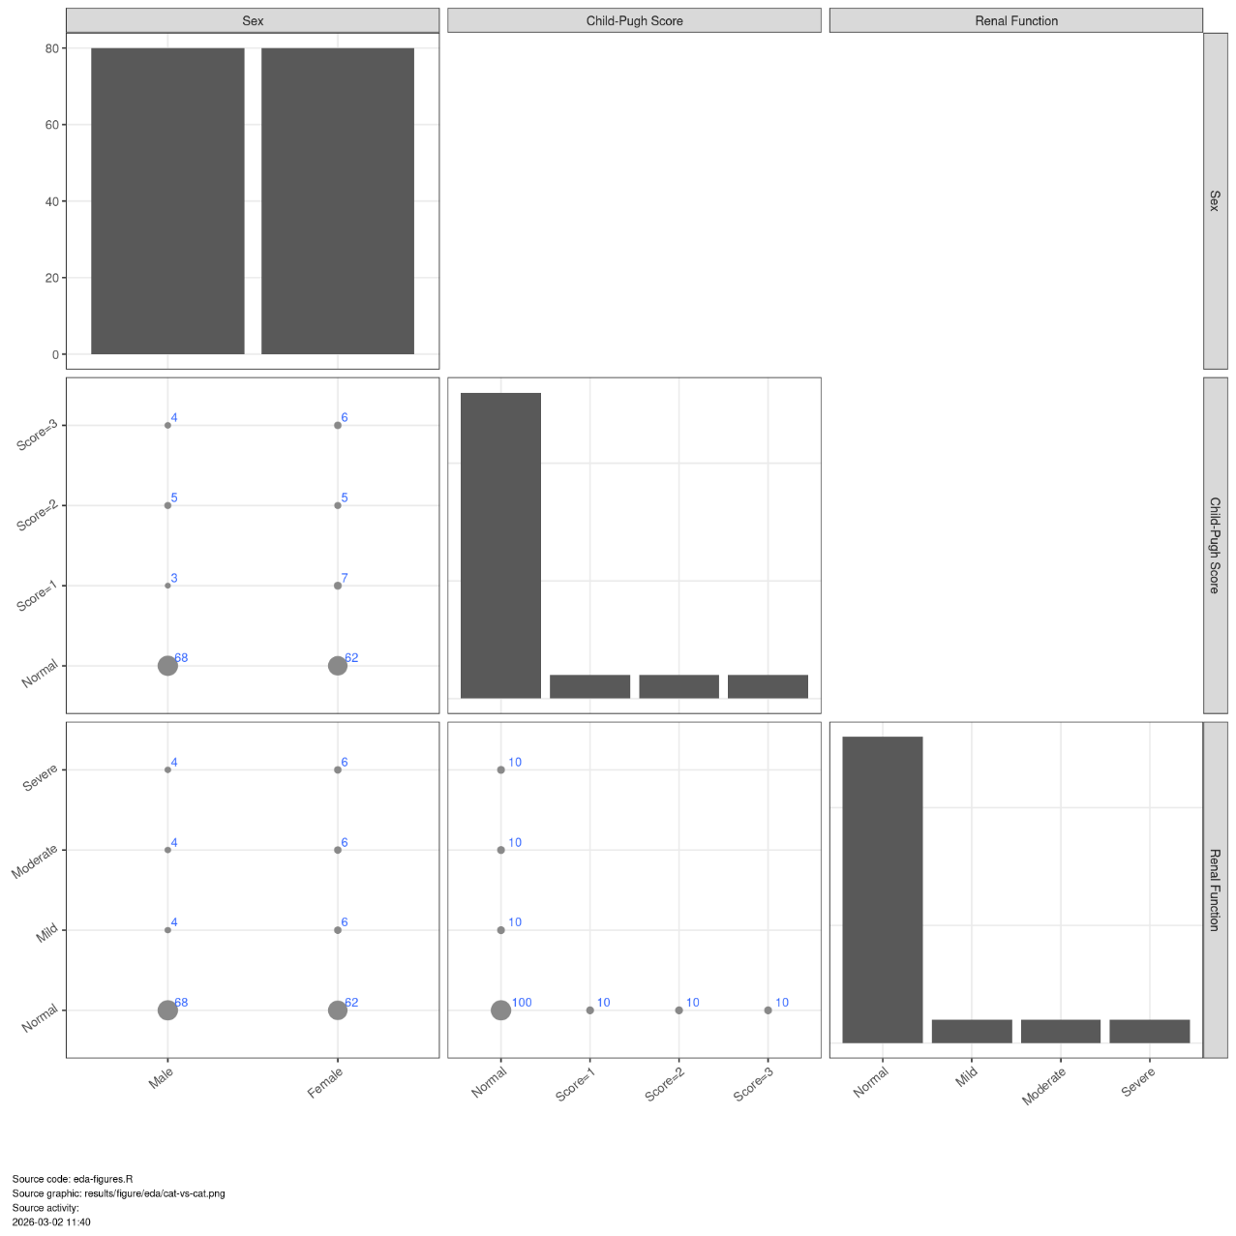
The diagonal plots show bar graphs with number of subjects in each category. The lower plots show points where the size of the point is related to the number of subjects in each category (larger size = more subjects) and the number of underlying observations (blue numbers).

Pharmacokinetics
AZD1234 concentration-time profiles showed a {{fast/slow}} absorption, followed by a exponential decay over time. The PK appears approximately dose-proportional with no obvious changes with time on treatment (Figure 5, Figure 6 and Figure 7).
Additional plots including graphs on the linear scale is provided in Appendix D (Figure D3 to Figure D5).
Figure 6 Concentrations versus Time after Dose by {{Study and Dose}} (log scale)
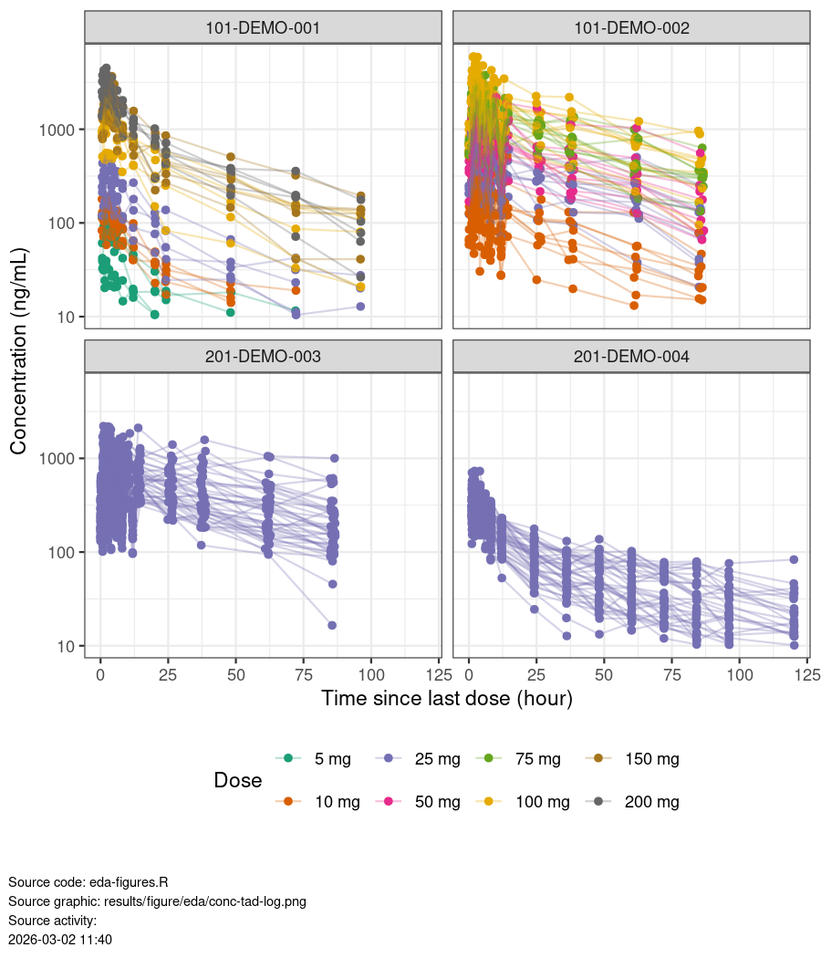
Spaghetti -plots of individual PK profiles. Points are observations, lines connect observations from the same participant. Point shape indicate data above or below the quantification limit (XX ng/mL, dashed line)

This is same perdon I can talkg about sht master minf that we can do that

Model Development
For the author:
Yes it was very nice progress I want to no worry aboyt this so very proud
Suggestions
- Reasoning for model selection at each stage of the model development process.
- Table for specific details of the model and change in likelihood.
- Description of the base and final models with emphasis on key attributes. Additional considerations provided in an appendix and referred to in these sections.
- Table with parameter estimates of base and final models.
- Consider placing model diagnostic plots in an appendix.
- Include individual graphs in appendix and include only for the final model. If many individuals, consider selecting a representative number of subjects, not the full set.
- Refer to GUID-0024307 General Considerations for Tables, Figures, Listings (TFL) for popPK reports from Clinical Pharmacology & Quantitative Pharmacology CPQP
A run summary of the key models is provided in Table 4.
Table 4 Summary of key models considered during model development
Run | Structure | OFV | Cond. no. | Covariates | Error | BSV
102 | Two-compartment model with first-order absorption and linear elimination. | 30998 | 30 | None | Proportional | KA, CL/F, V2/F with covariance
106 | Two-compartment model with first-order absorption and linear elimination. Effects of eGFR, age, and ALB on CL/F. | 30904 | 49 | Weight, albumin, age, and EGFR effects on CL/F. Weight effects on V2/F, Q/F, and V3/F. | Proportional | KA, CL/F, V2/F with covariance
BSV: between subject variability; OFV: objective function value; Cond. no.: condition number
Source code: run-log.R
Source file: results/table/model-run-log.docx

Base Model
  - Additional Exploratory Analyses
    - Available Data
Table D1 Summary of available data by study and dose
 | Number |  |  |  | Percent
Dose group | SUBJ | MISS | OBS | BLQ | OBS | BLQ
Study: 101-DEMO-001
5 mg | 5 | 0 | 61 | 14 | 13.6 | 3.1
10 mg | 5 | 0 | 65 | 10 | 14.4 | 2.2
25 mg | 5 | 0 | 73 | 2 | 16.2 | 0.4
100 mg | 5 | 0 | 75 | 0 | 16.7 | 0.0
150 mg | 5 | 0 | 75 | 0 | 16.7 | 0.0
200 mg | 5 | 0 | 75 | 0 | 16.7 | 0.0
Group Total | 30 | 0 | 424 | 26 | 94.2 | 5.8
Study: 101-DEMO-002
10 mg | 10 | 0 | 239 | 1 | 19.9 | 0.1
25 mg | 10 | 0 | 240 | 0 | 20.0 | 0.0
50 mg | 10 | 0 | 240 | 0 | 20.0 | 0.0
75 mg | 10 | 0 | 240 | 0 | 20.0 | 0.0
100 mg | 10 | 0 | 240 | 0 | 20.0 | 0.0
Group Total | 50 | 0 | 1199 | 1 | 99.9 | 0.1
Study: 201-DEMO-003
25 mg | 40 | 0 | 960 | 0 | 100.0 | 0.0
Group Total | 40 | 0 | 960 | 0 | 100.0 | 0.0
Study: 201-DEMO-004
25 mg | 40 | 0 | 559 | 41 | 93.2 | 6.8
Group Total | 40 | 0 | 559 | 41 | 93.2 | 6.8
BLQ: below limit of quantification, LLOQ: lower limit of quantification, MISS: missing observations (non-BLQ), SUBJ: subjects, OBS: observations above the LLOQ
Source activity:
2026-03-02 10:50
Source code: eda-tables.R
Source file: results/table/eda/pk-data-sum-dose-study.docx

- R environment and Package Details
<<Name:gof cwres |Title:GOF CWRES plot|Footnote:Conditional HAHSHAHHSHAHSHAHHSHSHSAHSHSHSH|Files:|Type:table>>

