**Proposal for Business Case of XYZ Co.**

Table of Contents

Table of Contents

TOC 2

1. **Introduction**

The business need of XYZ Co. for managing their business of electronic devices sale via online and stores with option to deliver to customer has arise to expand the business. The application to be developed for this requirement is described on a high level with all the primary components that are required to be developed for supporting this need.

1. **Assumptions/High Level Requirements**

The system in consideration is expected to be a online website that provides feature to primary 2 types of users. A customer and franchise store or operator at shops.

1. The customer should have way to manage own purchases, payments, order and delivery of products in their own profile/authenticated area via the use of online website.
2. The franchise store or operator at shop based on their roles and login can do order for products to be delivered at shop, make payments or track delivery of orders using the online portal.
3. The production unit has a mechanism of uploading the inventory with details about each product in an offline mechanism to the system.
4. System shall be able to manage and integrate with various payment providers like banks, Gpay or similar other payment options on the website.
5. Infrastructure requirements for various environments and tools shall be provided by the clients for team to work on.
6. **High Level Summary**

Application development for the portal shall happen in with agile team considering below points.

1. A business user shall provide user stories with expected behaviour for customer or system.
2. Development team would take care of developing these user stories as per scope and acceptance provided and with automated test of business logic and manual test of website pages, shall attempt to demo the feature every 2 week to business team with testing reports.
3. The development of the application shall be distributed to multiple teams as per components taking care of dependencies and priority of usage.

Below is a small snapshot of activities that shall happen in over all development of system and the involvement of people in those duration.

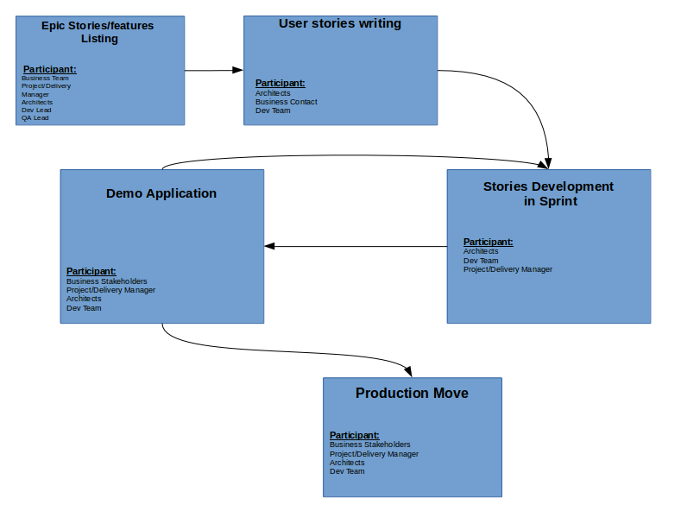

1. **Technical Details**

The system shall be developed with a composed application to manage order, products, and delivery with integration to payment. System shall be integrated with backend application using via queue, FTP or API on HTTP as per the need of backend.

Users shall be able to manage their own login credentials and basic profile in system.

1. **Posssible Technology Stack:**

|  |  |  |  |
| --- | --- | --- | --- |
| **Sr No** | **Technology/Tool** | **Version and Provider (if applicable)** | **Comments** |
| 1. | Spring Framework | 2.2.2 | Development Framework to implement web application |
| 2. | Java | 1.8 | Language to be used to code application |
| 3. | Rabbit MQ |  | Offline integration tool for backend integration and possible payment integrations |
| 4. | Mysql Database |  | Persistentence of application |
| 5. | Jenkins |  | Applying the test and deployment automation to ensure consitent package on test and prod. |
| 6. | Git |  | Manage source code of application |
| 7. | Maven |  | Packaging tool to bundle the application |
| 8. | VM/docker for Test Environment Machines |  | Deployment environment for test, integration and production. |

1. **Deployment Environments**

The system shall be deployed to some test, integration environment before deploying on production. The environment used here shall have docker VM on a machine with access for HTTP, FTP and other ports as required by tools.

**5. High Level System Design**

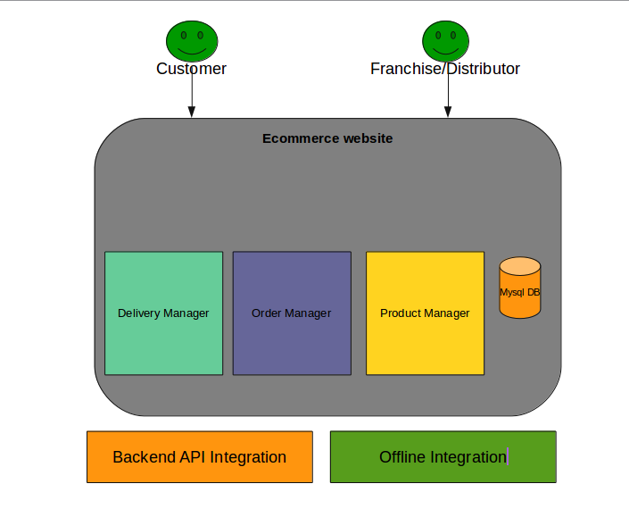

**6. Application Flows**

1. **Customer products browsing**

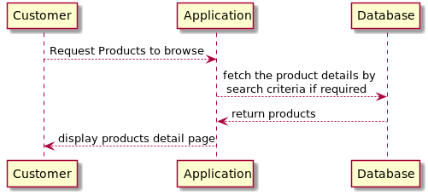

1. **Customer Products Purchase**

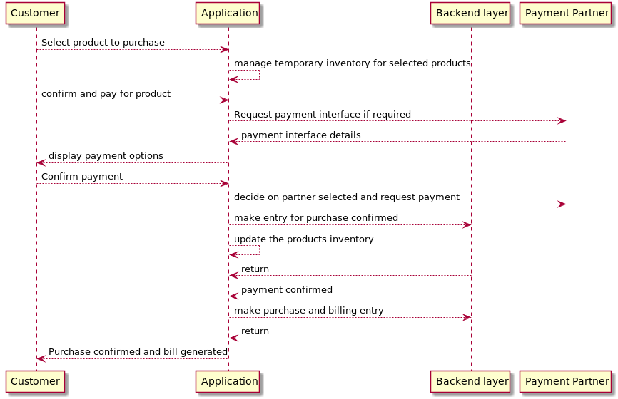

1. **Products Upload to system**

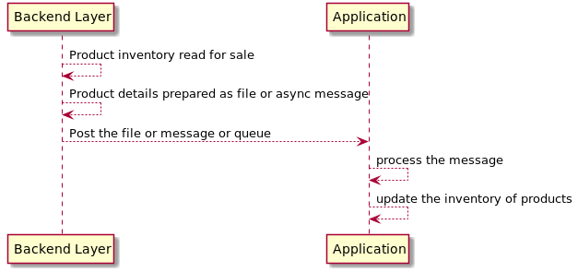

1. **Products Inventory Upload**

**Summary**

The system proposed here shall have various other features and flows but with limited details has not been described here. With the details of all the expected behaviours and features the extension to the details here can be provided.