App for EV charge2help points

- Introduction
The EV charging station will become the need like petrol pumps in future.

- Use Case Flows

- Find the help2charge
Based on location the EV charger points will be available which shall be displayed on map. The expectation is to use it for locating or put up map to drive down the location.

- Create help2charge points

Accessible By | Role | Comments
Back Support Agent | Admin | Create a new point for charge2point for entry in system

Basic Flow:
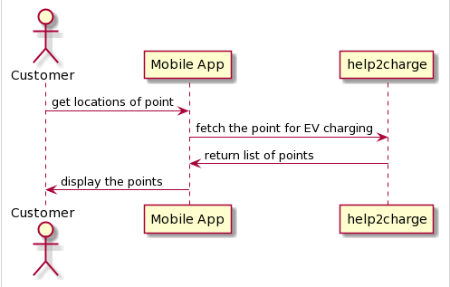

- Fetch help2charge points

Accessible By | Role | Comments
Customer | Individual | Person using the app can provide the details
Back Support Agent | Admin | Show the details of point

Basic Flow:

- Share help2charge points

Accessible By | Role | Comments
Customer | Individual | Person using app can share details via other app
Back Support Agent | Admin | Share the details via other app or message

- Modify help2charge points

Accessible By | Role | Comments
Back Support Agent | Admin | To be able to update any details of charge point
Back Support Person | Support Agent | To be able to update details like location, contract no, facilities etc.

- Register Customer for help2charge

- Slot booking for help2charge

