**Assignment – 2**

What is Sustainable and Unsustainable Development? Explain it.

Sustainable Development

Sustainable development is the type of development that satisfies the current needs of the society without interfering with “the ability of the future generations to meaaet their own needs”. On the contrary, unsustainable development does not consider the future generations, or their needs.

Sustainable development is the type of development that satisfies the current needs of the society without interfering with “the ability of the future generations to meet their own needs”. On the contrary, unsustainable development does not consider the future generations, or their needs.

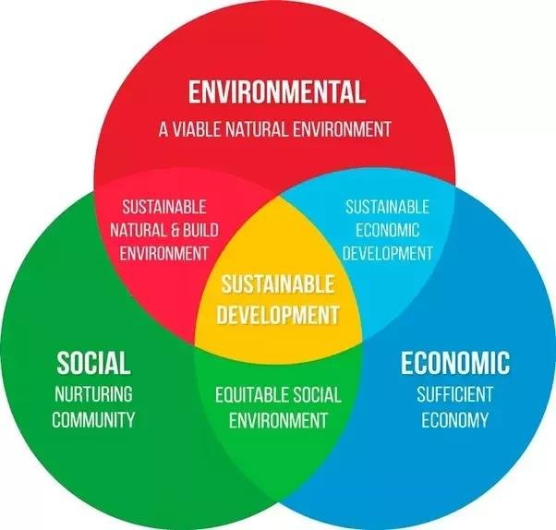

Example:-

A good example of sustainable development is a decision by governments to encourage use of renewable energy sources. This could be a part of plan to transform the energy market on a global scale. The long term achievement will be use of renewable sources of energy and protection of the environment. By use renewable energy, the current global energy crisis might be resolved, while at the same time, the future generations will be able to meet their needs. This is because renewable energy is cheaper than non-renewable energy. The environment will also be protected at present and in future (Kates & Parris, 2005).

Sustainable development projects around the world cover peace, environment, food, education, employment and other needs that are evident in the current world. In environment protection, sustainable development protects the integrity of the ecology, reduces wastes and protects the inhabitants or species in those environments. Activities geared towards sustainable development are meant to achieve equity in terms of resources. The present generation shares the unlimited resources with future generations while protecting the natural resources (Kates & Parris, 2005)

**Important Measures for Sustainable Development**

#### **(i) Technology:**

Using appropriate technology is one which is locally adaptable, eco-friendly, resource efficient and culturally suitable.

It mostly involves local resources and local labour. Indigenous technologies are more useful, cost-effective and sustainable. Nature is often taken as a model, using the natural conditions of that region as its components. This concept is known as “design with nature”. The technology should use less of resources and should produce minimum waste.

#### **(ii) Reduce, Reuse, and Recycle Approach:**

The 3-R approach advocating minimization of resource use, using them again and again instead of passing it on to the waste stream and recycling the materials goes a long way in achieving the goals of sustainability. It reduces pressure on our resources as well as reduces waste generation and pollution.

**(iii) Promoting Environmental Education and Awareness:**

Making environmental education the centre of all learning process will greatly help in changing the thinking pattern and attitude of people towards our earth and the environment. Introducing subject right from the school stage will inculcate a feeling of belongingness to earth in small children. ‘Earth thinking’ will gradually get incorporated in our thinking and action which will greatly help in transforming our lifestyles to sustainable ones.

**(iv) Resource Utilization as Per Carrying Capacity:**

Any system can sustain a limited number of organisms on a long-term basis which is known as its carrying capacity. In case of human beings, the carrying capacity concept becomes all the more complex. It is because unlike other animals, human beings, not only need food to live, but need so many other things to maintain the quality of life. Sustainability of a system depends largely upon the carrying capacity of the system. If the carrying capacity of a system is crossed (say, by over exploitation of a resource), environmental degradation starts and continues till it reaches a point of no return.

**(v) Improving Quality of Life Including Social, Cultural and Economic Dimensions:**

Development should not focus just on one-section of already affluent people. Rather it should include sharing of benefits between the rich and the poor. The tribal, ethnic people and their cultural heritage should also be conserved. Strong community participation should be there in policy and practice. Population growth should be stabilized.

Main features of sustainable development are as under:

**1. Sustained rise in real per capita income and economic welfare:**

There should be a sustained rise in real per capita income and economic welfare over time.

**2. Rational use of the natural resources**:

Sustainable development does not mean that natural resources should not be used at all. It simply means that natural resources be rationally used in a manner such that they are not excessively exploited.

**3. No reduction in the ability of future generation to meet their own needs**:

Sustainable development aims at making of natural resource and environments for asking or raising the existing standard of living in such a way as not to reduce ability of the future generations to meet their own needs.

**4. No increase in pollution**:

Sustainable development discards those activities which in order to maintain existing high standard of living, prove deter mental to nature resources and environment. According to the concept, one should drishti from undertaking such activities as may increase pollution and decrease quality of life of future generations

**Unsustainable Development**

**Definition:**-

Unsustainable development occurs when present progress is at the expense of future generations. For example, irresponsible planning and environmental degradation through exploitation of resources generates waste and pollution that damages ecosystems. Such practices are not sustainable in the long term

Unsustainable development does not take into consideration the social, economic or environmental needs of the future generations. According to research, unsustainable development can occur as a result of deliberate carelessness. However, that is not always the cause of unsustainable development. It can occur as a result of good intentions just like sustainable development. Lack of understanding of the possible long term consequences makes it to become unsustainable

Example:-

A good example of unsustainable development can occur in irrigation projects. These projects are always planned with good intentions and with good interest of both the current and future generations. They can be carried out to relieve countries suffering from hunger and poverty, which is a global predicament. In this way, the project falls under sustainable development since the future generation will not be affected by food insecurity.

However, over irrigation might result in depletion of natural water sources. Aral Sea in Asia is a typical example of a water source that was utilized in irrigation by the Soviet Union. Overuse of this sea initiated a long process of desertification that endangered the future generations. This turned a sustainable development project into an unsustainable development affecting millions of people and endangering the natural environment (Kates & Parris, 2005).

Another example of an unsustainable development that is initially planned with good intentions is an urban planning project. This plan is supposed to solve urban housing problem, prevent the growth of slums, and solve the sewerage and garbage problem. Growth in population changes everything that was initially planned. The houses constructed under the plan serve the current generation but cannot handle an increase in population. The future generations suffer the problem of water supply, getting rid of sewerage wastes and limited supply of electricity and other social amenities (Kates & Parris, 2005).

**Causes of Unsustainable Development:**

Unsustainable development is one in which we forget our responsibility towards the environment. In unsustainable development, we degrade the available resources. Not thinking about the needs of future generations is unsustainable development. Unsystematic planning can lead to damage to natural as well as human-made resources. It can cause extreme degradation of the environment as well as the living organism.

