Project Report
On
E-Disposer

Submitted by
Sanket Dhumal – 13
Sachin Pal – 56
(Semester - IV)

Year 2017-2018
Under the Guidance of
Prof.Megha Mudholkar
Prof. Brijesh Pandey

Table of Contents
Chapter 1 Introduction
- Introduction of the project
- Problem Definition
- Project Objectives
- Scope of project
Chapter 2 Literature Survey
- Existing System
- Proposed System
- Use case
Chapter 3 Analysis
3.1 Feasibility Analysis
3.2 Cost Benefit Analysis
3.3 Diagrams (Flowchart/ER/Data Flow)
Chapter 4 Methodology
4.1 Tools used
4.2 Procedure
Chapter 5 Screen Shots
Chapter 6 Testing and Validation
6.1 Test cases and Report
Chapter 7 Conclusion

Chapter 8 References
1. Introduction

E-Disposer is an online platform for buyers as well as sellers for e-waste where different users and companies can buy and sell any type of electronic waste it has. Through this app various individual or companies would be able dispose its e-waste properly so that it doesn’t affect the environment and is disposed in a correct way.

1.2 Problem Definition

There have been a lot of technical advancements and developments in a very less amount of time. The rates at which the technologies are changing are way too rapid then actually using it.
Huge production of a electronic device and then not using it leads the user to dispose such waste.
For example there are new feature with every new phone that is launched. As the technology gets older the mobile devices also cannot be updated as fast the previous growth. Hence there is a huge number of mobile which are to be thrown away.

1.3 Objective

The objectives of this system are as follows.
- Online platform for buyer and seller of e-waste
- Proper disposal of electronic devices
- Online record of all devices brought and sold.
- Information on various disposal centers.
- Recycling the equipment using proper channel

1.4 Scope

The scope of the project will be largely divided under many users who will be interested to buy and sell e-waste for their respective use. The seller will mostly be a firm which will be dealing with its actual processing for disposal after which they would be creating new products or will be recycling it. Also many users and firms may provide information regarding collection of their e-waste details so that interested user can go and buy it online. Also the Municipal Corporation can use it full their purpose regarding the e-waste disposal.

2. Literature Survey

2.1 Existing System

Currently there is no online platform where a user can post the details regarding any electronic waste it has which can be recycled for further use. There is no proper information about how and where to dispose this waste so that it doesn’t affect our environment.

2.2 Proposed System

E-Disposer is an online platform where a user can post information about the electronic waste it has. It contains details regarding the product like type, brand, condition etc.Genuine user can contact the seller and make the transaction.

3. Analysis

3.1.1 Feasibility Study

After doing the project E-Disposer, study and analyzing all the existing or required functionality of the system, the next task is to do the feasibility study for the project. It includes all the solution to the given problem. The proposed solution should satisfy all the user requirements and should be flexible enough so that future change can be easily done based on the upcoming requirements.

3.1.2 Technical Feasibility

It includes study of function, performance and constraints that may affect the ability to achieve an acceptable system. All the functionality provided in the System Requirement Specification (SRS) is checked and design has been made accordingly.

3.1.3 Operational Feasibility
No doubt the proposed System is fully GUI based that is user friendly and all the inputs to be taken all self-explanatory. Proper training has been conducted to know the essence of system to Hospital admin and user so that they can be comfortable with new system.

3.2 Cost Benefit Analysis
Hosting a app
- 5000rs for making the app
- 1800rs on-time registration for play store
- Purchasing Domain for one year
Benefits Analysis
- One shop-stop for all the buyers and sellers for e-waste.
- Saving up traveling cost for searching the product.
- Proper tracking for all the transactions.
- Due to proper disposal less harm to the environment.
- Some profit would be made using ADsense.

3.3 Diagram
3.3.1 Flowchart
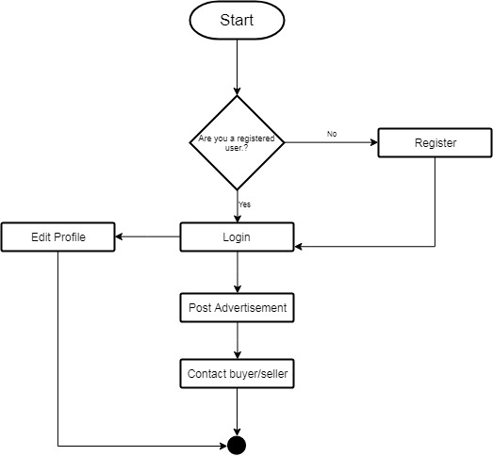
3.3.2 E-R Diagram
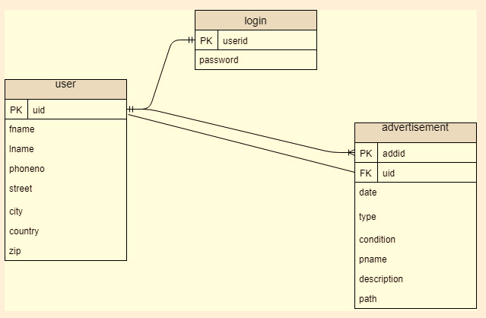
3.3.3 Use Case Diagram
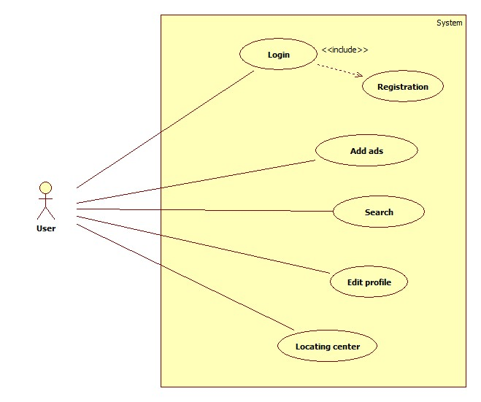

4. Methodology
4.1 Procedure
A user would approach the website whenever he has to sell any electronic waste that he has. He can post his phone number as well as all the details regarding him so that interested buyers can search for the product and contact him for the same. The user can upload all the device information and its image as well. He can also delete the posted ad after the transaction is done. The user can also lookup for disposal centers for manually dropping sites. The website also contain information regarding the e-waste and the website
4.2 Tools used
Front-End
- CodeIgnitor, HTML and CSS
- XAMPP server
- Bootstrap,Notepad++
Back-End
- MySQL
5 Screenshot
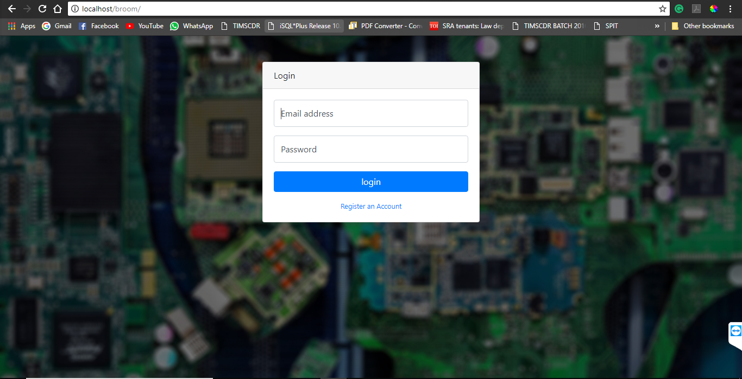

All advertisement
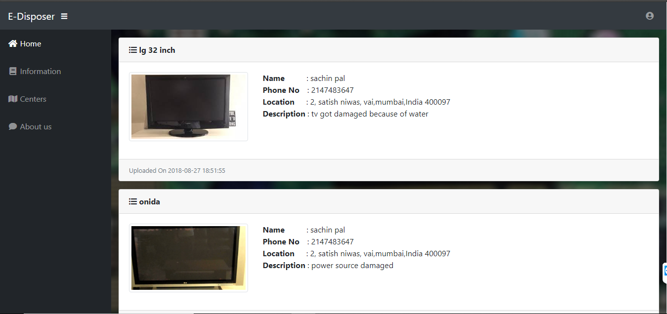

Information Page
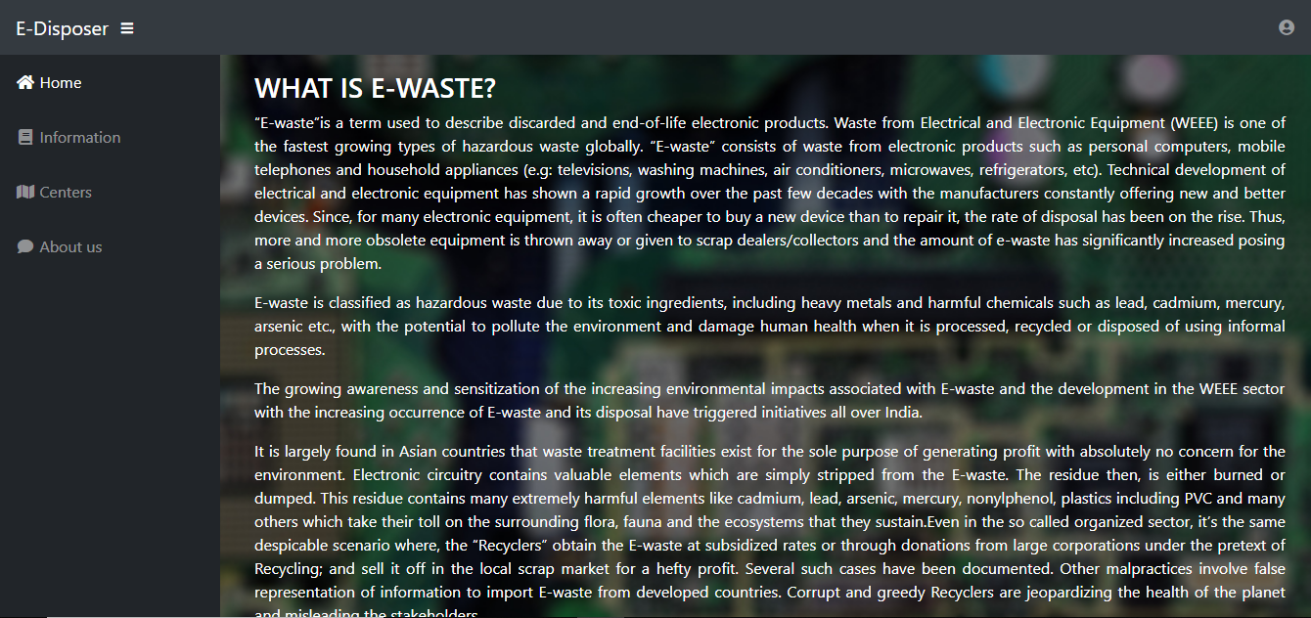

Centers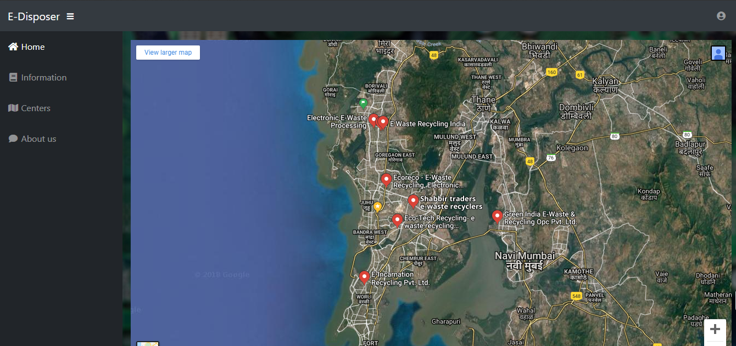

About 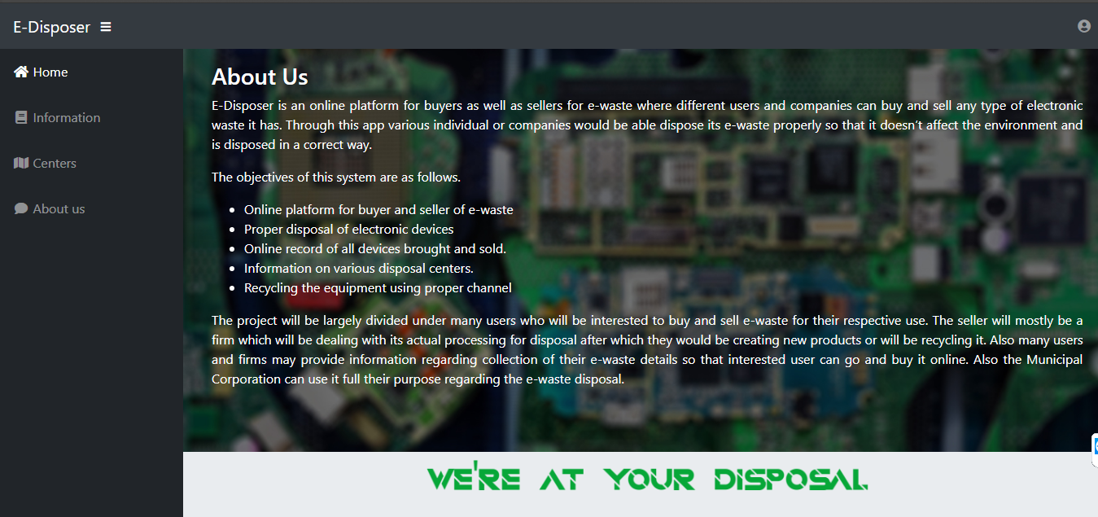

Adding advertisement
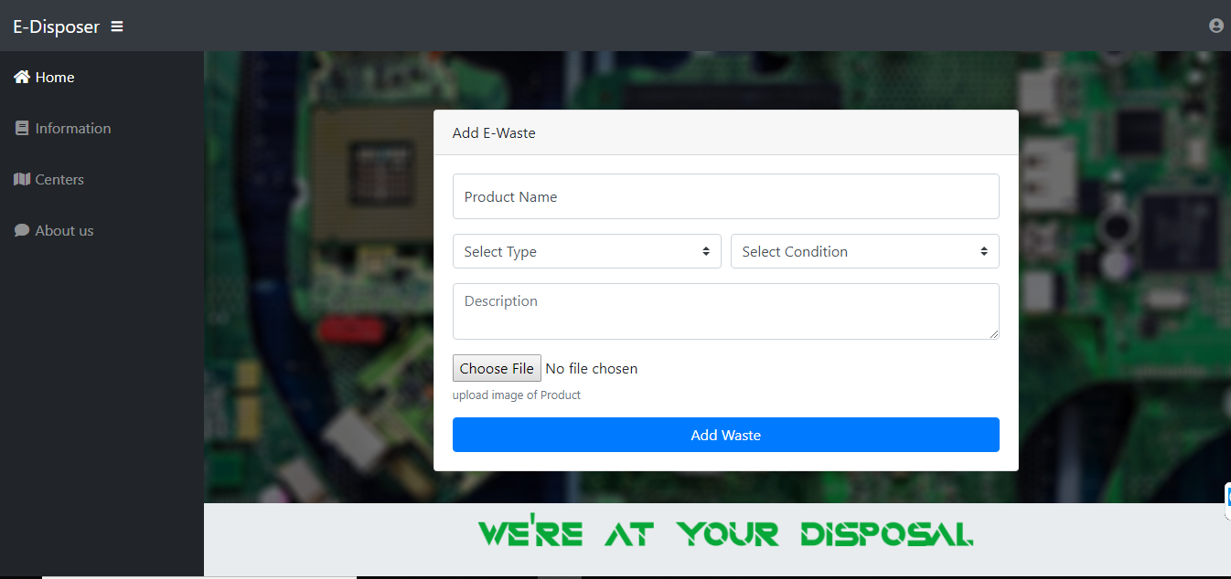

6. Test Case and Report
Test case of | Test Case name | Test case description | Test Steps |  |  | Test case status | Test Status | Test Priority
 |  |  | Step | Expected | Actual
Login | Validate Login | To verify that login is successful only on valid username & password combination. | Enter blank email and blank password. | An error message “Email is required”, “Password is required” must be displayed. | An error message “Email is required”, “Password is required” must be displayed. | Design | Pass | High
Login | Validate Login |  | Enter invalid email and password and click login | An error message ”Invalid email format” must be displayed. | An error message ”Invalid email format” is displayed. | Design | Pass | High
Login | Validate Login |  | Enter valid email & password | Login successful and the Homepage should be displayed. | Login successful and the Homepage is displayed. | Design | Pass | High
Registration | Validate register form | To verify that registration is successful only on valid details | Keeping all the entries blank. | Required field validation errors should be displayed. | Required field validation errors are displayed. | Design | Pass | High
Registration | Validate register form |  | Putting existing username and email. | Error message “Username already exists”, “Email already exists” should be displayed. | Error message “Username already exists”, “Email already exists” is displayed. | Design | Pass | High
Registration | Validate register form |  | Putting all the correct details. | User should be registered and login page should be displayed | User is registered and login page is displayed | Design | Pass | High
All ads | Test system | To verify that all the ads of all users are seen on system. | No Input | It should give error for not entering the location | Please login | Nearby system | Pass | High
All ads | Test system | To verify that all the ads of all users are seen on system. | If user is logged in. | All ads posted by him is shown | All the nearby hospital are available to user | All the nearby hospital are available to user | Pass | High

7. Conclusion
The project report entitled "E-Disposer" has come to its final stage. The system has been developed with much care that it is free of errors and at the same time it is efficient and less time consuming. The important thing is that the system is robust. It was a wonderful and learning experience for us while working on this project. This Project took us through the various phases of project development and gave us real insight into the world of software engineering. It was due to this project we came to know how professional software is designed. We enjoyed each and every bit of work we had put into this project. The project is further extendable by make them on Android platform and provide give more features to the project

8. References
- E-waste centers maps
- www.w3schools.com
- www.bootstrap.com
- www.codeignitor.com
- https://en.wikipedia.org/wiki/Electronic_waste
- https://books.google.co.in/books/about/Electronic_Waste_Management.html?id=9Oj49a2aDPsC

