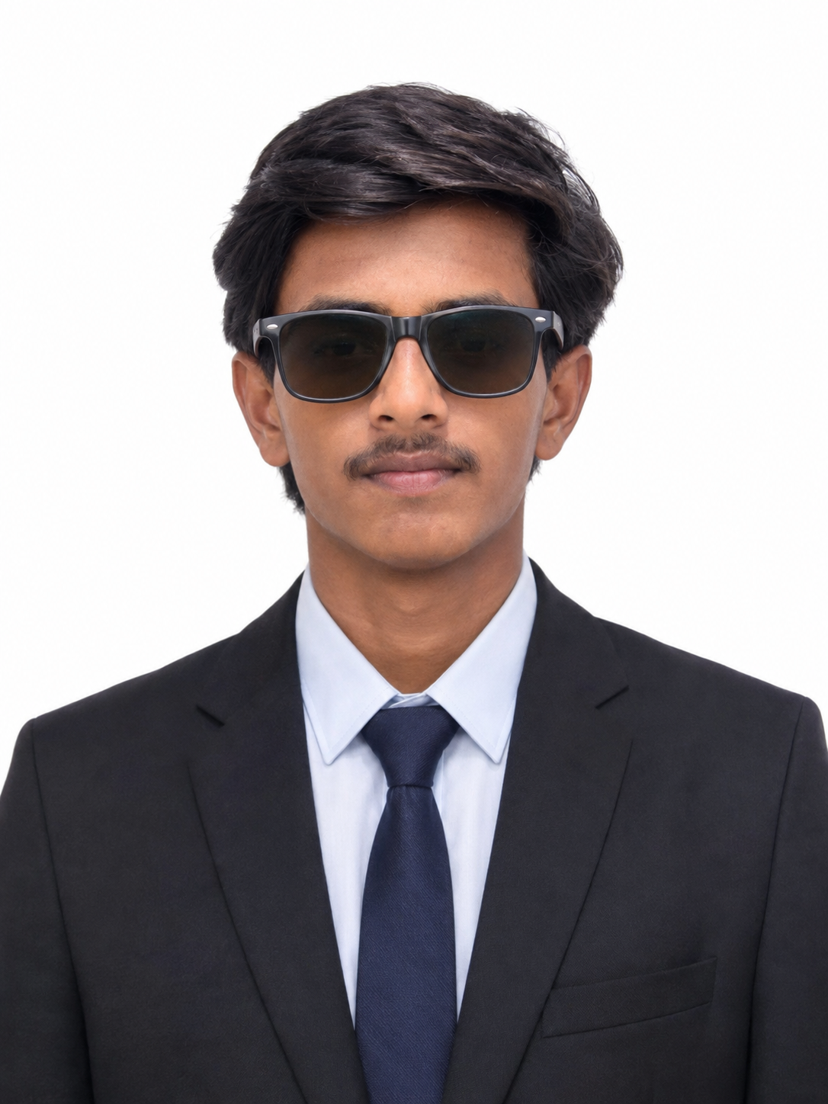 | Sachin R Karankal  Career-focused and results-driven professional  Mobile: +91 9226313805  WhatsApp: +91 9226313805  Instagram: @patil_sachin_sg  Email: sachinpatil12345te@gmail.com
PROFESSIONAL SUMMARY
Dedicated and professional individual with strong communication skills, a passion for growth, and a commitment to delivering quality work. I have practical exposure to AI & ML, Power BI, and data-driven thinking, and I value consistency, responsibility, and continuous learning in every opportunity I take.
EDUCATION
Diploma in Computer Engineering
R C Patel College of Engineering and Polytechnic, Shirpur
Currently in 3rd year of study
Focused on hands-on technical learning and practical industry exposure
SKILLS
- Communication
- Leadership
- Problem Solving
- Time Management
- Teamwork
- Customer Support
- Adaptability
- Professionalism
- AI & ML
- Power BI
- Python
- Data Analysis
INTERNSHIP EXPERIENCE
Internship in AI & ML
Completed internship training in Artificial Intelligence and Machine Learning, gaining practical exposure to modern technology, model concepts, and data-driven problem solving.
PROJECTS
Fashion Intelligence Hub
Developed a style prediction and best marketplace recommendation system that helps users discover fashion trends and suitable products based on their preferences.
Credit Card Fraud Detection Dashboard
Built a dashboard that predicts credit card fraud and displays all relevant transaction and fraud-related information for analysis and decision-making.

