Task 1: Repository Setup & First Branch
- Create a new GitHub repository.
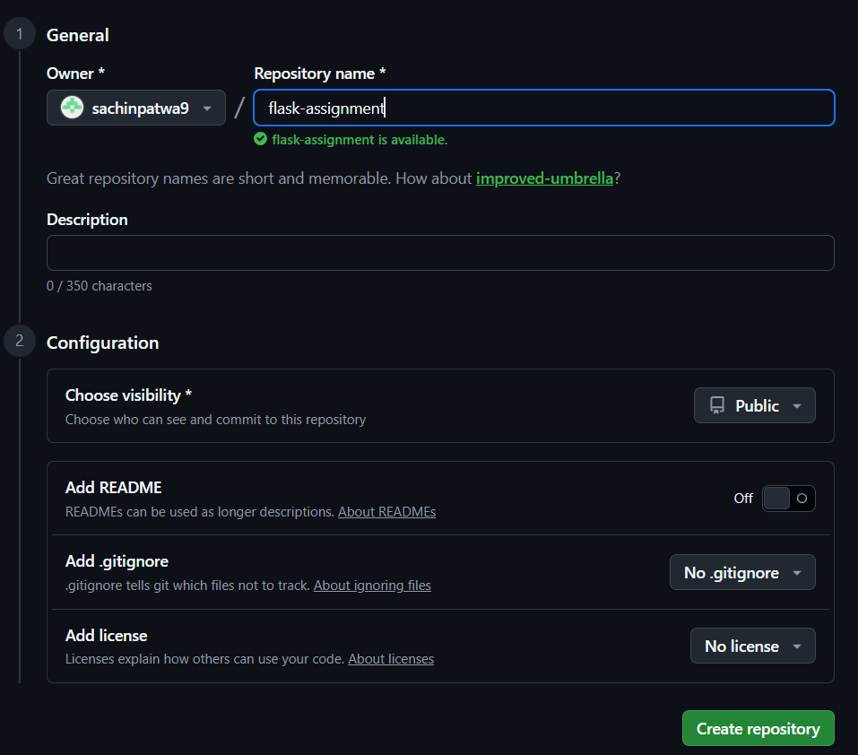
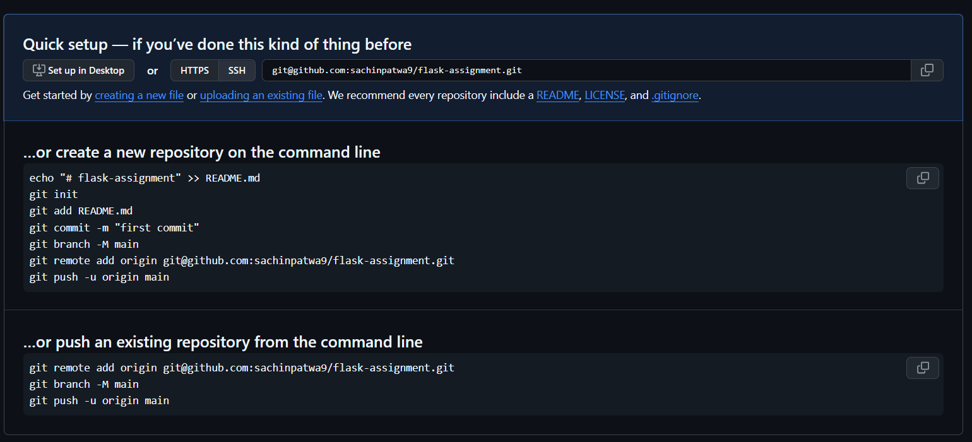

- Clone the repository to your local machine using SSH (generate an SSH key if needed, and add the public key to your GitHub account).
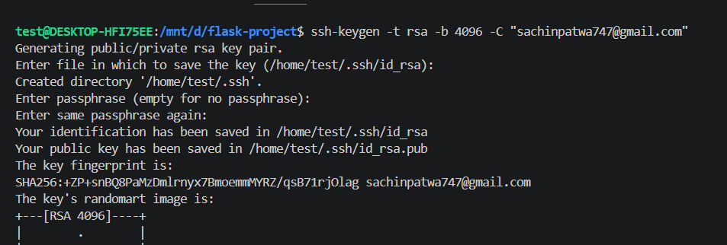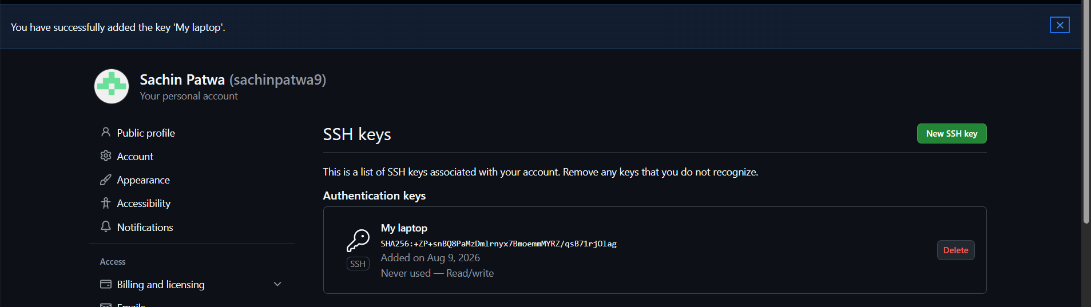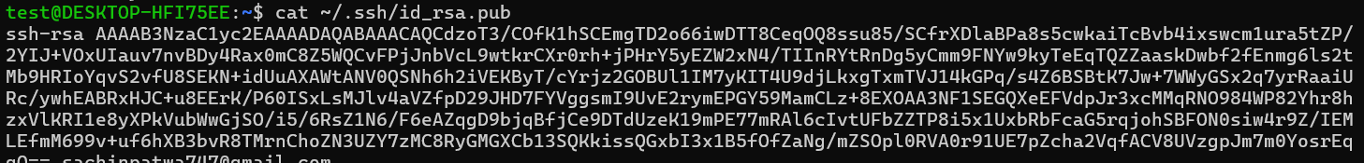
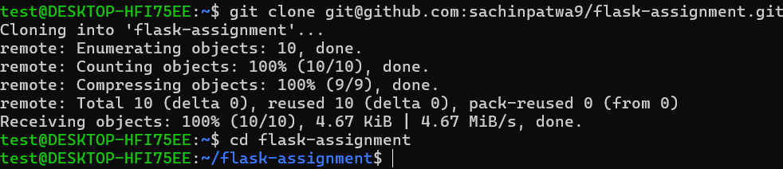

- Create a new branch named after your username (e.g., Tutedude)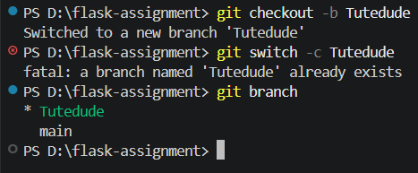

- Add your Flask project files to this branch.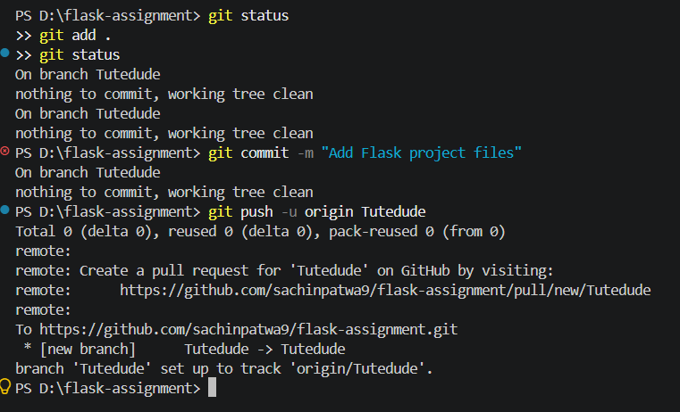

- Commit the changes and merge the branch into the main branch.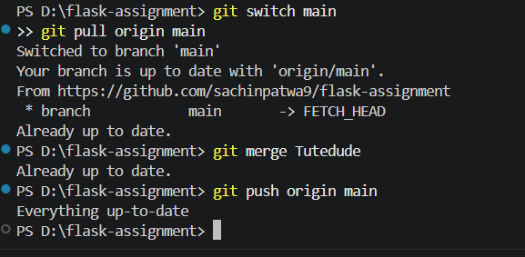
Task 2: Update JSON & Resolve Conflicts
- Create a new branch named _new (e.g., Tutedude_new).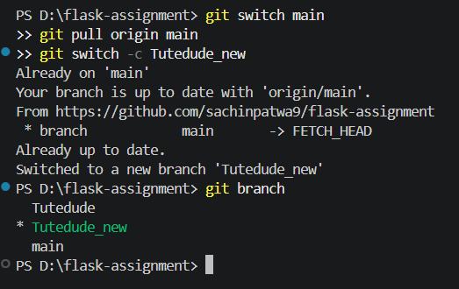

- Update the content of the JSON file used for the /api route in this branch.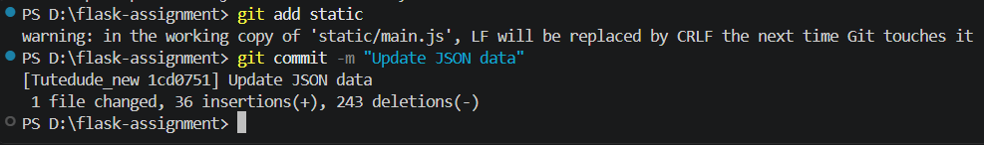
- Merge the _new branch into the main branch.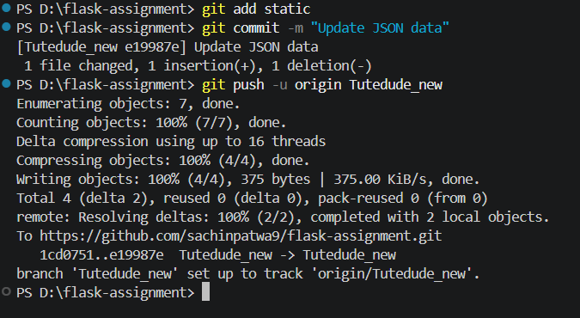
- If there are conflicts during the merge, resolve them by accepting the changes from the _new branch.
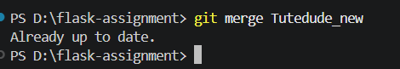
- Add the resolved changes to the staging area, commit them, and push the updates to the remote repository. 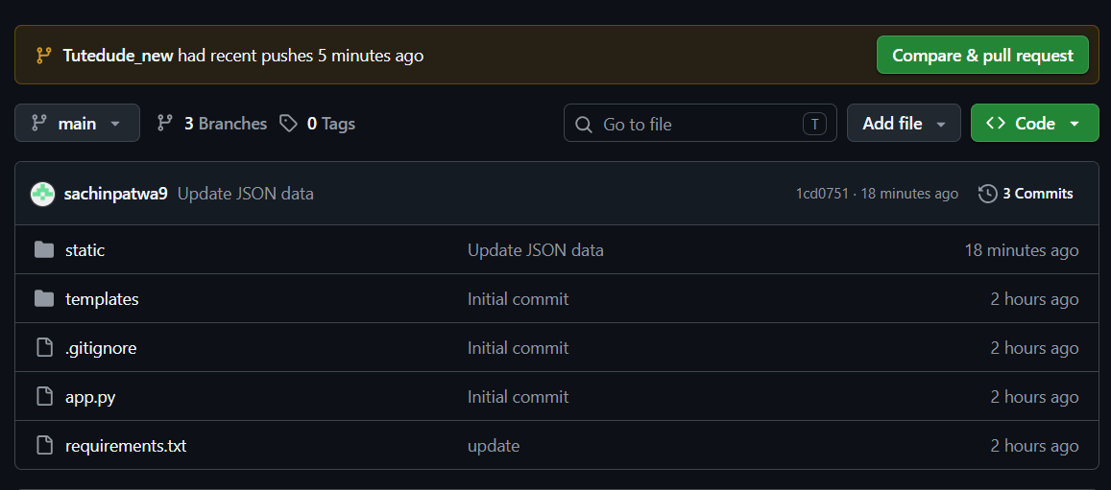

Task 3: Parallel Feature Development
- Branch Creation: Create two branches, master_1 and master_2, from the main branch.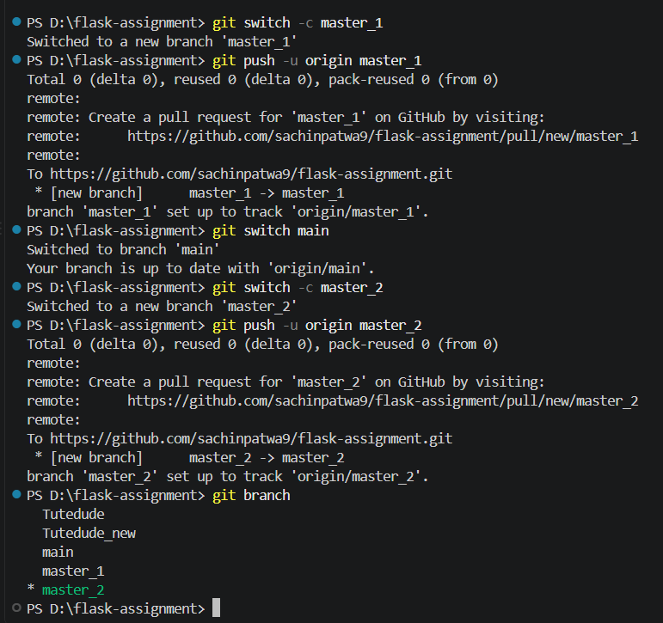

- Feature Development in master_1: Create a To-Do Page in the frontend with a form containing the fields Item Name and Item Description.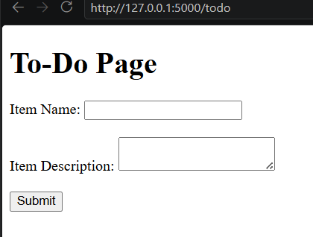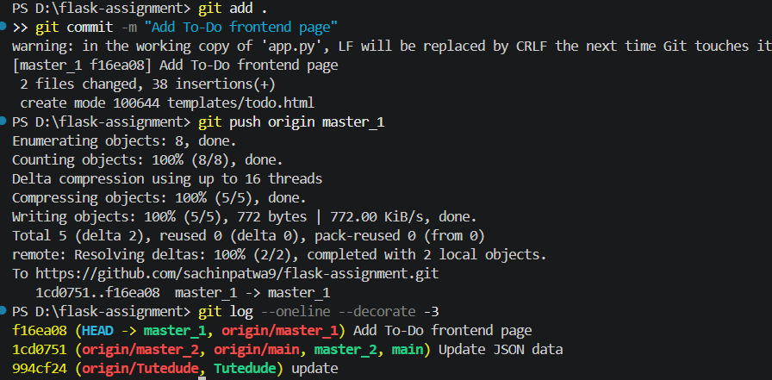
- Backend API in master_2: Create a backend route named /submit todo item that accepts itemName and itemDescription via a POST request and stores these details in a MongoDB database.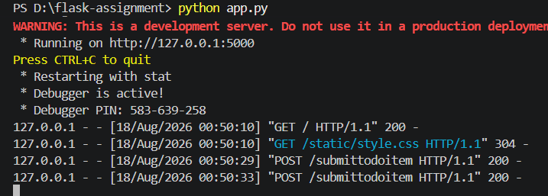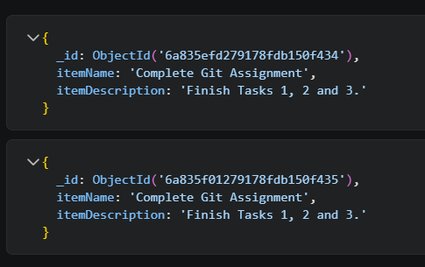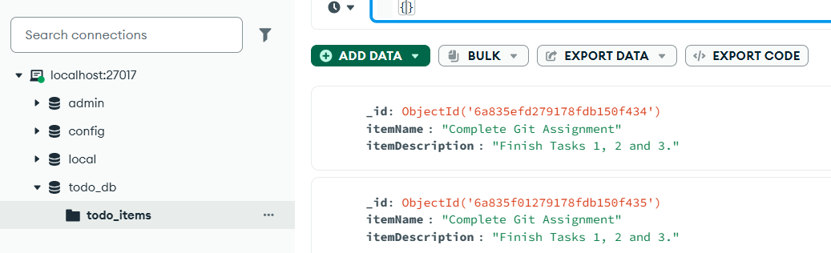
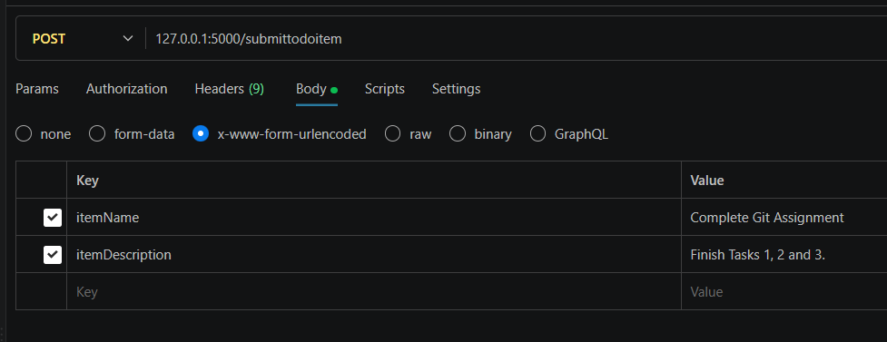

- Merging Changes: Merge the changes from both master_1 and master_2 into the main branch.
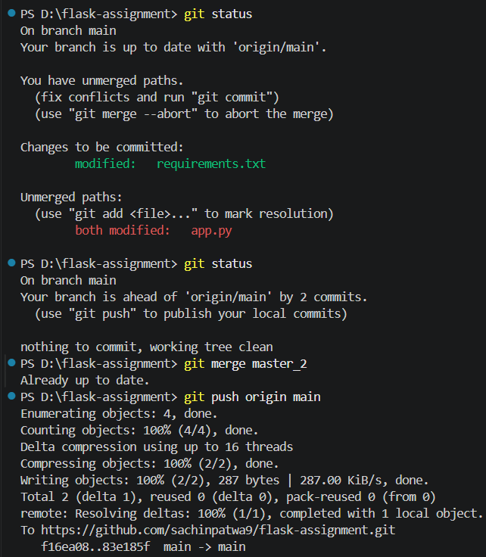
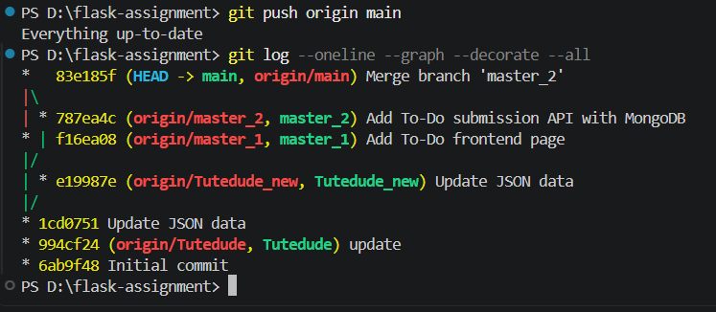
Task 4: Sequential Commits, Reset & Rebase
- Enhancing the To-Do Form in master_1: Add the following fields to the To-Do form: Item ID, Item UUID, Item Hash.
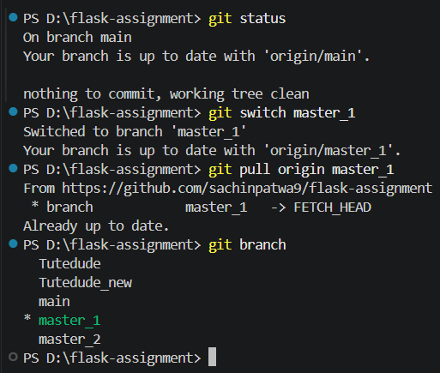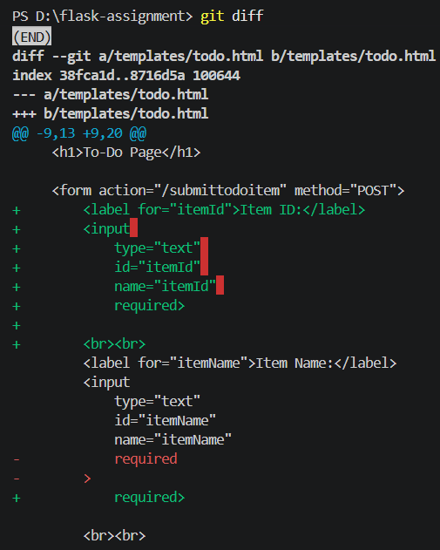
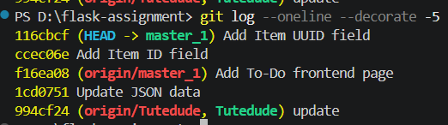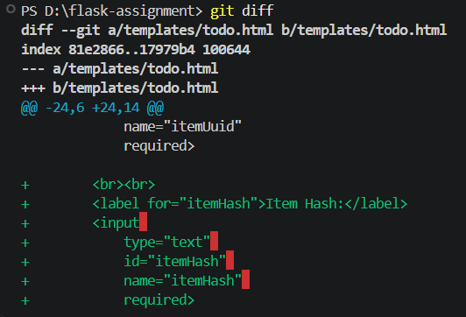
- Committing in Sequence: Add and commit each field separately — first commit: Item ID; second commit: Item UUID; third commit: Item Hash.
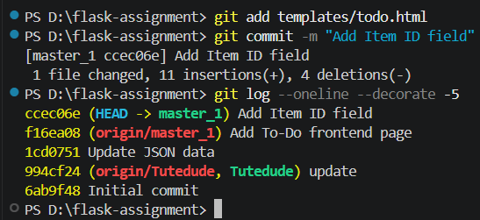

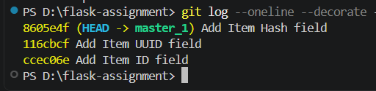
- Merging to main: Merge the master_1 branch into the main branch.
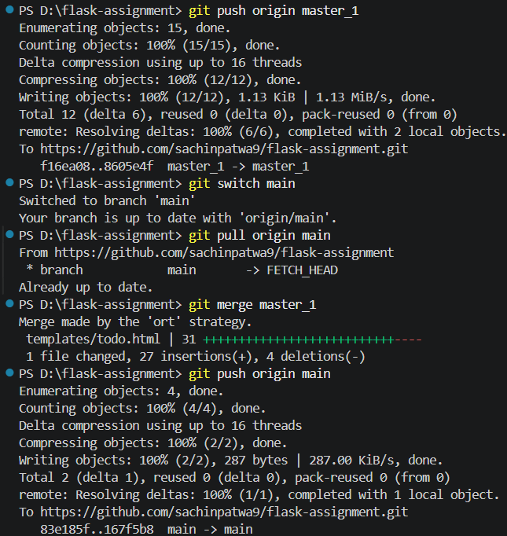
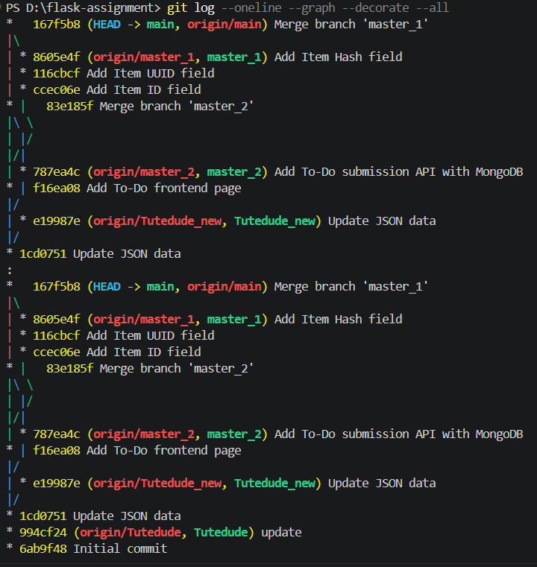

- Git Reset: In the main branch, roll back to the commit where only the Item ID field was added. Use git reset --soft to ensure changes remain staged, then re-commit this state and merge it to main.
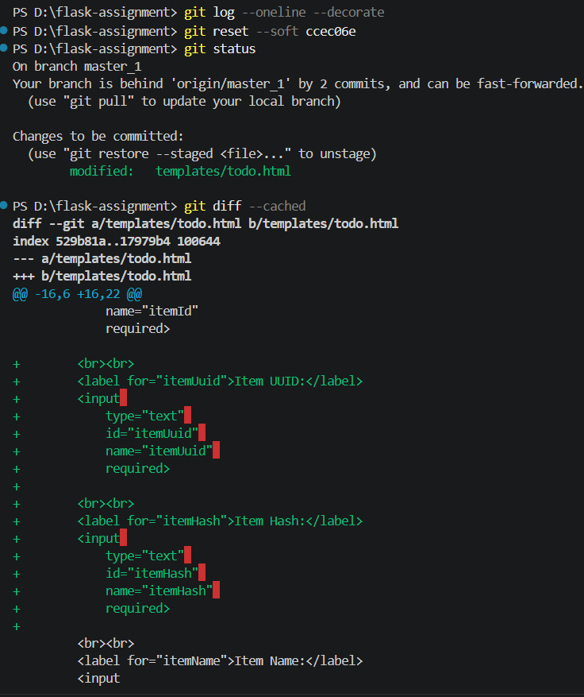
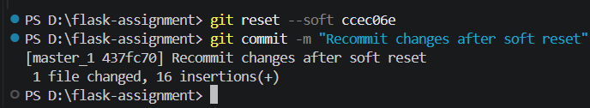
- Rebasing: Rebase the updated main branch changes onto master_1 using git rebase main master_1. Preserve individual commits (do NOT squash) to maintain commit history.
