Data Types in C

A data type specifies the type of data that a variable can store such as integer, floating, character, etc.

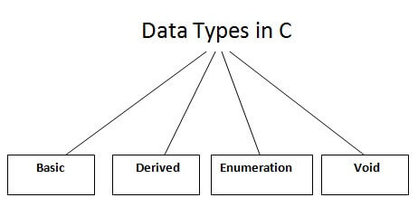

There are the following data types in C language.

|  |  |
| --- | --- |
| **Types** | **Data Types** |
| Basic Data Type | int, char, float, double |
| Derived Data Type | array, pointer, structure, union |
| Enumeration Data Type | enum |
| Void Data Type | void |

Basic Data Types

The basic data types are integer-based and floating-point based. C language supports both signed and unsigned literals.

The memory size of the basic data types may change according to 32 or 64-bit operating system.

Let's see the basic data types. Its size is given **according to 32-bit architecture**.

|  |  |  |
| --- | --- | --- |
| **Data Types** | **Memory Size** | **Range** |
| **char** | 1 byte | −128 to 127 |
| signed char | 1 byte | −128 to 127 |
| unsigned char | 1 byte | 0 to 255 |
| **short** | 2 byte | −32,768 to 32,767 |
| signed short | 2 byte | −32,768 to 32,767 |
| unsigned short | 2 byte | 0 to 65,535 |
| **int** | 2 byte | −32,768 to 32,767 |
| signed int | 2 byte | −32,768 to 32,767 |
| unsigned int | 2 byte | 0 to 65,535 |
| **short int** | 2 byte | −32,768 to 32,767 |
| signed short int | 2 byte | −32,768 to 32,767 |
| unsigned short int | 2 byte | 0 to 65,535 |
| **long int** | 4 byte | -2,147,483,648 to 2,147,483,647 |
| signed long int | 4 byte | -2,147,483,648 to 2,147,483,647 |
| unsigned long int | 4 byte | 0 to 4,294,967,295 |
| **float** | 4 byte |  |
| **double** | 8 byte |  |
| **long double** | 10 byte |  |