## 2019103555 PRANAVA RAMAN B M S 20/10/2021

OOAD - ASSIGNMENT 1

**Q1**: Add given functions [display, shuffle, deal, initialize, sort, topOfPile, bottomOfPile, insert, draw, discard] to the diagram and Describe the arguments & functionality of the functions in each class.

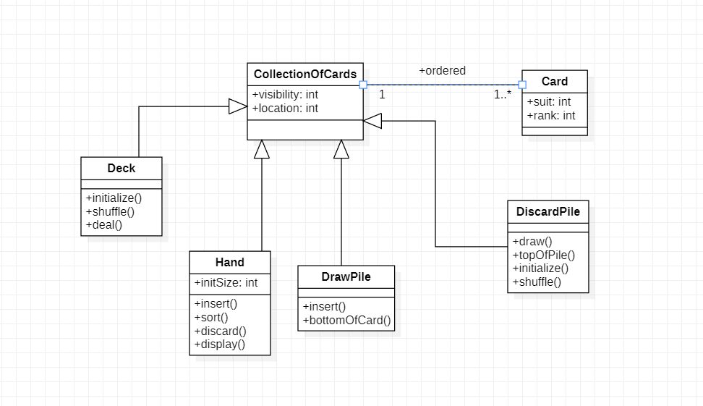

|  |  |  |  |
| --- | --- | --- | --- |
| **Class** | **Function** | **Description** | **Arguments** |
| **Deck** | initialize() | Before beginning a game, the deck is initialized either with the joker or without them. | (bool includeJoker) |
| shuffle() | After initializing, the deck which has an array of cards has to be shuffled before playing. | (Card card[]) |
| deal() | The cards are dealt by the players. | (Card card) |
| **Hand** | insert() | When the cards are dealt, the picked card must be inserted in the hand to own it. | (Card card) |
| sort() | The array of cards in the hand can be sorted to organize them according to suit and rank. | (Card card[]) |
| discard() | The cards in the hand can also be discarded while dealing. | (Card card) |
| display() | In a situation where the player is winning, the cards in the hand must be displayed to claim victory according to suit and rank. | (Card card) |
| **DiscardPile** | insert() | When a player discards a card, it is inserted in the DiscardPile | (Card card) |
| bottomOfCard() | The inserted card is kept such that bottomOfCard is facing up | (Card card) |
| discard() | In a situation where the DrawPile becomes empty, cards from the DiscardPile is discarded to add to the DrawPile | (Card card) |
| **DrawPile** | draw() | When a player picks a card, it is drawn from the DrawPile | (Card card) |
| topOfPile() | The picked card needs to be drawn from the topOfPile | (Card card) |
| initialize() | Before starting a game or when the DrawPile becomes empty, the DrawPile is initialized with an array of cards. | (Card card[]) |
| shuffle() | The DrawPile is shuffled before starting the game. | (Card card[]) |
| **Card** | dispay() | Any single card can be displayed to show suit & rank. | (Card card) |

**Q2**: Modify the given class diagram so that portions of the same column may appear on more than one page. If the user edits the text on one page, the changes should appear automatically on other pages. You should change x location and y location into attributes of an association. Draw a complete class diagram.

The completed class diagram for the given scenario:

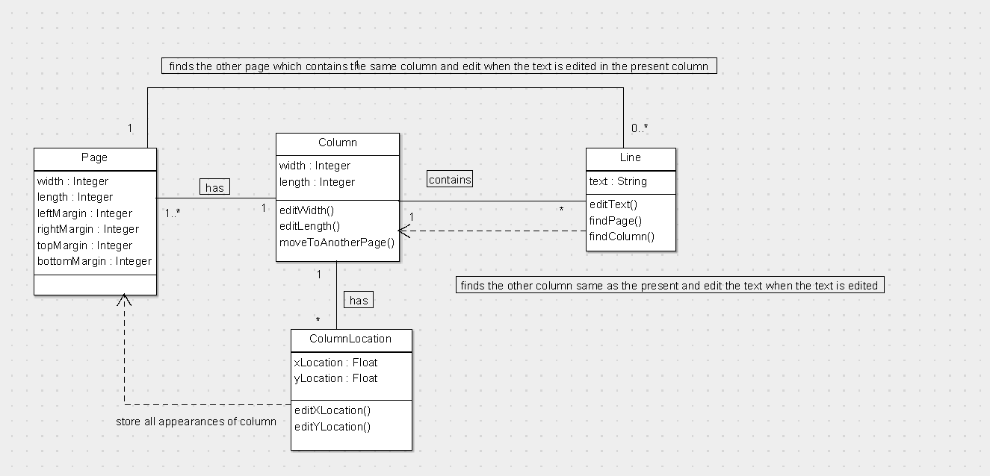

**Q3**: Add multiplicity and name the associations to the diagram.

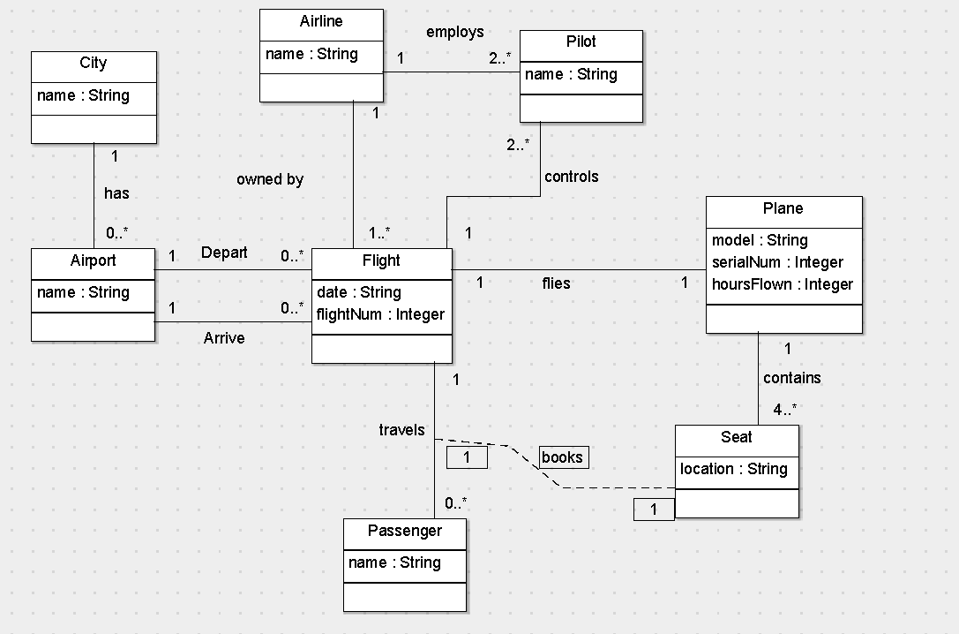

The relationships that hold true are:-

|  |  |  |
| --- | --- | --- |
| **Class-1** | **Description** | **Class-2** |
| City | 1 City can have 0 or many Airports | Airport |
| Flight | 0 or many Flights departs from an Airport | Airport |
| Flight | 0 or many Flights arrives at an Airport | Airport |
| Airline | 1 Airline owns 1 or more Flights | Flight |
| Airline | 1 Airline can employ 2 or more Pilots | Pilot |
| Plane | 1 Plane can fly 1 Flight at any given time | Flight |
| Passenger | 0 or more Passengers travel in a Flight | Flight |
| Pilot | 2 or more Pilots control a Flight at any given time | Flight |
| Passenger | 1 Passenger can Buy 1 Seat for them | Seat |
| Plane | 1 Plane has 4 or more Seats | Seat |