
IILM UNIVERSITY, GREATER NOIDA
School of Computer Science and Engineering
SUMMER INTERNSHIP REPORT
ON
"SQL AND DATABASE MANAGEMENT SYSTEMS VIRTUAL INTERNSHIP (HINDI)"
Submitted in partial fulfilment of the requirements for the degree of
Bachelor of Technology in Computer Science and Engineering
Submitted By
Name: | Sachin Raj
Roll No.: | 2410030656
Class / Section: | 3CSE21
Internship Organization: | EduSkills Academy
Internship Domain: | SQL and Database Management Systems
Internship Duration: | 8 Weeks (April – June 2026)

Academic Session: 2026–27

CANDIDATE’S / STUDENT DECLARATION
I hereby declare that this Summer Internship Report is my own academic work and has been prepared for the fulfilment of the academic requirements of the Bachelor of Technology programme in Computer Science and Engineering at IILM University, Greater Noida. The report is based on the internship completion certificate and the internship information made available to me. Wherever supporting sources are referred to, they have been acknowledged appropriately.
I further declare that no unsupported internship activities, technologies, projects, results, or achievements have been intentionally claimed in this report. The content has been presented conservatively in accordance with the available internship material.

Signature: ______________________
Name: Sachin Raj
Roll No.: 2410030656

ACKNOWLEDGEMENT
I would like to express my sincere gratitude to EduSkills Academy for providing the opportunity to complete the SQL and Database Management Systems Virtual Internship (Hindi). The internship offered a structured learning experience in an important area of computer science and helped me strengthen my understanding of databases and SQL-oriented concepts.
I am thankful to IILM University, Greater Noida, and the School of Computer Science and Engineering for encouraging students to undertake internship-based learning as part of their academic development. I also acknowledge the guidance and support of faculty members and mentors whose academic direction helped me connect internship learning with my B.Tech CSE studies.
I would also like to thank my family and well-wishers for their encouragement and support throughout the learning period. Their motivation helped me complete the internship and prepare this report.

ABSTRACT
This report presents a concise account of the SQL and Database Management Systems Virtual Internship (Hindi) completed as part of the academic learning journey in Computer Science and Engineering. The internship was conducted in virtual mode for a duration of eight weeks during April–June 2026 and was supported by EduSkills Academy. The internship domain focused on SQL and Database Management Systems, which are fundamental to the storage, organization, retrieval, and management of structured information in modern software systems.
The purpose of undertaking the internship was to gain structured exposure to database-related concepts and to understand the role of SQL in interacting with organized data. Based on the information available in the internship certificate, the report discusses the internship conservatively around the supported domain of SQL and database management. The learning scope therefore includes database concepts, structured and relational data organization, and SQL-oriented data querying and management concepts, without claiming specific tools, projects, implementations, or technologies that are not mentioned in the provided material.
The internship contributed to the development of foundational technical knowledge, analytical thinking, and a clearer understanding of how database systems support software applications. It also provided academic exposure to a practical technology domain that is directly relevant to B.Tech CSE studies. The overall outcome of the internship is an improved conceptual foundation for further learning in database systems, data management, and software development. No capstone project or specific project implementation is stated in the supplied certificate; therefore, this report does not claim one. The internship completion certificate is included as supporting evidence in its original form.

TABLE OF CONTENTS
Candidate’s / Student Declaration ................................ i
Acknowledgement .................................................. ii
Abstract ......................................................... iii
Table of Contents ................................................ iv
List of Tables ................................................... v
Internship Completion Certificate ................................ 1
4. PROJECT / INTERNSHIP DESCRIPTION .............................. 2
4.1 Introduction ................................................. 2
4.2 Organization Profile ......................................... 3
4.3 Problem Statement ............................................ 3
4.4 Internship / Project Objectives .............................. 4
4.5 Scope of the Internship / Project ............................ 5
4.6 Technologies and Tools Used .................................. 6
4.7 System / Project Architecture ................................ 7
4.8 Methodology .................................................. 7
4.9 Expected / Achieved Outcomes ................................. 9
4.10 Certificates and Supporting Evidence ........................ 10
10. CAPSTONE PROJECT ............................................. 11
11. SKILLS ACQUIRED .............................................. 12
12. CHALLENGES AND LEARNING ...................................... 13
13. CONCLUSION ................................................... 14
14. BIBLIOGRAPHY / REFERENCES .................................... 15

LIST OF TABLES
Table 4.1: Technologies and Tools Used ................................... 6
No additional tables are used in this report.

INTERNSHIP COMPLETION CERTIFICATE
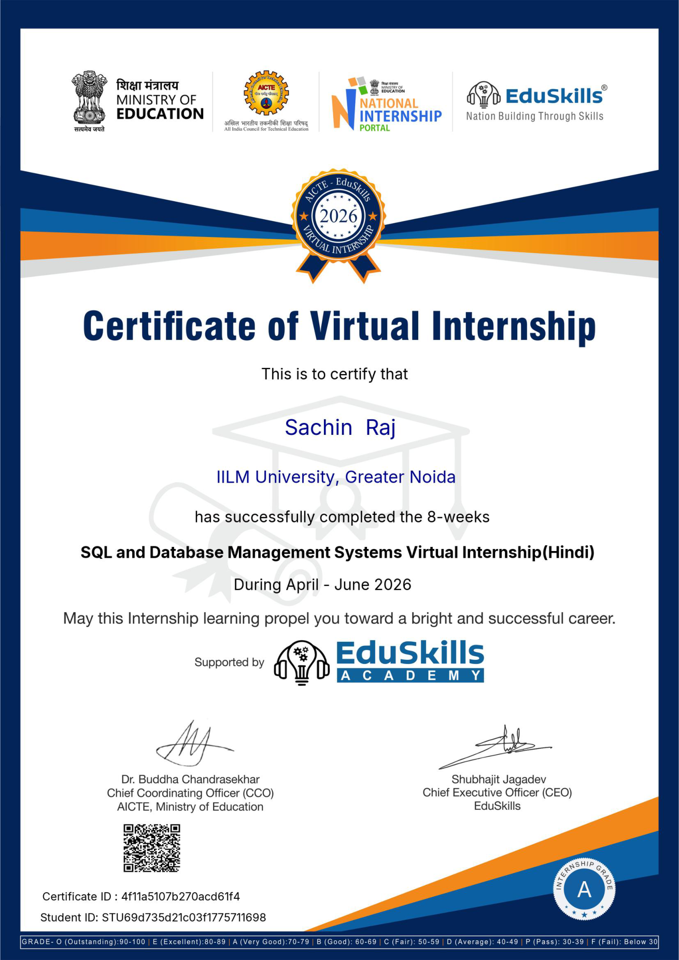

4. PROJECT / INTERNSHIP DESCRIPTION

4.1 Introduction
Database Management Systems are an essential part of modern computing because software applications depend on organized, reliable, and accessible data. A database provides a structured environment for storing information, while a Database Management System (DBMS) supports the creation, organization, retrieval, and management of that information. SQL, commonly used for interacting with relational data, provides a standard way to express operations related to data querying and management.
The internship domain of SQL and Database Management Systems is therefore directly relevant to Computer Science and Engineering. The purpose of undertaking this internship was to gain structured exposure to the database domain and to strengthen foundational understanding that can support further study and application development. The internship certificate confirms successful completion of an eight-week virtual internship titled “SQL and Database Management Systems Virtual Internship (Hindi)” during April–June 2026.

4.2 Organization Profile
The internship certificate identifies EduSkills Academy as the supporting internship provider. Based on the available material, EduSkills Academy supported the SQL and Database Management Systems Virtual Internship completed by the student. The certificate also displays associated internship ecosystem and education marks, including the AICTE and National Internship Portal marks. Since detailed organizational history, services, clients, statistics, and operational information are not provided in the supplied material, this report does not make additional claims about the organization.

4.3 Problem Statement
Modern software systems must handle information in a structured and dependable manner. Without proper data organization, storing records, retrieving relevant information, maintaining consistency, and supporting application operations become difficult. The internship domain addresses this broad technical need by introducing the principles of database management and the role of SQL in working with structured data. The central learning problem is therefore to understand how information can be organized in database systems and how SQL-based operations support access to and management of data.

4.4 Internship / Project Objectives
- To develop a foundational understanding of Database Management Systems.
- To understand the importance of structured data organization in software systems.
- To gain exposure to SQL as a language used for working with database data.
- To understand the relationship between databases, applications, and information management.
- To strengthen analytical thinking while approaching data-related problems.
- To connect database concepts with the broader B.Tech CSE curriculum.
- To develop a foundation for further learning in database systems and software development.

4.5 Scope of the Internship / Project
The technical scope of the internship is limited to the domain explicitly identified in the certificate: SQL and Database Management Systems. The internship supports conceptual learning related to database systems, structured data, and SQL-oriented interaction with data. The learning scope is useful for understanding how applications depend on organized information and how database technologies form an important component of software systems.
The domain has possible applications across information systems, enterprise software, web applications, academic systems, and other data-driven environments. However, the supplied certificate does not identify a specific deployed application, project, capstone, software tool, or implementation. Accordingly, the report discusses possible domain applications only as general relevance and does not claim that the student implemented such applications during the internship.

4.6 Technologies and Tools Used
Table 4.1: Technologies and Tools Used
Technology / Tool | Purpose | Application During Internship
SQL | Language for expressing operations on structured data. | Studied as the core technology domain indicated by the internship title.
Database Management Systems | Framework for organizing and managing structured information. | Studied as the central subject area indicated by the internship title.

4.7 System / Project Architecture
The supplied internship certificate does not mention a capstone project, practical system, or implemented software solution. Therefore, no system or project architecture has been included in this report. Introducing an architecture without source support would inaccurately represent the internship work.

4.8 Methodology
The detailed module-wise curriculum is not provided in the certificate. Therefore, the internship methodology is described only at a high level based on the confirmed learning domain and without claiming specific completed exercises or implementations.
Stage 1 – Fundamentals: Introduction to the importance of data organization and the role of database systems.
Stage 2 – Core Technical Concepts: Understanding the central ideas associated with Database Management Systems and structured data.
Stage 3 – SQL-Oriented Learning: Developing conceptual familiarity with SQL as the domain language associated with working with structured database information.
Stage 4 – Conceptual Integration: Connecting database concepts with the broader context of software applications and information management.
Stage 5 – Final Learning Outcome: Consolidating the internship learning into a stronger foundation for further study and practical development.

4.9 Expected / Achieved Outcomes
The internship strengthened foundational technical knowledge in the domain of SQL and Database Management Systems. It contributed to a clearer understanding of the role of databases in organizing and managing structured information and supported the development of a more analytical approach to data-related problems.
The internship also provided exposure to a technology domain that is relevant to software development and the B.Tech CSE curriculum. While the certificate does not document a specific project implementation or detailed practical exercise, the successful completion of the eight-week internship indicates completion of the internship learning experience recognized by the provider. The knowledge gained can be useful as a foundation for advanced database coursework and future technical learning.

4.10 Certificates and Supporting Evidence
- Internship completion certificate: Included in this report in its original form.
- Certificate title: SQL and Database Management Systems Virtual Internship (Hindi).
- Duration stated on certificate: 8 weeks.
- Internship period stated on certificate: April – June 2026.
- Certificate ID: 4f1a-5107-b70a-cd61f4.
- No additional communication, email proof, practical-work screenshots, or separate certificates were provided with the report material.

10. CAPSTONE PROJECT
No capstone project or project title is explicitly mentioned in the supplied internship certificate or supporting material. Therefore, a separate project description, architecture, workflow, implementation methodology, and results section cannot be supported by the available evidence. No project implementation is claimed in this report.

11. SKILLS ACQUIRED

Technical Skills
- Foundational understanding of SQL as a database-related technology domain.
- Basic conceptual understanding of Database Management Systems.
- Understanding of structured data organization.
- Awareness of the role of databases in software systems.
- Foundation for further learning in data management and database technologies.

Professional Skills
- Self-directed learning in a virtual internship environment.
- Analytical thinking related to technical concepts.
- Ability to connect internship learning with academic coursework.
- Structured documentation and reporting of internship learning.
- Awareness of professional learning expectations in a technology domain.

12. CHALLENGES AND LEARNING
Learning a database-related domain can require careful understanding because concepts such as structured information, data organization, and database interaction are closely connected. A virtual learning environment also requires consistent self-discipline and independent revision. These are realistic learning considerations for an internship in this domain and do not refer to any specific incident.
The main learning outcome was the recognition that database knowledge develops progressively. A clear understanding of fundamentals supports later learning in SQL, database design, application development, and data-driven systems. The internship therefore served as a useful starting point for continued technical development in the database domain.

13. CONCLUSION
The SQL and Database Management Systems Virtual Internship (Hindi) provided an academically relevant learning experience in a core area of Computer Science and Engineering. Completed over eight weeks during April–June 2026, the internship strengthened foundational understanding of database systems and the role of SQL in working with structured information.
The internship experience complements the B.Tech CSE programme by connecting academic study with a technology domain used across many software systems. Although the available certificate does not document a specific capstone project, software implementation, or detailed toolset, the successful completion of the internship demonstrates structured exposure to the subject area. The knowledge gained provides a useful base for further coursework, database-focused learning, and future software development studies.

14. BIBLIOGRAPHY / REFERENCES
[1] EduSkills Academy, “Certificate of Virtual Internship: SQL and Database Management Systems Virtual Internship (Hindi),” Internship Completion Certificate, Apr.–Jun. 2026.
[2] Oracle, “SQL Language Reference,” Oracle Database Documentation.
[3] PostgreSQL Global Development Group, “PostgreSQL Documentation: SQL Language,” PostgreSQL Documentation.
[4] International Organization for Standardization, “ISO/IEC 9075: Information technology — Database languages — SQL,” ISO.

