IILM UNIVERSITY
GREATER NOIDA
School of Computer Science and Engineering

SUMMER INTERNSHIP REPORT
ON
“SQL and Database Management Systems Virtual Internship (Hindi)”

Submitted in partial fulfilment of the requirements for the degree of
Bachelor of Technology in Computer Science and Engineering

Submitted By:
Name: Sachin Raj
Roll No.: 2410030656
Class / Section: 3CSE21
Programme: B.Tech CSE

Internship Organization: EduSkills Academy
Internship Domain: SQL and Database Management Systems
Internship Duration: 8 Weeks
Academic Session: 2026–27

IILM UNIVERSITY, GREATER NOIDA

CANDIDATE’S / STUDENT DECLARATION
I hereby declare that this Summer Internship Report titled “SQL and Database Management Systems Virtual Internship (Hindi)” is a true and original academic record prepared by me on the basis of the internship completion certificate and the internship information provided for this report. The report has been prepared in partial fulfilment of the academic requirements of the Bachelor of Technology programme in Computer Science and Engineering at IILM University, Greater Noida.
To the best of my knowledge, the contents of this report have not been copied from any other student’s work for academic submission. Where information was not available in the supplied internship material, no unsupported activities, technologies, project results, or achievements have been claimed.

Signature: ______________________
Name: Sachin Raj
Roll No.: 2410030656

ACKNOWLEDGEMENT
I would like to express my sincere gratitude to EduSkills Academy for providing the opportunity to complete the SQL and Database Management Systems Virtual Internship (Hindi). The internship provided a structured learning opportunity in the area of databases and SQL.
I am thankful to IILM University, Greater Noida, and the School of Computer Science and Engineering for encouraging students to gain practical and industry-oriented learning exposure through internship programmes. I also acknowledge the guidance and support of faculty members and mentors associated with my academic and internship learning.
Finally, I would like to thank my family and everyone who supported and encouraged me during the internship period. Their support helped me complete the internship and prepare this report.

ABSTRACT
This report presents an academic summary of the “SQL and Database Management Systems Virtual Internship (Hindi)” completed through EduSkills Academy. According to the internship completion certificate, the internship was successfully completed over a duration of eight weeks during April–June 2026. The internship domain focuses on SQL and Database Management Systems, which are fundamental areas of computer science and software development because modern applications depend on structured data storage, retrieval, organization, and management.
The purpose of undertaking this internship was to gain structured exposure to the concepts associated with databases and SQL and to strengthen understanding of how data-oriented systems relate to computing applications. The certificate confirms successful completion of the internship; however, it does not provide a detailed module-wise syllabus, a list of specific software tools, or a capstone project description. Therefore, this report conservatively discusses the internship domain without claiming unsupported implementation activities or technologies.
The internship contributed to the development of technical understanding in the broader area of database systems and SQL, while also supporting professional skills such as self-directed learning, consistency, technical comprehension, and the ability to connect academic concepts with industry-oriented domains. The overall outcome of the internship is a stronger foundation for future coursework and projects involving data management, database-backed applications, and related computer science subjects. The experience is relevant to the B.Tech CSE curriculum because database systems form an important foundation for software engineering and application development.

TABLE OF CONTENTS
Candidate’s / Student Declaration i
Acknowledgement ii
Abstract iii
Table of Contents iv
List of Tables v
Internship Completion Certificate —
1. Project / Internship Description 1
1.1 Introduction 1
1.2 Organization Profile 2
1.3 Problem Statement 2
1.4 Internship / Project Objectives 3
1.5 Scope of the Internship / Project 3
1.6 Technologies and Tools Used 4
1.7 System / Project Architecture 4
1.8 Methodology 5
1.9 Expected / Achieved Outcomes 6
1.10 Certificates and Supporting Evidence 7
2. Skills Acquired 8
3. Challenges and Learning 9
4. Conclusion 10
5. Bibliography / References 11

LIST OF TABLES
Table 1.1: Technologies and Tools Used 4

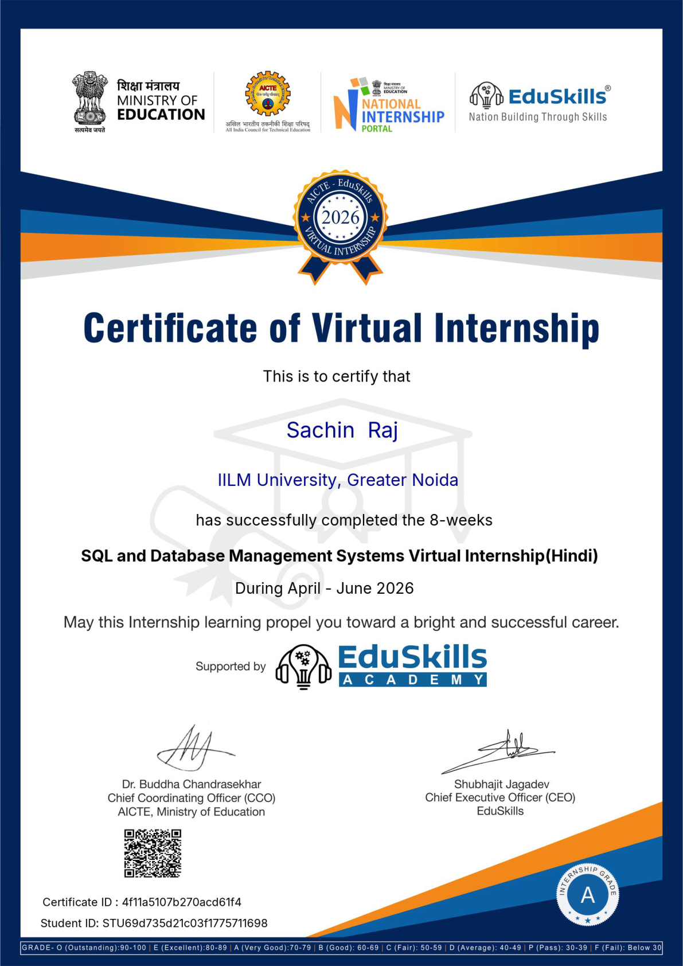

1. PROJECT / INTERNSHIP DESCRIPTION

1.1 Introduction
Database systems are an important part of modern computing because applications need reliable methods to organize, store, retrieve, and manage information. SQL is widely associated with communicating with relational database systems and is therefore a relevant foundation for students of Computer Science and Engineering. The SQL and Database Management Systems Virtual Internship (Hindi) was undertaken to gain structured learning exposure in this technical domain.
The internship was completed over eight weeks during April–June 2026. Based on the supplied certificate, the report focuses on the stated domain of SQL and Database Management Systems. Detailed module-wise content and specific implementation tasks are not listed on the certificate, so the discussion remains limited to the supported internship domain and its academic relevance.

1.2 Organization Profile
The internship completion certificate identifies EduSkills Academy as the supporting internship provider. The certificate also displays the National Internship Portal and AICTE/Ministry of Education branding associated with the internship certificate. The available material confirms the provider name and the successful completion of the virtual internship. No additional organization history, statistics, clients, or operational details are claimed in this report because such information was not provided in the supporting material.

1.3 Problem Statement
Modern software systems depend on organized data. A fundamental technical challenge is to manage data in a structured manner so that it can be stored, accessed, queried, and maintained effectively. The internship domain addresses the need for foundational understanding of SQL and Database Management Systems, helping learners develop knowledge relevant to data-oriented applications.

1.4 Internship / Project Objectives
• To develop a structured understanding of the SQL and Database Management Systems domain.
• To strengthen foundational knowledge relevant to organized data management in computing systems.
• To understand the role of databases within software and information systems.
• To relate SQL and database concepts to the broader field of Computer Science and Engineering.
• To develop technical learning discipline through completion of an eight-week virtual internship.
• To improve readiness for future coursework and projects involving database-oriented systems.
• To gain industry-oriented learning exposure through a recognized virtual internship programme.

1.5 Scope of the Internship / Project
The technical scope of the internship is centred on the broad area of SQL and Database Management Systems. From a learning perspective, the domain supports understanding of how structured information is handled within computing environments. Such knowledge is relevant to future academic work and software projects involving database-backed applications and information systems.
The supplied certificate does not specify a particular application, dataset, capstone project, software platform, or implemented system. Therefore, the scope described here is educational and domain-oriented rather than a claim of a specific deployed project.

1.6 Technologies and Tools Used
Table 1.1: Technologies and Tools Used
Technology / Tool | Purpose | Application During Internship
SQL | Database query and data management language domain covered by the internship title. | The certificate identifies SQL as part of the internship domain; no specific practical implementation details are provided.
Database Management Systems (DBMS) | Framework for understanding organized storage and management of data. | The certificate identifies Database Management Systems as part of the internship domain; no specific DBMS software is named.

1.7 System / Project Architecture
No capstone project, practical system, or system architecture is explicitly described in the supplied internship certificate. Accordingly, an architecture diagram has not been invented for this report.

1.8 Methodology
The supplied certificate confirms successful completion of an eight-week virtual internship but does not provide a detailed stage-by-stage curriculum or development methodology. Based strictly on the supported information, the learning process can be described conservatively as follows:
• Domain Orientation: The internship was undertaken in the stated area of SQL and Database Management Systems.
• Structured Learning Period: The programme was completed as an eight-week virtual internship during April–June 2026.
• Conceptual Learning: The internship domain provided exposure to the broad concepts associated with SQL and database management.
• Completion and Outcome: Successful completion was certified by the internship provider.
Stages such as named modules, practical exercises, integration activities, testing procedures, or a capstone project are not specified in the available certificate and are therefore not presented as confirmed internship activities.

1.9 Expected / Achieved Outcomes
The successful completion of the internship indicates completion of the learning programme in the stated domain. The principal outcomes supported by the internship topic and completion certificate are summarized below:
• Improved technical familiarity with the broad area of SQL and Database Management Systems.
• A stronger conceptual foundation for future database-related coursework.
• Better awareness of the importance of data management within software systems.
• Industry-oriented exposure through an eight-week virtual internship experience.
• Development of self-learning, consistency, and technical comprehension skills.
• Useful preparation for future academic projects involving database concepts.
The certificate does not provide measurable project results, performance metrics, or detailed implementation outcomes. Therefore, no specific technical results beyond successful completion are claimed.

1.10 Certificates and Supporting Evidence
The following supporting evidence was provided and is included in this report:
• Internship Completion Certificate for the SQL and Database Management Systems Virtual Internship (Hindi).
• Certificate details showing successful completion of an eight-week internship during April–June 2026.
• Certificate ID: 4f1a5107b270acd61f4.
No additional communication records, screenshots of practical work, or separate certificates were supplied for inclusion in this report.

2. SKILLS ACQUIRED

2.1 Technical Skills
• Foundational understanding of the SQL and Database Management Systems domain.
• Awareness of the role of structured data management in computer science applications.
• Improved readiness to study database-related subjects and technologies in greater depth.

2.2 Professional Skills
• Self-directed learning in a virtual internship environment.
• Consistency and responsibility in completing a structured internship programme.
• Ability to connect academic learning with an industry-oriented technical domain.
• Improved confidence in approaching database-related topics for future learning.

3. CHALLENGES AND LEARNING
Learning a technical domain through a virtual internship requires regular engagement, independent study, and the ability to understand concepts without relying entirely on classroom interaction. SQL and Database Management Systems also involve technical terminology and concepts that require careful and progressive learning. The available certificate does not describe specific incidents or difficulties faced during the internship; therefore, this section discusses general learning challenges rather than claiming particular events.
The internship highlights the importance of maintaining a disciplined learning routine, reviewing technical concepts carefully, and building a strong conceptual foundation before attempting more advanced database-related work. These learning habits are useful for future B.Tech CSE coursework and project activities.

4. CONCLUSION
The SQL and Database Management Systems Virtual Internship (Hindi), completed through EduSkills Academy over eight weeks during April–June 2026, provided a meaningful learning experience in an important area of Computer Science and Engineering. The internship strengthened awareness of SQL and database management concepts and their relevance to modern software and information systems.
The experience complements the B.Tech CSE programme by supporting foundational understanding of data-oriented computing and by encouraging independent technical learning. Although the supplied certificate does not describe a capstone project, specific software tools, or detailed implementation activities, the successful completion of the internship represents useful academic and professional exposure. The knowledge gained will be valuable for future coursework and projects involving database-backed systems.

5. BIBLIOGRAPHY / REFERENCES
[1] EduSkills Academy, “Certificate of Virtual Internship: SQL and Database Management Systems Virtual Internship (Hindi),” Certificate issued for Sachin Raj, April–June 2026, Certificate ID: 4f1a5107b270acd61f4.
Note: The internship certificate was the primary source provided for this report. No additional internship curriculum, module list, project documentation, or technology-specific documentation was supplied.

