**Curriculum Vitae**

**Full Name**: Dr. Mrs. Sunita Rajesh Tandulwadkar.

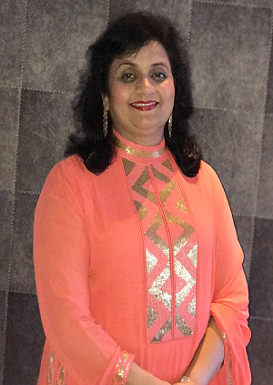

**Mobile Number**.: +91 9822015850

**E Mail:** sunitaivfindia@gmail.com

**Qualifications**:

M.D (Obstetrics and Gynaecology),

FICS (Gynae Endoscopy)

FICOG

Diploma in Endoscopy (Germany)

**Present Posts Held:**

**Head of the Department (OBGY),**

Ruby Hall Clinic, Pune

**Chief**,

Ruby Hall IVF & Endoscopy Centre

**Founder & Medical Advisor,**

SOLO STEMCELLS - A Stem Cell Research & Application Center, Pune

Elected Board Member of the International Society of Gynaecologic Endoscopy (ISGE), 2013-2017.

Elected Board Member Academic Council of ICOG (Indian College of Obstetricians and Gynecologists), 2014-2017

Vice-President, West Zone FOGSI (2017)

Chairperson, Infertility Committee FOGSI (Federation of Obstetrics and Gynaecology of India), 2011-2013

Vice President, IAGE (Indian Association of Gynaecology Endoscopy), (2018-2019)

Joint General Secretary, ISAR (Indian Society of Assisted Reproduction) (2018-2019)

Founder Honorary Secretary, Maharashtra Chapter ISAR

Chairperson, Maharashtra Chapter ISAR (2018-2020)

Active Member of European Society of Human Reproduction & Embryology (ESHRE)

Active Member of All American Society of Gynaecological Laparoscopist (AAGL)

Active Member of American Society of Reproductive Medicine (ASRM)

Reviewer and Advisor to The Esteemed Journal Fertility & Sterility and Human Reproductive Sciences

Reviewer in Fertility Sterility.

**Special Training:**

Obtained Special Training In Advanced Laparoscopic Surgery At Singapore In 1997.

Obtained Special Training In Advanced Gynae Laparoscopic Surgery At Kiel University Germany In 1997

Visited Kiel University Germany to see the set up for establishing an international Endoscopy Training Centre

Obtained special training of Laparoscopic Pelvic Floor Surgery in St. George Hospital, Sydney (Australia) in May 2002 from world renowned surgeons like Alan Lam and Greg Cario.

Obtained Special Training of Laparoscopic Pelvic Floor Surgery from Dr. C Y Liu, USA in Nov 2002.

## Training of IVF

 Obtained extensive personal training in IVF & ICSI in Sydney IVF Centre, Australia in May 2002.

Underwent advanced course in IVF & Blastocyst Culture and Transfer in National University Hospital, Singapore In June 2002.

Obtained training in IVF from National University Hospital, Singapore.

Obtained extensive training in IVF & ICSI from Harley Street Fertility Centre, London.

Conferences & Workshops Organised:

Conducted CME Programme in Poona Hospital in Oct.1997 on ‘Operative Endoscopy In Gynaecology’.

Organised C.M.E On Gynacological Endocrinology In Pune In 1999 Along With Dr. Geeta Pandya (Gynaecological Endocrinologist, Mumbai)

Organised Workshop for Laproscopic Surgery in Pune in 2000 Along With FOGSI & POGS.

Organised Interactive Workshop for Basic & Advanced Laproscopic Surgery in Pune in March 2001

Had organized a Panel Discussion on Male Infertility with the Urologist Of Ruby Hall at Hotel Pride in Jan 2003

Had organized an International Update in Infertility with 5 International And 25 National Faculties at Le Meridian, Pune with the occasion of Inauguration of Ruby Hall Fertility & Endoscopy Centre, on 1-2 March 2003.

Had Conducted Live Endoscopic Workshop at Jalgaon on 20th April 2003

Has conducted Live Gynecological Endoscopic Workshops in Dehradun.

Organised Pre Congress Workshop on Endoscopy, Infertility and Sonography at Pune as a part of Yuva FOGSI 2005 Conference.

Organised an International Conference on Infertility in March 2006 on the eve of completion of three successful years of Ruby Hall IVF – Endoscopy Centre. Attended By 570 Gynaecologists from India And Neighbouring Countries.

Organized an International conference on Ovulation Induction and Endoscopy (IOI and ICE 2008) in May 2008.

Organising Secretary for ISAR 2009: 14th National Congress in Assisted Reproductive Technologies held in Pune

Organising Chairperson in Surgigyn 2009: International Workshop On Pelvic Floor And Gynae-Endoscopy Held in June 2009, in Pune

Convenor for Pre-Congress Workshop on Stimulation Protocol in ‘Ovary Unraveled’ Dec 2009

Inaugurated Maharashtra Chapter of ISAR as Founder General Secretary in April 2011

Organizing Chairperson of IAGE Annual International Conference on ‘Safe Endoscopy’ in June 2011 in Pune.

Organizing Chairperson on of 1st National conference on Health & Happiness in May 2011.

Organized annual conference of Maharashtra Chapter of ISAR in May 2012 at Le Meridien, Pune.

Organizing Secretary for Annual Conference of the International Society of Gynaecologic Endoscopy (ISGE), in association with Indian Association of Gynaecological Endoscopists (IAGE) held in Mumbai from October 03rd to 06th 2013.

Organizing Chairperson of 6th International conference in Gynae-endoscopy and Reproduction from 27th Feb- 1st Mar 2015 ‘**SURGE 2015’** at Ruby Hall Clinic in association with IAGE, endorsed by MSR and POGS

West Zone coordinator for **“ENDOGYN 2015”** conference on Endoscopy Surgery by IAGE in association with Asia & Oceania Federation of Obstetrics & Gynaecology (AOFOG) and The Bengal Obstetric & Gynaecological Society (BOGS) from 20th-22nd March 2015.

Organizing Secretary at the FOGSI-FIGO Conference on Best Practices, Breakthroughs and Current Dilemmas in OBGYN between 24th and 26th June 2016 at Hotel Westin, Pune. Was the National Convener of Workshop on Endoscopy: A Modern Journey through the same old Pelvis on 24th June 2016.

Organising Chairperson of MaCORM 2016, the 5th Annual Maharashtra State chapter of ISAR Conference, in association with POGS, to be held in Pune from 4th to 6th November 2016.

Organising Chairperson of FOGSI CNN 2017, an international Conference of FOGSI, in association with Pune Obstetrical and Gynaecological Society (POGS) to be held at JW Marriott, Pune, between 23rd and 25th June 2017.

Organising Chairperson of STAR 2018, Regional Meeting of International Society For Gynecologic Endoscopy in Association with Indian Association of Gynaecological Endoscopists to be held JW Marriott, Pune, between 6th and 9th September 2018.

Publications:

**Own Books:**

* Has published a book titled **‘Endoscopy Simplified: Practical Tips By Experts’** in 2008. Released second edition of ‘**Practical Endoscopy: Tips by Experts’** with Jaypee Publications on 9th October 2014 at ISGE Asian Meet in Kochi and on 22nd November 2014 at MSR conference ‘FEM 2014’ at Mumbai.
* Has written a book on ‘**Letrozole: A New Era In Ovulation Induction’** in 2009 (4 volumes)
* Has written a book ‘**Optimizing IUI Results – A Guide To Gynecologists’** Along With International Contributors. Published By Jaypee Publication Released In Dec 2009 In An International Conference.
* Published **Four Workbooks on Hysteroscopy, IUI, LSCS & Normal Labour** in POGS Conference in April 2011
* Released ART textbook ‘**Art and Science of ART**’ published by Jaypee brothers in the international conference in Pune SURGE 2015 on 28th February 2015.
* A Textbook on **“Ovulation Induction”** is in compilation stage.

In Journals:

* **J Gynecol Endosc Surg**. 2009 Jul-Dec; 1(2): 89–93. doi:  10.4103/0974-1216.71614PMCID:  PMC3304274 PMID: 22442519  
  **Hysteroscopy in Postmenopausal Bleeding**

Sunita Tandulwadkar, Prashant Deshmukh, Pooja Lodha, and Bhavana Agarwal.

* **J Hum Reprod Sci.** 2014 Jan;7(1):13-8. doi: 10.4103/0974-1208.130802.  
  **Obstetric complications in women with IVF conceived pregnancies and polycystic ovarian syndrome.**Tandulwadkar SR1, Lodha PA1, Mangeshikar NT1.
* **Autologous Intrauterine Platelet-Rich Plasma Instillation for Suboptimal Endometrium in Frozen Embryo Transfer Cycles: A Pilot Study**  
  Sunita R. Tandulwadkar,1,2,3 Manasi V. Naralkar,2,3 Akash D. Surana,2 M. Selvakarthick,3 and Avinash H. Kharat3
* Journal of Human Reproductive Sciences Article Title-Role Of Autologous Bone Marrow –Derived Stem Cell Therapy For Follicular Recruitment In Premature Ovarian Insufficiency :Review Of Literature And A Case Report of World’s First Baby With Ovarian Autologus Stem Cell Therapy In A Perimenopausal Woman. Gupta S, Lodha P, Karthick MS, Tandulwadkar SR
* "Pulmonary Adenocarcinoma in Pregnancy: A Challenging Case" for publication in Journal of South Asian Federation of Obstetrics and Gynaecology. Dr Dilpreet Kaur, Dr Vaishali Giri, Dr Vaishali Korde Nayak, Dr Sunita Tandulwadkar. -Under Publication.

**Contributed chapters in:**

* “Controversies in Laparoscopic Management Of Infertility”, In An International Book Published in June 2003.
* “Controversies In The Management Of Adnexal Masses Of Ovarian Origin” in a book, “Beyond The Boundaries” Published by Dr. Prakash Trivedi
* ‘Salpingoscopy And Fallopioscopy In Tubal Evaluation’ in a book published by Dr. Kamini Rao.
* “Pre-Op Preparation Of Endometrium Before Thermal Ablation” In FOGSI Focus on DUB in 2006.
* “Role Of Hysteroscopy In Congenital Uterine Anomalies” in FOGSI publication in Sept. 2006.
* ‘Submucous Myoma’ in a book published by Dr. Gautam Allahbadia
* “Difficulties In Laparoscopic Myomectomy” in FOGSI – Focus 2008
* “Detorsion And Conservative Therapy For Twisted Adnexa” in Journal of Gynecological Endoscopy And Surgery, Jan 2009.
* “Making Laparoscopic Myomectomy Safe” in the book Safe & Effective – Gynaecological Endoscopy & Minimal Access Surgery.”
* **“**Hysteroscopy- A mode of screening women with post-menopausal bleeding: Our Experience” in SAFOG Journal, 2011.
* "The New Bipolar technology of Versapoint” in the textbook of Hysteroscopy published in 2011 by Dr. Nandita Palshetkar.
* "Fibroids Uterus and Infertility" in FOGSI Focus in Feb 2012.
* “Complications in Endoscopic Surgery” in post-graduate OBGY textbook published by FOGSI.
* “Supportive drugs used in the first trimester” in the FOGSI book 'A practical Guide to First Trimester in Pregnancy' in 2012.
* “Obstetric outcome following ART” in “Textbook of Infertility” by Dr. Kamini Rao in 2014.
* **‘Scenario of ART in India’** in Prof. Filippo Ubaldi’s international textbook of ART in 2014.
* Invited to write a review article on ‘Obstetric outcomes of patients with PCOS, undergoing IVF and ET’ in Journal of Human Reproductive Sciences in Jan-March 2014 edition.
* “Stem cells in Infertility” for book to be released in ISAR 2019.

**Invited As International Faculty**

* Invited to present videos and papers in AAGL Conference (American Association of Gynecologic Laparoscopists) at Miami & Presented Videos & Papers on “Laparoscopic Hysterectomy In Fibroid Uterus” and “LAVH / VLH – My Experience of 5 years” in November 2002.
* Invited to the ISGE Conference in Malaysia In April 2004 to present videos on “Laparoscopic Tubo-Tubal Anastomosis At Isthmic End” and “Laparoscopic Sling For Nulliparous Prolapse”
* Invited to present videos on “Laparoscopic Management Of Twisted Adnexa In Infertile Woman” and “Hysteroscopic Metroplasty In Unicornuate Uterus To Improve The Reproductive Outcome” in a conference organized by Asia Pacific Endoscopy Society on ‘Limits Of Endoscopic Surgery’ at Sydney, Australia in August 2006.
* Invited to deliver a talk on “Single Blastocyst Transfer” at International Congress of Gynaecology and Obstetrics (ICGO-2012) in Guangzhou, China, in December 2012.
* Invited to sit on the Program Planning Committee at the Rhea of Hope Oncofertility Conference, September 8-11, 2013 in Atlanta, GA.
* Organizing Secretary for Annual Conference of the International Society of Gynaecologic Endoscopy (ISGE), in association with Indian Association of Gynaecological Endoscopists (IAGE) to be held in Mumbai from October 03rd to 06th 2013.
* Invited as faculty for session on “Endoscopy-Ultrasound at its best in fertility enhancement” at ASPIRE 2014, at Brisbane, Australia in April 2014.
* Invited to deliver a talk on “Laparoscopic Myomectomy: How to keep it safe” at the MESGE/ISGE conference in Dubai 2014.
* Invited to present a video on “Laparoscopy in Adolescent Age” and a poster on “Remaining innovative in uterine cavity with hysteroscope” at the AAGL conference in Vancouver in November 2014.
* Invited as faculty to deliver talk on “Laparoscopy in adolescent age group for benign conditions” at the annual ISGE conference in Australia in March 2015.
* Invited as a Moderator for a Video Session on Laparoscopy at the 44th AAGL Global Congress of Minimally Invasive Gynecology, in Las Vegas, NV in November 2015.
* Invited Faculty at the ISGE 25th Annual Congress and 4th Croatian Congress on Minimally Invasive Gynaecological Surgery in Opatija between 25th to 28th May 2016.
* Invited as faculty at ISGE & IGES Endoscopy and Laparoscopy 5th National Congress and Asia- Pacific Regional meet at Bali in 2016 by ISGE in September 2016.
* Invited as a Speaker to the 2nd World Congress on Polycystic Ovarian Syndrome, to be held at Orlando, USA in October 2016.
* Invited as a faculty at the 7th World Gene Convention 2016, to be held at Shanghai, China in November 2016.
* Invited as a Speaker at the Global Congress on Hysteroscopy at Barcelona, Spain between 2- 5 May 2017, to deliver a talk on ‘Uterine Malformations- Unicornuate Uterus, is there a place for hysteroscopic management?’
* Invited as a Speaker for ‘Ornela Sizzi Women Surgeons Day’ at Rome, Italy on June 10th 2017, to deliver a talk on ‘Laparoscopic Hysterectomy and Contraception in the developing World’.
* Invited as a Speaker at the ESGE 26th Annual Congress in Antalya, Turkey, between 18th- 21st October 2017.

**Invited As National Faculty**

* Invited as a Guest Speaker in Pune Ob-Gy Society to deliver a lecture on “Laparoscopic Hysterectomy” in August 1998.
* Invited as the faculty and to deliver lectures on “Laparoscopic Hysterectomy” and Role of Endoscopy In Infertility” at the Gyn. Endoscopy Workshop organized by International College Of Surgeons, Indian Section at ICS Conference at Indore in September 1998.
* Invited to demonstrate Advanced Laparoscopic Surgeries in the workshop at Kolhapur, Maharashtra by Kolhapur Ob- Gy Society in 2000.
* Invited to present Videos on “Role of Laparo-Hystero-Vaginoscopy In Congenital Anomalies Of Female Genital Tract” in Indian Association Of Gynaecological Meeting in Mumbai in 2002.
* Invited as a Speaker and chairperson for a session on Myomas in Mumbai in the conference of Giant Strides In Gyn. Endoscopy, in March 2002.
* Invited as speaker in Bombay-Pune Ob-Gy Society combined meeting at Lonavala to speak on “Surgical Treatment of Unruptured Ectopic Pregnancy” in August 2002.
* Invited as faculty in the conference organized by Aurangabad OBGY Society in December 2002.
* Invited by IMA Kolhapur, to deliver a talk on “Recent Management in DUB” in December 2002.
* Invited as faculty to participate in AMOGS 2003 (All Maharashtra Ob-Gy Society) at Solapur on 7th-8th February 2003.
* Invited as a National faculty to participate in An Update of Infertility & Endoscopy in Kochi on 12th & 13th March 2003.
* Invited as Faculty at Cochin to participate in “A Debate On Laparoscopic Hysterectomy” on 12th April 2003.
* Invited to deliver a talk on “Key Points In Prevention Of Complications In Laparoscopic Hysterectomy” at Mahabaleshwar in a conference organized by Satara & Pune Ob-Gy Society in August 2003.
* Invited as a National Faculty in Kochi in an International Workshop on Endoscopy October 2003.
* Invited as a National Faculty for Endoscopic Workshop In 2004-2005:

1. Mumbai- International Conference organized by Images, FOGSI, MOGS
2. Ahmedabad -Organised by IAGE & Ahmedabad Obstetrics And Gynaecological Society
3. Coimbatore- Organised by IAGE & Coimbatore Obstetrics and Gynaecological Society
4. Patna- Organised by Local Society
5. Satara- Organised by Local Society
6. Baramati- Organised by Local Society
7. Nasik- Organised by AMOGS Endoscopy Committee
8. Aurangabad- Organised by Local Society
9. Chandrapur- Organised by AMOGS Endoscopy Committee.
10. Latur – Organised CME on Infertility with Latur Ob-Gy Soc

* Invited as operative faculty for the Hysteroscopic Workshop and to speak on “Laparoscopic Myomectomy – How To Optimize The Results” in Nagpur Annual Conference in 2005.
* Invited as Faculty in Bangalore For ISRM Conference in 2005.
* Invited as Faculty at Aurangabad in ICOG Conference to speak on “Laparoscopic Myomectomy How To Improve Results” in 2006.
* Invited to speak on “Laparoscopic Management Of Chocolate Cyst” at Yuva FOGSI 2006 conference in New Mumbai.
* Invited to speak on “Laparoscopic Management Of Twisted Adnexa” by Mumbai Ob-Gy Society in April 2006.
* Invited to deliver a talk on “Ovulation Induction For IUI” and “Laparoscopic Management Of Twisted Adnexa” by the Kolhapur Ob-Gy Society in June 2006.
* Invited to deliver a talk on “Chronic Pelvic Pain” and “Laparoscopic Management Of Endometrioma” by the Baroda Ob-Gy Society in July 2006.
* Invited to deliver a talk on “Endocrinology Of Ovulation” and “Laparoscopic Management Of Endometrioma” by the Surat Ob-Gy Society in July 2006.
* Invited as an Operative Faculty in an Endoscopy Workshop organized by Images on 15th October 2006 in Bangalore.
* Invited to speak on “Advances In ART” at Ulhasnagar On 10th September 2006.
* Invited to speak on “Role Of Hysteroscopy In Uterine Anomalies” in an International Conference on ART organized by FOGSI on 16th-17th September 2006 in Mumbai.
* Invited to deliver a talk on “Ovarian Endometrioma” at in a conference organized by Endometriosis Society on 30th Sept 2006 in Kolhapur.
* Invited to speak on “Laparoscopic Management Of Myoma –How To Optimize The Outcome?” and to present a video “Twisted Adnexa- The Current Management” in an International Conference On ART in November 2006 in Varanasi.
* Invited as a faculty in an International Conference on Endoscopy in Bangalore on 14th October 2006.
* Invited as a faculty in International Conference on Infertility in Mumbai On 18th November 2006.
* Invited as a Faculty at International Conference on Infertility At Varanasi on 24th-25th November 2006.
* Invited as an Operative Faculty to demonstrate Total Laparoscopic Hysterectomy in State Level Conference Organised By Gujarat Ob-Gy Society In December 2006 in Bharuch.
* Invited as a Faculty in a conference organized by Indian Fertility Society on 10th December 2006 in Delhi.
* Invited as a Speaker in All India FOGSI Conference and received Fellowship in ICOG in the same conference in January 2007 in Kolkata.
* Invited as Faculty to participate in CME on Infertility in National AICOG Conference in January 2007.
* Invited Faculty in National Operative Workshop On Vaginal Minimal Access Surgery & PCOS And Ovulation Induction in December 2008.
* Invited as Moderator for the topic “Controversies In ART” in ‘ISOPARB’ 2009 on 22nd March 2009.
* Invited Faculty in Trivandrum Ob-Gyn Society Conference in September 2009.
* Invited Faculty and as a Panelist in a Panel Discussion On Fertility Preservation Strategies in Mumbai FOGSI Conference in September 2009.
* Invited to talk on “Endometriosis Surgery versus IVF” in the International Conference ‘Ovary Unraveled’ in December 2009.
* Invited Faculty in National Conference on Gynae Endocrinology at AIIMS Delhi organised By GESI, AIIMS & FOGSI in April 2011.
* Invited Operative Faculty in Hysteroscopy Workshop at Cuttack in April 2011, Ranchi & Jalandhar in May 2011 and Goa in June 2011.
* Organizing Secretary for The 14th National Conference Of ISAR 2009.
* Conducted Symposium On Infertility for Panaji Ob-Gyn Society In March 2009.
* Invited Faculty in Bhubaneswar Ob-Gyn Society Symposium On Infertility in 2010.
* Organized workshops in 2011-2013 to teach gynecologists across the country “Operative Hysteroscopy” – “See one, Do one, Teach one”, a 3 year project as Chairperson Infertility Committee, FOGSI in 50 cities.
* Invited as Faculty and Convener of Infertility Workshop in AICOG 2012 at Varanasi.
* Invited to deliver several lectures and conduct hysteroscopy workshops across the country as Infertility Committee Chairperson in 2012.
* Invited to speak on “Endometriosis and Infertility” at FIGO-FOGSI Conference 2012.
* Invited as Faculty in World Congress-BCGIP (Building Consensus in Gynecology, Infertility and Perinatology) Program on “Imaging & Endoscopy in Gynaecology” and “Ovum Donation” in Delhi in November 2012.
* Invited to deliver an oration “How to make Endoscopy safe”, in Delhi on 1st December 2012.
* Convener of Advanced Infertility Workshop in AICOG (All India Congress of Obstetricians and Gynecologists) in Mumbai in January 2013.
* Invited to speak on “Single Blastocyst Transfer” and “Myoma in Infertility” at ISAR Annual Conference 2013 at Rourkela, Orissa.
* Invited to conduct an evidence based video session on “What's going wrong with IUI" at ASPIRE (Asia Pacific Initiative on Reproduction) 2013, in Chennai on 18th May 2013.
* Invited as a speaker at infertility CMEs held in Kolkata, Delhi, Bangalore, Hyderabad held in April-June 2013.
* Invited to deliver lecture on “Single Blastocyst Transfer” at Maharashtra Chapter ISAR, June 2013.
* Organizing Secretary and operative faculty for Annual Conference of the International Society of Gynaecologic Endoscopy (ISGE), in association with Indian Association of Gynaecological Endoscopists (IAGE) held in Mumbai from October 03rd to 06th 2013.
* Invited to deliver lecture on “How to make myomectomy safe”and was a moderator for panel discussion on “Endometriosis and infertility”at Annual Conference of International Society of Gynaecologic Endoscopy (ISGE), in association with Indian Association of Gynaecological Endoscopists (IAGE) held in Mumbai from October 03rd-06th 2013.
* Invited as faculty in National AICOG conference held in Patna in February 2014 to conduct two Panel Discussions as part of Infertility Workshop: “Nuances of Ovarian Stimulation” and “Endometriosis and Infertility”.
* Invited as a moderator for Panel Discussion on “Managing PCOS in different age groups” at the AICOG 2014.
* Invited to deliver a lecture on “Myoma: Which one to remove and when?” at the ISAR conference on 14th February 2014 at Ahmedabad.
* Invited to deliver a lecture on “Laparoscopy in adolescent age group” in April 2014 for the 29th annual POGS CME in Pune.
* Invited to deliver a keynote address on “Endometrium-Embryo: A two-way dialogue” at the 4th National Conference of the Gynae Endocrine Society of India on 27th April 2014, in Delhi, India.
* Invited to deliver a lecture on “How to make myomectomy safe” in Indore in May 2014.
* Invited as an operative faculty at a conference in Indore in May 2014, demonstrating Laparoscopic Myomectomy and Total Laparoscopic Hysterectomy.
* Invited as operating faculty to demonstrate total laparoscopic hysterectomy and to deliver a lecture on “Laparoscopy in adolescent age” at the IAGE-MISCON conference in AIIMS on 29th August 2014.
* Invited faculty as a moderator for panel discussions on “Optimizing Implantation” and “Recurrent Implantation Failure” at MSR’s ‘**FEM 2014’** conference in Mumbai in November 2014.
* Invited to deliver talk on “Myoma and Infertility” by Ujjain OBGY Society on 13th December 2014.
* Invited as faculty to deliver talk on “OI for IUI and OI in endocrinological derangements” and to moderate a panel discussion on “Dilemmas in treatment of infertility” FOGSI Infertility CME “Basic Infertility for Gynecologists: Must to know” on 14th December 2014 in Indore.
* Invited as faculty to deliver lecture on “Laparoscopic in adolescent age for benign conditions” at the 38th Annual conference of State Organization of Obstetricians and Gynecologists of Gujarat **(**SOGOG) on 20th December 2014.
* Invited as faculty to deliver lecture on “Adenomyosis and infertility” at ‘Fertivision 2014’ the annual conference of Indian Fertility Society (IFS) on 21st December 2014.
* Invited Faculty as a speaker to deliver lecture on “Endoscopy in Mullerian Anomalies”, as a panelist for panel discussion on “Third Party Reproduction” and as chairperson for scientific session on “Gamete Factory with evolving Technology” at the AICOG 2015, Chennai from 21st-24th January 2015.
* Invited as faculty to deliver talk on **“**Optimizing IUI Results” at the 29th conference of AMOGS (Association of Maharashtra Obstetrics and Gynecological Societies) on 7th February 2015.
* Invited to deliver anoration on “Myomectomy and Infertility” by the Hyderabad Ob-Gy Society on14th February 2015.
* Invited as convener of ART workshop, to deliver talk on “Ovum pick up”, as a chairperson for scientific session on “Drugs for controlled ovarian

Stimulation” and as a moderator for panel discussion on “When to shift

From IUI to IVF” for nodal conference of MSR “I2M: Infertility to Maternity” in Aurangabad on 27th March 2015.

* Invited as faculty for ENDOGYN 2015 conference on Endoscopy Surgery by IAGE in association with Asia & Oceania Federation of Obstetrics & Gynaecology (AOFOG) and The Bengal Obstetric & Gynaecological Society (BOGS) from 20th-22nd March 2015.
* Invited as moderator for panel discussion on “Estrogen- Womb to Tomb” on 5th April 2015 in Delhi.
* Invited as faculty for 20th National conference of ISAR (Indian Society for Assisted Reproduction) from 10th April -12th April 2015 in Chennai.
* for Panel discussion on “Endometriosis” and delivered a lecture on “Optimizing Pregnancy rates in IUI” at the CME on Basic Infertility for Gynaecologists with AOGD at Ahmedabad on 7th June 2015.
* Invited as a moderator for Panel Discussion on “Fertility Enhancing Hysteroscopic Surgeries” and delivered a lecture on “Optimizing Pregnancy rates in IUI” at the CME on Basic Infertility for Gynaecologists with JOGS at Jaipur on 14th June 2015.
* Invited as a moderator for Panel discussion on “Endometriosis and Infertility” and delivered a lecture on “Optimizing Pregnancy rates in IUI” at the CME on Basic Infertility for Gynaecologists with BOGS at Baroda on 20th June 2015.
* Invited as a moderator for Panel discussion on “Endometriosis” and delivered a lecture on “Myoma and Infertility” at the CME on Basic Infertility for Gynaecologists with SOGS at Surat on 21st June 2015.
* Invited as a moderator for Panel discussion on “Endometriosis” and delivered a lecture on “Optimizing Pregnancy rates in IUI” at the CME on Basic Infertility for Gynaecologists with Patna Ob-Gyn Society at Patna on 2nd August 2015.
* Invited as a moderator for Panel Discussion on “Fertility enhancing hysteroscopic surgeries” at the Annual Conference of Delhi Gynaecological Endoscopists Society; FENIX-2015, Women-Fertility and Beyond: Inception to Xcellence on 29th -30th August, 2015 at AIIMS, New Delhi.
* Invited as an Operative Faculty at Bhopal in a conference jointly organized by the Bhopal Ob-Gyn Society with IAGE on 26th-27th September 2015.
* Invited as an Operative Faculty at Ahmedabad on 31st October and 1st November in Urogynaecology conference held by FOGSI in association with Ahmedabad Ob-Gyn Society.
* Invited as Faculty for Panel Discussion on “Parenthood Journey: From dreams to realization with ART” on 12th December 2015 at IMA GPCON, Pune.
* Invited to speak on “Laparoscopy in Acute Abdomen in Adolescent age group” at Mumbai on 13th December 2015 by Mumbai Ob-Gyn Society.
* Invited to speak on “Management of Ovarian Endometrioma” on 19th December 2015 at SOGOG 2015, Ahmedabad.
* Invited as Faculty for Pre-Congress Workshop: ART-Assisted reproductive technology (ABC of Infertility) on “Laparoscopy: Should it remain an essential component of the fertility work up” on 13th January, 2016 and Moderator for Panel Discussion on “Managing Fertility issues in PCOS” on 15th January,2016 at AICOG, Agra.
* Demonstrated Total Laparoscopic Hysterectomy at the 12th AAGL International Congress on the Ultimate Advances in Minimally Invasive Gynaecological Surgery alongwith IAGE at Mumbai in June 2016.
* Invited to speak on ‘Difficult TLH’ at the 12th AAGL International Congress on the Ultimate Advances in Minimally Invasive Gynaecological Surgery alongwith IAGE at Mumbai in June 2016.
* Organizing Secretary at the FOGSI-FIGO Conference on Best Practices, Breakthroughs and Current Dilemmas in OBGYN between 24th and 26th June 2016 at Hotel Westin, Pune. Was the National Convener of Workshop on Endoscopy: A Modern Journey through the same old Pelvis on 24th June 2016.
* Invited to speak on “Refractory Endometrium: Resolving Unsolved Mysteries” at the Pre-Congress Workshop on Ovulation Induction at FOGSI-FIGO BBC, Pune on 24th June 2016.
* Invited to speak on “Infertility and Myomas: Inseparable Surrogate Siblings” at the Workshop on Endoscopy ‘A Modern Journey through the same old Pelvis’ at FOGSI-FIGO BBC, Pune on 24th June 2016.
* Invited to speak on “Difficult TLH” at FOGSI-FIGO BBC, Pune in June 2016.
* Invited as a faculty at IAGE SOUTH ZONE Conference- ENDOVISION at Bangalore on 16th and 17th July 2016, where she demonstrated total laparoscopic hysterectomy.
* Invited as a Faculty at ICOG - FOGSI National Conference on Fertility Regulation and Women’s Health organized by ICOG - FOGSI in association with OGSH on 27th & 28thAugust 2016 at Hyderabad International Convention Centre(HICC), Hyderabad.
* Invited as an operating faculty at SAGE 2017, the regional conference of European Society for Gynaecological Endoscopy 9ESGE) in association with Indian association of Gynaecological Endoscopists (IAGE) from 17th to 19th February 2017 at Mumbai.
* Invited as an operating faculty at ENDOGYN 2017 at Kolkata in March 2017.
* Invited as a faculty at the Annual CME of Pune Obstetric and Gynaecological Society (POGS) on 8th and 9th April 2017 at Hotel Sheraton, Pune. Delivered a talk on ‘Painting the Art of Pregnancy after ART’.
* Invited faculty at the 22nd Annual Congress of ISAR (Indian society of Assisted Reproduction) 2017 at Gurgaon between 21st and 23rd April 2017.
* Invited as a faculty for the annual conference of Indian Association of Gynaecological Endoscopists (IAGE) at Bangalore between 5th and 7th May 2017.
* Invited in at least 20 National Conferences from Oct 2017 till today.

**Academic Achievements & Awards:**

* Presented an award winning paper On “**Laparoscopic Hysterectomy-Our Experience”** in Annual Meeting of Pune Ob-Gy Society in 1998.
* Received an award for her video on “**Laparoscopic Tubo-Tubal Anastomosis At Isthmic End”** at Endo-Surge 2003 Organized By IAGE and at International Conference Of Gynae-Endoscopist at Malaysia in April 2004.
* Received Best Innovative Surgery Prize for the Video on **“Metroplasty In Unicornuate Uterus With Versapoint”** in Yuva FOGSI 2005.
* Received Best Paper Prize for the paper on **“Metroplasty In Unicornuate Uterus With Versapoint”** in POGS annual conference in Nov 2006.
* American Society Of Reproductive Medicine has kept her video on **“Laparoscopic Management Of Twisted Adnexa”** in their video library for educational purpose.
* Received **Masters Award** for excellence in the field of Infertility, Endoscopy and Teaching by IMAGES for the year 2011 in September, at Cochin.
* Conferred upon with **“Sarvashree” award & Gold Medal**, in recognition of her outstanding achievement in the field of IVF & Endoscopy since 20 years, for unstinted support to and active involvement in public causes & adherence to highest ethical standards.
* Awarded **Gold Medal** **twice** from Chairman of Ruby Hall Clinic, Dr. K. B. Grant for her hard work, dedication & excellence in her field.
* She has received a letter of appreciation in April 2012 from the then **President of India, Shrimati Pratibha Patil** on completion of ten years of success of Ruby Hall IVF and Endoscopy Centre, Pune for her work in the field of Endoscopy and Infertility.
* She has received the **Punyashloka Ahilyabai Holkar Award** for her work in the field of women and child health, given by the Government of Maharashtra. The award recognizes pioneering contribution of an individual in empowering women and raising women's issues. It was conferred to her on 26th January 2015.
* She has received the **Global Healthcare Excellence Award 2015** on 18th November, 2015 in New Delhi for her exemplary work in Healthcare & Service sector. Proclaimed, **“Most Emerging Gynaecologist of Maharashtra”**
* She has received a **Medal & Certificate of Appreciation** on 28th November, 2015 from Grant Medical Foundation’s Ruby Hall Clinic, Pune for her exemplary achievements & accomplishments in the field of Healthcare.
* She has received the **Rashtriya Gaurav Award** on 7th December, 2015 in New Delhi for services rendered in excellence in the Women’s Healthcare sector.
* She has received the **Best Citizen of India Award** in 2016.
* She has received the ‘**Glory of India Award’** and Certificate of Excellence on 4th October 2016 at Bangkok in the hands of H.E. Kom Dabbaransi, Former Deputy Prime Minister of Kingdom of Thailand.
* She has received the ‘**Best Gynaecologist of Maharashtra’** award on 23rd October 2016 at New Delhi, at the hands of Shree J P Nadda, Minister of Health & Family Welfare, Dr. Harshvardhan, Former Minister of Health & Family Welfare, and Shree Anurag Thakur, Member of Lok Sabha, Himachal Pradesh.
* She has been selected for the **‘Best Medical Practice’** and **‘Rose of Paracelsus Award’** by Europe Medical association at Dubai on 30th and 31st January 2016, which is a symbol of the reliability of a medical institution and its admirable reputation in the opinion of the patient.
* She has been awarded the **‘Society Leadership Award 2017’** by the **Stardust Group** for her relentless pursuit of excellence, leadership, dedication and passion towards her work. She was featured in Society magazine, and her achievements, the values she believes in, her success mantra and her driving force highlighted.

Innovations:

Innovated several Laparoscopic Instruments and presented the use of these instruments in various conferences.

Started the trend of Laparoscopic Hysterectomy in the city of Pune from 1996

Established State Of The Art Fertility & Endoscopy Centre in Ruby Hall Clinic and achieved pregnancy in the 1st Case in Dec. 2002

Innovated new technique for Laparoscopic Tubo-Tubal Anastomosis at Isthmic End and Presented at:

1. “Endo-Surge 2003” Organized by IAGE And Received Best Video Award.
2. At International Conference of Gynae-Endoscopist At Malaysia In April 2004

Performed first 3D total laparoscopic hysterectomy at Ruby Hall Clinic in Pune on 7th June 2013.

**SOCIAL ACTIVITIES: (Photos attached)**

* Conducting free OPD’s for **below poverty line** patients at Tadiwala Road where approx 40-45 patients attend Antenatal clinic on three days (Monday, Wednesday, Friday) in a week since 2000. These OPD’s are run with the help of 6 Gynaecology resident doctors of Ruby Hall Clinic.
* Conducting free deliveries and caesarean sections for these **below poverty line** patients at Ruby Hall Clinic wherein they get best of medical facilities. These services are being run since 2000. Apart from Obstetric work they are also provided other surgeries free of cost.(Photos attached)
* Patients who are **below poverty line (those with yellow ration card)** are provided Obstetrics & Gynaecology services free of charge.
* Has arranged and attended numerous health programmes as a Rotary member in field of OBGYN as well as infertility.
* Has arranged Pap smear camps in peripheral villages of Pune in association with Social Service Department of Ruby Hall Clinic from time to time.
* Had arranged Breast Cancer Awareness camp in Pune in 2011 in association with NGO
* Has published various community awareness articles in leading newspapers like TOI from time to time

**-: DECLARATION :-**

I hereby declare that the above particulars are true and correct to the best of my knowledge and belief and in the event of any information being found false or incorrect, my candidature will be liable to be canceled.

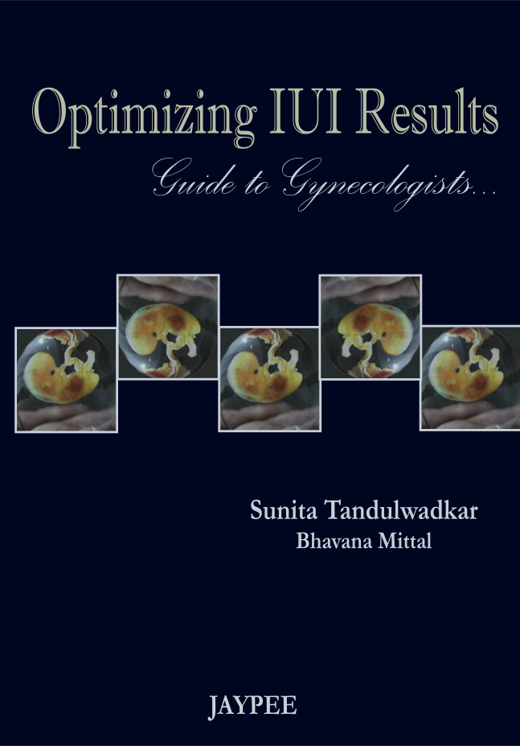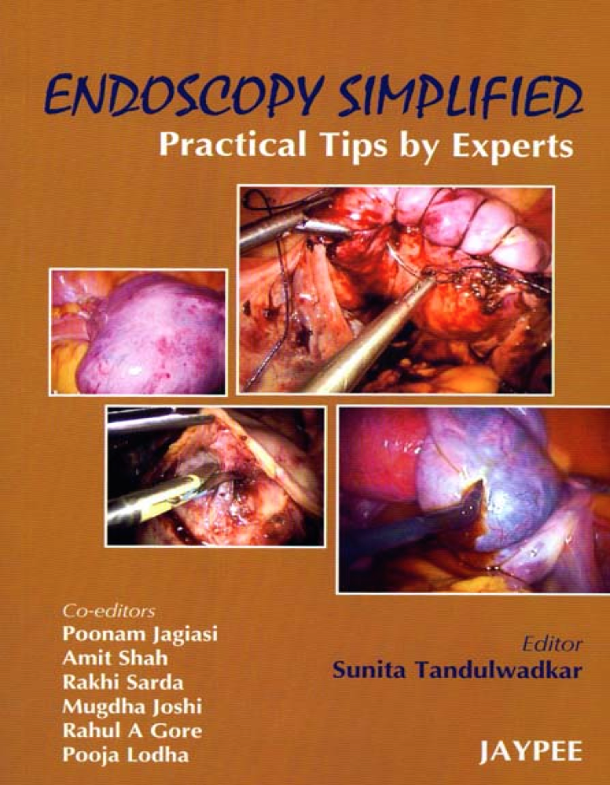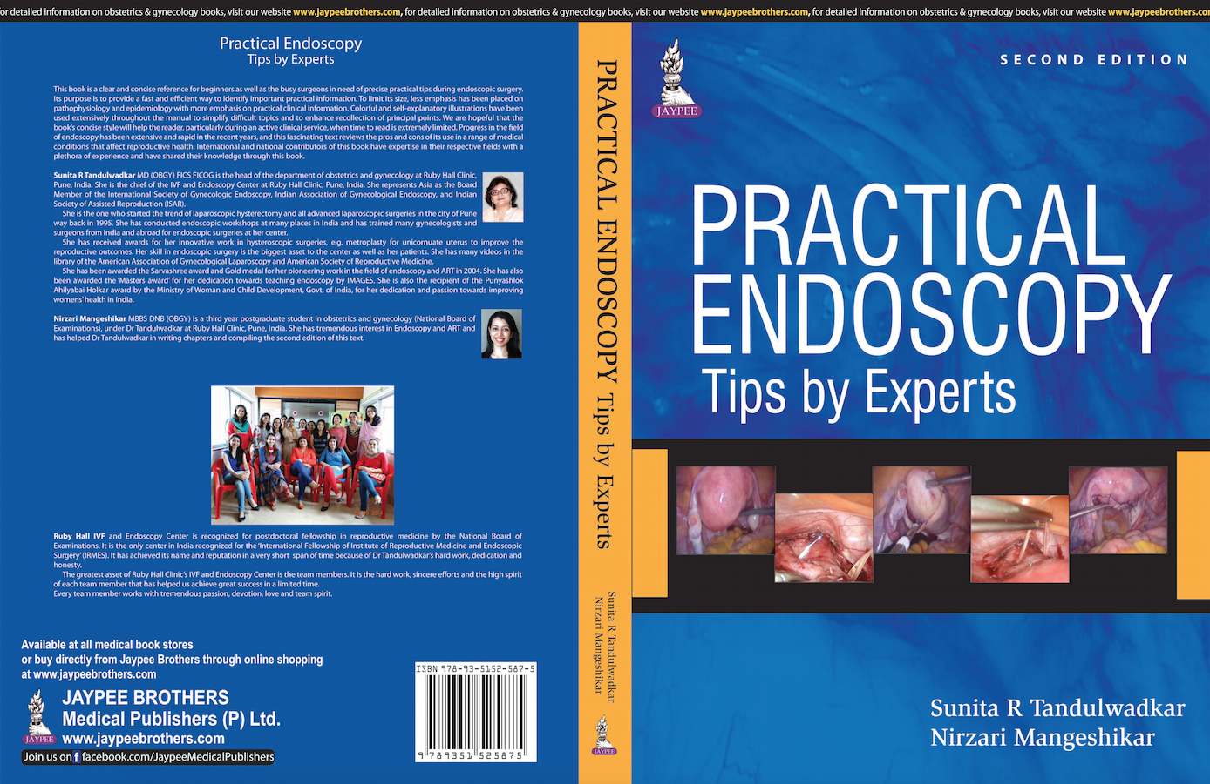

Published various textbooks of Endoscopy and Infertility along with her post-graduate students.

