BOB Lewis 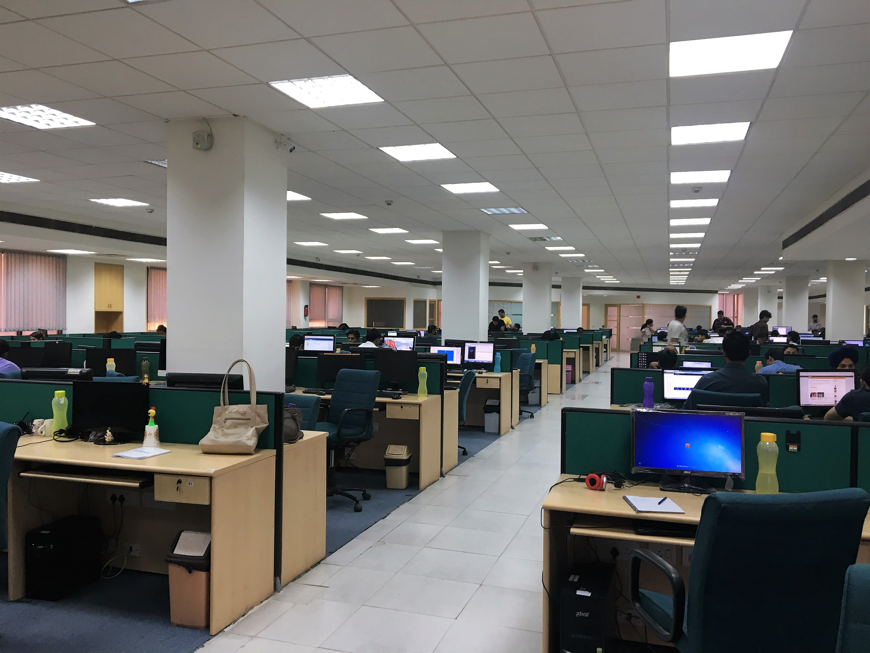
E-Mail: sbob42323@gmail.com
Mobile: +91-11111111111
VISHVESHWARYA INSTITUTE OF ENGINEERING & TECHNOLOGY
To contribute towards achieving organisational goals and benefits with the help of my knowledge and experience. To acquire highest level professionalism through better learning and continuous opportunities and deliver to the best of my abilities. I am seeking an opportunity which provides respect, enhance skills and praise efforts and commitment

EXPERIENCE SUMMARY

Total Experience: - April 2015 – Till date

Currently working in Ericsson Global India Pvt. Ltd. as a Quality Testing Engineer on the third party payroll through-
- Avion System Pvt. Ltd. from (1st April 2015 to 31st dec 2015)
- Manpower Pvt. Ltd. from ( 2nd jan 2016 to Till date)

PROJECTS WORKED ON

- T-MOBILE – USA (April 15-Till Date)

CURRENT RESPONSIBILITIES

- Taking care of the quality testing of full telecom parameters.
- Taking care of protocols test.
- Good exposure to SQL Server Programming.
- SDLC models
- Handling Database and Resolving the Technical issues in Tool
- Manage share folder through permission
- Managing the Team as a Team leader.
- Involved with Client to make sure to remove the issues faced.
Key skills
- Knowledge about OOps concept
- Knowledge about software testing method.
- STLC (software testing life cycle).
- Well versed about GSM/WCDMA and LTE technologies.
- Knowledge understanding of Microsoft windows.
- Well versed with Microsoft Excel & Power Point.
- Windows 7/8.

CAREER ABRIDGMENT
- Participated in summer training in “Telephone exchange department “ at N.C.L (Coal india)
Sonbhadra (u.p).
- A quick learner & self-directed; consistent at updating self with emerging trends in the industry.
- An efficient key player in challenging & creative environments with excellent capacity to adapt to new technologies and skills.

C0-CURRICULAR ACTIVITIES
- Got appreciation from Ericsson Global India Pvt.Ltd for Industrialized Site Engineering.
- Organize event (ECLECTICS) held at VGI Campus in the year 2012.
- Second position in Technical Exhibitions held at VGI Campus in the year 2012.
- Participated in workshop of robotics held at VGI Campus in the year 2012.
- Participated in modeling competition held at IIT KANPUR in the year 2012.
- Participated in “Allusion” held at VGI Campus in the year 2011.
- Participated in indian space history held at VGI Campus in the year 2011.
- Participated in workshop of V.L.S.I held at 2012.
- Participated in “Circuit building” event held at VGI Campus in the year 2012

ACADEMIC PURVIEW
- Completed B.Tech. (Electronics and TeleCommunication) from Vishveshwarya Institute of Engineering and Technology, Gautam Buddh Nagar under U.P. Technical University, Lucknow. Secured 66.02% marks.
- Class 12th from S.V.M KHADIA, U.P. Board with 57%. Passed examination in 2009.
- Class 10th from B.P.S SONBHADRA , U.P. Board with 62.22%. Passed examination in 2007.

IT KNOW HOW

- Miscellaneous: Internet Applications and MS Office, C, C++, Core java.

HOBBIES
- Dancing
- Cooking
- Sleeping
- Acting

SUMMER TRAINING
17Jun-16July Telephone Exchange – COAL INDIA (SONBHADRA)
Description: Successfully completed summer training on Telephone Exchange depaartment.

PERSONAL DOSSIER
Languages Known : English and Hindi.
Father’s Name : Mr. abcv Singh
Address (Permanent) : 43 Vishunpur Jaraha,Khanjadipur,Chunar , Mirzapur, U.P-231304
Address (Current) : 103 J & K BLOCK , LAXMI NAGAR ,DELHI -110092
Date of Birth : 25/10/1992

DECLARATION

I hereby declare that aforesaid details are true and best to my knowledge.

Date 06-15-2016
Place-Delhi (Vandana Singh)

