Project Synopsis
HCLTech Career Shaper Programme | III Year Industry Project | 2025-26

Field | Details
Project Title | AI-Based Resume Screening and Candidate Shortlisting System
Project No. | 34
Domain | Digital-Data-AI / AIML
Difficulty | Advanced
Duration | 4 Weeks
Format | Individual Project
Learner Name | Ashish Kumar Pal
Roll Number | 2300321530045
College / Campus | ABES Engineering College, Ghaziabad
Mentor Name | Amrit Kaur
Submission Date | [FILL IN]

1. Problem Statement
Recruiters and HR teams in companies that receive hundreds of resumes for a single opening must read each resume against the job description by hand. This first-pass screening is slow, inconsistent between reviewers, and easily overlooks qualified candidates, which delays hiring and makes decisions harder to justify. This project builds an AI-assisted tool that reads a job description and many resumes, scores and ranks candidates with evidence-backed explanations, and leaves the final decision to the recruiter.

2. Proposed Solution & Approach
I built a Streamlit web application in Python. The recruiter pastes or uploads a job description and uploads multiple resume PDFs. Google Gemini extracts a structured job profile (required skills, preferred skills, minimum experience, education) and a structured profile for each resume; Sentence Transformers measure the semantic similarity between the job description and each resume. Gemini then checks every required and preferred skill against the resume and must quote evidence that is verified in the resume text, while professional experience is calculated only from dated employment, so personal and academic projects are never counted as jobs.
A Python scoring step (not the LLM) combines the results: Final Score = 30% JD similarity + 50% skill match + 20% experience, re-normalised when experience is unavailable. Candidates are ranked by final score and shown with matched and missing skills and a short AI-written summary. The tool supports the recruiter's decision and does not replace it.

3. System Architecture
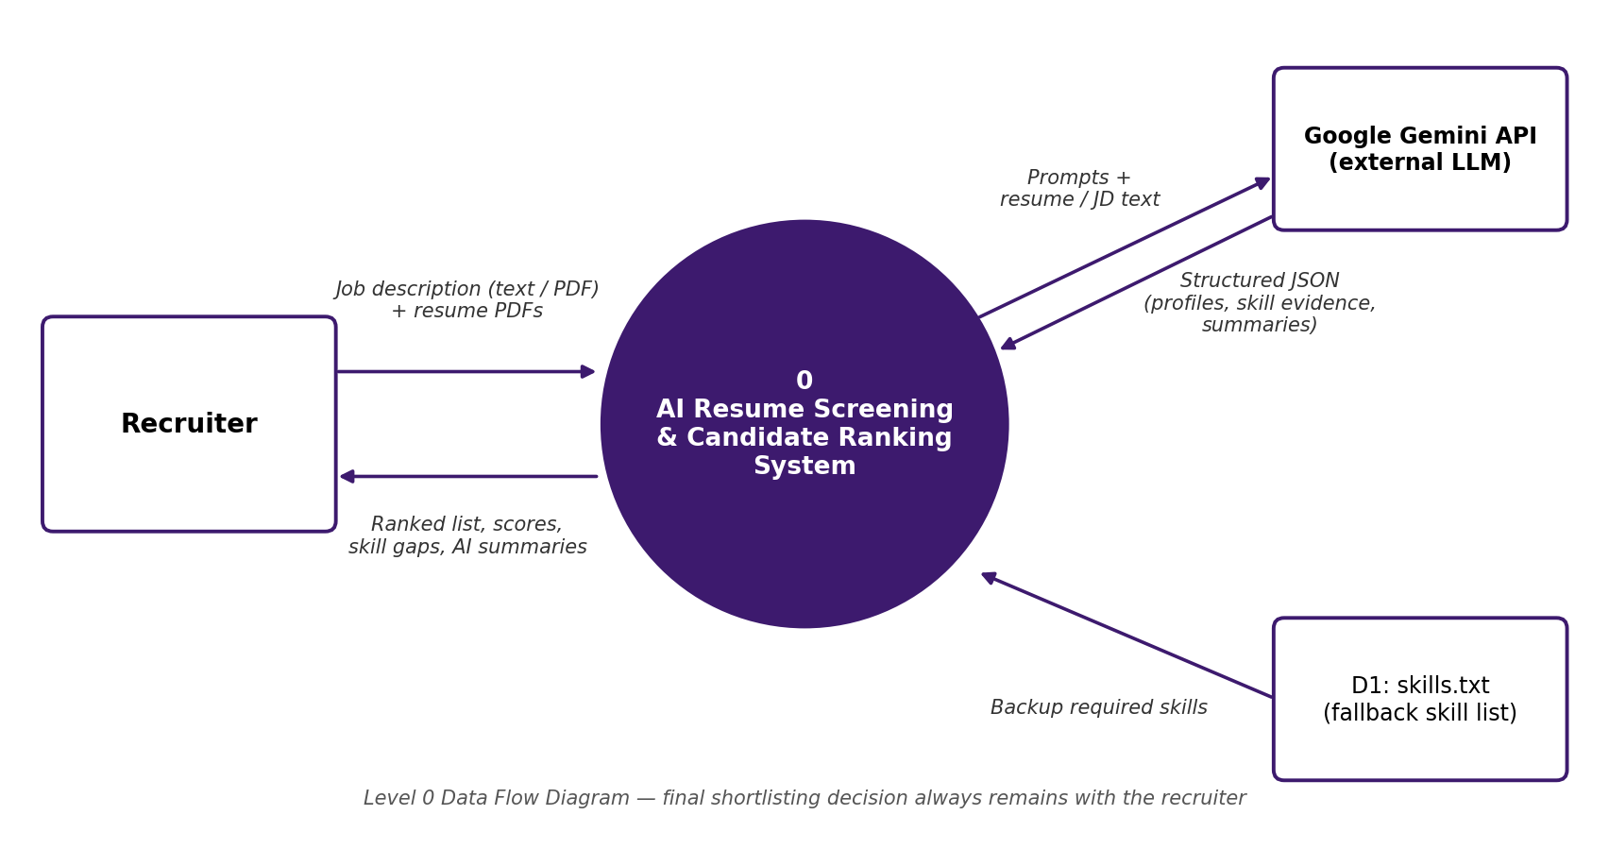
Figure 1: Level 0 Data Flow Diagram
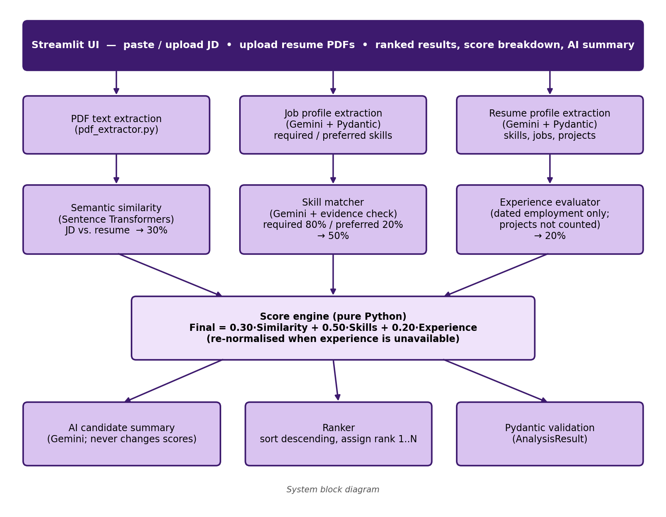
Figure 2: System block diagram

4. Technology Stack
Frontend / UI: Streamlit
Backend / Logic: Python (modular code for PDF text extraction, skill matching, experience calculation and scoring); Pydantic for data validation; python-dotenv for configuration
Database: None (a fallback skill list is kept in a text file, data/skills.txt)
AI/ML Framework: Google Gemini via the google-genai SDK (structured extraction, evidence-based skill matching, candidate summaries); Sentence Transformers (semantic similarity)
Visualisation: Streamlit components (ranked results, expandable candidate panels, score breakdowns)
Hardware: None specific (standard laptop; Gemini accessed through its API)

5. Dataset Used
Dataset file name: dataset.csv (provided in project folder)
Number of rows: 500
Number of columns: 8
Key columns (list 5): years_exp, skills_matched, education_score, keyword_density, predicted_score (the file also has resume_id, job_role and shortlisted)
Any additional data collected: 15 synthetic resumes (PDF) and one job description (Junior Software Engineer), generated with ChatGPT and used to test the screening pipeline end to end. The application reads resume PDFs; the provided 500-row, 8-column dataset is used for exploratory data analysis, not as the live resume input.

6. Key Results & Metrics
Metric 1: Ranking agreement (Spearman correlation vs. expected fit tiers, 15 test resumes) — 0.90
Metric 2: Response time — about 4 seconds per resume
Metric 3: Candidates from different fit tiers ranked in the correct order — 78 of 83 pairs (94%)
Business value achieved: First-pass screening of a resume takes seconds instead of minutes of manual reading. Every ranking comes with matched and missing skills, a score breakdown and a short summary, so the recruiter can see why a candidate ranked where they did.
Note: results are from one job description and 15 synthetic resumes, with expected fit tiers assigned by manual reading of each resume against the job description. They are indicative and not a statistically validated measure of hiring quality.

7. Fairness and Bias Audit
A controlled name-and-age cue audit was conducted using five synthetic resumes and one Junior Software Engineer job description. Each resume was tested with unchanged duplicate copies, male- and female-coded names using two surnames, and two date-of-birth cues. Skills, experience, education, projects and layout were held constant apart from the cue being tested.
Across 30 name/age variants, the largest final-score change was 1.34 points; no variant exceeded the predefined 2-point materiality threshold, and no decision label changed. The age cue showed no consistent direction. The Khan surname scored approximately one point higher than Verma across the tested comparisons, while female-coded first names scored slightly lower on average. These small differences should be monitored rather than dismissed.
The audit is indicative, not proof of fairness: it used only five synthetic base resumes, one job description and a limited set of names and age cues. The full “Fairness Report: Name and Age Cue Audit” is submitted as a separate supporting document. Recommended safeguards include removing names, email addresses and dates of birth before similarity scoring where feasible, repeating the audit with more resumes and job descriptions, and retaining human review for every hiring decision.

8. Challenges Faced & How Resolved
Challenge 1: Personal and academic projects could be mistaken for work experience and inflate scores. Resolution: The extraction prompt separates employment from projects, and total experience is calculated in Python from dated employment only, without double-counting overlapping periods. Experience stays unknown when there is no dated employment.
Challenge 2: An LLM can claim that a candidate has a skill without real support in the resume. Resolution: Gemini must return short exact quotations as evidence, and the code checks that each quotation actually appears in the resume text before a skill counts as matched. A known trade-off is that strict checking can reject valid paraphrases.
Challenge 3: LLM output can be incomplete or malformed, and a failed call could stop the whole ranking. Resolution: All Gemini calls use a JSON response schema validated with Pydantic, temperature zero and automatic retries with backoff. A failed candidate summary is caught so the ranking still completes, and the final score is always calculated by Python, never by the LLM.

9. References
1. N. Reimers and I. Gurevych, "Sentence-BERT: Sentence Embeddings using Siamese BERT-Networks," Proceedings of EMNLP-IJCNLP 2019, pp. 3982–3992. https://arxiv.org/abs/1908.10084
2. Google, "Structured output," Gemini API Documentation. https://ai.google.dev/gemini-api/docs/structured-output
3. Government of India, "The Digital Personal Data Protection Act, 2023 (Act No. 22 of 2023)." https://www.indiacode.nic.in/bitstream/123456789/22037/2/a2023-22.pdf
4. Pydantic Documentation. https://docs.pydantic.dev/latest/

5. Ashish Kumar Pal, “Fairness Report: Name and Age Cue Audit,” supporting report for HCLTech Career Shaper Programme, Project 34.

10. Ethical Compliance Declaration
I confirm that:
☐ All dataset usage complies with the source licence.
☐ No personally identifiable information (PII) is stored without consent.
☐ AI tools used for code/writing are disclosed in the Appendix.
☐ This project complies with the DPDP Act 2023 where applicable.

Learner Signature: _________________________ Date: ________________

Appendix: AI Tools Used
ChatGPT: generated the 15 synthetic test resumes and the test job description.
Google Gemini: runs inside the application for job and resume profile extraction, skill-evidence matching and candidate summaries.
Claude (Anthropic): assisted with project planning, analysis of the test results and drafting of this synopsis.

Project Synopsis | Ashish Kumar Pal | 2300321530045 | HCLTech Career Shaper Programme 2025-26

