Right Brain Library Management

Project Understanding:

We went through the reference website link provided to us and also need few clarifications and inputs from your side specifically to understand the project flow. In this document we present our understanding of what needs to be accomplished in the project along with the budget and time estimation.

Reference site link: ​https://www.rightbraineducationlibrary.com/ will be help if we get a login with membership.

Project Statement:

- To design and develop a web application which will provide a highly enriching and a vast range of learning experience for kids. It will be like a library which provides different options to learn and improve knowledge, improve their application skills and expand creativity for different subjects. Provide them a easily understandable and enjoyable way of learning different aspects of the subject.

Module List: We have listed out initial

S. No | Type | Milestone days MD
1 | Front End Home page design, admin panel for showing
 | related content and manage it whenever needed
 | Logo design
2 | Registration, Membership plan and related admin panel
 | mgmt, Payment Gateway Paypal integration for membership
 | plans
3 | Manage modules for free membership, manage modules for
 | paid membership and related Admin panel for managing
 | the same
4 | Content management with Admin Panel (all content
 | modules as listed in right brain price and plan table) or if we
 | can get content modules from client
5 | Web Service and DB Architecture
6 | User security, Confidentiality and membership management

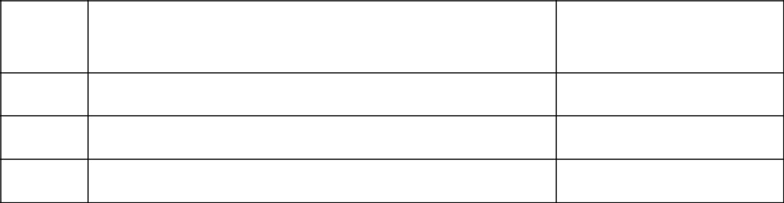
- Blogs Management With Admin panel and Contact US

- Bug Fixes and Feedback points

Total MD’s Total Cost

Project Requirement: ​The specific section / modules of he portal has been listed below (an approximate understanding as of now):

1. User Management:

- Allow new user registration

- Provide a measure of user authentication before activating it by going through a admin approval process

- Email verification will be provided along with admin approval so as to avoid or discourage fake account registrations

- Allow admin to view, edit or delete and activate / deactivate a user account

- User content access control (linked to membership plans and a setup related to free membership)

- Log out, Change password, Profile features
- ​Let us know if option need to be provided in user profile to add info related to kids which customer has, if yes will it be used to analyse which content has to be shown. Let us know if content will be based on age group)

2. Content Management:

- Admin can create and delete content that can be viewed by registered users

- View, Edit, Delete content types

- To be implemented on the portal with the required fields as specified in the specification document.

3. Employee Management:

As this portal will require lot of content management it will need employees to upload the content with various instructions. Admin can create employees and assign roles. Roles will be assigned and this will control who can view and update content and its types, who can delete a content and its types, who can create a content and its types.

Let us know the roles that need to be created.

Let us know how many admins will be there and we anticipate there will be one super admin to manage all activities at back end.

4. Brain Exercises:
- Test your recall:- Make a list — of grocery items, things to do, or anything else that comes to mind — and memorize it. An hour or so later, see how many items you can recall. Make items on the list as challenging as possible for the greatest mental stimulation
- Let the music play:- Learn to play a musical instrument or join a choir. Studies show that learning something new and complex over a longer period of time is ideal for the aging mind.
- Do math in your head:- Figure out problems without the aid of pencil, paper, or computer; you can make this more difficult — and athletic — by walking at the same time.
- Take a cooking class:- Learn how to cook a new cuisine. Cooking uses a number of senses: smell, touch, sight, and taste, which all involve different parts of the brain.
- Learn a foreign language:- The listening and hearing involved stimulates the brain. What’s more, a rich vocabulary has been linked to a reduced risk for cognitive decline.
- Create word pictures:- Visualize the spelling of a word in your head, then try and think of any other words that begin (or end) with the same two letters.
- Draw a map from memory:- After returning home from visiting a new place, try to draw a map of the area; repeat this exercise each time you visit a new location.
- Challenge your taste buds:- When eating, try to identify individual ingredients in your meal, including subtle herbs and spices.
- Refine your hand-eye abilities:- Take up a new hobby that involves fine-motor skills, such as knitting, drawing, painting, assembling a puzzle, etc.
- Learn a new sport:- Start doing an athletic exercise that utilizes both mind and body, such as yoga, golf, or tennis.

