Command | Usage
cat filename | this will display the contents of filename on the terminal.
tac filename | The tac command (cat spelled backwards) prints the lines of a file in reverse order. Each line remains the same, but the order of lines is inverted. The syntax of tac is exactly the same as for cat, as in:
cat file1 file2 | Concatenate multiple files and display the output; i.e. the entire content of the first file is followed by that of the second file
cat file1 file2 > newfile | Combine multiple files and save the output into a new file
cat file >> existingfile | Append a file to the end of an existing file
cat > file | Any subsequent lines typed will go into the file, until Ctrl-D is typed
cat >> file | Any subsequent lines are appended to the file, until Ctrl-D is typed
Cat :

cat is short for concatenate and is one of the most frequently used Linux command line utilities. It is often used to read and print files, as well as for simply viewing file contents. To view a file, use the following command:

echo:

echo can be used to display a string on standard output (i.e. the terminal) or to place in a new file (using the > operator) or append to an already existing file (using the >> operator).
Command | Usage
echo string > newfile | The specified string is placed in a new file
echo string >> existingfile | The specified string is appended to the end of an already existing file
echo $variable | The contents of the specified environment variable are displayed

head :
head reads the first few lines of each named file (10 by default) and displays it on standard output. You can give a different number of lines in an option.
For example, if you want to print the first 5 lines from grub.cfg, use the following command:
$ head –n 5 grub.cfg

tail
tail prints the last few lines of each named file and displays it on standard output. By default, it displays the last 10 lines. You can give a different number of lines as an option. tail is especially useful when you are troubleshooting any issue using log files, as you probably want to see the most recent lines of output.
For example, to display the last 15 lines of somefile.log, use the following command:
$ tail -n 15 somefile.log
You can also just say tail -15 somefile.log.
To continually monitor new output in a growing log file:(-f is follow)
$ tail -f somefile.log
This command will continuously display any new lines of output in somefile.log as soon as they appear. Thus, it enables you to monitor any current activity that is being reported and recorded.

Viewing Compressed Files
When working with compressed files, many standard commands cannot be used directly. For many commonly-used file and text manipulation programs, there is also a version especially designed to work directly with compressed files. These associated utilities have the letter "z" prefixed to their name. For example, we have utility programs such as zcat, zless, zdiff and zgrep.
Here is a table listing some z family commands:
Command | Description
$ zcat compressed-file.txt.gz | To view a compressed file
$ zless somefile.gz or $ zmore somefile.gz | To page through a compressed file
$ zgrep -i less somefile.gz | To search inside a compressed file
$ zdiff file1.txt.gz file2.txt.gz | To compare two compressed files
Note that if you run zless on an uncompressed file, it will still work and ignore the decompression stage. There are also equivalent utility programs for other compression methods besides gzip.
For example, we have bzcat and bzless associated with bzip2, and xzcat and xzless associated with xz.

sed Command Syntax and Basic Operations
You can invoke sed using commands like those listed in the accompanying table.
Command | Usage
sed -e command <filename> | Specify editing commands at the command line, operate on file and put the output on standard out (e.g. the terminal)
sed -f scriptfile <filename> | Specify a scriptfile containing sed commands, operate on file and put output on standard out
The -e command option allows you to specify multiple editing commands simultaneously at the command line. It is unnecessary if you only have one operation invoked.
Now that you know that you can perform multiple editing and filtering operations with sed, let’s explain some of them in more detail. The table explains some basic operations, where pattern is the current string and replace_string is the new string:
Command | Usage
sed s/pattern/replace_string/ file | Substitute first string occurrence in every line
sed s/pattern/replace_string/g file | Substitute all string occurrences in every line
sed 1,3s/pattern/replace_string/g file | Substitute all string occurrences in a range of lines
sed -i s/pattern/replace_string/g file | Save changes for string substitution in the same file
You must use the -i option with care, because the action is not reversible. It is always safer to use sed without the –i option and then replace the file yourself, as shown in the following example:
$ sed s/pattern/replace_string/g file1 > file2
The above command will replace all occurrences of pattern with replace_string in file1 and move the contents to file2. The contents of file2 can be viewed with cat file2. If you approve, you can then overwrite the original file with mv file2 file1.
Example: To convert 01/02/… to JAN/FEB/…
sed -e 's/01/JAN/' -e 's/02/FEB/' -e 's/03/MAR/' -e 's/04/APR/' -e 's/05/MAY/' \
-e 's/06/JUN/' -e 's/07/JUL/' -e 's/08/AUG/' -e 's/09/SEP/' -e 's/10/OCT/' \
-e 's/11/NOV/' -e 's/12/DEC/'

awk Command Syntax and Basic Operations
As with sed, short awk commands can be specified directly at the command line, but a more complex script can be saved in a file that you can specify using the -f option.
Command | <header>
awk 'command' file | Specify a command directly at the command line
awk -f scriptfile file | Specify a file that contains the script to be executed
The table below explains the basic tasks that can be performed using awk. The input file is read one line at a time, and, for each line, awk matches the given pattern in the given order and performs the requested action. The -F option allows you to specify a particular field separator character. For example, the /etc/passwd file uses ":" to separate the fields, so the -F: option is used with the /etc/passwd file.
The command/action in awk needs to be surrounded with apostrophes (or single-quote (')). awk can be used as follows:
Command | Usage
awk '{ print $0 }' /etc/passwd | Print entire file
awk -F: '{ print $1 }' /etc/passwd | Print first field (column) of every line, separated by a space
awk -F: '{ print $1 $7 }' /etc/passwd | Print first and seventh field of every line

sort
sort is used to rearrange the lines of a text file either in ascending or descending order, according to a sort key. You can also sort by particular fields of a file. The default sort key is the order of the ASCII characters (i.e. essentially alphabetically).
sort can be used as follows:
Syntax | Usage
sort <filename> | Sort the lines in the specified file, according to the characters at the beginning of each line
cat file1 file2 | sort | Combine the two files, then sort the lines and display the output on the terminal
sort -r <filename> | Sort the lines in reverse order
sort -k 3 <filename> | Sort the lines by the 3rd field on each line instead of the beginning
When used with the -u option, sort checks for unique values after sorting the records (lines). It is equivalent to running uniq (which we shall discuss) on the output of sort.

uniq
uniq removes duplicate consecutive lines in a text file and is useful for simplifying the text display.
Because uniq requires that the duplicate entries must be consecutive, one often runs sort first and then pipes the output into uniq; if sort is used with the -u option, it can do all this in one step.
To remove duplicate entries from multiple files at once, use the following command:
sort file1 file2 | uniq > file3
or
sort -u file1 file2 > file3
To count the number of duplicate entries, use the following command:
uniq -c filename

Using paste
paste can be used to combine fields (such as name or phone number) from different files, as well as combine lines from multiple files. For example, line one from file1 can be combined with line one of file2, line two from file1 can be combined with line two of file2, and so on.
To paste contents from two files, you can do:
$ paste file1 file2
The syntax to use a different delimiter is as follows:
$ paste -d, file1 file2
Common delimiters are 'space', 'tab', '|', 'comma', etc.
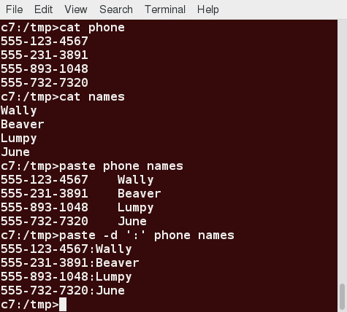

Using join
To combine two files on a common field, at the command prompt type join file1 file2 and press the Enter key.
For example, the common field (i.e. it contains the same values) among the phonebook and cities files is the phone number, and the result of joining these two files is shown in the screen capture.
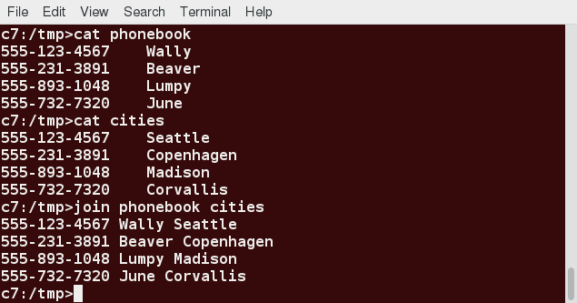

Using split
Split the file into pieces, by default it split on 1k line. we can pass number of line by which we want split to be performed by l flag then that number. Eg. split -l 2 file_name => it will create multiple file each having 2 line in it from file named file_name.
We will apply split to an American-English dictionary file of over 99,000 lines:
$ wc -l american-english
99171 american-english
where we have used wc (word count, soon to be discussed) to report on the number of lines in the file. Then, typing:
$ split american-english dictionary
will split the American-English file into 100 equal-sized segments named 'dictionaryxx. The last one will, of course, be somewhat smaller.
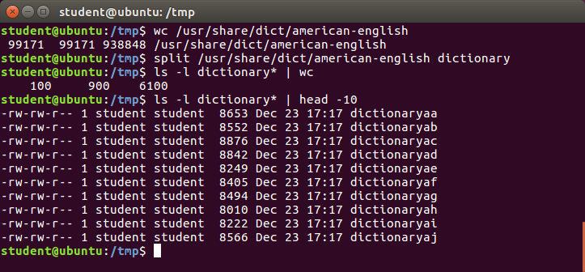

Regular Expressions and Search Patterns
Regular expressions are text strings used for matching a specific pattern, or to search for a specific location, such as the start or end of a line or a word. Regular expressions can contain both normal characters, as well as so-called meta-characters, such as * and $.
Many text editors and utilities such as vi, sed, awk, find and grep work extensively with regular expressions. Some of the popular computer languages that use regular expressions include Perl, Python and Ruby. It can get rather complicated, and there are whole books written about regular expressions; thus, we will do no more than skim the surface here.
These regular expressions are different from the wildcards (or meta-characters) used in filename matching in command shells such as bash. The table below lists search patterns and their usage.
Search Patterns | Usage
.(dot) | Match any single character
a|z | Match a or z
$ | Match end of string
^ | Match beginning of string
* | Match preceding item 0 or more times
For example, consider the following sentence: The quick brown fox jumped over the lazy dog.
Some of the patterns that can be applied to this sentence are as follows:
Command | Usage
a.. | matches azy
b.|j. | matches both br and ju
..$ | matches og
l.* | matches lazy dog
l.*y | matches lazy
the.* | matches the whole sentence

grep
grep is extensively used as a primary text searching tool. It scans files for specified patterns and can be used with regular expressions, as well as simple strings, as shown in the table:
Command | Usage
grep [pattern] <filename> | Search for a pattern in a file and print all matching lines
grep -v [pattern] <filename> | Print all lines that do not match the pattern(-v is invert match)
grep [0-9] <filename> | Print the lines that contain the numbers 0 through 9
grep -C 3 [pattern] <filename> | Print context of lines (specified number of lines above and below the pattern) for matching the pattern; here, the number of lines is specified as 3

strings
strings is used to extract all printable character strings found in the file or files given as arguments. It is useful in locating human-readable content embedded in binary files; for text files, you can just use grep.
For example, to search for the string my_string in a spreadsheet:
$ strings book1.xls | grep my_string

tr
The tr utility is used to translate specified characters into other characters or to delete them. The general syntax is as follows:
$ tr [options] set1 [set2]
The items in the square brackets are optional. tr requires at least one argument and accepts a maximum of two. The first designated set1 in the example lists the characters in the text to be replaced or removed. The second, set2, lists the characters that are to be substituted for the characters listed in the first argument. Sometimes, these sets need to be surrounded by apostrophes (or single-quotes (')) in order to have the shell ignore that they mean something special to the shell. It is usually safe (and may be required) to use the single-quotes around each of the sets, as you will see in the examples below.
For example, suppose you have a file named city containing several lines of text in mixed case. To translate all lower case characters to upper case, at the command prompt type cat city | tr a-z A-Z and press the Enter key.
Command | Usage
$ tr abcdefghijklmnopqrstuvwxyz ABCDEFGHIJKLMNOPQRSTUVWXYZ | Convert lower case to upper case
$ tr '{}' '()' < inputfile > outputfile | Translate braces into parenthesis
$ echo "This is for testing" | tr [:space:] '\t' | Translate white-space to tabs
$ echo "This is for testing" | tr -s [:space:] | Squeeze repetition of characters using -s
$ echo "the geek stuff" | tr -d 't' | Delete specified characters using -d option
$ echo "my username is 432234" | tr -cd [:digit:] | Complement the sets using -c option
$ tr -cd [:print:] < file.txt | Remove all non-printable characters from a file
$ tr -s '\n' ' ' < file.txt | Join all the lines in a file into a single line

tee
tee takes the output from any command, and, while sending it to standard output, it also saves it to a file. In other words, it "tees" the output stream from the command: one stream is displayed on the standard output and the other is saved to a file.
For example, to list the contents of a directory on the screen and save the output to a file, at the command prompt type ls -l | tee newfile and press the Enter key.
Typing cat newfile will then display the output of ls –l.
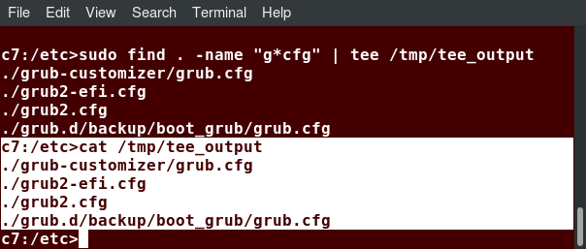

wc
wc (word count) counts the number of lines, words, and characters in a file or list of files. Options are given in the table below:
Option | Description
–l | Displays the number of lines
-c | Displays the number of bytes
-w | Displays the number of words
By default, all three of these options are active.
For example, to print only the number of lines contained in a file, type wc -l filename and press the Enter key.
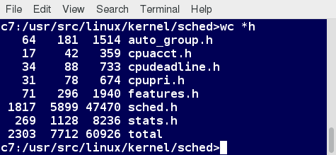

cut
cut is used for manipulating column-based files and is designed to extract specific columns. The default column separator is the tab character. A different delimiter can be given as a command option.
For example, to display the third column delimited by a blank space, at the command prompt type ls -l | cut -d" " -f3 and press the Enter key.
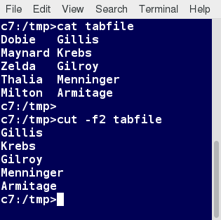

Using sed (Lab)

Exercise
Search for all instances of the user command interpreter (shell) equal to /sbin/nologin in /etc/passwd and replace them with /bin/bash. (Do not overwrite /etc/passwd.)

Solution
You can see a solution for this exercise here:
To get the output on standard out (terminal screen):
$ sed s/’\/sbin\/nologin’/’\/bin\/bash’/g /etc/passwd
or to direct to a file:
$ sed s/’\/sbin\/nologin’/’\/bin\/bash’/g /etc/passwd > passwd_new
Note this is kind of painful and obscure, because we are trying to use the forward slash (/) as both a string and a delimiter between fields. Instead, you can do:
$ sed s:’/sbin/nologin’:’/bin/bash’:g /etc/passwd
where we have used the colon (:) as the delimiter instead (you are free to choose your delimiting character!). In fact, when doing this, we don’t even need the single quotes:
$ sed s:/sbin/nologin:/bin/bash:g /etc/passwd
works just fine.

