Index.html

<!DOCTYPE html>

<html lang="en">

<head>

    <meta charset="UTF-8">

    <meta http-equiv="X-UA-Compatible" content="IE=edge">

    <meta name="viewport" content="width=device-width, initial-scale=1.0">

    <link rel="stylesheet" href="style.css">

    <link rel="stylesheet" href="https://cdn.jsdelivr.net/npm/bootstrap@4.4.1/dist/css/bootstrap.min.css"

        integrity="sha384-Vkoo8x4CGsO3+Hhxv8T/Q5PaXtkKtu6ug5TOeNV6gBiFeWPGFN9MuhOf23Q9Ifjh" crossorigin="anonymous">

    <script src="https://code.jquery.com/jquery-3.4.1.slim.min.js"

        integrity="sha384-J6qa4849blE2+poT4WnyKhv5vZF5SrPo0iEjwBvKU7imGFAV0wwj1yYfoRSJoZ+n"

        crossorigin="anonymous"></script>

    <script src="https://cdn.jsdelivr.net/npm/popper.js@1.16.0/dist/umd/popper.min.js"

        integrity="sha384-Q6E9RHvbIyZFJoft+2mJbHaEWldlvI9IOYy5n3zV9zzTtmI3UksdQRVvoxMfooAo"

        crossorigin="anonymous"></script>

    <script src="https://cdn.jsdelivr.net/npm/bootstrap@4.4.1/dist/js/bootstrap.min.js"

        integrity="sha384-wfSDF2E50Y2D1uUdj0O3uMBJnjuUD4Ih7YwaYd1iqfktj0Uod8GCExl3Og8ifwB6"

        crossorigin="anonymous"></script>

    <title>Document</title>

</head>

<body>

    <!DOCTYPE html>

<html lang="en">

<head>

  <title>Bootstrap </title>

  <meta charset="utf-8">

  <meta name="viewport" content="width=device-width, initial-scale=1">

  <link href="https://cdn.jsdelivr.net/npm/bootstrap@5.0.1/dist/css/bootstrap.min.css" rel="stylesheet">

  <script src="https://code.jquery.com/jquery-3.4.1.min.js"></script>

  <script src="https://cdn.jsdelivr.net/npm/@popperjs/core@2.9.2/dist/umd/popper.min.js" integrity="sha384-IQsoLXl5PILFhosVNubq5LC7Qb9DXgDA9i+tQ8Zj3iwWAwPtgFTxbJ8NT4GN1R8p" crossorigin="anonymous"></script>

  <script src="https://cdn.jsdelivr.net/npm/bootstrap@5.0.1/dist/js/bootstrap.min.js" integrity="sha384-Atwg2Pkwv9vp0ygtn1JAojH0nYbwNJLPhwyoVbhoPwBhjQPR5VtM2+xf0Uwh9KtT" crossorigin="anonymous"></script>

</head>

<body>

    <nav class="navbar navbar-expand-sm navbar-dark bg-dark">

        <a class="navbar-brand" href="#">Intern Crowd</a>

      <div class="container-fluid">

        <div class="collapse navbar-collapse " id="navbarNav">

          <ul class="navbar-nav me-auto order-0 ">

            <li class="nav-item">

              <a class="nav-link btn btn-infor" role="button" href="#top">Home</a>

            </li>

            <li class="nav-item">

              <a class="nav-link btn btn-infor" href="#services">Services</a>

            </li>

            <li class="nav-item">

                <a class="nav-link" href="#login">Login</a>

            </li>

            <li class="nav-item">

                <a class="nav-link" href="#internship">Internship</a>

            </li>

            <li class="nav-item">

                <a class="nav-link" href="#about">About us</a>

            </li>

            <li class="nav-item">

              <a class="nav-link" href="#contacts">Contacts</a>

            </li>

          </ul>

          <div class="ms-auto">

            <button class="navbar-toggler" type="button" data-bs-toggle="collapse" data-bs-target="#navbarSupportedContent" aria-controls="navbarSupportedContent" aria-expanded="false" aria-label="Toggle navigation">

              <span class="navbar-toggler-icon"></span>

            </button>

        </div>

          <form class="d-flex ms-auto order-5">

          <input class="form-control me-2" type="search" placeholder="Search" aria-label="Search">

          <button class="btn btn-outline-success" type="submit">Search</button>

          </form>

        </div>

      </div>

    </nav>

    <section id="banner">

        <div class="container">

            <div class="row">

                <div class="col-md-8">

                    <!-- <div class="float-right"><img src="image1.jpg" alt="DigiTech" width="200"></div> -->

                    <p class="promo-title"><strong>Enter The World Of Coding By Enrolling In Our Internship Program Today!!</strong></p>

                    <p><i>"In every student, there is a power to change the world"</i></p>

                    <button> <a href="/internship.html" target="_blank">Get Started</a></button>

                </div>

            </div>

        </div>

    </section>

    <!-- services section  -->

    <section id="services">

        <div class="container">

            <h2 class="title text-center"><strong>SERVICES PROVIDED BY US</strong></h2>

            <ol>

                <li>Web Development</li>

                <li>Java Development</li>

                <li>Android App Development</li>

                <li>Digital Marketing</li>

                <li>C/C++ Developmemt</li>

                <li>Cloud Computing</li>

            </ol>

        </div>

    </section>

    </section>

    <section>

        <div class="container">

            <div class="row">

                <div class="col-md-16 about"><br>

                    <center><h3 class="about-title"><strong>We Have Best Internships For You</strong></h3><br></center>

                    <p>You've Probably Heard About How Programming Shines With New Technology. We Have to Be Aware Of How Programming Can Initiate New Innovations. What's A Better Approach For Our Students Is to Grasp And Adapt To The Technology Around Them.</p>

                </div>

            </div>

            <section id="internship">

                <h2 class="title text-center"><strong></strong>Internships</h2>

                <div class="box-container">

                    <div class="box">

                        <img src="https://interncrowd.in/images/subject-icon-8.png" alt="Web Development" height="100px">

                        <h3>Web Development</h3>

                        <p>Website needs to work across all devices and it needs to be fast as possible.</p>

                    </div>

                    <div class="box">Java Development

                    </div>

                </div>

            </section>

            <section id="login">

                <div class="container">

                    <h2 class="title text-center"><strong>Login</strong></h2>

                    <div class="row">

                        <div class="col-nd-6 login">

                            <div class="text-center">

                                <button type="button" class="btn btn-dark" id = "registration_button" onclick="document.location='registration.html'">Registration</button>

                                <button type="button" class="btn btn-dark" id = "login_button" onclick="document.location='login.html'">Login</button>

                            </div>

                        </div>

                    </div>

                </div>

            </section>

            <section id="about">

                <h2 class="title text-center">About Us</h2><br>

                <div class="text-center">

                    <img src="facebook.png" alt="facebook" width="30">

                    <img src="instagram.png" alt="instagram" width="30">

                    <img src="linkedin.png" alt="LinkedIn" width="30">

                    <img src="twitter.png" alt="Twitter" width="30">

                    <img src="whatsapp.png" alt="whatsapp" width="30">

                    <img src="youtube.png" alt="YouTube" width="30">

                </div>

            </section>

        </div>

    <section id="contacts">

        <div class="container">

            <div class="row">

                <div class="col-md-4 footer-box">

                    <h3>Intern Crowd</h3>

                    <p>Intern Crowd Is An Online Coding Platform that Offers Specially Programming Courses For Students. You've Probably Heard About How Programming Shines With New Technology. We Have To Be Aware Of How Programming Can Initiate New Innovations. What's A Better Approach For Our Students Is To Grasp And Adapt To The Technology Around Them.</p>

                </div>

                <div class="col-md-4 footer-box">

                    <p><strong>CONTACT US</strong></p>

                    <p><i class="fa fa-map-marker"></i>Mumbai, Kolkata</p>

                    <p><i class="bi bi-telephone"></i>9999999999</p>

                    <p><i class="fa fa-envelope-o"></i>xyz@gmail.com</p>

                </div>

                <div class="col-md-4 footer-box">

                    <label><strong>REGISTER YOUR FIRST SESSION</strong></label>

                    <input type="text" placeholder="Enter your Email Id" name="Email" required><br>

                    <button id="signin" type="submit">sign In</button>

                </div>

            </div>

        </div>

    </section>

</body>

</html>

</body>

</html>

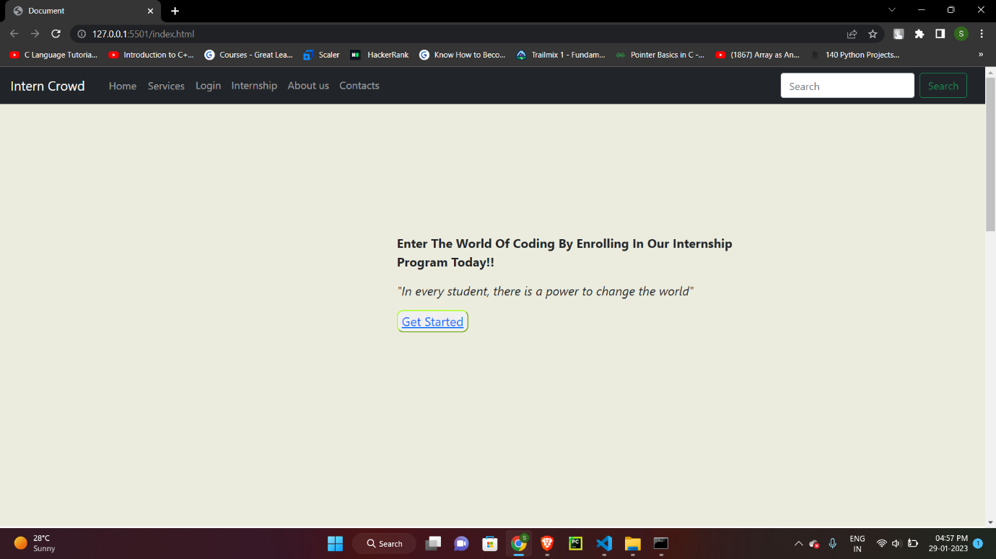

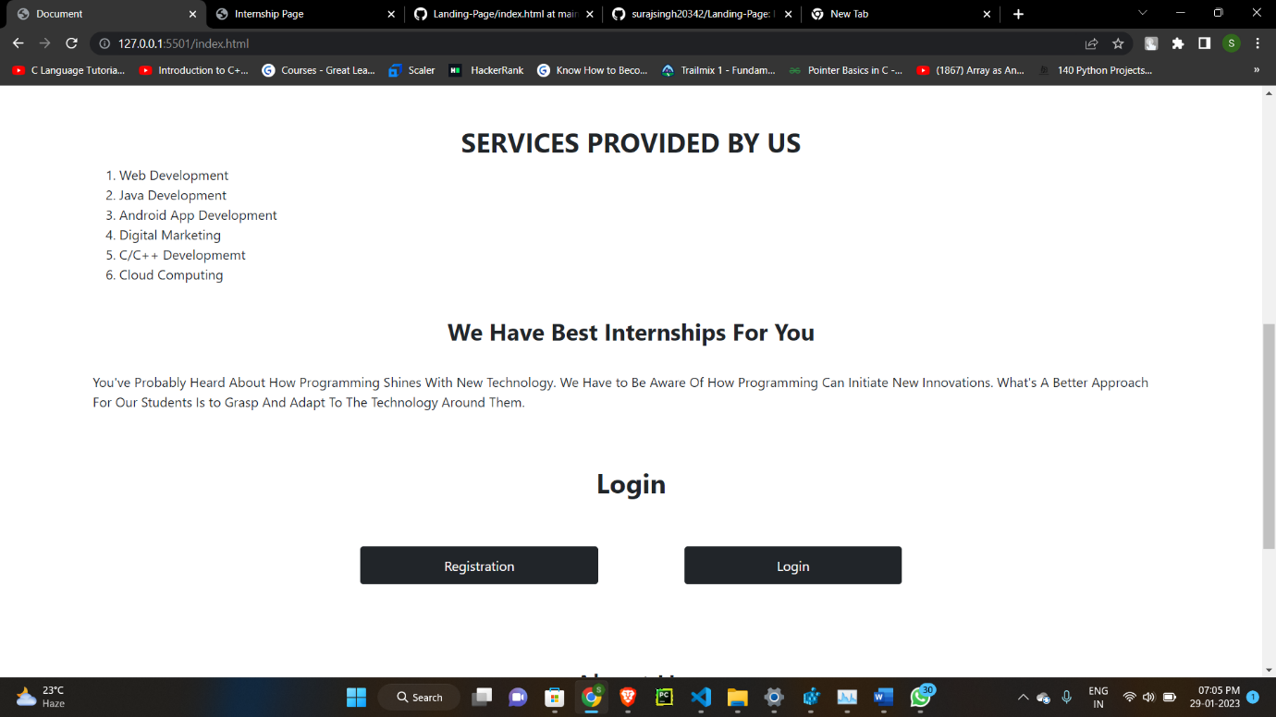

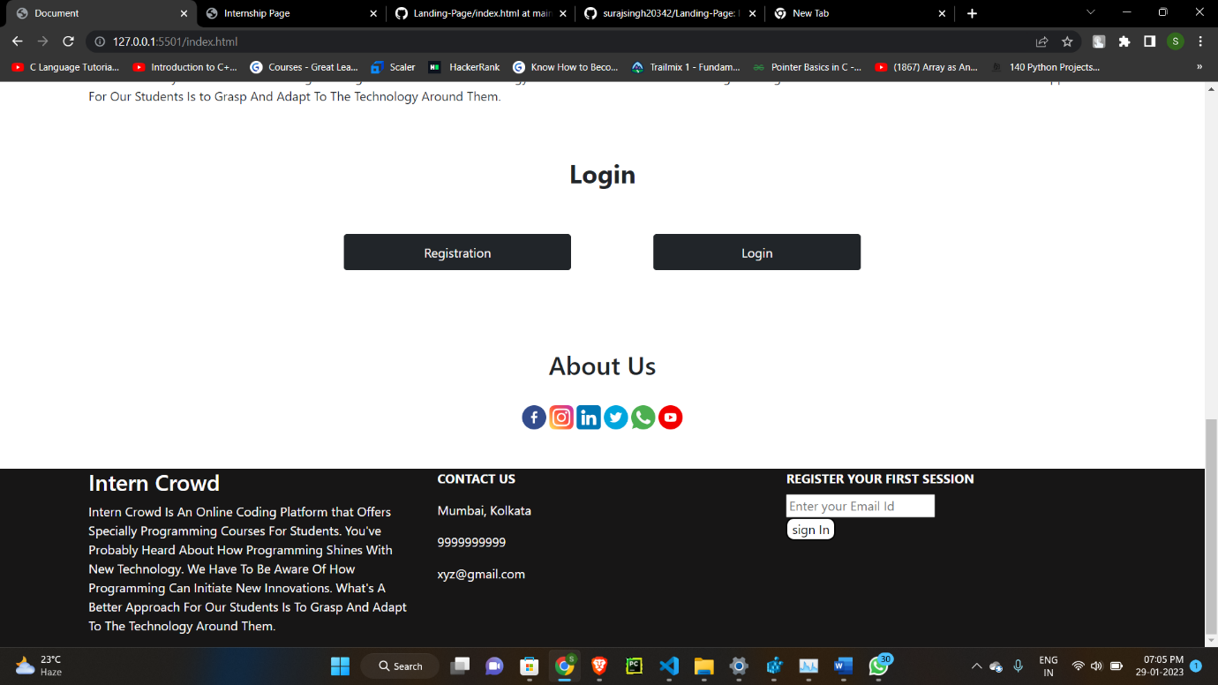

Internship.html

<!DOCTYPE html>

<html lang="en">

<head>

    <meta charset="UTF-8">

    <meta http-equiv="X-UA-Compatible" content="IE=edge">

    <meta name="viewport" content="width=device-width, initial-scale=1.0">

    <title>Internship Page</title>

    <style>

        .box-wrapper {

            height: 50vh;

            display: flex;

            flex-direction: row;

            text-align: center;

        }

        #box1 {

            padding: 35px;

            margin-left: 20px;

            margin-right: 30px;

            padding-bottom: 330px;

            border: solid 2px rgb(114, 204, 114);

        }

        #box1 img {

            height: 80px;

        }

        #box1:hover {

            background-color: #0eb582;

            color: white;

        }

        #box2 {

            padding: 35px;

            margin-left: 20px;

            margin-right: 30px;

            padding-bottom: 330px;

            border: solid 2px rgb(114, 204, 114);

        }

        #box2 img {

            height: 80px;

        }

        #box2:hover {

            background-color: #0eb582;

            color: white;

        }

        #box3 {

            padding: 35px;

            margin-left: 20px;

            margin-right: 30px;

            padding-bottom: 330px;

            border: solid 2px rgb(114, 204, 114);

        }

        #box3 img {

            height: 80px;

        }

        #box3:hover {

            background-color: #0eb582;

            color: white;

        }

        #box4 {

            padding: 35px;

            margin-left: 20px;

            margin-right: 30px;

            padding-bottom: 330px;

            border: solid 2px rgb(114, 204, 114);

        }

        #box4 img {

            height: 80px;

        }

        #box4:hover {

            background-color: #0eb582;

            color: white;

        }

        .box-wrapper1{

            height: 20vh;

            display:flex;

            flex-direction: row;

            text-align: center;

        }

        #box5 {

            padding: 35px;

            margin-top: 50px;

            margin-left: 20px;

            margin-right: 30px;

            padding-bottom: 330px;

            border: solid 2px rgb(114, 204, 114);

        }

        #box5 img {

            height: 80px;

        }

        #box5:hover {

            background-color: #0eb582;

            color: white;

        }

        #box6 {

            padding: 35px;

            margin-top: 50px;

            margin-left: 20px;

            padding-bottom: 330px;

            border: solid 2px rgb(114, 204, 114);

        }

        #box6 img {

            height: 80px;

        }

        #box6:hover {

            background-color: #0eb582;

            color: white;

        }

    </style>

</head>

<body>

    <div class="box-wrapper">

        <div id="box1">

            <img src="https://interncrowd.in/images/subject-icon-8.png" alt="Web image">

            <h3>Web Development</h3>

            <p>Website needs to work across all devices and it needs to be fast as possible.</p>

        </div>

        <div id="box2">

            <img src="https://interncrowd.in/images/student-icon-9.png" alt="java image">

            <h3>Java Development</h3>

            <p>It includes owning a particular application or working on several at one time.</p>

        </div>

        <div id="box3">

            <img src="https://interncrowd.in/images/student-icon-10.png" alt="Android Image">

            <h3>Android App Development</h3>

            <p>It created for making devices running the operating systems of Android.</p>

        </div>

        <div id="box4">

            <img src="https://interncrowd.in/images/student-icon-11.png" alt="Digital marketing">

            <h3>Digital Marketing</h3>

            <p>It is a marketing and advertising of a business, product, or service using social media.</p>

        </div>

    </div>

    <div class="box-wrapper1">

        <div id="box5">

            <img src="https://interncrowd.in/images/subject-icon-7.png" alt="C/C++ image">

            <h3>C/C++ Developmemt</h3>

            <p>It is a general-purpose Programming and coding language.</p>

        </div>

        <div id="box6">

            <img src="https://interncrowd.in/images/subject-icon-12.png" alt="Cloud image">

            <h3>Cloud Computing</h3>

            <p>It is the delivery of distinct services over the internet.</p>

        </div>

    </div>

</body>

</html>

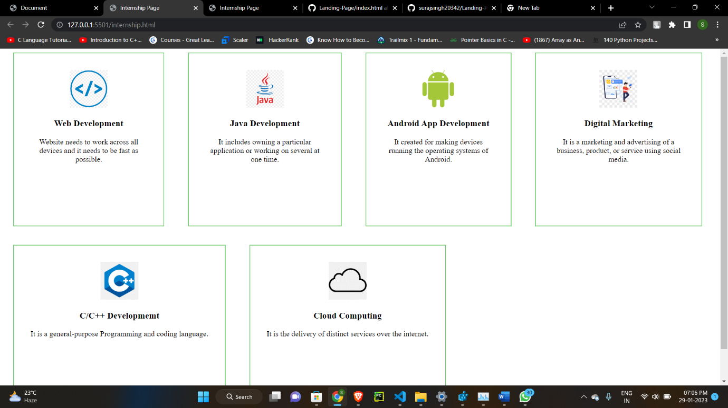

Login.html

<!DOCTYPE html>

<html lang="en">

<head>

    <meta charset="UTF-8">

    <meta http-equiv="X-UA-Compatible" content="IE=edge">

    <meta name="viewport" content="width=device-width, initial-scale=1.0">

    <title>Login Page</title>

    <style>

        body{

            font-family: 'Courier New', Courier, monospace;

            background-color: aliceblue;

        }

        .home{

            float: right;

            background-color: black;

            color: white;

            padding: 10px 50px 10px 50px;

            font-size: medium;

            border-radius: 10px;

        }

        .SignUp{

            float: left;

            background-color: black;

            color: white;

            padding: 10px 50px 10px 50px;

            font-size: medium;

            border-radius: 10px;

        }

        .signin{

            background-color: yellow;

            color: black;

            width: 100%;

            border: none;

            cursor: pointer;

            font-weight: 1000;

            padding: 15px;

            margin: 10px 10px;

        }

        input[type="text"], input[type="password"]{

            width: 100%;

            padding: 12px 20px;

            border: 2px solid black;

            display: inline-block;

            box-sizing: border-box;

        }

        .container{

            font-size: medium;

            background-color: aquamarine;

        }

        form{

            border: 3px solid #f1f1f1;

        }

    </style>

</head>

<body>

    <button class="SignUp" onclick="document.location='registration.html'">Sign Up</button>

    <button class="home" onclick="document.location='index.html'">Home</button>

    <br><br><center><h1><strong>Login</strong></h1></center>

    <form>

        <div class="container">

            <br><br><label><strong>Username :</strong></label>

            <input type="text" placeholder="Enter Username" name="Username" required><br>

            <label> <strong>Password :</strong></label>

            <input type="text" placeholder="Enter Password" name="Password" required><br><br>

            <button class="signin" type="submit">Sign In</button><br><br>

        </div>

    </form>

</body>

</html>

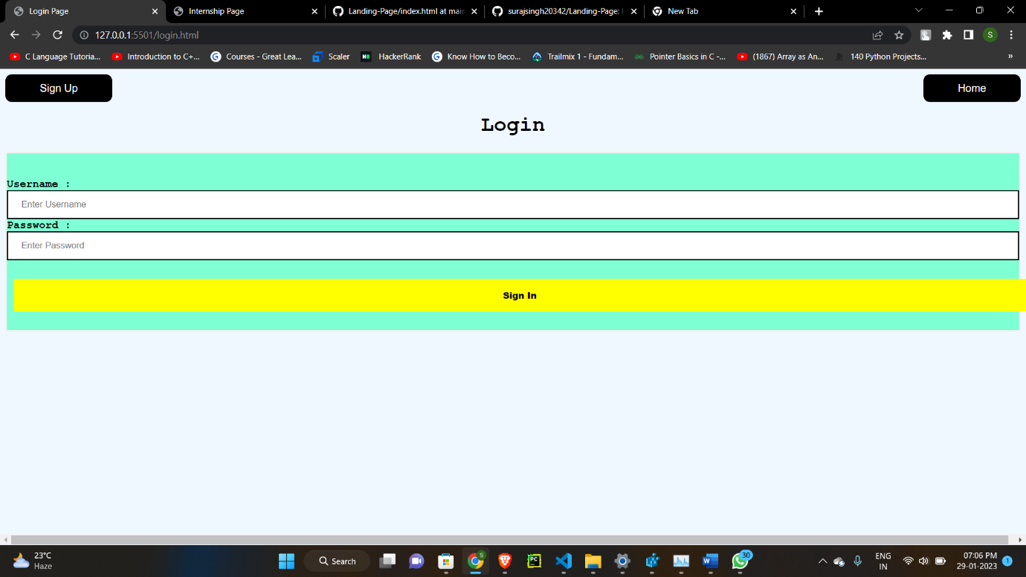

Registration.html

<!DOCTYPE html>

<html lang="en">

<head>

    <meta charset="UTF-8">

    <meta http-equiv="X-UA-Compatible" content="IE=edge">

    <meta name="viewport" content="width=device-width, initial-scale=1.0">

    <title>Registration  Page</title>

    <style>

        body{

            font-family:'Courier New', Courier, monospace;

            background-color: azure;

        }

        .signup{

            background-color: yellow;

            width: 100%;

            color: black;

            padding: 15px;

            margin: 10px 10px;

            border: none;

            cursor: pointer;

            font-weight: 1000;

        }

        form{

            border: 3px solid #f1f1f1;

        }

        input[type=text],input[type=password]{

            width: 100%;

            margin: 8px 0;

            padding: 12px 20px;

            display: inline-block;

            border: 2px solid black;

            box-sizing: border-box;

        }

        .container{

            padding: 25px;

            background-color: aquamarine;

        }

        .home{

            background-color: rgb(0, 0, 0);

            color: #f1f1f1;

            float: right;

            padding: 10px 50px 10px 50px;

            font-size: medium;

            border-radius: 10px;

        }

        .login{

            background-color: black;

            color: #f1f1f1;

            float: left;

            padding: 10px 50px 10px 50px;

            font-size: medium;

            border-radius: 10px;

        }

    </style>

</head>

<body>

    <button class="login" onclick="document.location='login.html'">Login</button>

    <button type="button" class="btn btn-dark home" onclick="document.location='index.html'">Home</button><br><br>

    <center> <h1 "><strong>Registration</strong></h1></center>

    <form>

        <div class="container">

            <label><strong>Username :</strong></label>

            <input type="text" placeholder="Enter Username" name="Username:" required><br>

            <label><strong>Email :</strong></label>

            <input type="text" placeholder="Enter Email" name="Email" required><br>

            <label><strong>Password :</strong></label>

            <input type="text" placeholder="Enter passward" name="Password" required><br>

            <label><strong>Conform Password :</strong></label>

            <input type="text" placeholder="Enter Password" name="Password" required><br><br>

            <button class="signup " type="submit">Sign Up</button>

        </div>

    </form>

</body>

</html>

