
T1-T3, Manglam electronic mall
Riddhi siddhi, Jaipur
www.dekho.co | info@dekho.co
Toll Free : 1800-102-6126

Date- 24/08/2022

TO WHOM-SO-EVER IT MAY CONCERN

This is to certify that Ayushi Valecha worked as Angular Trainee in our company from 26th of June to 9th of August with our entire satisfaction. During his working period we found him a sincere, honest, hardworking, dedicated employee with a professional attitude and very good job knowledge. He is amiable in nature and character is well.

We wish him every success in life.


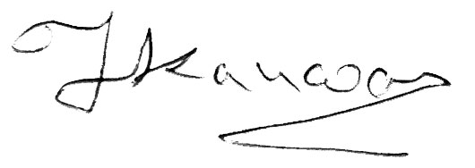

Sincerely,

[Tejasvi Kanwar]
Human Resource Manager

