1. Install python from <https://www.python.org/downloads/>
2. Update environment variable (path) with
   1. C:\Users\ss\AppData\Roaming\npm;C:/Program Files (x86)/Microsoft Visual Studio/Shared/Python36_64; => this is for python
   2. C:\Program Files (x86)\Microsoft Visual Studio\Shared\Python36_64\Scripts; => this is for pip. Pip is used to install packages like pandas etc.
3. Command to check python or pip is installed/setup properly or not  
   *>python –version*

*>pip -- version*

1. Install pandas

*>pip install pandas*

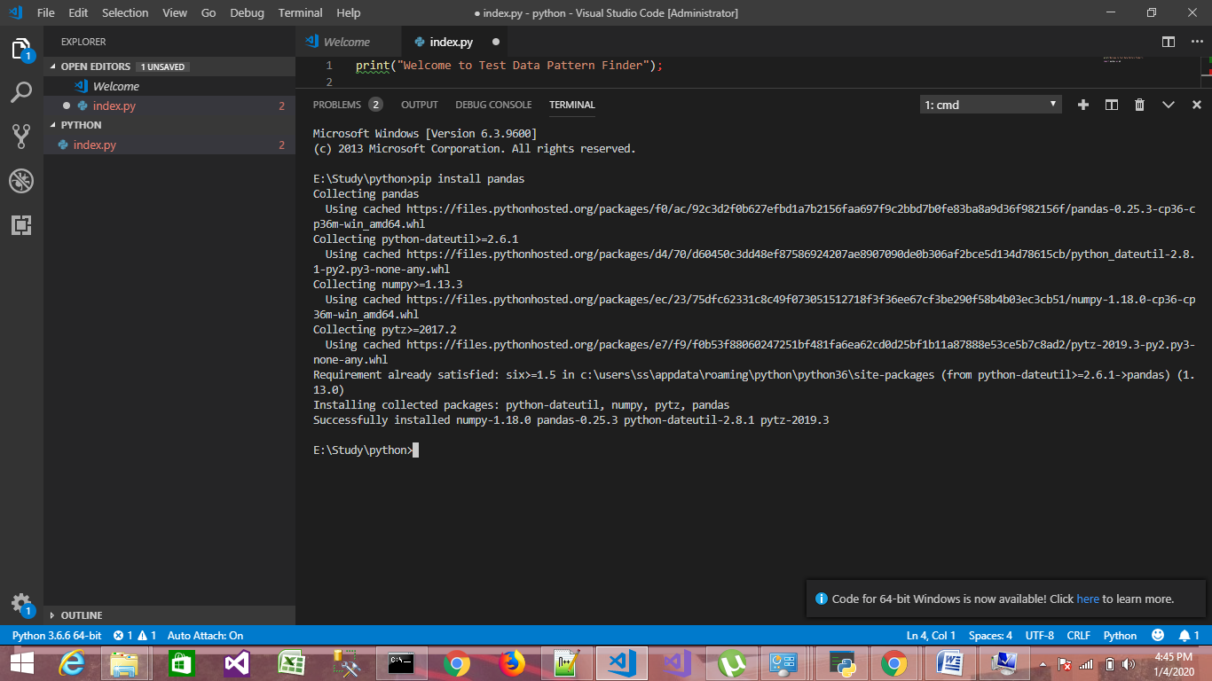

1. To work with Excel install xlrd.

*>pip install xlrd*

1. To plot data as chart we require to use module

*>pip install matplotlib*

1. To write output to exel we need this module

*>pip install openpyxl*

1. To show output on gui we are using pandasgui so install it using

*>pip install pandasgui*