1. 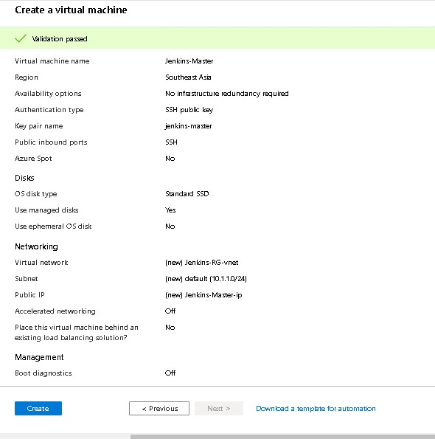Create a virtual machine with ubuntu image

1. SSH into the machine and installed Jenkins server
2. Jenkins server up and running on this URL : [http://52.187.5.134:8080](http://52.187.5.134:8080/)