**Book Management API Application**

**INTRODUCTION**

The Book Management API is a web-based application designed for the process of managing book records within an educational institution. Developed in the Go programming language and utilizing the gofr web framework, this API offers a simple and efficient solution for performing essential CRUD operations on book data.

**Features:**

**Create - Add Book:**

Easily add new books to the system by providing their name, age, and enrollment information through a user-friendly API endpoint (POST /add).

**Read - View Books:**

Retrieve a comprehensive list of all registered books along with their details, facilitating easy access to information about the book body (GET /view).

**Update - Update Book Details:**

Modify and update the information of existing books using the dedicated API endpoint (PUT /update/:id), allowing for real-time adjustments to book records.

**Delete - Remove Book:**

Effortlessly remove books from the system based on their unique identifier (GET /d/:id). This feature ensures accurate and up-to-date book records.

**SEQUENCE DIAGRAM FOR THE APPLICATION**

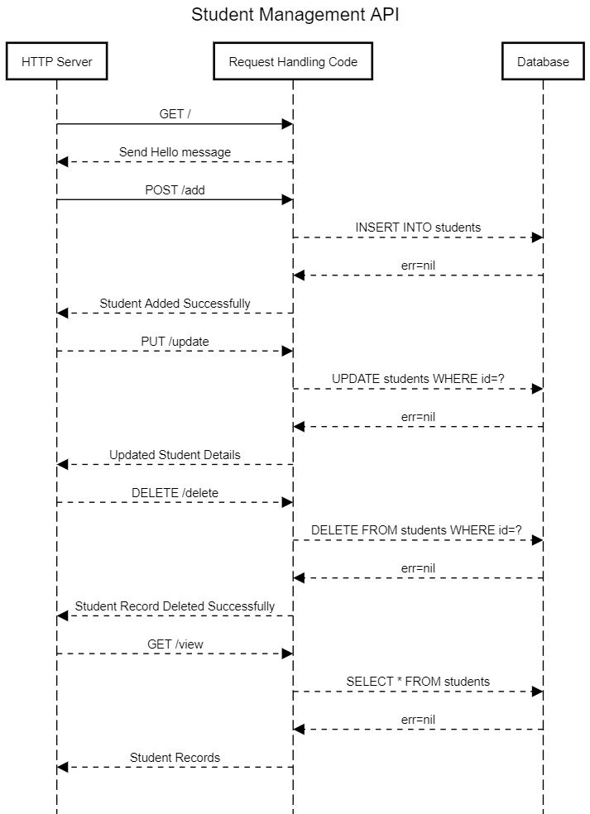

**Book Management API UML Diagram**

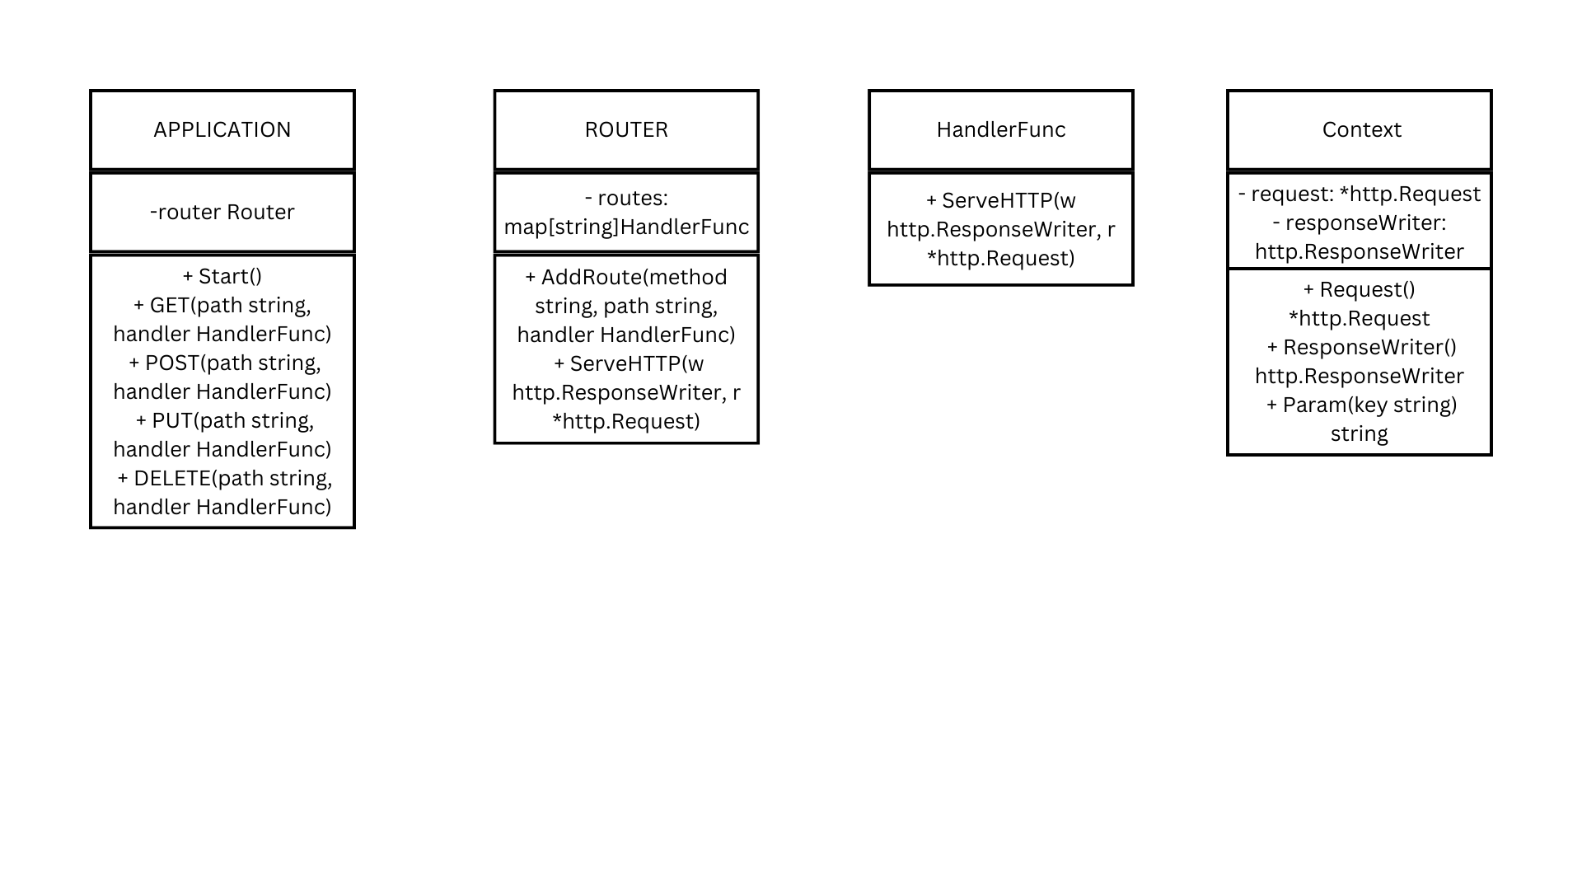

**Database Integration:**

The API seamlessly integrates with an SQLite database (books.db), providing a robust and scalable solution for storing book information. The database employs a straightforward structure with columns for book ID, name, age, and enrollment information.

**Web Framework - gofr:**

The API leverages the gofr web framework, simplifying the process of handling HTTP requests and responses. This lightweight framework enhances the development experience, allowing for rapid implementation of RESTful API endpoints.

**Usage:**

**Clone the Repository:**

git clone https://github.com/Adityamishra1352/bookManagementGoFr.git

cd bookManagementGoFr

**Install Go:**

Ensure that you have Go installed on your machine. Follow the official Go installation guide if needed.

**Install Dependencies:**

go get -u gofr.dev/pkg/gofr

**Build the Project:**

Build the Go project to generate the executable file. This assumes your main package is in the root directory.

go build

**Run the Application:**

go run main.go

**Access the API Endpoints:**

Once the application is running, users can access the API endpoints through a tool like cURL, Postman, or a web browser.

**Conclusion:**

The Book Management API provides a straightforward and accessible solution for educational institutions seeking an efficient way to manage and maintain book records. Whether adding new books, updating existing details, or retrieving information, this API offers a user-friendly interface to facilitate seamless interactions with book data. As an open-source project, developers can further extend and customize the API to meet specific requirements, making it a versatile tool for educational institutions of varying scales.