**Google Cloud Platform (GCP) Virtual Machine Setup with Auto-Scaling and Security**

**1. Introduction**

Google Cloud Platform (GCP) offers a comprehensive suite of cloud services that enable organizations to deploy, manage, and scale applications efficiently. One of its core services, Compute Engine, allows users to create and manage virtual machines (VMs) on demand, offering flexibility and scalability.

In cloud-based infrastructures, auto-scaling ensures that resources are dynamically adjusted based on workload, minimizing costs while maintaining optimal performance. Additionally, security measures, including Identity and Access Management (IAM) and firewall rules, help to protect resources from unauthorized access and cyber threats.

This document provides an in-depth, step-by-step guide on deploying a Virtual Machine (VM) instance, configuring auto-scaling policies, and implementing security configurations to ensure a secure and scalable infrastructure in GCP.

**2. Objectives**

The primary objectives of this implementation are:

* Deploy a Virtual Machine (VM) instance in GCP.
* Configure Auto-Scaling Policies to optimize resources dynamically based on workload demands.
* Implement Security Measures, including IAM roles and firewall rules, to protect cloud resources from unauthorized access.
* Provide a clear architectural design representing the system interactions.
* Include source code repositories for deployment automation.

**3. Step-by-Step Implementation**

**3.1 Creating a VM Instance in GCP**

A Virtual Machine (VM) serves as the primary computational resource for running applications in a cloud environment. Below are the detailed steps to create a VM instance in Google Cloud Platform.

**Step 1: Log in to GCP Console**

1. Open a web browser and navigate to [**Google Cloud Console**](https://console.cloud.google.com/).
2. Sign in with your Google account.

**Step 2: Navigate to Compute Engine**

1. In the left-hand navigation menu, go to Compute Engine > VM Instances.
2. Click Create Instance.

**Step 3: Configure the VM Instance**

1. **Enter Instance Name**: e.g., my-instance.
2. **Select a Region & Zone**: Choose a region nearest to your users for better performance.
3. **Choose a Machine Type**: Select e2-medium (2 vCPUs, 4 GB RAM) or adjust based on workload needs.
4. **Boot Disk Selection**:
   * Click Change and select Ubuntu 20.04 LTS.
5. **Enable Firewall**: Check the boxes for Allow HTTP and HTTPS traffic.
6. Click **Create** to launch the instance.

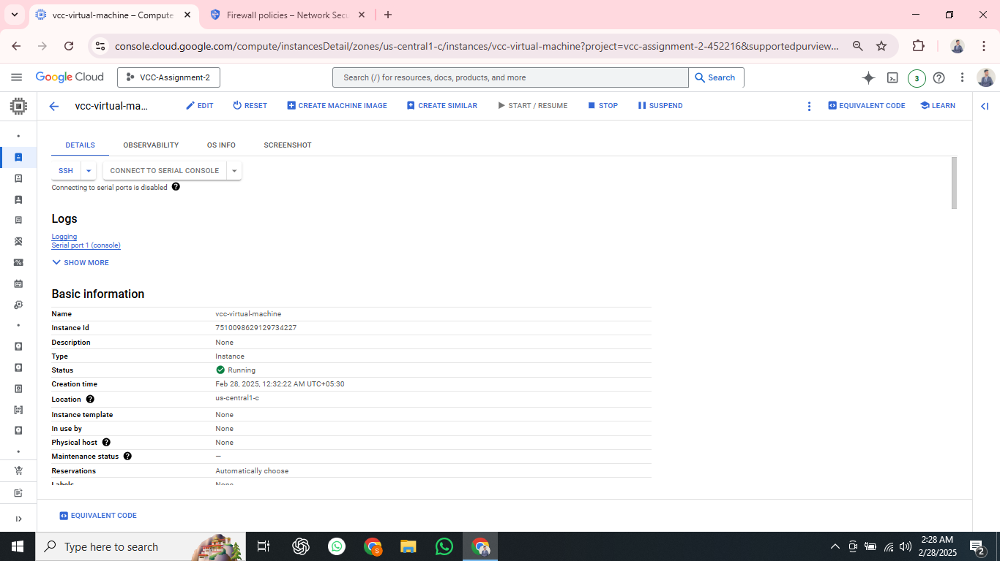

**3.2 Configuring Auto-Scaling Policies**

Auto-scaling ensures that additional VM instances are created when CPU utilization increases and reduces instances when demand is low, optimizing cost and performance.

**Step 1: Create a Managed Instance Group**

1. Navigate to Compute Engine > Instance Groups.
2. Click Create Instance Group.

**Step 2: Configure Instance Group**

1. Choose Managed Instance Group.
2. Select an Instance Template (Create one if necessary).
3. Set Auto-Scaling to Enabled.

**Step 3: Define Auto-Scaling Policies**

1. **Metric:** CPU utilization.
2. **Target CPU Utilization:** 60%.
3. **Minimum Instances:** 1.
4. **Maximum Instances:** 5.
5. Click **Create**.

**3.3 Implementing Security Measures**

Security is critical when managing cloud resources. Implementing IAM roles and firewall rules ensures that access to resources is well-managed and protected.

**3.3.1 Setting Up IAM Roles**

IAM (Identity and Access Management) allows role-based access control for better security.

**Step 1: Navigate to IAM**

1. Go to IAM & Admin > IAM.
2. Click + Add to add a new user.

**Step 2: Assign Roles**

1. **Enter Member Email**.
2. Assign roles:
   * **Compute Viewer**: Read-only access.
   * **Compute Admin**: Full control over Compute Engine resources.
3. Click **Save**.

**3.3.2 Configuring Firewall Rules**

Firewall rules define which traffic is allowed to reach instances.

**Step 1: Create a Firewall Rule**

1. Navigate to VPC Network > Firewall.
2. Click Create Firewall Rule.

**Step 2: Configure Firewall Rule**

1. **Enter Rule Name**: allow-http-ssh
2. **Target**: Apply to all instances.
3. **Source IPv4 Range**: 0.0.0.0/0 (or restrict as needed).
4. **Allowed Protocols & Ports**:
   * **TCP:** 22, 80, 443
5. Click **Create**.

**4. Architecture Design**

The following architecture diagram visually represents the interaction between the VM, auto-scaling policies, firewall settings, and IAM roles.

**Explanation of Architecture Diagram**

1. **User Requests**: Incoming traffic from users is directed to the GCP Load Balancer.
2. **Load Balancer**: Distributes requests efficiently among multiple VM instances.
3. **Google Compute Engine (VMs)**: The primary compute resources handling the user workload.
4. **Auto-Scaling Policy**: Automatically scales instances up/down based on CPU utilization.
5. **Firewall Rules**: Defines security rules for allowing HTTP, HTTPS, and SSH access.
6. **IAM Policies**: Ensures restricted access through Compute Admin and Viewer roles.
7. **Google Cloud Storage**: Used for storing logs and backups.
8. **Logging & Monitoring**: Helps in performance tracking and security monitoring.

**5. Running a Python Program on the VM**

**Purpose of Implementing a Python Program**

Once the virtual machine is set up and cloned from the source code repository, it is essential to verify its functionality. Running a Python program from the VM ensures that it has internet connectivity, necessary dependencies installed, and the ability to execute real-world tasks. The Python script being executed is a web scraper, which fetches the titles of popular websites. This confirms that the VM is fully functional and can handle network requests efficiently.

**Implementation Steps**

1. **Clone the Repository Containing the Python Script**:

git clone https://github.com/your-repository-link.git

cd your-repository-folder

1. **Install Necessary Dependencies**:

sudo apt update

sudo apt install python3-pip -y

pip3 install requests beautifulsoup4

1. **Run the Python Web Scraping Script**:

python3 web_scraper.py

1. **Expected Output**:

This output confirms that the VM is successfully executing Python scripts, has internet access, and can perform automated tasks.

**6. Source Code Repository**

All deployment scripts and configurations are stored in the following GitHub repository:

<https://github.com/sachinsingh2156/VCC-Assignment-2.git>

**7. Conclusion**

This report provides a detailed, structured guide for deploying a Virtual Machine in GCP with auto-scaling and security configurations. By implementing these steps, organizations can efficiently manage cloud resources while ensuring security compliance and high availability. The architecture ensures scalability, optimized performance, and robust security in cloud environments.

**References**

1. **Google Cloud Documentation** - Compute Engine

<https://cloud.google.com/compute/docs>

1. **Google Cloud IAM & Security**

<https://cloud.google.com/iam/docs>

1. **Google Cloud Auto-Scaling**

<https://cloud.google.com/compute/docs/autoscaler>

1. **Firewall Rules in GCP**

<https://cloud.google.com/vpc/docs/firewalls>

1. **Python Web Scraping with BeautifulSoup**

<https://www.crummy.com/software/BeautifulSoup/>

1. **GitHub Repository Management**

<https://docs.github.com/en/get-started>

**Appendix**

1. **Video Presentation Link :**

https://drive.google.com/file/d/1-oEEXT2IwhaFPseKNxAYPaxxtXM84POx/view?usp=sharing

1. **PPT Link:**

<https://docs.google.com/presentation/d/1RzAQHK5lOoeLwOtN0Wc3uVYk5vlLF28L/edit?usp=sharing&ouid=110909031381492795570&rtpof=true&sd=true>

1. **System Architecture Diagram:**

<https://drive.google.com/file/d/1spQ4_FVAJUDE23ku-jr5a-wWVYZSx7_2/view?usp=sharing>

1. **GitHub Repository Link:**

<https://github.com/sachinsingh2156/VCC-Assignment-2.git>