Name:- Sachin Singh Rawat

RollNo:- 58

BCA – A (5th Sem)

**Android Assingment**

Q1 :- write a code to print prime index characters .

Sol . XML CODE

<?xml version="1.0" encoding="utf-8"?>

<androidx.constraintlayout.widget.ConstraintLayout xmlns:android="http://schemas.android.com/apk/res/android"

xmlns:app="http://schemas.android.com/apk/res-auto"

xmlns:tools="http://schemas.android.com/tools"

android:layout_width="match_parent"

android:layout_height="match_parent"

tools:context=".MainActivity2">

<TextView

android:id="@+id/textView3"

android:layout_width="170dp"

android:layout_height="50dp"

android:text="Enter your String"

android:textSize="20sp"

app:layout_constraintBottom_toBottomOf="parent"

app:layout_constraintEnd_toEndOf="parent"

app:layout_constraintHorizontal_bias="0.066"

app:layout_constraintStart_toStartOf="parent"

app:layout_constraintTop_toTopOf="parent"

app:layout_constraintVertical_bias="0.171" />

<EditText

android:id="@+id/editTextText"

android:layout_width="wrap_content"

android:layout_height="wrap_content"

android:ems="10"

android:inputType="text"

app:layout_constraintBottom_toBottomOf="parent"

app:layout_constraintEnd_toEndOf="parent"

app:layout_constraintHorizontal_bias="0.925"

app:layout_constraintStart_toStartOf="parent"

app:layout_constraintTop_toTopOf="parent"

app:layout_constraintVertical_bias="0.17" />

<Button

android:id="@+id/button3"

android:layout_width="wrap_content"

android:layout_height="wrap_content"

android:text="Button"

app:layout_constraintBottom_toBottomOf="parent"

app:layout_constraintEnd_toEndOf="parent"

app:layout_constraintHorizontal_bias="0.468"

app:layout_constraintStart_toStartOf="parent"

app:layout_constraintTop_toTopOf="parent"

app:layout_constraintVertical_bias="0.352" />

<TextView

android:id="@+id/textView4"

android:layout_width="252dp"

android:layout_height="86dp"

app:layout_constraintBottom_toBottomOf="parent"

app:layout_constraintEnd_toEndOf="parent"

app:layout_constraintHorizontal_bias="0.584"

app:layout_constraintStart_toStartOf="parent"

app:layout_constraintTop_toTopOf="parent"

app:layout_constraintVertical_bias="0.531" />

</androidx.constraintlayout.widget.ConstraintLayout>

JAVA CODE

package com.example.myapplication;

import androidx.appcompat.app.AppCompatActivity;

import android.annotation.SuppressLint;

import android.os.Bundle;

import android.view.View;

import android.widget.Button;

import android.widget.EditText;

import android.widget.TextView;

public class MainActivity2 extends AppCompatActivity {

@SuppressLint("MissingInflatedId")

@Override

protected void onCreate(Bundle savedInstanceState) {

super.onCreate(savedInstanceState);

setContentView(R.layout.activity_main2);

EditText e1;

Button b1;

TextView t1;

e1= findViewById(R.id.editTextText);

b1 = findViewById(R.id.button3);

t1 = findViewById(R.id.textView4);

b1.setOnClickListener(new View.OnClickListener() {

@Override

public void onClick(View view) {

String s = e1.getText().toString();

String s1="";

for(int i=2 ; i<s.length() ; i++)

{

int j = check(i);

if(j==1)

{

s1 = s1 + s.charAt(i);

}

}

t1.setText(s1);

}

});

}

public int check(int no)

{

int c=0;

for(int i=2 ; i<=no ; i++)

{

if(no%i==0)

{

c++;

}

}

if(c==1)

{ return 1; }

return 0;

}

}

OUTPUT

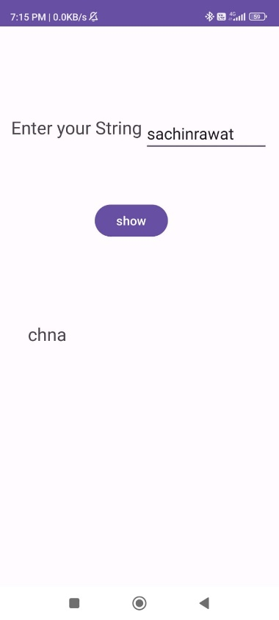

Q2 :- write a code to print duplicate and non-duplicates elements in array .

Sol. XML CODE

<?xml version="1.0" encoding="utf-8"?>

<androidx.constraintlayout.widget.ConstraintLayout xmlns:android="http://schemas.android.com/apk/res/android"

xmlns:app="http://schemas.android.com/apk/res-auto"

xmlns:tools="http://schemas.android.com/tools"

android:layout_width="match_parent"

android:layout_height="match_parent"

tools:context=".MainActivity">

<Button

android:id="@+id/button"

android:layout_width="118dp"

android:layout_height="64dp"

android:text="Duplicates"

/>

<Button

android:id="@+id/button2"

android:layout_width="118dp"

android:layout_height="64dp"

android:text="Non - duplicates"

/>

<TextView

android:id="@+id/textView"

android:layout_width="351dp"

android:layout_height="115dp"

android:textSize="24sp"

app:layout_constraintBottom_toBottomOf="parent"

app:layout_constraintEnd_toEndOf="parent"

app:layout_constraintStart_toStartOf="parent"

app:layout_constraintTop_toTopOf="parent"

app:layout_constraintVertical_bias="0.316" />

<TextView

android:id="@+id/textView2"

android:layout_width="353dp"

android:layout_height="119dp"

android:textSize="24sp"

app:layout_constraintBottom_toBottomOf="parent"

app:layout_constraintEnd_toEndOf="parent"

app:layout_constraintHorizontal_bias="0.461"

app:layout_constraintStart_toStartOf="parent"

app:layout_constraintTop_toTopOf="parent"

app:layout_constraintVertical_bias="0.75" />

</androidx.constraintlayout.widget.ConstraintLayout>

JAVA CODE

package com.example.myapplication;

import android.view.View;

import android.widget.Button;

import android.widget.EditText;

import android.widget.TextView;

import android.widget.Toast;

import org.w3c.dom.Text;

import java.io.File;

import java.io.FileInputStream;

import java.io.FileNotFoundException;

import java.io.FileOutputStream;

import java.io.IOException;

import java.io.InputStream;

public class MainActivity extends AppCompatActivity {

@SuppressLint("MissingInflatedId")

@Override

protected void onCreate(Bundle savedInstanceState) {

super.onCreate(savedInstanceState);

setContentView(R.layout.activity_main);

Button b1 , b2;

int a[] = {1,2,1,2,3,3,4,5,6,7};

int b[] = new int[10];

int c=0;

for(int i=0 ; i<a.length ; i++)

{

c=1;

if(a[i]!=-1)

{

for(int j=i+1 ; j<a.length ; j++)

{

if(a[i]==a[j])

{

c++;

a[j]=-1;

}

}

b[i]=c;

}

}

TextView t1, t2;

t1 = findViewById(R.id.textView);

t2 = findViewById(R.id.textView2);

b1 = findViewById(R.id.button);

b2 = findViewById(R.id.button2);

b1.setOnClickListener(new View.OnClickListener() {

@Override

public void onClick(View view) {

int k=0;

String s1="" , dup="";

for(int i=0 ; i<a.length ; i++)

{

if(a[i]!=-1)

{

if(b[i]>1)

{

k=a[i];

s1 = String.valueOf(k);

dup = dup + s1;

}

}

}

t1.setText(dup);

}

});

b2.setOnClickListener(new View.OnClickListener() {

@Override

public void onClick(View view) {

String nondup="" , s1="";

int k=0;

for(int i=0 ; i<a.length ; i++)

{

if(a[i]!=-1)

{

if(b[i]==1)

{

k=a[i];

s1 = String.valueOf(k);

nondup = nondup + s1;

}

}

}

t2.setText(nondup);

}

});

}

OUTPUT

} 