GLOBAL SUPERSTORE 2016
SALES & PROFIT ANALYSIS
Project Report
Sachin Sisodiya

1. Executive Summary
This project analyzes the Global Superstore 2016 dataset using Python. The dataset contains 51,290 order-line records covering 2012–2015. Across the dataset, total sales are $12,642,501.91, total profit is $1,467,457.29, and the overall profit margin is 11.61%. The analysis examines trends, products, markets, customers, shipping and returns to produce business-oriented insights.

2. Objectives
- Measure overall sales, profit, quantity and order performance.
- Analyze sales and profit trends over time.
- Compare product categories, sub-categories and markets.
- Understand customer segment performance.
- Identify high-sales and loss-making products.
- Evaluate shipping modes and average shipping duration.
- Measure returned-order rate.
- Examine the relationship between discount and profit.

3. Dataset Description
The supplied workbook contains three sheets: Orders, Returns and People. The Orders sheet is the primary analytical table. Returns is used to identify returned orders, while People provides regional manager information.
Index | Sheet | Rows | Columns
0 | Orders | 51290 | 28
1 | Returns | 1079 | 3
2 | People | 24 | 2

4. Tools and Technologies
Python, Pandas, NumPy, Matplotlib, Seaborn, Jupyter Notebook and OpenPyXL.

5. Data Preparation
- Converted Order Date and Ship Date to datetime format.
- Created Year and Month features from Order Date.
- Created Ship Days as the difference between Ship Date and Order Date.
- Created Profit Margin % from Profit divided by Sales.
- Mapped returned Order IDs from the Returns sheet to the Orders data.
- Postal Code contains many missing values; it was not required for the core analysis.

6. Key Performance Indicators
Index | KPI | Value
0 | Total Sales | $12,642,501.91
1 | Total Profit | $1,467,457.29
2 | Total Quantity | 178,312
3 | Unique Orders | 25,728
4 | Unique Customers | 17,415
5 | Unique Products | 3,788
6 | Profit Margin | 11.61%
7 | Returned Orders | 1,079
8 | Return Rate | 4.19%

7. Yearly Performance
Sales and profit both increased across the four years in the dataset. 2015 records the highest sales and profit among the four years.
Index | Sales | Profit | Quantity | Orders | Profit Margin %
2012 | 2,259,450.90 | 248,940.81 | 31,443.00 | 4,515.00 | 11.02
2013 | 2,677,438.69 | 307,415.28 | 38,111.00 | 5,473.00 | 11.48
2014 | 3,405,746.45 | 406,935.23 | 48,136.00 | 6,883.00 | 11.95
2015 | 4,299,865.87 | 504,165.97 | 60,622.00 | 8,857.00 | 11.73
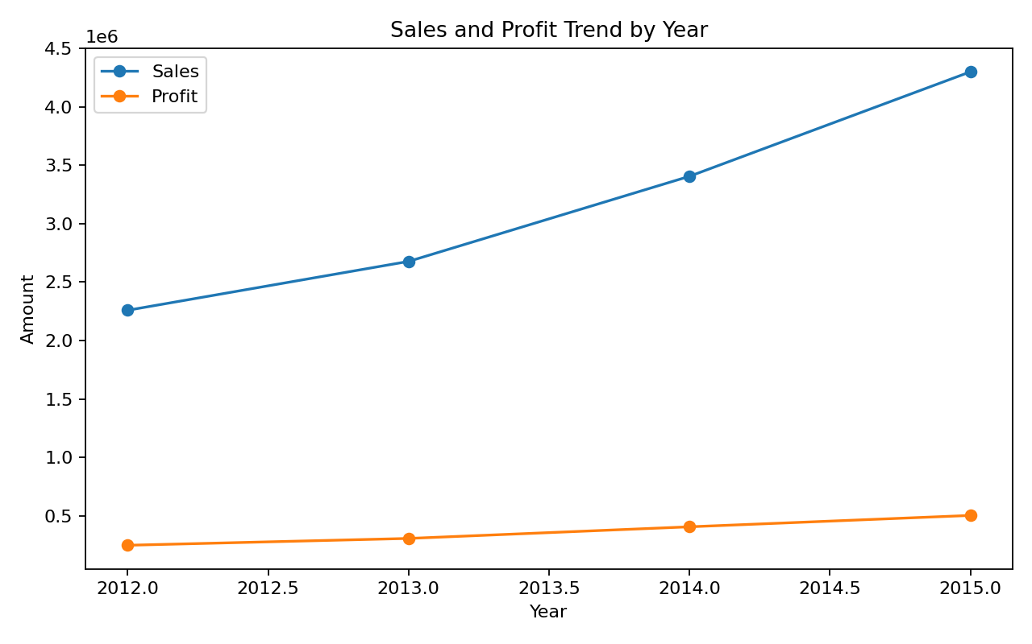

8. Category Performance
Technology has the highest category sales at $4,744,557.50. Office Supplies has the highest category profit after grouping the transaction records, while Furniture has a lower profit contribution relative to its sales.
Index | Sales | Profit | Quantity | Orders
Technology | 4,744,557.50 | 663,778.73 | 35,176.00 | 8,428.00
Furniture | 4,110,451.90 | 285,082.73 | 34,892.00 | 8,222.00
Office Supplies | 3,787,492.51 | 518,595.83 | 108,244.00 | 19,464.00
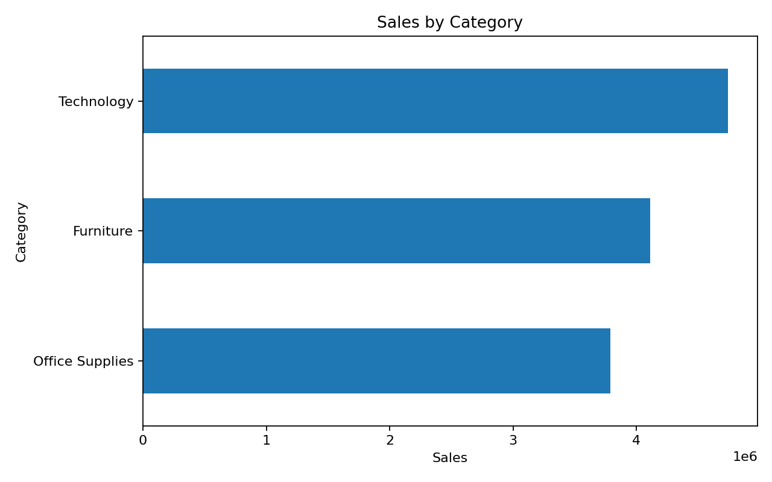

9. Market Performance
Asia Pacific has the highest market sales at $4,042,658.27. Europe has the highest market profit at $449,551.72.
Index | Sales | Profit | Orders
Asia Pacific | 4,042,658.27 | 403,176.04 | 7,080.00
Europe | 3,287,336.23 | 449,551.72 | 6,013.00
USCA | 2,364,129.03 | 304,214.41 | 5,203.00
LATAM | 2,164,605.17 | 221,643.49 | 5,144.00
Africa | 783,773.21 | 88,871.63 | 2,288.00
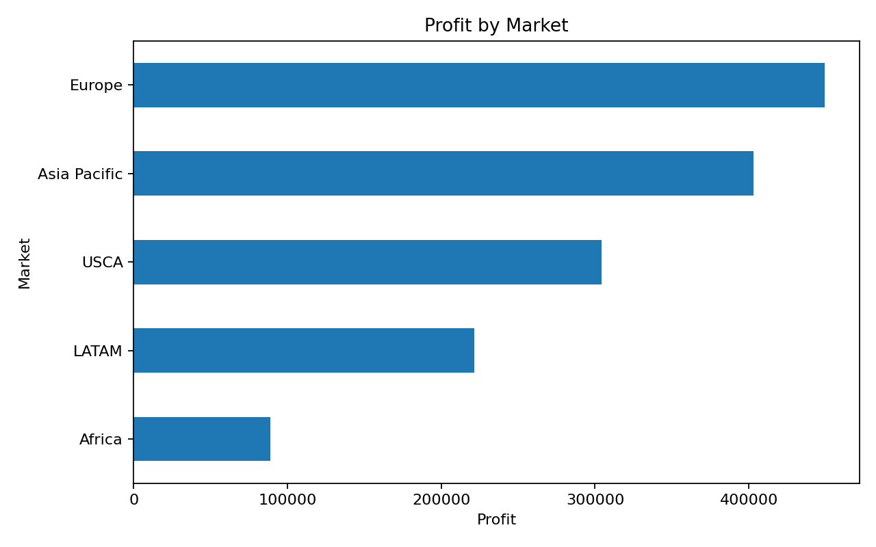

10. Customer Segment Analysis
Consumer is the largest segment by sales, with $6,507,949.42 in sales.
Index | Sales | Profit | Orders
Consumer | 6,507,949.42 | 749,239.78 | 13,291.00
Corporate | 3,824,697.52 | 441,208.33 | 7,724.00
Home Office | 2,309,854.97 | 277,009.18 | 4,713.00
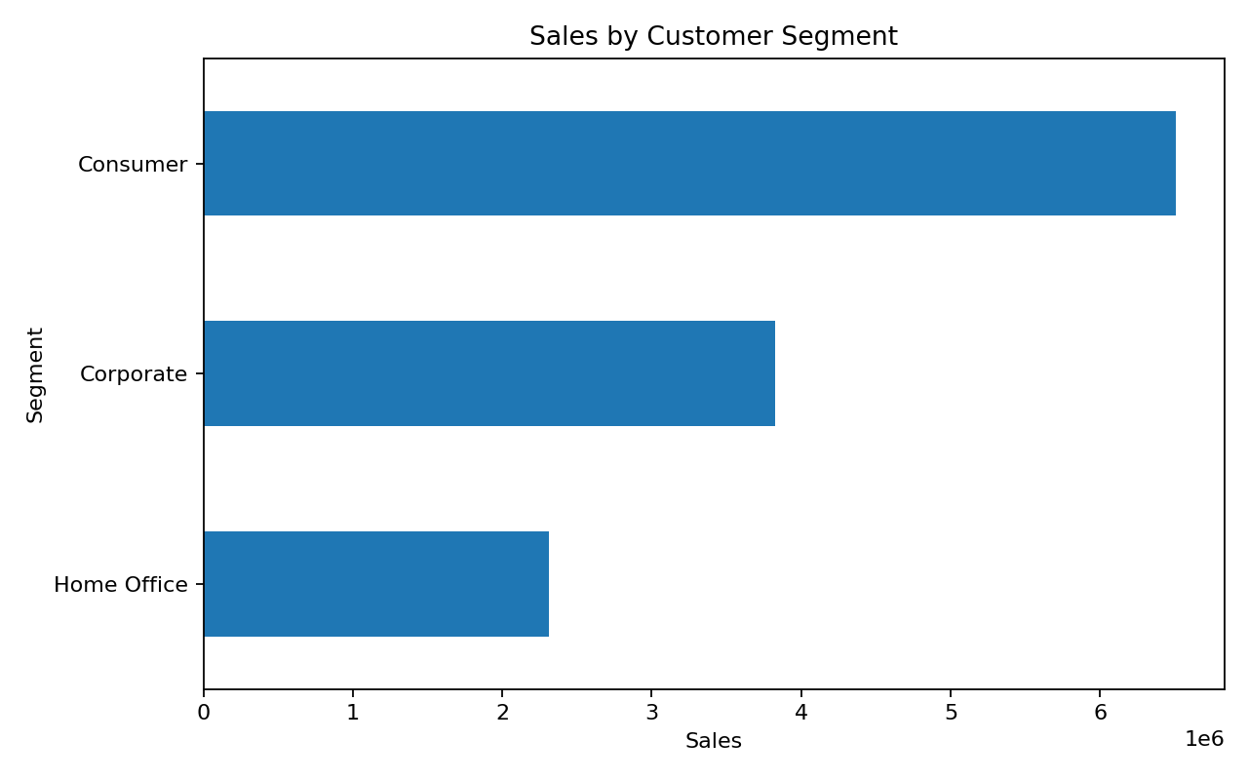

11. Product Analysis
The following table shows the ten products with the highest aggregated sales.
Index | Sales | Profit | Quantity
Apple Smart Phone, Full Size | 86,935.78 | 5,921.58 | 171.00
Cisco Smart Phone, Full Size | 76,441.53 | 17,238.52 | 139.00
Motorola Smart Phone, Full Size | 73,156.30 | 17,027.11 | 134.00
Nokia Smart Phone, Full Size | 71,904.56 | 9,938.20 | 147.00
Canon imageCLASS 2200 Advanced Copier | 61,599.82 | 25,199.93 | 20.00
Hon Executive Leather Armchair, Adjustable | 58,193.48 | 5,997.25 | 169.00
Office Star Executive Leather Armchair, Adjustable | 50,661.68 | 4,710.98 | 141.00
Harbour Creations Executive Leather Armchair, Adjustable | 50,121.52 | 10,427.33 | 142.00
Samsung Smart Phone, Cordless | 48,653.46 | -198.09 | 108.00
Nokia Smart Phone, with Caller ID | 47,877.79 | 9,465.33 | 96.00
The following products have the lowest aggregated profit and should be investigated for pricing, discounting, cost and demand factors.
Index | Sales | Profit | Quantity
Cubify CubeX 3D Printer Double Head Print | 11,099.96 | -8,879.97 | 9.00
Lexmark MX611dhe Monochrome Laser Printer | 16,829.90 | -4,589.97 | 18.00
Motorola Smart Phone, Cordless | 38,931.04 | -4,447.04 | 74.00
Cubify CubeX 3D Printer Triple Head Print | 7,999.98 | -3,839.99 | 4.00
Bevis Round Table, Adjustable Height | 5,654.80 | -3,649.89 | 22.00
Bevis Computer Table, Fully Assembled | 11,177.90 | -3,509.56 | 43.00
Rogers Lockers, Blue | 28,214.59 | -2,893.49 | 167.00
Chromcraft Bull-Nose Wood Oval Conference Tables & Bases | 9,917.64 | -2,876.12 | 27.00
Bevis Wood Table, with Bottom Storage | 11,134.66 | -2,782.59 | 34.00
Lesro Training Table, Rectangular | 2,711.65 | -2,581.28 | 25.00

12. Shipping Analysis
Standard Class is the most frequently used shipping mode. Average shipping duration is calculated from the order and ship dates.
Index | Sales | Profit | Avg_Ship_Days | Orders
Standard Class | 7,578,652.11 | 890,596.02 | 5.00 | 15,405.00
Second Class | 2,565,671.68 | 292,583.53 | 3.23 | 5,146.00
First Class | 1,830,976.14 | 208,104.68 | 2.18 | 3,845.00
Same Day | 667,201.98 | 76,173.07 | 0.04 | 1,349.00

13. Returns Analysis
There are 1,079 unique returned orders among 25,728 unique orders, giving a return rate of 4.19%.

14. Statistical Analysis: Discount and Profit
The Pearson correlation between Discount and Profit is -0.3165. This indicates a negative linear association in this dataset. Correlation alone does not establish causation, so the result should be interpreted alongside product, market and pricing context.

15. Key Business Insights
- Sales increased from $2,259,450.90 in 2012 to $4,299,865.87 in 2015.
- Technology generated the highest category sales ($4,744,557.50).
- Asia Pacific generated the highest market sales ($4,042,658.27), while Europe generated the highest market profit ($449,551.72).
- Consumer generated the highest segment sales ($6,507,949.42).
- Standard Class was the most commonly used shipping mode.
- Several products have negative aggregated profit and merit detailed review.
- The observed discount-profit correlation is -0.3165; this should be treated as association rather than proof of causation.
- The returned-order rate is 4.19% and can be monitored as an operational KPI.

16. Recommendations
- Monitor loss-making products and review their pricing, discount levels, shipping costs and demand.
- Use market-level profit analysis alongside sales when allocating commercial attention.
- Track category and sub-category margins instead of relying only on revenue.
- Monitor returned orders by region, product and category to identify recurring service or product issues.
- Use discount analysis with other variables such as category, market and product rather than applying a blanket discount policy.
- Maintain a recurring dashboard for yearly sales, profit, margin, returns and shipping KPIs.

17. Limitations
- The analysis is descriptive and does not establish causal relationships.
- Postal Code contains substantial missing data and is not used for the main conclusions.
- The dataset covers historical transactions through 2015; conclusions describe this dataset and period.
- No predictive model is included because the requested project deliverables focus on analysis, visualization and business insights.

18. Conclusion
The project demonstrates a complete Python-based workflow for business data analysis: loading and validating data, cleaning and feature engineering, KPI calculation, exploratory analysis, visualization, statistical interpretation, and business recommendations. The resulting notebook is designed to be reproducible by placing the dataset in the same folder and running the cells sequentially.

19. Reproducibility
Install the libraries listed in requirements.txt, place global_superstore_2016.xlsx beside the notebook, start Jupyter Notebook, and execute the notebook from top to bottom.

